


United Nations Development Programme
Project Document template for projects
financed by the various GEF Trust Funds

Project title: National child project under the GEF Africa Minigrids Program: Zambia Minigrids (ZMG)
Country: Zambia | Implementing Partner (GEF Executing Entity): Rural Electrification Authority (REA) |  |  |  | Execution Modality: National Implementation Modality (full NIM)
Related UNDP Strategic Plan Outcome 3 – Resilience built to respond to systemic uncertainty and risk
UNSDCF Outcome 4: By 2027, ecosystems are healthier, and more people, including the marginalized and vulnerable, are more resilient, contribute to and benefit from the sustainable management and use of natural resources and environmental services, and more effective responses to climate change, shocks and stresses. Relevant Indicators 1.1.: Greenhouse gas net emission levels reduced. (UNSDCF Indicator 4.1) and 1.2: Proportion of renewable energy in total energy. mix (UNSDCF Indicator 4.2)
Output 1.2.: Public and private sector led solutions developed and applied at scale to improve access to clean energy. Relevant Indicators 1.2.1.: Number of new scalable solutions promoting renewable energy in key development sectors and 1.2.2: Number of people in rural areas with access to renewable energy solutions.
UNDP Social and Environmental Screening Category: Substantial |  |  | UNDP Gender Marker: GEN2.
Atlas Award ID: 00144038 |  |  | Atlas Project/Output ID: 00131925
UNDP-GEF PIMS ID number: 6613 |  |  | GEF Project ID number: 10841
LPAC meeting date: 18 November 2022
Last possible date to submit to GEF: 31 August 2022
Latest possible CEO endorsement date: 18 December 2022
Project duration in months: 48 months
Planned start date: 1 June 2023 |  |  | Planned end date: 31 May 2027
Expected date of Mid-Term Review: 1 March 2025 |  |  | Expected date of Terminal evaluation: 1 February 2027
Brief project description:
The Africa Minigrids Program (AMP) is a UNDP/GEF-supported regional technical assistance program, aiming to support access to clean energy by increasing the financial viability and promoting scaled-up commercial investment in renewable minigrids, with a focus on cost-reduction options and innovative business models. The AMP currently consist of the AMP Regional Project and 21 projects. The Zambia Minigrids (ZMG) Project is a national child project under the AMP. The project objective is to “support access to clean energy by increasing the financial viability, and promoting scaled-up commercial investment, in low-carbon mini-grids in Zambia with a focus on cost-reduction levers and innovative business models”. The Project will be nationally implemented by the Rural Electrification Authority (REA) over a 4-year period.
The project design proposal has five project outcome areas:
- The first outcome area focusses on advancing stakeholder ownership in a national mini-grid delivery model, and creating appropriate policies and regulations to facilitate the implementation of renewable energy minigrids. For this component, the Project will work closely together with the Zambia Off-Grid Task Force and various public and private sector stakeholders.
- The second outcome area covers business model innovation with REA and private sector developers and will support selected pilot mini-grids. A detailed minigrid pilot plan will be developed in the first year.
- A third outcome area is focusing on leveraging public and private capital, where possible linked with the financing of productive uses of energy, through innovative financial instruments to deploy and scale up mini-grids in Zambia.
- A fourth outcome area in the project consists of digitalization as a lever to lower investment risks as well as by increased knowledge, awareness and network opportunities in the minigrid market, including two-way interactions with the AMP Regional Project.
- The fifth component covers monitoring and evaluation activities.
The project will result into direct lifetime emission reduction of 13.78 ktCO₂ and indirect emission reduction of 643.33 MtCO₂, increased installed solar capacity of 450 kW and storage capacity of 1.091 MWh. The number of expected direct beneficiaries is 4,396.
Financing Plan
GEF Trust Fund grant |  |  | USD 1,363,947
UNDP TRAC resources |  |  | USD 100,000
- Total Budget administered by UNDP |  |  | USD 1,463,947
- Total confirmed co-financing to this project not administered by UNDP |  |  | USD 13,450,000
- Grand-Total Project Financing (1)+(2) |  |  | USD 14,913,947
Signatures:
Signature: print name below |  | Agreed by Government Development Coordination Authority |  | Date/Month/Year: within 6 months of GEF CEO endorsement
Signature:  Linus Chanda,  Chief Executive Officer |  | Agreed by Rural Electrification Authority (REA) |  | Date/Month/Year: within 6 months of GEF CEO endorsement
Signature:  Lionel Laurens,  Resident Representative |  | Agreed by UNDP |  | Date/Month/Year: within 6 months of GEF CEO endorsement

Table of Contents

1. Table of Contents 3
List of boxes 5
List of acronyms and abbreviations 7
2. Development Challenge 9
2.1 Context and global significance 9
2.2 Zambia’s minigrid sector: baseline and barrier analysis 11
2.3 Relevance to national priorities 15
3. Strategy 17
3.1 Africa Minigrids programme 17
3.2 Zambia Minigrids Project 22
3.3 Linkages of the ZMG Project with the AMP regional programme 25
3.4 Linkages with SDGs 25
4. Results and Partnerships 27
4.1 Components and outputs 27
4.2 Expected results 48
4.3 Stakeholders, partnerships and co-financing 49
4.4 Risk and assumptions 54
4.5 Mainstreaming gender 58
4.6 Sustainability, innovativeness and potential for scaling up 58
5. Project Results Framework 62
6. Monitoring and Evaluation (M&E) Plan 65
7. Governance and management arrangements 68
8. Financial Planning and Management 72
9. Total UNDP Budget and Work Plan 74
10. Legal context 77
11. Risk management 77
12. Mandatory Annexes 80
Annex A. Gef budget template 81
Annex B. Additional budget information 83
Annex C. Project map 85
Annex D. Multi-Year Work Plan 86
Annex E. Monitoring Plan 88
Annex F. UndP ATLAS RISK REGISTER 92
Annex G. Baseline information and Mini-grid model business cases 97
G.1 Background information on energy and electrification in Zambia 97
G.2 Minigrids baseline situation and barrier analysis 103
G.3 Minigrid model business cases 113
Annex H. GEF core indicators and GHG emission reduction 131
H.1 Introduction; applicable GEF core indicators 131
H.2 Project’s minigrid targets 132
H.3 Project’s target contributions to GEF-7 Core Indicators 133
H.4 Differences with respect to PIF targets 138
H.5 Methodology for calculating GEF targets 139
Annex I. Project staff, consultancies and subcontracts 144
Annex J. Gender analysis and action plan 149
J.1 Gender mainstreaming analysis 149
J.2 Gender action plan (GAP) 157
Annex K. Stakeholder engagement plan 164
K.1 Stakeholder engagement plan 164
K.2 Grievance mechanism 168
K.3 Communication and knowledge management plan 170
Annex L. Social and environmental safeguards planning (SESP) 171
Annex M. GEF Taxonomy 186
Annex N. Procurement plan 188
Annex O. Environmental and sOCIAL MANAGEMENT FRAMEWORK (ESMF) 192
Annex P. Project capacity and HACT assessment 192
Annex Q. UNDP quality assurance report 192
Annex R. Agreements (co-financing letters) 192

List of boxes

Box 1 Experiences with minigrid development in Zambia 13
Box 2 Mini grid delivery models 14
Box 3 Barriers to minigrid development in Zambia 15
Box 4 Policy and plans related to off-grid electrification 16
Box 5 Africa Minigrids Programme (AMP) participating countries 17
Box 6 Africa Minigrids Program’s architecture and Theory of Change 18
Box 7 DREI Framework - Risks and barriers to developing renewable energy minigrids 19
Box 8 AMP’s key areas of opportunities 20
Box 9 Digital technologies and solutions 21
Box 10 How the ZMG Project’s interventions address identified barriers and challenges 23
Box 11 AMP regional programme indicative service offering 24
Box 12 Linkages of rural and renewable electricity with SDGs other than SDG-7 26
Box 13 Overview of project components and outputs 27
Box 14 Business models applicable in the ZMG project 32
Box 15 Key principles for minigrid pilot implementation 33
Box 16 Cost reduction and revenue generation opportunities in minigrids 35
Box 17 Electric cooking in minigrids 36
Box 18 Data sharing for minigrids and indicative specifications 37
Box 19 Summary description of pilot minigrid projects 38
Box 20 Indicative specifications for the project’s Digital Platform 44
Box 21 GEF 7 core indicators 48
Box 22 Mini-grid stakeholders, Zambia, and their role in project outputs 49
Box 23 Co-financing and sources 51
Box 24 Experiences from baseline and partner programmes 52
Box 25 Project risks, including impact and probability, and mitigation measures 54
Box 26 Monitoring and evaluation plan and budget 66
Box 27 M&E linkages to the AMP regional project 67
Box 28 Project governance arrangements: Full NIM with Government as Implementing Partner 69
Box 29 Co-financing and sources 72
Box 30 GDP per capita, Zambia (current USD) 97
Box 31 Energy access and poverty 100
Box 32 Electrification and geospatial modelling 102
Box 33 Electrification solutions map 103
Box 34 Licensing process for minigrids 104
Box 35 Overview of mini-grid regulatory framework, Zambia 105
Box 36 Stand-alone solar market 107
Box 37 REF budget inflows 109
Box 38 Mobile geographical coverage 111
Box 39 Key data of recently proposed solar PV minigrids 113
Box 40 Energy demand and load curve, minigrid (without large PUE) 114
Box 41 Minigrid solar PV capacity and battery configuration, Case 1 (village, no large PUE) 114
Box 42 Ability and willingness to pay 115
Box 43 Solar PV minigrid CAPEX, OPEX and LCOE with tariff and subsidy optimization 116
Box 44 Solar PV minigrid financial indicators (with 50% grant, 35% debt financing and 15% equity) 117
Box 45 Solar PV minigrid financial indicators (with no grant, 85% debt financing and 15% equity) 118
Box 46 CAPEX and OPEX, 32 kW micro hydropower facility 119
Box 47 Hydropower minigrid CAPEX, OPEX and LCOE with tariff and subsidy optimisation 120
Box 48 Impact of large PUE on energy demand, load curve and LCOE of a small-sized minigrid 121
Box 49 Impact of electric cooking on energy demand and load curve of a small-sized minigrid 122
Box 50 Impact of demand stimulation through HE cooking on tariffs and household demand (solar minigrid) 123
Box 51 Business case of rehabilitation and expansion of ZCF-supported solar mill 124
Box 52 Summary table, business cases 125
Box 53 Business case of larger minigrid (hydropower or solar PV) 126
Box 54 Cost comparison between various studies 130
Box 55 Beneficiaries of pilot minigrid systems 132
Box 56 Summary of project pilots 133
Box 57 Project results – expected at PIF and at CEO endorsement 134
Box 58 Indicative MG system – Pilot 1 135
Box 59 Indicative MG system – Pilot 2 137
Box 60 System sizing calculation 140
Box 61 Inputs used to determine system sizing, CAPEX and OPEX, and WACC 143
Box 62 Married women ages 15-49 who participate in decision-making at the household level 151
Box 63 Labour force participation rate (percent) by rural/urban and sex (2020) 151
Box 64 Gender balance of select occupational categories in rural Zambia, 2020 152
Box 65 Gender balance of select occupational categories in rural Zambia, 2020 152
Box 66 Select examples of women leaders in renewable energy 153
Box 67 Gender analysis of Zambia's first solar PV mini grid 154
Box 68 Gender of chiefs by year in Zambia 155
Box 69 Main messages from IAEREP gender assessment report 156

List of acronyms and abbreviations

AfDB African Development Bank
AFOLU Agriculture, forestry and other land-use
AMP Africa Minigrids Programme
ATP Ability to pay
BPPS-NCE Bureau for Programme and Policy Support (BPPS) - Nature, Climate & Energy (NCE)
CAPEX Capital expenditure
CO₂-eq Carbon dioxide (equivalent)
CDR Combined Delivery Report
CEO Chief Executive Officer
CO Country Office
CPD Country Programme Document (UNDP)
CSO Civil Society Organization
DBZ Development Bank of Zambia
DFID Department for International Development
DoE Department of Energy
EoP End of Project
ERC Evaluation Resource Center (of UNDP)
ERB Electricity Regulation Board
ESAP Electricity Services Access Project
ESMAP Energy Sector Management Assistance Program
EU European Union
EUR Euro
GAP Gender Action Plan
GCF Green Climate Fund
GDP Gross Domestic Product
GEF Global Environment Facility
GHG Greenhouse gas
GIS Geographical information system
GIZ Deutsche Gesellschaft für Internationale Zusammenarbeit
GWh Gigawatt-hour (billion watts)
IAREP Increase Access to Electricity and Renewable Energy Production
IEA International Energy Agency
IFC International Finance Corporation
IPP Independent power producer
IT Information technology
Km Kilometer
kW Kilowatt
kWh Kilowatt-hour
LV Low voltage
M&E Monitoring and evaluation
MoE Ministry of Energy
NHCC National Heritage Conservation Commission
MHP Mini/micro hydropower
MoF Ministry of Finance
MTF Multi-Tier Framework
MTR Mid-Term Review
MV Medium voltage
MWh Megawatt-hour (million watts)
NAPSA National Pension Scheme Authority
NDC Nationally Determined Contributions
NES National Electrification Strategy
NPD National Project Director
NREL National Renewable Energy Labortory
O&M Operation and maintenance
OPEX Operational expenditure
OPPI Office for Promoting Private Power Investment
PAYG(O) Pay-as-you-go
PM Project Manager
PMU Project Management Unit
PPA Power purchase agreement
PPG GEF Project Preparation Grant
PSC Project Steering Committee (Project Board)
PTA Principal Technical Advisor
PV Photovoltaics
QAMF Quality assurance and monitoring framework
RE Renewable energy
REA Rural Electrification Authority
REF Rural Electrification Fund
REMP Rural Electrification Master Plan
RGC Rural growth centre
RMI Rocky Mountains Institute
RTA Regional Technical Advisor
SDG Sustainable Development Goal
SME Small and medium-size enterprise
SE4All Sustainable Energy for All
SHS Solar home system
SIAZ Solar Industry Association of Zambia
SIDA` Swedish International Development Cooperation Agency
tCO₂ Metric ton of carbon dioxide
ToC Theory of change
ToR Terms of Reference
UNZA University of Zambia
USAID United States Agency for International Development
USD United States dollar
VAT Value added tax
W_{p} Watt-peak
WHO World Health Organization
WTP Willingness to pay
ZABS Zambia Bureau of Standards
ZANACO Zambia National Commercial Bank
ZARENA Zambian Renewable Energy Agency
ZCF Zambia Cooperative Federation
ZDA Zambia Development Agency
ZEMA Zambia Environmental Management Agency
ZESCO Zambia Electricity Supply Corporation
ZICTA Zambia Information and Communications Technology Authority

Development Challenge

Context and global significance

Country context

Zambia has an estimated population of approximately 19.3 million people (in 2022), the majority of whom (54.7%) live in rural areas. The average household size is 5.0 people per household. Zambia has a relatively low population density when compared with other East African countries, 26 people per square kilometre. The population has been growing at a steady rate of around 3% annually and the population is expected to grow to more than 24.3 million people in 2030. Zambia’s economy is strongly dependent on its most important sector – copper mining – which alone accounts for around 70% of export revenue and contributes approximately 10% of GDP, with the bulk of the remainder coming from non-mining industries and the services sector. Zambia’s GDP in 2020 was USD 18.1 billion. As growth has slowed down in recent years, and public debt has risen, this has resulted in borrowings increasing to such an extent that the country has been classified to be at a high risk of debt distress .

Power sector; electrification

The Ministry of Energy is the overarching regulating authority responsible for the energy sector in Zambia. Zambia Electricity Supply Corporation (ZESCO) is the state-owned vertically integrated utility company, established in 1970, that operates the national grid, and is responsible for the generation of much of the electricity supply in Zambia. The country officially regulated and liberalised the power sector so that it is open for generation by independent power producers (IPPs). There are a few Independent Power Producers (IPPs) that feed electricity into the grid (with ZESCO as the sole off-taker). However, ZESCO is responsible for the generation of much of the electricity supplied in Zambia (owning about 83% of installed capacity).

Zambia’s installed capacity stood at about 3,011 megawatts (MW) in 2020. About 11% comes from coal, 7% from diesel/fuel oil, 3% from solar and 80% are based on large hydropower (which is increasingly vulnerable to climate change). Zambia has struggled since mid-2015 to meet increasing electricity demand, attributed to heavy reliance on hydropower with droughts during 2015 and 2016. During the power shortage in 2015-16, power was imported through the Southern African Power Pool (SAPP) and by investing in coal-fired plants. Zambia has several future hydropower generation projects planned as well as several initiatives to improve transmission and distribution which will require significant investment.

Access to electricity has increased from 14% (1993) to 42.2% in 2019 for the overall population, of which 37.7% are connected to the main grid and 4.7% off-grid access (mostly solar lanterns, 2.5%, rechargeable batteries 1.4%, solar home and lighting 0.7%). The rural electrification rate has only recently increased from just 5% in 2015 to close to 12% in 2019 (of which 4.1% were grid-connected and 7.8% off-grid). Grid extension is the most economical option for households in large, dense settlements that are close to the existing grid. ZESCO has a commercially-driven mandate and concentrates on the delivery of connections to economically-viable areas. ZESCO is responsible for both urban and rural areas but tends to focus on urban connections. Due to the challenges of electrifying rural areas, the Government established the Rural Electrification Authority (REA) as an autonomous agency in 2003.

REA is currently developing a new National Electrification Strategy (NES) in Zambia (with World Bank support) aided by geospatial modelling (see Box 32 in Annex G.2). To achieve universal electricity access in 2030, some 4.9 million new customers (meaning 17.9 million inhabitants) need to be supplied with electricity through grid densification, grid extension, minigrids (solar or hydro) and solar home systems (SHS). According to the geospatial analysis and modelling, grid densification and extension can connect about 28% of the new customers (implying that 58% of people would be grid-connected in 2030); minigrids can serve about 27% of the new clients, while 45% would be served with stand-alone solutions. However, the national total investments required to reach universal electrification sum up to USD 3 to 4 billion, spread across the 2022-2030 investment periods, of which USD 0.2-2.0 billion for mini-grid electrification, USD 0.25-3 billion for off-grid solutions, and USD 0.5-1.1 billion for grid extension and densification, depending on modelling and scenario assumptions.

Apart from grid extension, there are two types of off-grid electrification:
- Mini-grids form a small-scale source of electricity generation (5 kW to a few MW) that serve a localized group of customers (e.g., 100-1000 households) via a distribution grid that can operate in isolation from a national electricity transmission network (or are sometimes or later connected to the main grid). Mini-grids are typically the most economical option for households in dense settlements far from the current grid. A mini-grid will basically include a power generator and a network to distribute the electricity to the accessible consumers, to avoid the high costs of extending the main grid to these isolated areas. Those consumers should then be distant from the main grid (e.g., over 10-20 km), fairly close to each other (e.g., < 150 m or density > 50 customers/km²) and with sufficient load demand (>200 kWh/year). The systems can be powered by diesel or by renewable sources of energy (solar, hydro, wind, biomass) or in a hybrid configuration mixing different sources of power from renewables, battery and diesel to compensate for the fluctuation in availability and supply of the renewable energy source(s) in order to meet the load profile on the energy demand side;
- Stand-alone systems are isolated power systems that usually supply one rural customer (household, community infrastructure, battery charging station, multifunctional platforms and solar kiosk, water pumping station) without distribution and range in the size up to 5-10 kW. According to the power dimension, they can be grouped into the following categories: a) portable lights (i.e., rechargeable & solar lanterns), b) mini kits (i.e., pico-hydro, pico-solar systems), c) home systems (supplied by solar SHS, a wind generator or pico-hydro, with diesel backup or not).

Climate

According to the latest official reporting, Zambia’s GHGs emission level was 127,786 MtCO₂ (million metric ton CO₂ equivalent) emissions from agriculture, forestry and land-use change (AFOLU) and, without AFOLU, 8,871 MtCO_{2.} Energy production and use were responsible for 6,444 MtCO₂ (and industry and waste, 2,427 MtCO₂). AFOLU removals were -136,267 MtCO₂ implying that Zambia was a net sink in 2016, i.e., had negative net emissions of 9,508 MtCO₂. It is worthwhile noting that the sink reduced by 83% in comparison with the 1994 figure of -56,866 MtCO₂, basically due to a steady increase over time in emission from AFOLU (86,063 MtCO₂ in 1994), energy-related emissions (2,178 MtCO₂ in 1994, industry and waste, 613 MtCO₂), while AFOLU removals have more or less remained at the same level (-142,929 MtCO₂) in 1994.

Zambia’s minigrid sector: baseline and barrier analysis

Baseline summary description

In recent decades, electricity access has typically relied on a model of large, centralized power generation and extending publicly-funded grid connections. In some countries, this has proved successful, in other countries the poor financial health of grid-connected power systems has held back progress. Today, innovative off-grid solutions, namely renewable energy minigrids (‘minigrids’) and solar home systems (often using a Pay-as-you-go, PAYG, model), offer great potential for electricity access. The particular technology choice for electricity access (grid extension, minigrids or stand-alone solar) will be determined based on the least-cost solution for the particular site and scenario. Minigrids will have an important role to play; IEA geospatial analysis has shown that under a universal electricity access scenario by 2030, minigrids would be the cheapest technology for connecting 450 million people, two-thirds of whom live in sub-Saharan Africa.

This minigrid opportunity is driven by several converging trends: falling hardware costs (solar modules, batteries, energy-efficient appliances, and modular approaches), new digital technologies (including mobile money), and innovative, private-sector business models (new service offers, lowering customer acquisition costs). Just as mobile phones have eliminated the need to build costly landlines for communication, there is evidence that minigrids, with private sector involvement, could enable Africa to leapfrog traditional power systems that consist of large, polluting, and typically heavily-subsidized fossil-fueled power plants and expensive transmission lines. A range of public and private sector delivery models for minigrid electricity exist (see Box 2)

In Zambia, minigrid development started in the last century by missionaries, using hydropower. ZESCO operates eight diesel-based minigrids, and has done so for many years. ZESCO has little experience in the development and operation of renewable energy mini-grids, so far running one hydro minigrid (a 1 MW facility in Shiwang’andu, in Muchinga Province). REA developed some mini-grids, including the 640 kW Kasanjiku mini-hydro and the 60 kW solar minigrid in Mpanta, to which, more recently, several solar minigrids have been or will be added (Chunga, Lunga, etc). Until recently mini-grids were implemented by public sector agencies. The first private sector minigrid was set up in Zengamina in Mwinilunga District, powered by a 705 kW mini-hydro. The mini-grid landscape in Zambia is nascent but rapidly evolving with private minigrid developers expanding their business in Zambia. Several models have been deployed thus far in Zambia, including utility, private sector, community, and hybrid (public-private) models. For an overview of minigrid development in Zambia, the reader is referred to Box 1.

In the before-mentioned WB-supported electrification modelling for the new National Electrification Strategy, the majority of the population served by grid extensions is located in the North and East of the country (see the electrification map of Box 33, Annex G.2). Grid densification is centred around the major cities that are already connected. The WB modelling also suggests that solar home systems will be used by 32 % of the population for 0.7 % of the demand (which is low as the service level is Tier 1-2 only, see Box 31 for an explanation of energy service tier levels). Mini-grids are expected to serve 19% of the population with 35.0 % of the demand at Tier 2-to 4 service levels. In the modelling, the predominant technology for mini-grids is solar PV and batteries due to their higher availability, with hydropower mini-grids appearing on a limited number of sites close to rivers.

Apart from minigrids systems, off-grid solutions are rapidly penetrating to rural energy markets (see Box 36 for an overview of the latest development in the Zambian stand-alone solar market). Unlike other off-grid energy solutions, such as most solar home systems currently on the market, minigrids have the added advantage of supporting both residential and institutional energy needs (e.g., lighting and small appliances) and productive energy uses (e.g., milling, irrigation, and light manufacturing). Minigrids can, therefore, have a positive impact on the local economy and contribute to sustainable community development; and, more importantly, they can support future energy demand growth. Minigrids also have the benefit of being able to be deployed fast at relative speed. This realization has meant that there is an increasing emphasis on developing low-cost minigrid business models as a way to achieve universal electricity access.
Box 1 Experiences with minigrid development in Zambia

Public sector owned and operated
ZESCO operates two diesel-powered and one hydropower minigrid. ZESCO is responsible for the construction and operation of the grid. | - ZESCO operates two diesel-powered minigrids  - Shinwang’andu mini-hydro power (1 MW) at, Chinsali District in Muchinga Prov | Financed by ZESCO (86%) and GEF (14%). The facility was producing 710 MWh in 2014 with 300 kWh storage capacity. Users pay a flat tariff per month (plus connection fee of K 150)  Note: Until recently ZESCO operated seven isolated diesel-based mini-grids but only two remained operational at the end of 2017. The two mini-grids are run from 06:00 – 24:00. Older diesel stations have been de-commissioned as the national grid is extended
REA developed and community operated
Identified and developed by REA, these sites are then transferred to and operated by a community cooperative. The mini-grids are run on non-profit principles and charge minimal fees but may potentially have viability issues | - Mpanta Solar (60 kW), Samfya District, Luapula Prov,[Kafita cooperative]. Operational since 2013 | USD 1.3 million; co-financing by UNEP/UNIDO/GEF. Energy for 480 households (HH, some 2300 people), school, RHC. Users pay a flat tariff per month of USD 4-10 (plus connection fee of K 150), resulting in a tariff of USD 0.033/kWh (hardly enough to cover O&M cost)  Note: Missions have installed a number of community-based mini-hydro mini-grids (e.g. Nyangombe, 73 kW; Mangingo, 17 kW, Lwawu, 50 kW) that typically power residence, hammer mill and mission buildings
Public-private partnership
REA has identified the sites that were part of IAREP Call for Proposals in 2019. In the PPP model, responsibility is broken down and allocated along the  lines of development, financing, construction, operations and ownership. REA has about 200 sites earmarked for solar MG development | - Kasanjikyu mini-hydro (640 kW) in Mwinilunga District, NW Prov | USD 10 million investment, targeting 2250 connections Incl 11 schools, hospital, constructed in 2019. Ability to pay (ATP) estimated at USD 15 (residential) and USD 20 /month. Cost-reflective taruff USD 0.57/kWh (with 100% CAPEX subsidy, USD 0.08/kWh)
 | - Lunga 300 kW (Lunga District, Luapula Prov  - Chunga 90 kW (at Kafue Nat Park)  - Chishi (Bangweulu Lake, Luapula Prov) | The sites were offered for development in 23019 IAREP Call for Proposals (Lot 1) in two contracts (with EUR 0.5-2 million support).  Chunga: 100 clients (4 km distribution. Available energy 118 MWh/yr), Invest: USD 0.45 million. LCOE: USD 1.16/kWh. Tariff with 80% subsidy: USD 0.54/kWh (eq. monthly payment: USD 0.39-3.05; WTP: USD 10). With 100%: USD 0.38/KWh  Lunga: about 1500 clients (17 km distribution; available enrrgy: 770 Mwh/yr). CAPEX: USD 3.2 million, ATP: USD 15.2/month. LCOE: USD 1.1/kWh. Tariff with 80% subsidy: USD 0.36/kWh (eq. monthly payment: USD 0.29-1.80; WTP: USD 1.33-3.30). With 100%: USD 0.20/KWh.
Private sector (with grant support)
Private developers  will usually seek a combination of viability gap financing (grants provided by e.g. IAREP, BFGA, others), equity. Typically, solar MG are smaller than PPP or utility-managed MGs. Some developers plan the mini-grid around one or more anchor productive uses (e.g. Solera). Other prioritise low-demand customers (e.g. SMG). Private developers often provide a ‘standard’ technology which helps to reduce cost and mobile payment options.  Private MG developers operating in Zambia are Engie, Smart Minigrid (SMG), Solera. | - Sinda, solar 30 kW, Eastern Prov | Investment cost (USD 270,000, with USADF grant of USD 100,00). Owned and operated by Muhanya Solar. Operations started in 2017, serving 60-20 households in 2.5 km distribution. Muhanya with the NGO Musika experiments with PAYG (with MTN and Airtel). Approx. energy yield: 52 MWh (year 1). OPEX: approx. USD 12500/yr. LCOE: about USD 1.7/kWh. With 70% grant drops to USD 0.23/kWh. In 2017 customers paid USD 13-40 per month, translating into average tariff of USD 0.23 per kWh
 | - Standard Microgrid (Kafue, other sites) | Standard MG has 15 kW units (that can provide power to 150 HH). Local entrepreneurs operate as agents, re-selling prepaid credit to community members. Cloud based grid software enables the remote technical support team to monitor the performance of many grids from one location. Focus is general on low-consuming customers hence the smaller MG size.
 | - Chatandika, 28.3 kW solar MG | Engie’s SolarPower Cornmer provides energy to 127 homes (designed for demand of 22.5 kW, 238 HH, and clinic, 2 kW; 96 kWh storage; 9 km distribution. Total cost: EUR 250,000 (70% equity, 30% grant) Smart metering and the cloud-based payment platform (with pay-as-you-). Witb EU-IAREP support, Engie plans to set up 60 MGs (50 kW at 28 sites and 100 kW at 32 sites) and with BGFA, 100 kW at 11 sites, a combined 10 MW in total
 | - Solera (Luangwa bridge, other sites) | Solera has the 25 kW SunSquare. It supports Mobile Money Payments to pay for Services, through integration with multiple Telecom Operators. Focus on developing productive uses (currently some 50 SMEs)
 | - Zengamina mini-hydro 750 kW in Mwinilunga District, NW Prov  (plans to add a new MHP (Zengamina II, 1.5 MW (at Chiyesu) and possibly connect to the main grid at Mwinilungu) | Zambia’s first private MG. Cost: about USD 3 million with funding from NWPT and UK-based charities. Zengamina Power Co) was constructed between 2004-2008 and in operation since 2008. Power is supplied to about 700 customers (incl. plus Kalene Hill Mission and hospital, school, and some PUE (pineapple canning, rock crushing). A 33 kV line was built to supply a nearby commercial farm. Initially, average tariffs were about USD 0.08-0.11/kWh (different tariffs for HH, businesses and social services, later changed to USD 0.06-.13/KWh plus stepped tariff USD 7-9/month). Tariff system designed in public consultation. However, revenues are not enough to have financial viability, only achieving breakeven on OPEX (not CAPEX) after 7 years. Generation was about 2.2 GWh in 2019
Sources: GetInvest.eu (2019); Ruralec (Engie Case study), REA Presentations (P. Kabango; P. Mubanga), ENEA (2016), Muhanya solar (p.c.), Zengamina Power Co (p.c.), www.muhanyasolar.com, www.usadf.gov/off-grid; AfDB/Se4All (2018); GetInevst case study Sinda; ERB 2019
The recent surge in mini-grid (MG) development has been helped by advances in MG-specific regulatory framework, focusing on licensing, economic and technical requirements. The framework was developed by the Electricity Regulation Board (ERB) and the EU-financed IAREP project, in consultation with various private and public sector stakeholders, in 2018. After the road-testing of the mini-grid regulations in 2019, the ERB finalized and approved the mini-grid regulatory framework in February 2020, which covers the four areas of legal, tariffs, grid encroachment and technical (see Box 35 for an overview of Zambia’s mini-grid specific regulations). The new framework allows differentiating regarding permits, technical requirements and tariff-setting between MGs based on size and complexity: a) MGs with size < 100 kW have ‘very light-handed’ regulation, b) and MGs sized between 100 kW-1 MW will have ‘light-handed’ regulations.
Box 2 Mini grid delivery models

The concept of a minigrid ‘delivery model’ is a key concept for the Africa Minigrid (AMG) projects.
Definition: A minigrid delivery model, determined by the national government, is the cornerstone of a country’s over-arching minigrid regulatory framework. It defines who finances, builds, owns and who operates and maintains the minigrids. Where applicable, it seeks to engage the private sector. A minigrid delivery model is closely associated to other key components of a minigrid framework, including tariff structures, subsidy level and financial mechanism.
In each country, identifying one (or more) delivery models will provide a framework for all sector stakeholders to plan for the longer term, particularly with regard to mobilizing private investment as one of the main objectives of the project. Figure 5 below describes the spectrum of design options for delivery models, across a number of different elements (ownership, policies, finance etc.).

Conceptual outline of minigrid delivery models and regulatory framework
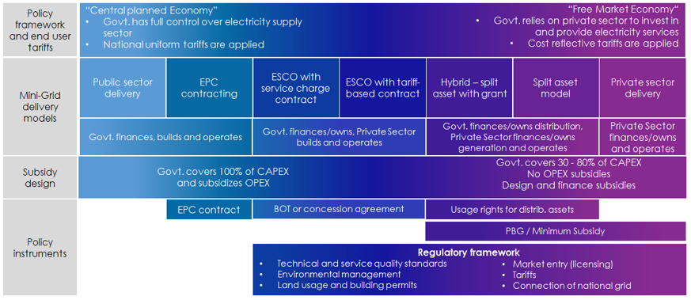

This decision-making process around identifying a delivery model is complex and countries will be encouraged to establish a national dialogue for this purpose, involving all relevant stakeholders to varying degrees (different ministries such as energy, finance, health and environment, local authorities, the public, the media, the beneficiary communities, utilities, the private sector, and other key stakeholders) in order to build a national consensus on the basis of which large-scale deployment of mini-grids can be accelerated and have a sustainable impact.
The more clarity there is on the part of the government regarding the choice of delivery model, the easier it is to develop or plan business models which can reduce minigrid costs. A clearly identified delivery model minimizes the risk of investments being made based on assumptions that are not in line with government expectations and may lead to conflicts and economic losses down the line. It also helps the government to answer the important questions related to the rural electrification sector to provide clarity for private investors and operators and build confidence.

Barriers to minigrid development in Zambia

Despite the significant potential, several risks and barriers exist in Zambia for renewable minigrid development and scaling up. From an investor’s perspective, these risks result in higher financing costs (equity and debt) and reduce the competitiveness of minigrids relative to alternative sources of energy (e.g., diesel generators). All else being equal, the need for higher returns that reflect these risks translates into higher energy prices that, in turn, require larger subsidy requirements for rural electrification programs. The table below summarizes the main barriers to minigrid development in Zambia, organized across the project’s areas of intervention. For a detailed discussion of the baseline situation and barriers to a more widespread minigrid electrification, the reader is referred to Annex G.2.

Box 3 Barriers to minigrid development in Zambia

Barriers related to: | Remaining barriers
Policy-regulatory environment for mini-grid development | - The existence of clear strategies and policies on the role of minigrids vis-à-vis grid extension and stand-alone options for rural electrification in Zambia is limited  - Solar (and or other renewable energy) systems developers have often difficulties finding skilled people for design, installation and operation and maintenance, while vocational and educational need to be upgraded to provide these relatively new skills
Business models and private sector involvement | - Most rural areas in Zambia have low population densities with low energy demand and servicing these customers may not be financially viable  - Off-grid tariffs in Zambia are subjected to much social pressure, and willingness and ability to pay (WTP/ATP) are far lower than cost-reflective rates
Financing and financial modalities | - Mini-grid initiatives are financed on a project-by-project basis, rather than as part of a long-term vision part of an off-grid electrification plan and without public or private funds to match  - Commercial financing for MGs is non-existent. Market technology and business models of minigrid companies are rather unknown to local commercial banks. Individual MG investments are often too small and considered high risk  - Public financial support for the viability gap funding of off-grid projects has been limited and does not reach the amounts needed to reach 2030 universal access targets
Digitalisation and knowledge management | - Government stakeholders often lack specific knowledge or face budgetary and technical capacity constraints to fully utilise the potential of digital solutions to broadly improve sector oversight and planning. In general, the government needs to carry out systematic monitoring and evaluation of electrification activities, feeding back into their planning and decision-making. Awareness and knowledge on minigrid activities in other African countries need to be improved while adopting regional regulations can encourage an upscaled, regional, market for prospective MG developers.

Relevance to national priorities

The context for and expected contribution from renewable energy minigrids is reflected in several key policies and planning documents. While there may be further enhancements possible, the overall legal framework in the country adequately allows for the planning, development, operation, maintenance and utilization of minigrids in Zambia.

Under the framework of the Nationally Determined Contributions (NDC) to the 2015 Climate Change Agreement, Zambia intends to reduce its CO₂eq emissions by 25% by 2030 compared to the baseline scenario through domestic efforts with limited international support, and by 47% with substantial international support. This is equal to a total emissions reduction of 38 MtCO₂eq in 2030 compared to the baseline year. This will be achieved by implementing three streams of programmes (sustainable forest management, sustainable agriculture, and renewable energy and energy efficiency, driven by the country’s Climate Response Strategy and interlinked with sectoral development policies for energy, forestry, agriculture, water, town and country planning, sanitation, and transport. For the renewable energy and energy efficiency sector, Zambia aims to promote the switching from conventional and traditional energy sources to sustainable and renewable energy sources and practices and foster the use of off-grid renewable energy technologies for rural electrification as decentralized systems

Box 4 Policy and plans related to off-grid electrification

Policy / planning document | Relevance
Vision 2030 and National Development Plans | The National Long-term Vision 2030 (Vision 2030) expresses Zambia’s aspirations for the year 2030. The vision will be operationalised through the five-year development plans, starting with the 5th National Development Plan, and annual budget. The 7th National Development Plan 2017 to 2021 (NDP) sets out the strategy to improve energy production and distribution for sustainable development by enhancing the generation, transmission and distribution of electricity, promoting renewable and alternative energy, and improving electricity access to rural and peri-urban areas
National Energy Policy (1994, revised 2008, 2019) | The NEP2008 set the scene for the liberalisation of the electricity sector and specifies measures to improve electricity access through a) enacting legislation for the public and private sector, b) investment and participation, and c) applying viability gap funding mechanisms, d) enabling isolated grid systems with cost-reflective tariffs. The 2019 update further mentions that The Government will also establish  the Energy Fund. This Fund will facilitate the development of the entire energy sector.
Electricity Act and Energy Regulation Act (1995, amended 2003, and again in 2019/20) | The Acts provide the overarching legal framework for the generation, transmission, distribution and supply of electricity in Zambia, including the Electricity (Licensing) Regulations and the Electricity (Supply) Regulations. The Energy Regulation Act formally established the Energy Regulation Board (ERB) and defined its functions and powers.
Rural Electrification Act (2003) | The Act established the Rural Electrification Authority (REA), specified its functions and equipped it with a Rural Electrification Fund (REF)
Zambia Distribution Grid Code (2016) | The Code provides the basic rules, procedures, requirements and standards for the operation, maintenance, and development of electricity distribution systems in Zambia.
Renewable Energy Feed-in Tariff Strategy23 (2017) | REFit, established by the Ministry of Energy aims to increase national generation output through private sector investment in small and medium-size renewable energy plants of up to 20 MW. The scheme allocated 200MW of electricity capacity supply from renewable sources (of small to medium scale) to be connected with the grid.
The Power System Development Master Plan | Comprehensive sector planning document for the period up to 2030, developed in 2010
Rural Electrification Master  Plan (REMP) | In 2008 REA developed REMP for the term 2009-2030. The plan identifies 1,217 un-electrified Rural Growth Centres (RGCs) to be electrified through grid extension, standalone solar systems and mini-grids by 2030 to achieve 51% rural electricity access. Largely outdated, the Plan is being updated with World Bank support (ESAP project) into a National Electrification Strategy (NES)
Minigrid Regulations | First developed in 2018 and approved by ERB in 2020, introduces very light-handed’ regulations (regarding licensing, tariffs, technical; requirements, grid encroachment, power distribution) for minigrids below 100kW and ‘light-handed’ regulations for mini-grids between 100kW-1MW;
Environmental Management Act (2011) | This Act makes provision for integrated environmental management, the protection and conservation of the environment, and the sustainable management and use of natural resources and related matters. Part I sets out the principles governing environmental management.
Nationally Determined Contributions (NDC) | This document outlines Zambia’s Intended Nationally Determined Contributions (INDCs), which aim for a reduction of between 20,000 GgCO_{2e} and 38,000 GgCO_{2e} or 25% and 47% against 2010 baseline conditions.

Strategy

Africa Minigrids programme

Programmatic approach.
This project is part of the broader Africa Minigrids Programme (AMP), a regional technical assistance program to support access to clean energy by increasing the financial viability and promoting scaled-up commercial investment in renewable minigrids, with a focus on cost-reduction levers and innovative business models. The programmatic approach aims to achieve greater impact by creating new minigrid markets across the African continent, which, in aggregate, will create scale and momentum, attracting private sector interest and investment. It will also allow for a broader sharing of knowledge and good practice, and create economies of scale in providing program services.
Programme design.
Box 5 Africa Minigrids Programme (AMP) participating countries

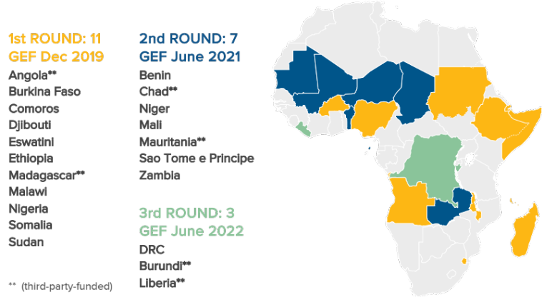

As shown in Box 5 and Box 6 below, AMP is comprised of two main elements: (i) a Regional Project, acting as the knowledge, advocacy and coordinating platform of the Programme; and (ii) a cohort of 21 AMP National Projects which together host an estimated total of 396 million people without electricity, or more than two thirds out of the 587 million total people without access to electricity in Africa. The AMP participating countries share a common approach, seeking to reduce minigrid costs via five country-level components.
Programme’s Theory of Change (TOC).
This project will follow the AMP Theory of Change (TOC), developed in the Program Framework Document (PFD) and set out in Box 6 below. This TOC is premised on a baseline context where, while good progress is being made, several risks and barriers are driving high financing costs (equity and debt) and reducing the competitiveness of minigrids with respect to fossil-fuel-based alternatives. All else being equal, the need for higher returns that reflect these risks translates into higher energy prices that, in turn, adversely affect affordability for the end-user, or require larger subsidy requirements for rural electrification programs. As a result, renewable energy minigrids do not get financed and built at scale. By focusing on cost-reduction levers and innovative business models, the project can improve the financial viability of renewable energy minigrids which in turn can accelerate and scale up their adoption as part of the effort towards achieving universal energy access. When renewable energy minigrids are more competitive, private capital and commercial financing will then flow, resulting in various program benefits: investment at scale, GHG emission reductions, and electrification and lower tariffs for end-users.

Alignment with GEF focal areas.
Box 6 Africa Minigrids Program’s architecture and Theory of Change

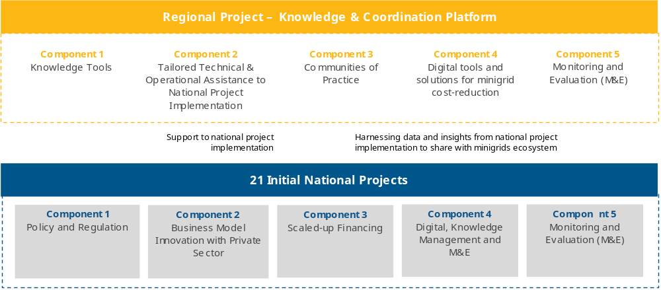

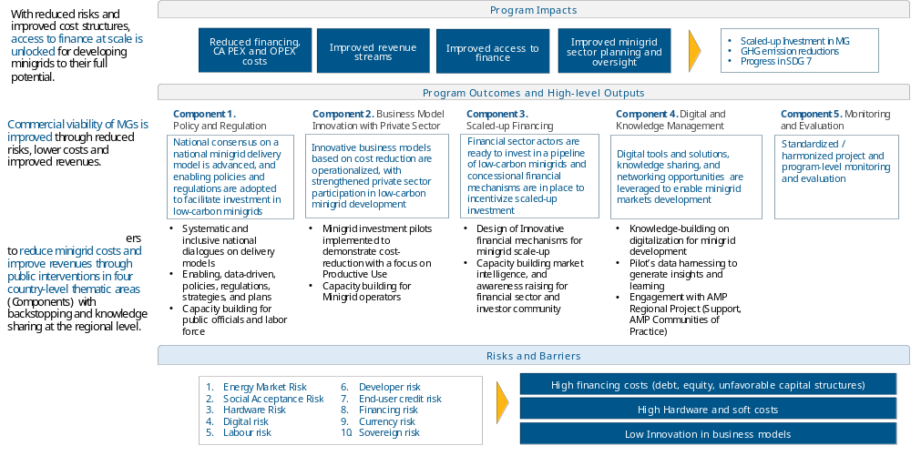
The proposed strategy is aligned with the GEF Strategic Focal Areas CCM-1-1 “Promote innovation and technology transfer for sustainable energy breakthroughs for de-centralized renewable power with energy storage”.
UNDP’s Derisking Renewable Energy Investment (DREI).
The Programme’s TOC draws on UNDP’s Derisking Renewable Energy Investment (DREI) Framework by focusing on cost reduction levers across the AMP themes of policy and regulation, business model innovation and private sector, innovative finance, as well as digitalization that can be employed to reduce risk (e.g., policy derisking), compensate for risk (e.g. financial incentives) or transfer risk (e.g. financial derisking).

Box 7 DREI Framework - Risks and barriers to developing renewable energy minigrids
Risk Category | Underlying Barriers | Description
Energy Market Risk | Market outlook | Lack of political will and/or uncertainty regarding national/state targets for electrification and renewable energy minigrid investment, including lack of electrification plans, rural electrification agencies/institutions, and good data (geospatial) on energy demand and lowest cost technology options.
Energy Market Risk | Market access, competition and grid expansion | Lack, or limitations (suboptimal design, lack of capacity), in the current government policy framework for minigrids including off-grid services areas; well-defined concessions (size, years, targets, bundling); compensation schemes in case of grid expansion.
Energy Market Risk | Tariffs | Uncertainty or inflexibility in electricity tariff regulations for minigrid developers
Energy Market Risk | Technical standards | Lack of clarity, uncertainty and/or inconsistent government technical requirements for minigrids regarding (i) quality of service and (ii) grid integration, should it occur.
Energy Market Risk | Competing subsidies | Competition from subsidized diesel and kerosene (mostly used for lighting); negative perceptions of minigrid tariffs due to subsidized grid-distributed electricity.
Social acceptance risk | Unfamiliarity with minigrids | Risk arises from lack of awareness and resistance to renewable energy and minigrids in communities, also from resistance from incumbent businesses.
Hardware risk | Availability and quality of hardware | Lack of availability of quality hardware and national quality standards for components of minigrids, and/or the lack of institutionalization of a minigrid quality assurance framework. In several countries, hardware costs are also higher than expected because of the lack of a supply chain for spare parts.
Hardware risk | End-of-life waste management | Risks arising from lack of policies and planning regarding disposal of hardware, including batteries, at the minigrid end-of-life
Hardware risk | Customs | Cumbersome customs/clearing process for importing hardware, leading to delays in delivery; punitively high customs tariffs on minigrid hardware.
Digital risk | Networks and software availability | Lack of cellular coverage in rural areas for minigrid remote monitoring and payments
Labour risk | Inadequate capacity | The lack of a competitive labour market of educated, skilled and qualified potential employees to design, construct, operate and maintain minigrids, leads to higher costs, hiring non-local staff and suboptimal performance.
Developer risk | Project development and management capacity | Minigrid business developers may not have the necessary expertise and capabilities to formulate financially viable projects and operate minigrids. Also, there is no ‘one-size-fits-all’ solution yet, implying that business models need to be contextualized.
Developer risk | Developers’ creditworthiness | Inability of developers to secure low-cost financing from investors due to lack of credit worthiness, or insufficient cash flows to meet investors’ return requirements.
End-user credit risk | Lack of customer creditworthiness | Lack of end-user credit data; customers’ willingness and ability to pay and methods of payment for electricity.
Financing risk | Capital scarcity | Limited availability of long-term domestic loans, well-capitalized actors and policy incentives.
Financing risk | Limited experience with minigrids | Investors’ lack of familiarity with minigrid projects and appropriate financing structures.
Currency risk | Local currency volatility | Currency mismatch between domestic currency revenues and hard currency financing.
Sovereign risk | Various uncertainties not specific to minigrids | Limitations and uncertainty related to conflict, political instability, economic performance, weather events/natural disaster, legal governance, ease of doing business, crime and law enforcement, land tenure and infrastructure in the country.

DREI is an innovative, quantitative framework to support policymakers for cost-efficiently promoting of private investment in renewable energy. A central focus of the DREI framework is on private sector financing costs. Developing countries often exhibit high financing costs for renewable energy due to investment risks that can exist in early-stage markets. The primary risks and barriers to renewable minigrid development and scaling up, as identified in the DREI Framework, are summarized in the table below. From an investor’s perspective, these risks result in higher financing costs (equity and debt) and reduce the competitiveness of minigrids relative to alternative sources of energy (e.g., diesel generators). All else being equal, the need for higher returns that reflect these risks translates into higher energy prices that, in turn, require larger subsidy requirements for rural electrification programs.
An opportunity is for policymakers to systematically address these investment risks, lowering financing costs and leading to competitive investment. Although there are both public and private strategies to address investment risks, the DREI framework is concerned mainly with public strategies, and identifies three central ways – often used in combination – that the public sector can improve the risk-return profile of private sector investment opportunities: (i) Reducing risk, targeting underlying barriers that create investment risk. These instruments are typically policies, such as legislation, or technical programmes (“policy derisking”); (ii) Transferring risk, shifting risk from the private to the public sector. These include instruments such as guarantees, or credit lines to commercial banks for on-lending (“financial derisking”); and (iii) Compensating for risk, increasing the return of investments. These are typically targeted subsidies for renewable energy (“direct financial incentives”). As RE minigrid markets mature, an opportunity also exists for diversifying risk through the aggregation of multiple mini-grid assets (“portfolio derisking”).
Program’s ‘Key Areas of Opportunity’.
The AMP has adopted a common architecture of four key components - a combination of enabling policy and regulations, business model innovation with private sector involvement, innovative financing and digital innovation - as the levers to lower investment risks, thereby reducing financing, hardware and soft costs while increasing revenues and improving system efficiencies. Within this architecture, AMP will emphasize - and seek to develop comparative advantages - in three ‘key areas of opportunity’: (i) an emphasis on advancing national dialogues on minigrid delivery models, (ii) promoting productive uses of electricity, and (iii) leveraging data and digital solutions for minigrid cost-reduction. Collectively these three areas can guide AMP’s overall direction, creating a niche identity for the program. This approach, illustrated in Box 8, is structured to advance the program objectives of cost-reduction and innovation for minigrids and give effect to the Theory of Change (ToC). How this project will address these areas of opportunity is described in detail further below.
Box 8 AMP’s key areas of opportunities
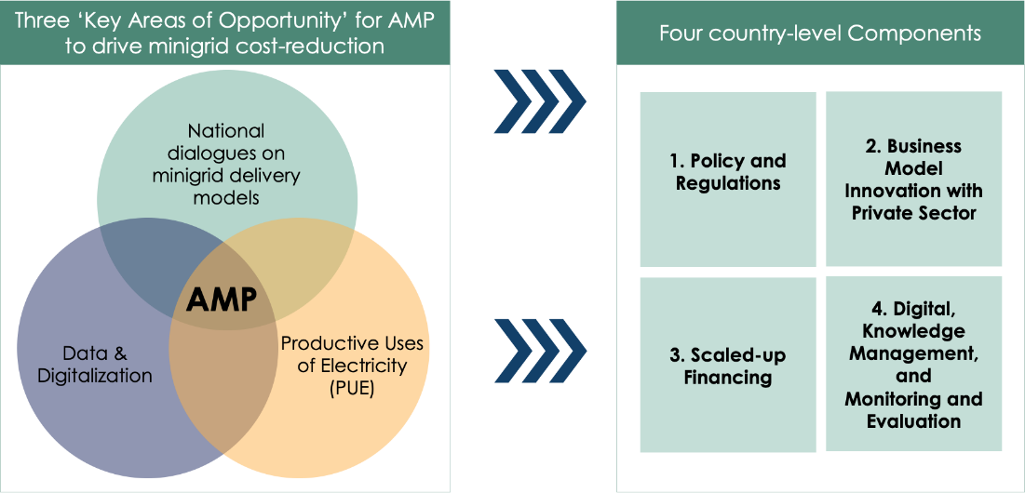
National dialogues on minigrid delivery models.
A delivery model (refer to the minigrid business concepts discussed in Box 2) that is suitable to country expectations and context for minigrids has proven critical to establishing an enabling and attractive investment environment for minigrids. Equally, a delivery model that has not been defined or is consistent with the national context, will be a certain impediment to scaled-up investment. An important focus of the AMP is therefore to encourage a national dialogue between key stakeholders in support of a suitable delivery model being defined.

Box 9 Digital technologies and solutions

Digital technologies and solutions are fundamental to enabling off-grid electrification. In fact, the emergence of minigrids as a viable solution to electrify remote and isolated communities relies strongly on certain digital technologies such as remote monitoring of minigrid operations and the use of digital money to collect customers’ payments. Different categories of digital solutions in the minigrid sector: (i) digital planning, (ii) digital operations, (iii) digital aggregation platforms, and (iv) digital payments. In common to all these is the potential of digital technologies – whether used by policy makers, financiers or minigrid developers - to lower minigrid costs, reduce risks, and address barriers to scale.
Data use opportunity for minigrids. Many opportunities around digitalization are related to leveraging the large amount of data generated by minigrid projects to surface actionable insights, learning and optimization to consolidate business models and technical solutions for scaling-up minigrids. For instance, the use of operational performance information from existing systems to forecast demand and design future minigrid can help avoid a very common pitfall of many minigrid systems which are significantly oversized and hence not financially viable. Based on improved data, Government stakeholders could leverage digital solutions for energy sector planning, to streamline licensing, monitor quality of service and broadly improve sector oversight. Data is a tremendously valuable asset in the minigrid sector that remains underutilized
Digital operations and payments. The potential for using data and digital tools and solutions to add value at various stages of the minigrids value chain is starting to get recognized. With enhanced capacity, minigrid developers could streamline their operations though smart metering and remote control of their assets and potentially reduce operations and maintenance costs. MG developers increasingly use certain digital technologies such as remote monitoring of minigrid operations and the use of digital money to collect customers’ payments.
Digital platform
For the project and minigrid sector more generally, a digital platform can serve one or more of the following purposes: a) provide a centralized database for all distributed energy projects/programs at the national level, b) collect, manage and aggregate data from minigrid sites , c) run digitized tenders and administer grants, d) performance verification of minigrid systems for improved sector oversight, e) teal-time monitoring and evaluation of electrification projects/programs, f) applying advanced analytics of minigrid portfolios to generate critical insights to advance the sector

The regional AMP provides a unique opportunity to develop a single set of metrics and guidelines for data collection, and use them to collect data from minigrid investment pilots across different national projects which the AMP Regional Project can then aggregate, derive insights from, and systematically disseminate knowledge with participating AMP countries and with the broader minigrids sector in Africa. At the same time, the link between the regional project and the various national child projects provides a unique ‘distribution channel’ opportunity across Africa for AMP to mainstream the use of digital tools and solutions for minigrids cost-reduction and scale-up.

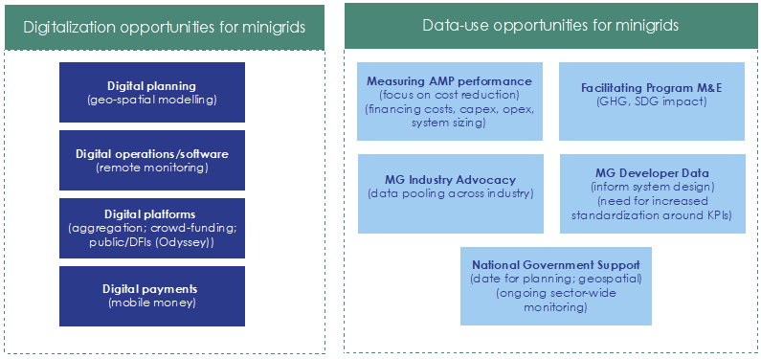

Digitalisation (digital solutions and tools) and harnessing the data opportunity.
The emergence of minigrids as a viable solution to electrify remote and isolated communities relies strongly on digital tools and solutions (see Box 9). Digital technologies and solutions are fundamental to enabling off-grid electrification and offer significant potential to lower minigrid costs, reduce risks, and address barriers to scale. Many of the opportunities around digitalization are related to leveraging the large amount of data generated by minigrid projects to surface insights, learning and optimization. Data is a tremendously valuable asset in the minigrid sector that remains underutilized. The programmatic approach allows the AMP to make an impactful contribution to growing a data asset and harmonized digitalisation in the sector. Employing digital integration as a catalyst for the minigrid sector reflects the UNDP digital transformation strategy that initiated a comprehensive process of connecting knowledge within the organisation and across networks, creating opportunities, improving operational efficiencies and building and maintaining partnerships and alliances. It also echoes the broader UN data-driven strategy and commitment to advance global “data action” with insight, impact and integrity.
Productive uses of energy (PUE).
While PUEs are widely recognized as a key element to improve the viability and sustainability of minigrids, the AMP focus is uniquely tailored, taking a deliberate, integrated approach across a broad ambit of the Sustainable Development Goals (SDGs; see Box 12). With the benefit of global experience and best practices, the AMP pursues solutions where productive uses are embedded in agricultural value chains or around which economic activity can be anchored. The AMP’s emphasis on energizing agricultural production is based on the demonstrated impacts and amplified benefits resulting from (i) improved product quality and increased yields, (ii) contributions to value addition, (iii) increased value retention within the rural communities, and (iv) contributions to socio-economic developmental objectives for rural areas, which in turn has a positive effect on the minigrid revenue model. Further recognizing that these multiple benefits cannot be assumed with energy access, but depend on wider development programmes, the AMP approach combines the delivery of electricity infrastructure with innovative business models and various interventions aimed at encouraging economic activity, supporting business development and stimulating rural economic transformation with an emphasis on improved wellness, empowering women and youth as well as ensuring sound social and environmental stewardship.

Minigrid investment pilots’ contribution to the Programme’s TOC.
National Projects include funds, under Component 2 (Business model innovation and private sector), for supporting minigrid investment pilots seeking to demonstrate innovative business models and cost-reduction opportunities. Minigrid pilots have a key role within AMP by contributing to demonstrating cost reduction which can be leveraged to improve the financial viability of renewable energy minigrids. Minigrid pilots are aligned with one or more of the three key areas of opportunity mentioned above by demonstrating: (i) a particular delivery model or elements of a delivery model around which the government wishes to build capacity and engage with minigrid developers; (ii) productive uses of electricity and their potential to reduce costs and enable minigrid development at scale; and/or (iii) opportunities around digitalization and the use of data for minigrid cost reduction. Feedback loops to other national project activities (e.g., national dialogues, capacity building) and with the AMP Regional Project (e.g., Community of Practice) are intended to actively disseminate the learnings from the pilots to inform both the policy and regulatory environment as well technical capacity building.

Zambia Minigrids Project

The Zambia Minigrids (ZMG) Project is a national project under the wider Africa Minigrids programme (AMP), supported by GEF (see the previous section, see Box 6). The project follow’s the overall AMP Theory of Change (TOC) (described in Section 3.1) premised on the understanding that the high costs of RE minigrids are partly attributed to a range of barriers and risks, each of which contributes a premium to the development costs of minigrid systems.

The hypothesis for the project is that by significantly reducing the investment risks for RE minigrids in a partner country, the levelized cost of electricity (LCOE) can be reduced, which in turn will accelerate and scale up the adoption of RE minigrids as part of the effort towards achieving universal energy access in the country and the broader region. Accelerating the adoption of clean energy also contributes to greater GHG emission reductions.
Box 10 How the ZMG Project’s interventions address identified barriers and challenges

Barriers and challenge | ZMG outcomes and outputs
Outcome 1 Stakeholder ownership in a national minigrid delivery model is advanced, appropriate policies and regulations are adopted to facilitate investment in low-carbon minigrids.
- The existence of clear strategies and policies on the role of minigrids vis-à-vis grid extension and stand-alone options for rural electrification in Zambia is limited  - Solar (and or other renewable energy) systems developers have often difficulties to find skilled people for design, installation and operation and maintenance, while vocational and educational need to be upgraded to provide these relatively new skills | 1.1 An inclusive national dialogue to identify minigrid delivery models is facilitated, clarifying priority interventions for an integrated approach to off-grid electrification  1.2 Minigrid DREI techno-economic analyses carried out to propose most cost- effective basket of policy and financial derisking instruments  1.3 Programme to develop competitive, skilled labour market in minigrids
Outcome 2 Innovative business models based on cost reduction are operationalized, with strengthened private sector participation in low-carbon minigrid development.
- Most rural areas in Zambia have low population densities with low energy demand and servicing these customers may not be financially viable  - Off-grid tariffs in Zambia are subjected to much social pressure, and willingness and ability to pay (WTP/ATP) far lower than cost-reflective rates | 2.1 Pilots developed, including on productive use/innovative appliances and modular hardware/system design, leading to cost-reduction in minigrids (INV)  2.2 Investment replication plan for minigrid development
Outcome 3 Financial sector actors are ready to invest in a pipeline of low-carbon minigrids and concessional financial mechanisms are in place to incentivize scaled-up investment.
- Mini-grid initiatives financed on a project-by-project basis, rather than as part of a long-term vision part of off-grid electrification plan and without public or private funds to match  - Commercial financing for MGs is non-existent. Market technology, and business models of minigrid companies are rather unknown to local commercial banks. Individual MG investments are often too small and considered high risk  - Public financial support for the viability gap funding of off-grid projects has been limited and does not reach the amounts needed to reach 2030 universal access targets | 3.1 Innovative financing solutions for minigrid development are identified and designed with supporting human and institutional capacity building
Outcome 4 Digitalization and data are mainstreamed, across stakeholders, into local minigrid market development. Increased knowledge, awareness and network opportunities in the minigrid market and among stakeholders, including benefitting from linkages to international good practice
- Government stakeholders often lack specific knowledge or face budgetary and technical capacity constraints to fully utilise the potential of digital solutions to broadly improve sector oversight and planning. In general, government needs to carry out systematic monitoring and evaluation of electrification activities, feeding back into their planning and decision-making. Awareness and knowledge on minigrid activities in other African countries need to be improve, while adopting regional regulations can encourage upscaled, regional, market for prospective MG developers. | 4.1 A project digital strategy is developed and implemented, including linkages to and following guidance from the AMP Regional Project  4.2 A ‘Minigrids Digital and Data Management Platform’ implemented to run tenders and manage data from pilots, and to support minigrids scale-up and cost-reduction  4.2 Quality Assurance and Monitoring Framework for measuring, reporting and verification is adopted and operationalized  4.3 Engage with regional project, via (i) Communities of Practice and (ii) capturing and sharing lessons learnt
Outcome 5 Monitoring and evaluation

The project objective is to “support access to clean energy by increasing the financial viability, and promoting scaled-up commercial investment, in low-carbon mini-grids in Zambia with a focus on cost-reduction levers and innovative business models”. The previous section 2.2 describes the baseline situation and barriers and gaps regarding a) policy and regulation area, b) business model and private sector involvement, and c) financing sources and financial mechanisms. While several baseline activities have been undertaken in recent years or are planned to address these, still several barriers and gaps remain.

Relative to other countries, the potential development in Zambia of mini-grids is shaped by country-specific challenges. One of these challenges is posed by the dispersed and low-density nature of most of the rural population. This hampers both grid extension as well as minigrid development to have a sufficient volume of customers to make the investments economic. While the cost of electrification is high, the issue of affordability (willingness and ability to pay by the customers, see Box 42) puts a limit on the mini-grid tariffs that can be charged. The Zambia mini-grid market remains early stage and does not yet have economies of scale advantage that would allow lowering the initial investment cost.

Many minigrids will need some grant support to keep tariffs affordable within the ability (or willingness) to pay range of rural low-income (and often irregular) income households in the order of 45-50%. This is illustrated by the feasibility analysis in Annex G.3 of a number of “model business cases “ of solar and hydropower minigrid plants for a hypothetical community in rural Zambia. The analysis considers the potential sale of electricity to various customer types (households, small commercial, and social services) while analysing the impact of productive uses of energy (PUE) and demand stimulation (with electric cooking as an example).
Box 11 AMP regional programme indicative service offering
Digital, Knowledge management and monitoring and evaluation (M&E)
- Knowledge building/sharing. The regional project will curate, develop and share knowledge with the project on program’s thematic areas (Policies and regulation, innovative business models, financing, digitalization).
- Insight Briefs development and dissemination. National projects will gather data and audio-visual content (video footage, photos, etc.) highlighting national project activities which will be the subject of an ‘insight brief’ to be developed and widely disseminated by the AMP Regional Project.
- Communities of Practice. One of the primary ways national project staff will interface with the regional project is via the ‘Communities of Practice’ (CoPs) and associated activities/platforms. While it is expected that many of the activities will be undertaken virtually (via internet-based platforms, webinars or digital platforms) it is also expected that the CoPs will include actual in-person workshops, meetings or training events that project staff will participate on.
- Common M&E Framework/QAMF. The AMP Regional Project will develop, with inputs from national projects, a Quality Assurance and Monitoring Framework (QAMF) for measuring, reporting and verification of the sustainable development impacts of all minigrid pilots supported by national projects, including GHG emission reductions.
- Data aggregation platform. The AMP Regional Project will deploy and use a web-based data management platform to aggregate data from all national project pilots based on the QAMF to track Results Framework indicators as well as program objectives, SDG impacts and GHG emission reductions.
- Systematic data analytics and insights. The regional project will harness data shared by the national projects to extract insights and learnings which will be disseminated across all national projects and within the broader minigrids ecosystem.

Technical and operational support for national projects’ implementation
  - Access to specialized expert international consultants in selected areas hired, retained, contracted and paid for by the AMP regional project and made available to all participating national project staff and selected beneficiaries on as needed basis. This support may range from virtual assistance to in-country missions.
  - Database of qualified international consultants and firms provided for information purposes to the project in an effort to assist in identifying high-quality experts and firms who may be available for contracting by national governments under their own procurement rules and modalities.
  - Generic terms of reference (ToR) for various standard activities will be provided to projects for information purposes.
  - Specialized advisory support for implementing UNDP’s minigrid DREI analyses. During project implementation, the UNDP DREI Core team, working with the regional project, will make available to national teams and consultants the resources and tools to conduct full quantitative DREI applications, and will provide ongoing support and quality assurance.
- Operational support for national projects. The AMP Regional Project will provide support to the project, on an ad-hoc and as-needed basis, through its PMU staff or by hiring or recommending subject matter experts, for the project to execute activities. Further details on specific support around M&E activities provided in Section VI (Monitoring and Evaluation Plan).

Given the challenging economics, Zambia’s specific circumstances will shape the initial project design and should be kept in mind as the project moves into implementation. While several baseline activities have been undertaken in recent years or are planned to address these, still several barriers and gaps remain as described in section 2.2.
The ZMG Project seeks to address the remaining barriers and the underlying causes by means of five components with outcomes and outputs summarized in Box 10 below.

Linkages of the ZMG Project with the AMP regional programme

The project will align with the AMP Regional Project to foster knowledge sharing, learning, and synthesis of experiences in a multi-directional manner, i.e., flowing from the AMP Regional Project to the ZMG Project, and vice versa, and between the ZMG Project and other national projects within the Program. The main role of the AMP Regional Project is to make best practices in regulations and policies, innovative and inclusive business models, digitalization and financing available to all AMP beneficiary countries while providing technical and operational support for national projects’ on-the-ground implementation. Box 11 provides a summary of the technical and operational support that will be available to the project. A full detailed elaboration of these offerings and the protocols attached to each service will be communicated to the project at the ZMG Project’s inception workshop. The areas of support, the listing of available firms/individual consultants under contract by the regional project and the protocol for how the project can request and/or access such expertise (if needed/requested) will be elaborated in the first year of regional project implementation and disseminated to this project and the staff of all other participating AMP national projects

Linkages with SDGs

Energy is addressed directly by Sustainable Development Goal #7 (SDG7), whose overarching aim is to ‘Ensure access to affordable, reliable, sustainable and modern energy for all’ with three targets to be reached by 2030, namely 7.1: Ensure universal access to affordable, reliable and modern energy services; 7.2: Increase substantially the share of renewable energy in the global energy mix, and 7.3: Double the global rate of improvement in energy efficiency.

Energy is intrinsically linked with many other SDGs. The table below (Box 12) gives a summary of ithe linkages of renewable energy and energy access (rural electrification) with some other SDGs.

Box 12 Linkages of rural and renewable electricity with SDGs other than SDG-7

Sustainable Development Goals | Linkage with renewable energy and rural electrification
1. End poverty in all its forms everywhere | Access to basic energy services is a requirement for poverty eradication
3. Ensure healthy lives and promote well-being for all at all ages | Basic energy services are required to deliver health services
4. Ensure inclusive and equitable quality education and promote life-long learning opportunities for all | Basic energy services are required to deliver education
5. Achieve gender equality and empower all women and girls | Basic energy services are required for women-led rural enterprises and activities
6. Ensure availability and sustainable management of water and sanitation for all | Energy is needed to supply clean water to rural communities
8. Promote sustained, inclusive and sustainable economic growth, full and productive employment and decent work for all | Productive uses of energy can make a rural energy system more viable by adding demand (and revenues) other than lighting for households. On its turn, the availability of power enables rural production (micro-businesses, agro-processing, tourism, rural manufacturing, other)
9. Build resilient infrastructure, promote inclusive and sustainable industrialization and foster innovation | Resilient infrastructure and public-private partnerships are required to ensure access to energy for all
10. Reduce inequality within and among countries | Access to electricity in rural areas brings potential to genuinely bring energy for all, including in remote rural areas, thus reducing inequalities
13. Take urgent action to combat climate change and its impacts | The carbon-intensive energy sector (based on fossil fuels) is a key driver of climate change. Renewable energy substitutes fossil fuels (zero emission)
15. Protect, restore and promote sustainable use of terrestrial ecosystems, sustainably manage forests, combat desertification, and halt and reverse land degradation and halt biodiversity loss | Linking small hydro and biomass-based projects with natural resources management (e.g., watershed protection; sustainable biomass production)
Compiled from Transforming our World: the 2030 Agenda for Sustainable Development (UN, 2015), Indicators and a Monitoring Framework for the Sustainable Development Goals, Sustainable Development Solutions Network (SDSN)

Results and Partnerships

Components and outputs
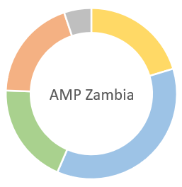

Policy and regulation | Business model innovation with private sector | Scaled-up financing | Digital and knowledge management | Monitoring and evaluation
1.1 An inclusive national dialogue to identify minigrid delivery models is facilitated, clarifying priority interventions for an integrated approach to off-grid electrification | 2.1 Pilots developed, including on productive use/ innovative appliances and modular hardware/ system design, leading to cost-reduction in minigrids | 3.1 Innovative financing solutions for minigrid development are identified and designed while supporting financial sector capacity building | 4.1 A project digital strategy is developed and implemented, including linkages to and following guidance from the AMP Regional Project | 5.1 M&E and Reporting, including (i) Conducting inception workshop and preparing report, (ii) Ongoing M&E, (iii) Mid Term Evaluation and (iv) Terminal Evaluation
1.2 Minigrid DREI techno-economic analyses carried out to propose most cost- effective basket of policy and financial derisking instruments | 2.2 Pre-feasibility studies for pipeline development. |  | 4.2 A ‘Minigrids Digital and Data Management Platform’ implemented to run tenders and manage data from pilots, and to support minigrids scale-up and cost-reduction
1.3 Programme to develop competitive, skilled labour market in minigrids | 2.3 Productive use pathway study |  | 4.3 Quality Assurance and Monitoring Framework for measuring, reporting and verification is adopted and operationalized
 |  |  | 4.4 Engage with the regional AMP project, via (i) Communities of Practice and (ii) capturing and sharing lessons learnt
Box 13 Overview of project components and outputs

Component 1 Policy and regulation

Outcome | Outputs
1. Stakeholder ownership in a national minigrid delivery model is advanced, appropriate policies and regulations are adopted to facilitate investment in low-carbon minigrids. | 1.1 An inclusive national dialogue to identify minigrid delivery models is facilitated, clarifying priority interventions for an integrated approach to off-grid electrification  1.2 Minigrid DREI techno-economic analyses carried out to propose most cost- effective basket of policy and financial derisking instruments  1.3 Programme to develop competitive, skilled labour market in minigrids

Component strategy and context

Appropriate delivery models, with associated tariff structures and subsidy mechanisms, are considered an essential prerequisite for financial scale-up in the mini-grid sector. The complex interplay between regulations, financial needs and suitable delivery models remains to be thoroughly assessed. On the regulatory front, a specific minigrids regulatory framework has been developed. The Framework, developed in 2018 was ‘road-tested’ and approved by ECB in 2020. It includes provisions regarding tariffs applicable to minigrids as well as technical requirements for minigrids in Zambia, disaggregating some of these by minigrid sizes. There is a need, however, to harmonise the mini-grid regulatory framework with the Electricity and Energy Regulation Acts, amended in 2020, while the virtues of a ‘one-stop-shop’ approach (streamlining the procedures of ERB, accessing land rights, environmental, public funding for PPPs) could be discussed.

As noted in the discussion of the theory of change (ToC), a range of perceived risks increase the development costs for small-scale RE, which in turn impacts the cost of electricity and the sustainability of installed systems. UNDP’s DREI minigrid methodology assesses risks across 10 pre-defined risk categories, identifying the underlying barriers, quantifying the impact on development costs, and suggesting the most appropriate policy and financial derisking instruments to address. The DREI analysis can act as a mechanism to engage national stakeholders in a comprehensive dialogue around the derisking measures necessary to advance the market and also allow for the project team to engage in early adaptive management in project design. National DREI analysis data will feed into a regional flagship AMP knowledge product on DREI and lowering minigrid financing, hard and soft costs. These consolidated knowledge resources and products will in turn be available to national projects for cross-country comparisons and further learning.

Output 1.1 An inclusive national dialogue to identify minigrid delivery models is facilitated, clarifying priority interventions for an integrated approach to off-grid electrification

Strategy

The AMP framework makes provision for a National Dialogue in each partner country to review and define, confirm or refine the chosen delivery models for the country, prioritise policy and financial derisking instruments identified by the DREI analysis building on existing dialogue structures in the countries. Such a dialogue could be adopted under the Off-Grid Task Force. The Off-Grid Taskforce is a government-led platform which brings together representatives of various Government ministries, statutory bodies, the private sector and development partners to coordinate initiatives and activities in the off-grid electrification space. The Taskforce was established with support from the Office of the Vice President. It is a multi-stakeholder platform that identifies and addresses off-grid market barriers thereby The Task Force has advised on improving import regulations for solar energy products, minigrid regulations, off-grid power affordability and market intelligence. For example, the resolution of a subsidy mechanism (e.g., under the Rural Electrification Fund) and policy guidance for its use in various delivery models (public, PPP, private), stimulation of access to finance and skills development in the off-grid market are likely to be an important element for discussion in the Task Force. The ZMG Project can support the Task Force in its activities, in particular, the awareness and publications and streamlining of procedures and regulations, as well as on the issue of job creation and skills development.

Informed by DREI findings and recommendations, prioritized topics will benefit from consideration at the National Dialogue. If findings of the National Dialogue merit further consideration, given the critical importance of the minigrid delivery model in unlocking private investment, Zambia will have the opportunity under the ZMG Project to analyse and assess the already existing delivery model[s] for their feasibility and prospects of success. Links will also be encouraged with the African Minigrid Developers Association which will be able to offer assistance and guidance on mini-grid issues.

Activities:
1.1.1. Facilitation of national dialogue decision-making on minigrid investments, financing, operations and results
Zambia has a national Off-Grid Energy Task Force, which is embedded in and led by the Ministry of Energy together with the Office of the Vice President. Since its launch in April 2018, this Task Force has facilitated, among other things, the implementation of a VAT exemption for LED lights, the drafting of a new national mini-grid policy and the initiation of discussions to improve the affordability of off-grid energy solutions. The Project will strengthen the Task Force to include a range of relevant stakeholders from the Government, local authorities, civil society, local media, private sector, rural populations, and others, and initiate a national dialogue to identify the optimal minigrid delivery model. The national dialogue will be centred around key issues regarding mini-grid regulation and streamlining licensing procedures, fiscal and non-fiscal incentives (such as duty on imports of minigrid-relevant equipment), gender mainstreaming, digital infrastructure (mobile money and PAYG; minigrid management and tracking systems), capacity strengthening (technical skills, project developers, financiers) and mini-grid planning. The ZMG project will support meetings and events as well as targeted assessments. One issue is the establishment of a ‘one-stop-shop’ for proponents to get the necessary permits and licenses. Another important challenge is the need for regulations on the handling of electronic and solar system batteries after the end of their life. In accordance with the Gender Action Plan, one specific working group will be set up to assure gender equity and equality during all phases of the AMP child project in Zambia.

The Project will support the Off-grid Task Force with selected operations, such as formulation of a communication and minigrid awareness strategy and realisation of multimedia products (newsletter, brochures, TV and radio, social media) and maintenance and expansion of the current off-grid website (www.offgrid.gov.zm).

1.1.2 Establish a feedback loop between national dialogue and the project
The Project will align the ongoing dialogue with activities implemented in parallel under the other outputs and loop respective (pre-)results back into the discussion. This will shed light on trends and progress regarding minigrid cost reduction (e.g., DREI analyses and tracking of minigrid costs), needed subsidy levels and consumer affordability). This will also include an assessment of experiences of licensing and permit requirements and processes and technical standards for building and operating minigrids streamlined, in close coordination with the authorities concerned and other development partners with recommendations

Output 1.2 Minigrid DREI techno-economic analyses carried out to propose the most cost-effective basket of policy and financial derisking instruments [and contribute to AMP Flagship Report on Cost Reduction]

Component strategy/Context

UNDP’s Derisking Renewable Energy Investment (DREI), introduced in section 3.1 is an innovative, quantitative framework to support policymakers to cost-efficiently promote private investment in renewable energy. In late 2018, UNDP expanded the DREI framework to include solar PV-battery minigrids, releasing open-source analytic and financial modelling tools to track investment risks, and financing costs, and to support the private sector and policymakers in modelling levelized costs, tariffs and subsidies for minigrids.

DREI provides a structure for policymakers to identify and understand investment risks to select public instruments that can de-risk and promote investments in RE minigrids. The DREI derisking table introduces a taxonomy of ten independent investment risks, 17 underlying barriers, and associated stakeholder groups; it then sets out matching policy and financial derisking instruments (see overview in Box 7). The risk environment and instrument selection stages of DREI deliver quantitative insights into financing costs and the impact of public instruments in lowering these costs. The financial modelling stage captures hardware and soft costs to determine the levelized cost of electricity (LCOE) of the technology being assessed.

UNDP’s DREI framework will be applied either qualitatively or quantitatively at various points in the project cycle, both at the national level in each AMP participating country, and then aggregated into regional knowledge products by the AMP Regional Project and disseminated widely. The DREI framework, both at the national and regional level (in aggregate), will act as the program’s mechanism to harvest and disseminate data on changes in the financing costs, hard and soft costs, and resulting costs for minigrids.

Activities:
1.2.1. Initial, full quantitative national DREI analysis (Year1)
A full quantitative DREI application will be conducted in the first year of project implementation. The PMU will assemble a task team to perform the national DREI analysis including consultants (international, national), government stakeholders, and members of the PMU. Deliverables will include interviews, completed financial models, and national reports/knowledge products. Initial TORs for these consultants are annexed to the project document (Annex I). This national analysis will be funded by the national project. The AMP Regional Project can in turn provide various support on DREI to the national project, including (i) finalizing TORs for the country-level; and (ii) sharing recommendations (in the form of a vetted roster of consultants) on international consultants that are trained on DREI already, as well as resources and tools (Excel models etc.) to conduct the DREI analysis. Results from the full quantitative national DREI analysis will be shared with the regional project to feed into a regional flagship AMP knowledge product across all AMP countries (funded by the regional project), on DREI and lowering minigrid costs. This full quantitative analysis can act as a mechanism to engage national stakeholders in a comprehensive dialogue around the derisking measures necessary to advance the market, and also allow for the project team to engage in early adaptive management in project design.

1.2.2 Dissemination of DREI analyses and adaptive management (Year 2)
This ‘light’ analysis will build on the earlier materials, refreshing data to track evolutions in financing costs as well as in hardware and soft costs. Updated data on the risk environment and financing costs will be collected and key financial modelling inputs updated with the latest hardware and soft costs. The outputs will be a brief update note of 2-5 pages, specifically focusing on changes in (i) the risk environment, (ii) financing costs, hard and soft costs, and the Levelized Cost of Electricity (LCOE), reflecting the experience gained during Project implementation. The administrative efficiency, the regional project will fund and execute this update (a ‘light quantitative DREI analysis’), on behalf of the national project.

1.2.3 Coordination with regional project on national DREI analysis update (Year 4)
In the final year, or year 4, of the national project’s implementation period, whichever happens first, the original national-level DREI analyses will be refreshed to track evolutions in financing costs as well as in hardware and soft costs. For administrative efficiency, the regional project will fund and execute this update (a ‘light quantitative DREI analysis’), on behalf of the national project. The deliverable will be a brief note of 2-5 pages on the DREI national update. The data from the national refreshed DREI analysis will be fed into an update note to the year 2 AMP flagship regional DREI knowledge product, which will provide an end-of-program overview of the evolution in minigrid costs across AMP countries. The national project’s contribution to this activity will be: (i) facilitating the DREI national update (to be funded and executed by the regional project); and (ii) disseminating the findings of the national DREI update note, and the update to the regional flagship DREI product.

Output 1.3 Programme to develop a competitive, skilled labour market in the minigrid sector

1.3.1 Assessment of technical skills needs and job creation
An analysis will be conducted of needs by private (and public) entities of technical, skilled, labour for minigrid assessment, development, construction and operation by means of a survey, whole gaps in university and vocational training institutes will be identified, while the landscape of the emerging off-grid job market will be explored. The above-mentioned off-grid website will have a space for linking qualified staff with job opportunities.

1.3.2 Apprenticeships
In cooperation with REA, universities and technical institutes and participating private developers, the Project will support some apprentices to gain practical experience in mini-grid feasibility studies and surveys and construction and O&M of minigrids.

Component 2 Business model innovation with the private sector

Outcome | Outputs
2. Innovative business models based on cost reduction are operationalized, with strengthened private sector participation in low-carbon minigrid development. | 2.1 Pilots developed, including productive use/innovative appliances and modular hardware/system design, leading to cost-reduction in minigrids (INV)  2.2 Pre-feasibility studies for pipeline development.  2.3 Productive use pathway study

Component Strategy/Context

The second component aims to demonstrate innovative business models, based on cost reduction, that can encourage private sector participation in RE minigrid development in the country. For Zambia, the focus under this component will be on using the wealth of experience from within the country, combined with the knowledge resources available from the regional project, to enhance feasibility and business model innovation. The project will also leverage the practical experience gained by minigrid developments in the country to help streamline development processes from conceptualization to commissioning, aiming to reduce the time and costs associated with the minigrid identification, design and implementation. In this respect, pilot beneficiaries (e.g., minigrid operators) receiving support from the project will be required to share minigrid performance data with the national project (see Box 18)

Zambia has gained invaluable experience in the development and operations of minigrids with lessons informing greater innovation in delivery models, tariff designs and productive uses, among others. Mini-grids were initiated by public sector agencies and operated by these or handed over to community-based cooperatives, but over the past decade, the number of private sector or public-private initiatives has grown rapidly, helped by the MG-specific regulatory framework (designed in 2018 and approved by ERB; see Box 35 in Annex G.2).

The private sector is envisaged to play a key role in minigrid development. Despite these learnings and advances in the regulatory environment, a financially independent or self-sufficient minigrid operation has not yet been achieved. The second component aims to demonstrate innovative business models, based on cost reduction, that can encourage private sector participation in RE minigrid development in the country. The ZMG Project will leverage the practical experience gained by minigrid developments in the country, combined with the knowledge resources available from the AMP programme, to help streamline development processes from conceptualization to commissioning, aiming to reduce the time and costs associated with the minigrid identification, design and implementation.
Box 14 Business models applicable in the ZMG project

Model | Examples | Application in ZMG project
Private-sector delivered | Private sector build, owns, operates (BOO) and arranges financing Depending on MG type and site characteristics, a grant may be needed (by government up to 50% and/or other sources) | The advantage of this model is that it allows the service provider to offer the needed energy services, designed on a case-to-case basis, and the services provided could also be structured in a manner that gives the off-taker an opportunity to subscribe to a preferred service at a cost he can afford. It is also possible to provide other services (such as energy services, battery charging or sales of solar products and internet services), in addition to stimulating access to high-efficiency appliances such as cookstoves.
PPP - split assets | REA finances and owns distribution (and/or some civil works), while developer finances, owns and operates generation and sales (connections). Some small grant portion may still be needed. | With REA providing a substantial part of the assets (distribution network may be 40-50% of costs), this will make it more financially attractive. However, contracts will need to have a clear definition of roles and responsibilities of the partners.
PPP- hybrid | A developer takes over assets already constructed by REA or another private/public entity, for example to refurbish and/or expand an existing generation, mini-grid or PUE facility | In one variant (PUE overlay) the developer will acquire PUE equipment and lease to the end-user (thus investing in the PUE itself and required minigrid investments to accommodate the PUE.  In another variant, the developer will be required to rehabilitate/upgrade, operate and maintain an existing mini-grid. The developer will own (ROO: rehabilitate, operate, own) or transfer back after a period of years (franchise period), ROT: rehabilitate, own, transfer). A contract specifies the rights and obligations of the two parties during the term of the PPP contract.  The reverse PUE overlay option is a variant in the ROO/ROT scheme, in which a developer acquires the energy generation part (and may well integrate in a bigger local minigrid scheme) and sells power (with guarantees and other transfer conditions) to the end-user. Thus, the end-user can leave rehabilitation and operation to the developer. The model can apply to PUE or social services (schools, clinic).

Output 2.1 Pilots developed, including productive use/innovative appliances and modular hardware/system design, leading to cost-reduction in minigrids (INV)

At the project preparation stage, considerable initial consultations, analysis and planning have been performed to advance the design of the minigrid pilots. This is described in the section directly below (Section IV) and associated annexes. At the beginning of project implementation, as an initial preparatory step, the PMU, in consultation with key stakeholders, and with support from the AMP regional project, will update and finalize the proposed approach to the design of the minigrid pilots, compiling a ‘Minigrid Pilot Plan’. Amongst other matters, the project’s ‘Minigrid Pilot Plan’ will include specifications for the project’s pilots that ensure the approach is aligned with key design principles set out in Box 15. The project’s Minigrid Pilot Plan will then (i) need to be reviewed and cleared by UNDP Zambia and BPPS NCE) and (ii) be shared with the Project Board.

This section describes the objective and main elements of such a plan. Several business models and types of projects may be considered.

Box 15 Key principles for minigrid pilot implementation

Principle 1. Digital platforms. The use of digital platforms for tendering the pilots is a central element of the overall AMP and digital strategy for the project. With digital platforms emerging as critical enabler for procurement and operation of cost-effective and viable minigrids, using a digital platform for pilot projects provides an opportunity to build capacity of key stakeholders in using this facility which can then set the foundation for later using digital platforms for sector-wide, large-scale tenders or results-based financing programs. Digital platform software can manage the selection, Monitoring and Evaluation (M&E) and payments of pilots including capacity building of the Implementation Partner, Project Management Unit and minigrid developers.
Principle 2. Productive use: third party ownership model. For pilots that will financially support the purchase of productive use equipment using an allocation under the GEF INV, it is required that the project will only provide its support via a third-party ownership model, as opposed to a self-ownership model. Third party ownership models involve the minigrid asset owner purchasing the productive use equipment, and then effectively leasing it back to the end-user, as part of an “energy as a service” offer.
Principle 3. Clear methodological basis for additionality for calculating the level of (GEF INV and/or UNDP TRAC)/financial support for capital expenditures (CAPEX). It is critical that the appropriate use of grant funding to the pilots be ensured, requiring a methodological basis for which the level of CAPEX subsidy will be determined during implementation using the principle of minimal concessionality. Suitable methodologies for minimal concessionality can include calculating the level of GEF INV support on the basis of achieving (i) Levelised Cost of Electricity (LCOE) parity with a diesel mini-grid, (ii) LCOE parity with pre-existing residential tariffs, or (ii) LCOEs based on the willingness to pay of the end-users (via surveys etc). During implementation, the AMP regional project may also provide updated guidance on suitable minimal concessionality methodologies.
Principle 4. Minigrid pilots data sharing. Pilot beneficiaries (e.g. minigrid operators) receiving support from the project will be required to share minigrid performance data with the national and regional project. Specific terms and conditions for data-sharing and how best to operationalize the commitment and its adoption by the beneficiaries will be defined and agreed upon with minigrid operators during project implementation, with support from the AMP Regional Project.
Principle 5. Compliance with UNDP Social and Environmental Safeguards and Gender requirements. Pilot projects receiving project funding are required to comply with all the relevant national standards of the country as well as UNDP standards as it pertains to social and environmental safeguards and gender equity. In support of this principle, an Environmental Safeguards Management Framework (ESMF), developed for the program (see Annex L) and a gender action plan accompany this ProDoc (Annex J). The ESMF will have to be incorporated and considered in developing the environmental and social management plans for pilot projects. A critical consideration under this framework is the need to ensure environmentally sound management of replaced equipment, including batteries, inverters and solar panels, after their usage. The responsible handling of waste with recycling of batteries and other recyclable equipment, should be clearly documented, budgeted and monitored in compliance with national and UNDP safeguards requirements.
Principle 6. Financial sustainability. The business and delivery models of the pilots will be determined during project implementation as part of the minigrid pilot plan. A core principle to be upheld will be to that all business models ensure the full financial sustainability of the minigrid pilot for the entirety of its asset lifetime, including the maintenance and replacement of key equipment such as batteries and inverters. These financial sustainability considerations will be evaluated, and must be in place, before the provision of any GEF INV to a minigrid pilot.

Greenfield projects
Greenfield minigrid pilots will be designed to demonstrate (for example) technology options (e.g., solar or hydro-powered MGs), value chain embedded productive uses (e.g., maize milling, irrigation, cold storage), demand stimulation (e.g., microfinance for small PUE), revenue diversification (e.g., selling to the grid, if connected, or serving as energy service hub by selling stand-alone energy technology or for battery charging). There may be different approaches to site identification:

1) Public-private partnerships (PPP); REA-identified sites
In this business model, REA-identified sites will be developed. Likely candidates are sites identified as part of IAREP and other activities. One or more MG sites can be included as a ZMG-supported pilot.
2) Privately-delivered; developer-identified sites
In this modality, developers can present their MG project concept in a Call for Proposals and will operate of which a number will be selected up to a pre-determined total (according to size or budget available)

The GEF contribution (INV) will cover part of the initial investment cost. Several business cases have been analysed on investment and operating cost, levelized cost of energy (LCOE) and tariff definition in view of the clients’ ability and willingness to pay. It was concluded that for a developer to be able to set up and run a viable minigrid site support, an investment grant of up to 50% may be needed (see Annex G). For a summary description of model pilot projects, the reader is referred to Box 19. In reality, the need for investment support may vary between 30% and 50%, depending on the size of the mini-grid (economics of scale), technology and site (hydropower is very site-specific), the inclusion of productive uses of energy or other forms of demand stimulation, and on the electrification objective (area coverage rate and grid service rate).

In the PPP, REA puts in the distribution assets (and/or some civil works; typically, 35-50% of investment) and the developer supplies the generation assets and the client connections. As the owner, REA will remain responsible for the distribution network, while the developer will operate generation and do the commercialisation. In the business case modelling of Annex G, there is no distinction made in terms of cost recovery between PPP and fully private-sector delivered; in both cases, the tariff revenues are used to pay both REA’s and the developer’s investment back over time.

In the “developed-identified sites”, the developer arranges the funds for the investment. As the GEF INV has a maximum of 45-50% of the initial investment cost (consisting of generation, distribution and metering, plus the cost of transport and installation), the private sector developer may not be able to provide the remaining 50-55% of equity upfront. The developer then has to find other grant support or seek debt financing. Regarding the latter, the developer will be supported by the project (if needed) to approach one of the banks that implement DBZ’s Off-grid Loan Facility. The DBZ has committed to supporting MG development (see Section 4.3). However, it should be noted that the Project will not interfere in any way with the banks’ decision to provide loans or not to prospective developers that will have to meet the requirements of the Fund and apply as any other applicant.

PUE overlay
Working with ZCF’s solar maize mill programme, it will be assessed and considered to deploy a minigrid as an overlay of the existing solar system that powers the maize mill. Building on the existing solar mill facility, the GEF contribution (INV) may support the expansion of the solar PV capacity (as needed), putting in battery storage, system reconfiguration and the distribution network.
The implementation modality will be a type of PPP, in which the local cooperative owns the productive use equipment and the developer acquires the power generation and added MG assets. Alternatively, the MG developers acquire the whole system (plus solar mill or other PUE) and lease the equipment to the coop. The exact formula for asset ownership will be discussed and analysed during project implementation.

Reducing operating cost and demand stimulation
One focus of the MG pilots is on achieving longer-term cost reduction. Private developers are already standardising hardware and reducing operational costs by installing remote monitoring equipment and data analysis software or improving revenue collection using PAYG smart meters. One selection criterion in Call for Proposals will be demonstrating cost-effectiveness by pursuing innovative cost reduction and revenue generation solutions (see Box 16).

A key lever determining mini-grid viability is stimulating demand, outside the usual peak hours. Apart from linking the minigrid with a large anchor load (such as a communication tower or a large PUE, such as solar mills or water pumping), the stimulation of smaller commercial uses (small retail shops, social meeting places, markets, or small workshops) helps to increase productive loads as businesses add new electrically-powered machinery. The growth of businesses will have a positive socio-economic impact. The Project will approach micro-finance organisations for these small enterprises to purchase electric appliances. Another way of stimulating demand is the introduction of electric cooking within the limits of the system’s capacity (see Box 17).

Hybridization with the main grid and energy kiosks
Given the recent advancements regarding grid encroachment in the ERB ‘light-handed’ regulatory framework for MGs, an interesting option is to pilot an MG that is designed to provide power to the local community and sell the excess power to the grid. This is a particularly interesting option for hydropower MGs and/or places where the main grid is weak and has interruption issues. Regular sales to the grid can generate additional revenue for the MG.
Another option is having the minigrid facility function as an energy kiosk facilitating energy services, such as charging of appliances, battery charging, energy-related services (such as providing internet access) as well as renting or sales of small solar (pico or solar home systems), to those that are outside the range of the minigrid distribution network) and high-efficiency appliances.
Box 16 Cost reduction and revenue generation opportunities in minigrids
(a) Reducing CAPEX
Options for reducing equipment and hardware costs include, providing access to modular or more efficient hardware, promoting local manufacture where feasible and supporting the development of lower cost equipment supply chains as well as clustering MG (that can be serviced from regional service points) to achieve more economies of scale. MG project aggregation may also be helpful to attract (private) investors that might not consider individual small MG projects.
(b) Reducing OPEX and digital tools
Operational costs can be reduced through on-site energy demand shaping. These will include direct levers such as reducing the hours of service, developing categories of customer with restricted or time limited energy access and indirect levers like time-of-use pricing or behavioural nudges. Operating cost can be reduced further through providing access to more efficient, higher quality equipment, reducing maintenance costs and the incidence of failure or improving revenue collection using PAYG smart meter technology.
The potential for using data and digital tools and solutions to add value at various stages of the minigrids value chain remains largely untapped. With enhanced capacity, minigrid developers could streamline their operations though smart metering and remote control of their assets and potentially reduce operations and maintenance costs by about 15% to 30%(*) through reduced site visits, labour and component replacement costs
(c) Supporting productive uses and demand stimulation
From the perspective of the minigrid operator, productive users of power are the most valuable. Their usage tends to be significant and predictable addition to the MG’s revenue stream. Importantly, generating additional income increases the user’s ability to pay for services directly and contributing to the economic vibrancy in a village indirectly improves the willingness to pay from other community members. Examples of specific PUE interventions include:
- Service/business centre: internet services (e-hub), sales or leasing of solar products and electric appliances (solar kiosk), including TV, lighting, high-efficiency cookers and small workshop equipment
- Value chain support (e.g., convert existing diesel equipment to electric equipment or new equipment, e.g., cooling for artisanal fishing communities or agricultural processes, such as maize milling, oil pressing, rice de-husking)
- Stimulation of off-peak household demand, including high-efficiency cooking
- Anchor loads (collaboration with a social service, such as schools and clinics, or telecommunications)

*) AMMP Technologies. “Reducing the cost of operations and maintenance for remote off-grid energy systems.” September 2018

Post-project replication
REA has compiled a list of about 220 sites suitable for MGs, most of them are solar PV with some hydropower sites. To support post-project replication an investment prospectus will be compiled for selected sites. This may include one or more of the following:
- Pre-feasibility assessment with research of socio-economic data for sample mini-grid sites (ability and willingness to pay, consumption of public institutions and productive users), detailed demand assessment, derivation of load profiles, estimation of site-specific development costs (transport cost, taxes/duties, labour cost, etc).
- Preparation of financial models and technical system designs Cost of Service models and calculation of macroeconomic benefit of rural industrialization for sample mini-grids under various grant funding and subsidization scenarios and various delivery models. These studies will take into account the results of the opportunities to boost economic activities through electricity access and productive use and financing opportunities (Output 2.3)
- Compilation of results in a report and presentation of results to government for further debate. Sharing of a report with authorities, industry, civil society, media and the general public, accompanied by the preparation and conduction of various events triggering discussion around the topic.

Activities:
Box 17 Electric cooking in minigrids

Until recently, the development community has not viewed electricity as a viable option for enabling access to clean cooking, because of reliability, safety, access, affordability, and sustainability challenges. Blackouts and brownouts on weak grids prevent people from cooking when they need to, and collective usage causes peak loads on already strained grids to spike and exacerbate underlying problems. For mini-grids, electric cooking is often perceived to be prohibitively expensive given the high tariff rates charged by most minigrids. Peak loading is a major concern for e-cooking on power-limited mini grids. Thus, usually, minigrid customers still rely on costly, time-intensive biomass fuels to cook daily meals.
However, a new generation of energy-efficient e-cooking appliances has become viable. Many of these devices are highly efficient at a specific task (for example, kettles for water boiling) and can therefore be combined with other appliances to cook the range of foods that make up a full menu. The familiar hot plate may consume 1-2 kW (0.3-0.7 kW DC), while an efficient electric pressure cooker (EPC) may consume 0.7-1.2 kW (0.2-0.4 kW DC).
To avoid overloading, aa variety of time-shifting techniques (e.g., asking people to cook outside certain hours) can decouple cooking from overall electricity peak demands on the mini grid, by smoothing out the load profile. The business case for e-cooking discussed in Annex G shows that due to demand increase the MG revenues increase, enabling lower tariffs. While the energy consumption of a household increases, the power bill may not increase proportionally under right circumstances. If the wood fuels used have a monetary value, the resulting avoided charcoal or firewood purchase can imply that e-cooking as part of the cooking fuel mix at low marginal extra cost.
Source: Cooking with electricity, a cost perspective (World Bank/ESMAP, 2020); Electric Pressure Cooking: Accelerating Microgrid E-Cooking through Business & Delivery Model Innovations, PowerGen, CLASP (2020)
2.1.1 Develop a Minigrid Pilot plan (year 1).
The PMU will lead and develop, in close collaboration with other stakeholders and support from the AMP Regional Project, a detailed project plan (the project’s Minigrid Pilot Plan’) for advancing the minigrid pilot(s). Once prepared, the project’s Minigrid Pilot Plan will first be reviewed for clearance by UNDP (CO and BPPS NCE), and then shared with the Project Board. This activity should be completed by the end of year 1. Building on the initial design information in this project document and its annexes, including the key principles for minigrid pilot implementation described in Box 15, the project’s Minigrid Plan Pilot Plan will determine, among other aspects, the following:
- Clear objective for the pilot(s)
- The minigrid delivery model(s) which will be demonstrated in the pilot(s), either the private sector-delivered or a PPP model (split assets or hybrid PPP; see Box 14.)
- The proposed type of pilot(s), which can include: (i) greenfield minigrid pilots (with a demand stimulation focus or productive use, and (ii) brownfield (refurbishing existing minigrids or productive use overlays);
- The estimated target number of pilot(s), based on ex-ante estimates of available GEF INV and co-financing
- Inputs, as necessary, on-site selection, including based on geo-spatial mapping, for the pilot(s)
- Site-specific assessments and other requirements (e.g., demand sizing, social and environmental safeguards (SES) assessments, gender assessments, e-waste disposal). Some assessments may be needed to be performed by the project ex-ante, to inform follow-up competitive tenders
- The use of the digital platform for competitive tendering, as necessary (see Component 4)
- Ongoing data collection from minigrid pilot(s), including data-sharing requirements from minigrid pilot(s) as well as digital hardware requirements (see Box 18)
- The project’s approach to ensuring minimal concessionality for the level of GEF INV support to the pilot(s) (when there are private sector beneficiaries)
- Review of the Implementing Partner’s (IP’s) modalities for transfer of GEF INV support to the pilot(s), ensuring they are aligned with UNDP’s policies and financial rules
- Coordination and rationale for any associated project technical assistance activities which may benefit the minigrid pilot(s)
- Elaboration of the text of the Call for Proposals

Whether in public-private partnership (REA or ZCF-identified projects) or proponent-identified, the private sector will be involved as minigrid owner (in PPP as split assets, with e.g., REA owning distribution system or some civil works, and ZCF owning the solar mill), and/or as a service provider (O&M, sales). In any case, where there is private sector engagement in the pilot(s), a competitive tender process will be executed and issued in a Call for Proposals using the digital tendering feature of the digital platform procured under Component 4.

2.1.2 Design and launch of Call for Proposals (year 2), using a digital platform (see Component 4).
Under this activity, the PMU, working with the digital platform vendor, specialist engineering, financial, procurement, and legal expertise, and the AMP regional project, will translate the approach set out in the project’s Minigrid Pilot Plan into the design of a customized tendering process on the digital platform, including requirements, specifications and evaluation criteria. The terms of reference will consider, among other factors which the PMU will determine with support from the AMP Regional project, the following: (i) establishing a requirement and incentives for pilots to share data with the project; (ii) including incentives for the proposals to be gender-responsive and (iii) including a requirement for environmentally-sound collection, storage and disposal of all electronic and electrical waste, including rechargeable batteries, associated with off-grid renewable energy technologies. At the end of this activity, the tendering process on the digital platform will be ready to launch. The tender process itself should be launched before the end of Year 2.
Box 18 Data sharing for minigrids and indicative specifications
Specific terms and conditions for data-sharing and how best to operationalize the commitment and its adoption by the beneficiaries will be defined and agreed upon with minigrid operators during project implementation, including details of what data can and cannot be used, based on consultations with industry stakeholders and with support from the AMP Regional Project.
The specifications around the data generation by the demonstration pilots supported by the project will consult and follow guidance/standards provided by the AMP Regional Project. A standardized Quality Assurance and Monitoring Framework (QAMF) for application in all minigrid pilots supported under the project will be developed in year 1 of the regional project and disseminated to all national projects.
A digital platform will be procured by the project (under Component 4) to serve different purposes including: (1) running digital tenders by which minigrid developers will be selected as beneficiaries to receive support under the project and (2) managing all technical and financial data related to minigrid sites.
Through the implementation of this digital management platform, minigrid developers selected to implement minigrid pilots with support from the project will have access to a set of best-in-industry tools for analyzing minigrids (e.g. demand forecasting, system optimization, distribution network design, detailed financial modeling at the site and portfolio level). Similarly, as part of the roll-out of the data platform, minigrid developers (as well as key government and other stakeholders) will receive capacity-building and in-depth training to use analytical tools and data management technologies.
Indicative minimum requirements and costs references for hardware/software for data-sharing are as follows:

Offering | Details
Hardware requirements per site | - Inverter monitoring (monitoring & control)  - Distribution monitoring  - Optional current transformers for energy meter if more than 10 kW (single phase) or 30 kW (three-phase)  - 24V power supply (50€)  - Various data cables and installation material  - Optional: 24V backup battery (50€)  - Optional: Cabinet for the complete monitoring system  - Industrial internet router  - Industrial or high-quality Ethernet Switches
Hardware requirements per connection | - Smart meter

Box 19 Summary description of pilot minigrid projects

A Minigrid Pilot Plan will be developed in the first year to determine the approach to minigrid pilots, including the number, size, expected energy consumption and type of clients. In order to be able to make an estimate of the expected direct greenhouse gas emission reduction of the pilot minigrids, it is assumed that the pilots minigrids chosen will be grouped in two indicative types:

a) Greenfield minigrid systems (solar PV-battery), including:
1) Public-private partnerships (PPP); REA-identified sites. In this business model, REA-identified sites will be developed. Please see Annex G in the project document for more information. Likely candidates are sites identified as part of IAREP and other activities. One or more MG sites can be included as a ZMG-supported pilot.
2) Privately-delivered; developer-identified site. In this business model, developers can present their MG project concept in a Call for Proposals and will operate of which a number will be selected up to a pre-determined total (according to size or budget available)

REA has compiled a list of about 220 sites suitable for MGs, most of them solar PV (with about five hydropower sites) that vary in size from 20 to 200 kW. Of this list, feasibility studies will have been finalised by the end of 2022 of six sites. Some of these may be included in the Minigrid Pilot plan to be implemented either as public-private partnership or fully by the developer (see Prodoc Box 14.).

A number of possible business cases for solar (and hydro) minigrids were developed that are presented in the prodocs Annex G.

b) PUE to minigrid (solar PV-battery).

Working with ZCF’s solar maize mill programme, the GEF contribution (INV) may support the expansion of the solar PV capacity (as needed), putting in battery storage, system reconfiguration and the distribution network.

The implementation modality will be a type of PPP, in which the local cooperative owns the productive use equipment and the developer acquires the power generation and added MG assets. Alternatively, the MG developers acquire the whole system (plus solar mill or other PUE) and lease the equipment to the coop. The exact formula for asset ownership will be discussed and analysed during project implementation.

To allow comparison between the Zambia pilots and the pilots in other countries participating in the Africa Minigrid Programme, the same set of assumptions are taken as in the regional programme even though they may be somewhat different from the more Zambia-specific assumptions of the business cases of Annex G. The methodology for estimation of the GEF indicators (including greenhouse gas emissions reductions) with the calculated ZMG Project targets are given in Annex H.
Pilot Name |  | Zambia Greenfield MG Pilot | Zambia PUE overlay Pilot
Type of Pilot |  | Greenfield MG | PUE overlay
Indicative number of minigrids |  | 3.9 | 2.3
Minigrid Technology: |  | Solar PV + Battery | Solar PV + Battery
System sizing assumptions |  | Custom-sized | PUE Overlay to a Custom-sized MG
Project Budget Allocated to pilot (as CAPEX subsidy) | GEF INV (USD) | 534,551 | 115,449
Project Budget Allocated to pilot (as CAPEX subsidy) | UNDP (USD) | - | -
Project Budget Allocated to pilot (as CAPEX subsidy) | Total (USD) | 534,551 | 115,449
Project Budget Allocated to pilot (as CAPEX subsidy) | Total (USD) | 650,000
Estimated Pilot CAPEX needs (USD) |  | 1,062,733 | 173,116
Estimated co-financing required (USD) |  | 528,182 | 57,667
Greenhouse Gas Emissions Mitigated (metric tons of CO2e) |  | 12,991 (direct) | 784 (direct)
Increase in installed renewable energy capacity per technology (kW – solar) (kWh - storage) |  | 0.406 (solar PV)  0.983 (storage) | 0.044 (solar PV)  0.108 (storage)
Number of direct beneficiaries disaggregated by gender (and customer segment) as co-benefit of GEF investment (number of people) |  | 4,085 people  -----------  3,900 people (residential)  80 people (social)  105 people (commercial/PUE) | 316 people  -----------  290 people (residential)  0 people (social)  21 people (commercial/PUE).

2.1.3 Execution of tender, contracting and payments to the selected pilot proponents
In year 2, the tender will be launched and executed according to the design finalized in activity 2.1.2, resulting in minigrid developers/operators being selected as pilot beneficiaries. Submissions to the tender will be competitively assessed against evaluation criteria (engineering, financial), with the PMU supported by appropriate expertise. Following the selection of beneficiaries, the PMU/IP will enter into legal contracts with the selected minigrids, again supported by appropriate expertise, and make payments on pre-defined milestones, including on the commissioning of minigrid plants. The digital platform will validate payment milestones. This activity may also include capacity building for government personnel with the digital platform, as well as capacity building for private sector actors to engage with the competitive tender.

2.1.4 Monitor pilot(s), collect and aggregate data shared by pilot(s)
Data generated by the pilot(s) will be collected using the digital platform, connecting directly to remote monitoring and smart metering equipment. Data that are not amenable to be collected by remote sensing will be collected either by the minigrid operator or some alternative way to be defined by the PMU supported by appropriate expertise. Data collected from the pilot(s) will be used at the project level to: (i) track the performance of the mini-grid systems in real-time; (ii) validate the underlying pilot(s) assumptions and business case; (iii) track performance enhancement in minigrid capacity utilization; and (iv) generate insights and lessons learned to share with the AMP Regional Project. Also, data collected from pilot(s) will be shared with the AMP Regional Project for aggregating and analysing data across all AMP national child projects. The regional project will use these data to: (i) generate insights and lessons learned; and (ii) inform the development of knowledge products, both to be disseminated across AMP participating countries and the broad minigrid sector.

Pilots and the project’s Environmental and Social Management Framework

Pilot minigrids funded by GEF INV are required to comply with all the relevant national standards of the country as well as UNDP standards on social and environmental safeguards, gender equity and stakeholder consultation. In support of this, an Environmental and Social Management Framework (ESMF), developed for the program, a Gender Action Plan and Stakeholder Engagement Plan accompany this Project Document. The ESMF is structured as a program-wide framework that provides guidance that is both generically applicable to all AMP country projects as well as country-specific. This guidance will have to be incorporated and considered in developing the environmental and social impact assessments and management plans for pilot minigrids. A critical consideration under this ESMF is the need to ensure environmentally sound management of replaced equipment, including batteries, inverters, and solar panels, after their usage. The responsible handling of waste with recycling of batteries and other recyclable equipment should be clearly documented, budgeted, and monitored in compliance with national and UNDP safeguards requirements and national requirements.

Output 2.2 Pre-feasibility studies for minigrid development

The Project will support several pre-feasibility assessments of the most promising REA-identified sites to be included as PPP for post-project replication (funding sources to be defined during project implementation)

Activities:
2.2.1 Pre-feasibility analysis of selected prospective MG sites
Research of socio-economic data for sample mini-grid sites (ability and willingness to pay, consumption of public institutions and productive users), detailed demand assessment, derivation of load profiles, estimation of site-specific development costs (transport cost, taxes/duties, labour cost, etc). Financial modelling and technical system designs, cost-of-service models and sample mini-grids under various grant funding, debt financing and subsidization scenarios (focussing on PPP and private-sector delivery models). The activity will be linked with activity 1.3.2 to allow young professionals to gain practical experience in carrying out technical and socio-economic feasibility and project design activities.

2.2.2 Investment and replication plan
Building on REA’s list of identified sites as well as sites suggested by private and public partners, and the results of activity 2.2.1 in combination with targets set in the new NES and the opportunities to boost economic activities through electricity access and productive use and financial support mechanisms (Output 3.3), a plan will be formulated as a basis for scaling up minigrid investments in that will include lessons learned from the implementation of project activities in Zambia as well as across all AMP countries and from GEF-funded minigrid projects worldwide.

Output 2.3 Productive use pathway study

Activities:
2.3.1 Assessment and drafting of a report on the role of MGs in rural development and financing sources and options
Existing GIS information on MG and off-grid energy access (obtained as part of WB ESAP activities) will be analysed from the viewpoint of links with productive uses and value chains. Based on WB/ESMAP Survey for Measuring Energy Access (2019) and the latest GIS information and in coordination with energy statistics activities of ZamStat, the potential opportunities to boost economic activities through electricity access and productive use will be mapped. The report will further build on the assessment in activity 3.1.1 on financing mechanisms focussing on reducing the costs of capital and risks by simultaneously providing finance for energy MG and the identified productive uses. The activity will engage entities such as ZCF, Ministry of Small and Medium Enterprises, Musika and the Ministry of Finance.

Component 3 Scaled-up financing

Outcome | Outputs
3. Financial sector actors are ready to invest in a pipeline of low-carbon minigrids and concessional financial mechanisms are in place to incentivize scaled-up investment. | 3.1 Innovative financing solutions for minigrid development are identified and designed while supporting financial sector capacity building

Component Strategy/Context

This component will study and make recommendations on institutionalising (and securing) a ‘minigrid funding window’ in REA/REF. The funding would make available grant support to (private) minigrid developers (e.g., in solicited proposals in the grant-support tender process, or for unsolicited proposals) for the purchase of MG equipment and selected productive use equipment. A gap analysis will be undertaken to identify the opportunities and challenges associated with different funding mechanisms. Government stakeholders (in particular REA, MoF and DoE staff) will be engaged to ascertain the appetite for the different funding institutional setups and mechanisms proposed.

This project will also seek to enhance the capacity of local financial institutions to scale up their participation in financing models for minigrids and scale up their ability to finance productive uses or other innovative financing solutions for minigrid developers to adopt and leverage, leading to cost reductions. Local and international private sector players will be engaged to determine what they see to be the key financial barriers and how these can be addressed by possible financing mechanisms will be proposed, while training will be provided in workshops, dialogues and conferences will be conducted with representatives from financial institutions as well as beneficiaries (MG developers, NGOs, rural businesses) to create awareness of the opportunities that exist with lending to for MG and linked PUE.

A Multi-Tier Framework Survey for Measuring Energy Access, supported by World Bank/ESMAP was carried out in 2017-2018 and the report with data was published in 2019. There is a need to link the findings on energy access with productive use opportunities and financial support tools and mechanisms.

Grant-funding (from the government, cooperation partners or charities) remain to be a key enabler to financing renewable as well as international finance for the millions of dollars that will be needed annually for minigrid development, according to the financial needs determined in the new NES and future minigrid expansion action plans (see Box 3). The assessment will cover the assessment of the institutionalising of dedicated ‘minigrid financing window’ (at Rural Electrification Fund, replenished with revenue from electricity sales, regular budget funding (from the Ministry of Finance) and multilateral and bilateral source of finance with a transparent set of rules for providing capital investment support for MGs.

While enabled with some form of capital subsidy, the MG developers will have to provide equity and may need debt financing. The analysis will assess the status and potential of financial instruments such as loans, debt and partial risk guarantees, and project insurance. It may also pilot new innovative blended finance instruments such as results-based financing and minimum revenue guarantees that help address cash flow risks. Such financing instruments will be developed building on activities of the recent World Bank ESAP and AfDB/GCF, and based especially on the results of the DREI analysis (Output 1.3) to leverage and de-risking private sector financing for renewable minigrid for minigrid developers as well as for productive use. Opportunities and connections will be identified with domestic and international organisations that might provide access to innovative, non-standard finance sources. Microfinance institutions can be involved in appliance lending to stimulate demand in the MG system (often low in the first years of operation) for small domestic appliances and productive uses (such as TV+DVD, refrigerators, high-efficiency, cookers, hair salon equipment, etc.).

Capacity building will take place to create systematic linkages with these sources of finance, where appropriate. The project will deliver training to familiarize commercial banks (and microfinance institutions) with the technical aspects, business models, and financial profiles of renewable minigrids, with the goal of creating a more positive lending attitude among these institutions, among others, by using the results of the DREI assessment (Component 1). At the same time, it is important that developers and promotors are trained so that they can develop bankable proposals.

Much of the agricultural output of rural areas is, as a result of non-existent rural electricity availability, transported to, aggregated and processed in areas connected to the national grid. Mini-grids present an opportunity to boost rural economies by shifting this primary processing into rural areas thereby retaining more value locally. The ZMG Project will support a national report on opportunities to more closely link rural development (agro-processing, water pumping and irrigation, cold storage and other productive use) with minigrids, end-user affordability and financing opportunities. All existing GIS information on market size will be collated (from the before-mentioned WB project-supported NES assessment) as well as data from publications will be collated including academic studies (e.g., on energy access demand and the recent Multi-Tier Framework Survey for Measuring Energy Access 2017-2018. The potential opportunities to boost economic activities through electricity access and productive use will be mapped against the different roles that can be played by:
- Developers and operators: investing in productive uses increases customer ability to pay and revenue per user in MGs (see also Annex G for a quantitative discussion of the effect);
- National and local governments planning: linking productive uses in rural development plans with minigrid planning;
- Finance institutions and investors: data on how PUE stimulates electricity demand and increases the MG’s revenue stream. This is also critical information for due diligence and capital raising.
- Consumer ability and willingness to pay.

Output 3.1 Innovative financing solutions for minigrid development are identified and designed while supporting financial sector capacity building

Activities:
3.1.1 Assessment and recommendations for MG financing institutionalisation
A review will be carried out of experiences obtained in IAREP, BGFA, WB, AfDB and the impact of direct capital subsidy (e.g., through a dedicated ‘minigrid financing window’ within REA/REF), and blended financing and de-risking instruments (venture capital funds, soft loans, debt and partial risk guarantees, minimum revenue guarantees, project insurance) as well as non-traditional instruments (e.g., crowd and blockchain funding). Linked with the DREI analysis of Output 2.2, recommendations on risk mitigation and mobilisation of funds will be formulated, in close cooperation with entities such as the Ministry of Finance, DBZ and pension funds.

3.1.2 Design of a capacity-building plan on stimulation of access to local finance and organisation and delivery of workshops, training and conferences
The activity consists of the development of a capacity-building plan and delivery of a series of training and seminars, specifically for: a) financial institutions (on the characteristics of off-grid projects and issues and options in financing) and b) mini-grid project developers (on the preparation of bankable financial proposals). The clean energy finance/mini-grid finance training will cover various topics, such as characteristics of financing for rural RE projects, financial modelling tools, business planning tools and exercises, customer credit appraisal tools and exercises, as well as loan product structuring tools and exercises, etc. In addition, one or more seminars will be organised to facilitate networking between financial institutions and project proponents, as well as general exchange on public and private financing issues and options between the financial sector and private developers as well as government staff and micro-finance institutions. The outcome of such exchange helps formulate the recommendations of the study of activity 3.1.1.

Component 4 Digital and knowledge management

Outcome | Outputs
4. Digitalization and data are mainstreamed, across stakeholders, into local minigrid market development. Increased knowledge, awareness and network opportunities in the minigrid market and among stakeholders, including benefitting from linkages to international good practice | 4.1 A project digital strategy is developed and implemented, including linkages to and following guidance from the AMP Regional Project  4.2 A ‘Minigrids Digital and Data Management Platform’ implemented to run tenders and manage data from pilots, and to support minigrids scale-up and cost-reductio  4.3 Quality Assurance and Monitoring Framework for measuring, reporting and verification is adopted and operationalized  4.4 Engage with the regional AMP project, via (i) Communities of Practice and (ii) capturing and sharing lessons learnt

Component Strategy/Context

The experience and results of the ZMG Project will feed the AMP Regional Project for onward sharing with other participating countries. There will also be opportunities for these results to be shared directly with other countries through corresponding knowledge management activities built into each child project. This will serve better integration between national projects. Integration will also be enhanced through the programmatic approach proposed for national project design around the three core thematic areas mentioned above. This fourth component has therefore been structured to link to the knowledge resource of the regional project, both to access available resources and support and to contribute to knowledge sharing. The expectation is that lessons learned, at the national and regional level, will enable the scaling up of rural electrification using RE minigrids, both within the country and in the region. Towards this objective, information will be collated and shared to be available to serve as a knowledge resource to both public and private sector players.

Digitization is proving a key enabler for individual systems and national planning and decision-making. This process starts with compiling GIS and statistical data on-grid and off-grid in cooperation with MoE and ZamStat. The ZMG project will generate data such as metering data from participating projects across the country, analysis of the data and development of profiles for different end users and consumer categories in rural areas. Information should facilitate modelling of utilization factors, the contribution of different interventions in terms of electricity usage and payback periods of newly introduced MG facilities It can also help identify suitable opportunities for future MG linked with productive uses. In addition to published load profiles and findings, the data can inform further research, technical and policy papers, industry briefs and case studies.

A prescribed intervention for the AMP is the development and operationalization of a Quality Assurance and Monitoring Framework (QAMF) for measuring, reporting and verification of the sustainable development impacts of minigrids, including GHG emission reductions), which will be operationalized based on standardized guidance from the regional project. Performance tracking of indicators and impact relies on a deliberate approach to identifying data sources, the definition of baseline, collection of data and tracking of progress over time. Surveys, questionnaires, feedback or evaluation forms, and tracking of visits to a website, all serve to assess the reach and scope of the contribution made by different elements of the project. Identifying and implementing these opportunities and monitoring instruments early on will both inform adaptations to the project design during implementation and enable a more accurate assessment of impact.

The digital strategy and QAMF will be supported by a digital platform. This platform will serve as an important integration point between outputs and between the national activities and the regional project. Given the digital platform’s central importance to the project’s functioning, it should be established as a priority in the first half of the first year of implementation. As part of the roll-out of the data platform, minigrid developers (as well as key government and other stakeholders) will receive capacity-building and in-depth training to use analytical tools and data management technologies. The digital platform will be procured by the project to serve different purposes including:
• Running digital tenders by which minigrid developers will be selected as beneficiaries under the project
• Managing all technical and financial data related to minigrid sites.
• Provide minigrid developers - selected to implement minigrid pilots with support from the project - access to a set of best-in-industry digital tools for analysing minigrids (e.g., demand forecasting, system optimization, distribution network design, detailed financial modelling at the site and portfolio level)
• Source of knowledge and information for minigrid developers and government stakeholders

The Digital, Knowledge Management component intends to actively leverage existing information and knowledge to broaden and refine the understanding of minigrids in the country context, support future planning and decision-making and contribute to the development of minigrids in the region. Activities in this Component serve as a two-way communication channel with the regional project for the aggregation of data and compliance with monitoring, reporting and evaluation requirements (Box 20). The ready availability of a credible knowledge resource will contribute across all risk categories: facilitating engagement with financial institutions, growing investor confidence, reducing operational and development costs, improving system utilisation and load management, and improving customer acquisition and relationship management. Reliable and detailed information will also support national planning and decision-making, enabling Zambia to optimise the contribution from clean energy minigrids for the country. Also, an active conversation between government and private developers will contribute to establishing a business-friendly environment to attract private sector participation and provide for a feedback mechanism necessary to enable iterative refinements to the policy environment.

The focus of this component is broad, expected to harness the learnings from Component 2 with the experience available at the regional level, to contribute across the majority of risk categories as prioritized during implementation. An emerging theme from lessons across minigrid systems is the importance of digital tools and solutions as a key driver for minigrids and minigrid cost-reduction as described in Box 16. Digitization is proving a key enabler for individual systems and national planning and decision-making. Practically, in the context of AMP projects, a key mechanism for realizing this opportunity will be each project’s use of a digital platform.

Through the implementation of this digital management platform, minigrid developers selected to implement minigrid pilots with support from the project will have access to a set of best-in-industry tools for analysing minigrids (e.g., demand forecasting, system optimization, distribution network design, detailed financial modelling at the site and portfolio level). Similarly, as part of the roll-out of the data platform, minigrid developers (as well as key government and other stakeholders) will receive capacity-building and in-depth training to use analytical tools and data management technologies. Through the implementation of this digital management platform, minigrid developers selected to implement minigrid pilots with support from the project will have access to a set of best-in-industry tools for analysing minigrids (e.g., demand forecasting, system optimization, distribution network design, detailed financial modelling at the site and portfolio level). Similarly, as part of the roll-out of the data platform, minigrid developers (as well as key government and other stakeholders) will receive capacity-building and in-depth training to use analytical tools and data management technologies. Following the Gender Action Plan, the project should “Ensure that digital capabilities do not unintentionally discriminate, violate user privacy, or serve as tools of coercive control”, which may be particularly relevant to women and other vulnerable groups.

Output 4.1 A project digital strategy is developed and implemented, including linkages to and following guidance from the AMP Regional Project

Activities:
4.1.1 Develop and implement a project digital strategy (the ‘Project Digital Strategy’)
Similar to all national child projects under the regional AMP programme, the ZMG Project will develop a Project Digital Strategy in year 1 which will be implemented thereafter. The Project Digital Strategy will be updated on an annual basis to reflect learnings from project implementation, the guidance received from the AMP Regional Project on digital/data tools and solutions, and insights gained from minigrid pilot(s) data.

4.1.2 Develop recommendations for a national-level digital strategy for minigrid development.
Upon implementation of the Project Digital Strategy and based on lessons learned around opportunities to leverage digital tools and solutions for minigrid sector development, the project will develop a set of evidence-based recommendations for rolling out digital solutions for minigrids at the national level. These recommendations will be shared with key national stakeholders and provide the basis for developing a digital strategy for minigrid development post-project.
Box 20 Indicative specifications for the project’s Digital Platform

The project digital platform will provide key functionality for the project in terms of acting as the (i) national digital convening platform for key stakeholders (public/private), (ii) providing ongoing data gathering and M&E on minigrids, including linking to the AMP regional project and (iii) acting as the mechanism for tenders for minigrid developers/sites.

Functionality | Details
National digital convening platform for key stakeholders | - Set up of a country-specific, web-based platform to manage all technical and financial data related to minigrid sites at the site and portfolio level  - Single site register of minigrid sites, with geospatial views and technical/financial benchmarks for site assessment  - Set of best-in-industry tools for analyzing minigrids, including demand forecasting, minigrid system design and optimization, and financial modeling  - Capacity-building and in-depth training of key government and other stakeholders to use analytical tools and data management technologies
National monitoring and evaluation platform (remote monitoring & analytics) | - Direct integration with smart meters and remote monitoring systems for live data feeds and monitoring (with options to address lack of remote monitoring systems or other restrictions)  - Big data analytics and customized reporting to calculate and report on standardized metrics for pilot performance, based on project QAMF  - Quality assurance of data quality, accuracy, relevance, consistency  - Interactive tools to analyze data, filter, and view at varying levels of granularity  - All pilot-specific data can be rolled up into national view, and all country-specific data can be rolled-up into regional view
Financing platform for running tenders to select minigrid pilot beneficiaries | - Complete end-to-end management of e-tenders for mini-grids customized to specific project/pilot needs (e.g., customized technology solutions, customized workflow, customized KPIs for pilot monitoring)  - Automated proposal analysis for quantitative proposal components  - Remote verification of connections through smart meter integrations  - Automated M&E analytics for all RBF program indicators (connections deployed, amounts paid, gender/environmental impact metrics, etc.)

Output 4.2 A ‘Minigrids Digital and Data Management Platform’ implemented to run tenders and manage data from pilots, and to support minigrids scale-up and cost-reduction

Activities:
4.2.1 Develop Terms of Reference (TORs) for procuring a Minigrids Digital Platform
The project will use standardized TOR provided by the AMP Regional Project and tailor them to the specific country/project needs. Box 20 provides indicative specifications for the Digital Platform which the AMP regional project will develop further into standardized TOR and the project PMU will tailor to the specific country/project needs.

4.2.2 Procure MG digital platform
The project will procure a country-level mini-grids digital platform and set it up to enable (i) convening and capacity building for key stakeholders (public/private), (ii) collecting and managing technical and financial data related to minigrid pilot(s) based on the project’s Quality Assurance and Monitoring Framework (QAMF), including links to the AMP Regional Project, and (iii) acting as the mechanism for running digital tenders for minigrid developers/sites.

However, the exact functionality will depend on being tailored to the specific country/project needs. In Zambia’s case, compatibility with the REA intranet and website and needs from projects supported by other development partners need to be accommodated. A system used already in Zambia is the Edison platform, which was introduced in 2016 as part of the BGFA programme as a market intelligence generation tool for its projects. Edison is connected to the companies’ internal systems and provides live information on energy service subscriptions sold, payments, upgrades and warranty events, among other data points, which allows for real-time verification. More details can be found at https://edisondata.io/services.

Output 4.3 A Quality Assurance and Monitoring Framework for measuring, reporting and verification is adopted and operationalized [for sustainable development impacts of all minigrids pilots supported, including GHG emission reductions]

Activities:
4.3.1 Provide inputs and feedback to the AMP Regional Project on the development of a standardized Quality Assurance and Monitoring Framework for application across AMP national projects (AMP-QAMF)
A standardized Quality Assurance and Monitoring Framework for application in all minigrid pilots supported under AMP national projects (AMP-QAMF) will be developed in year 1 of the AMP Regional Project and disseminated to all national project staff. This AMP-QAMF will build upon the minigrid Quality Assurance Framework (QAF), which is a set of technical and financial performance monitoring indicators, developed by NREL, and others, as well as the considerable data gathering, pooling and analysis work ongoing by AMP partners such as RMI, SE4All and AMDA. It is expected that national project staff will provide both inputs and feedback on the development of this framework as well as on how best to operationalize the committing to its adoption by the minigrid operators receiving support from the national project. Concerns around data privacy or sensitive data on the part of minigrid operators will be considered and addressed in each case.

4.3.2 Operationalize the AMP-QAMF
The adoption and utilization of this framework and associated data reporting protocols will be a mandatory requirement for all minigrid pilots supported under AMP (e.g., applicable to all national projects) and each minigrid operator/sponsor who is the beneficiary of investment subsidies and technical support by the project will be required to formally commit to using the QAF as a condition of assistance. The adoption of the QAF by all minigrid operators/sponsors supported under AMP national projects will ensure that the regional project can aggregate common data metrics and track a standardized set of key performance indicators across all minigrid pilots supported by AMP across all partner countries and report this data to the donor on a programmatic level.

Output 4.4 Engage with the regional project (AMP) via (i) Communities of Practice and (ii) capturing and sharing lessons learnt

Activities:
4.4.1 Communities of Practice (CoPs)
One of the primary ways national project staff will interface with the AMP Regional Project is via the ‘Communities of Practice’ (CoPs) and associated activities/platforms. While it is expected that many of the activities under the Regional Project Component #3 will be undertaken virtually (via internet-based platforms, webinars or digital platforms) it is also expected that the CoPs will include actual in-person workshops, meetings or training events.

4.4.2 Sharing of research and lessons learned with and by the AMP regional project.
Research and lessons learned will be systematically shared with the regional project based on guidelines that will be defined by the regional project and shared at the project’s Inception Workshop. Capacity building will be provided to the national project PMU to compile lessons learned and share knowledge effectively. Equally, regional data will be available alongside country-specific information and shared with industry role-players both in the public and private sector through electronic communication and active engagements with stakeholders. One activity will be the organisation (with AMP support) of a regional minigrids seminar in Zambia.

4.4.3 Collaborate with the regional project on an ‘Insight Brief’
Every AMP national project is expected (in the course of the four-year implementation cycle) to collaborate with regional project staff on the development of at least 1 ‘insight brief’ capturing (in an accessible format) selected key highlights from a successful national project activity. The ‘insight brief’ can cover any activity of the project and take the form of a written brief or video brief. The regional project has budgeted resources for the production of ‘insight briefs’ (under its Component #1 Knowledge Tools), but the success of regional staff in producing insight briefs highlighting national project activities will be dependent on content and data provided by the national project team and stakeholders.

Component 5 Monitoring and evaluation

Outcome | Outputs
5. Compliance with all mandatory monitoring and reporting UNDP/GEF requirements | 5.1 M&E and Reporting, including (i) Conducting inception workshop and preparing report, (ii) Ongoing M&E, (iii) Mid Term Evaluation and (iv) Terminal Evaluation

This Component will ensure compliance with all mandatory monitoring and reporting requirements of the GEF, including the following specific outputs (described in more detail in Section 6):

Output 5.1 M&E and Reporting, including (i) Conducting inception workshop and preparing report, (ii) Ongoing M&E, (iii) Mid Term Evaluation and (iv) Terminal Evaluation

This Component will ensure compliance with all mandatory monitoring and reporting requirements of the GEF, including the following specific outputs (described in more detail in Section 6):

Activities:
5.1.1 Conducting inception workshop and preparing the report
A project inception workshop will be held to officially launch the project and, among other aims, familiarize key stakeholders with the detailed project strategy, roles and responsibilities of the project team, and project planning instruments such as the Total Budget and Work Plan (Section 9), multi-year work plan (Annex D), Monitoring Plan (Annex E), and the Procurement Plan (Annex L), among others. The workshop will be organized by the PMU with support from the Implementing Partner (REA), and planned with support from the UNDP Country Office and the AMP Regional Project staff. Staff from the AMP Regional Project PMU will participate either remotely or in person in the Inception Workshop and will provide support to the project PMU to plan the workshop, and develop materials and content that will facilitate project planning activities including the template for the Inception Workshop Report. The Inception workshop report will be prepared by the PMU and submitted to UNDP within 60 days of signing the UNDP Project Document of this project.

5.1.2 Ongoing project monitoring of Results Framework indicators
As set out in the Monitoring and Evaluation Plan (Section 6), data on Results Framework Indicators will be systematically collected and analysed to provide decision-makers, managers, and project stakeholders with: (i) information on progress in the achievement of agreed objectives and the use of allocated resources, and (ii) regular feedback on the performance of projects and programs taking into account the external environment. Information from systematic monitoring serves as a critical input to ongoing PMU management decisions (adaptive management), evaluation, and learning.
The GEF Core indicators (see Box 21) included in the Results Framework (Section 5) as per this Project Document (Annex G) will be used to monitor global environmental benefits and will be updated for reporting to the GEF before the project’s evaluations, that is, the mid-term review (MTR) and terminal evaluation (TE) described under Activity 5.1.5 and Activity 5.1.6 below.

5.1.3 Ongoing project monitoring of key project plans
The project is accompanied by various plans including Stakeholder Engagement Plan (Annex J), a mitigation plan for project risks (Risk Register in Annex F), and Gender Action Plan (Annex I). These plans will be reviewed according to the monitoring and evaluation requirements. According to the project’s social and environmental risk rating, there is a need to carry out continuous monitoring of the social and environmental safeguards as proposed in the Environmental Social Management Framework (ESMF) and other SES frameworks/plans (Annexes K and N). The environmental and social management plan (ESMP) that will emanate from the application of the ESMF will also be monitored under this activity.

5.1.4 Annual progress reporting
Data collected by monitoring GEF Core indicators, Results Framework indicators, project plans and social and environmental safeguards will be used to prepare the annual Progress Implementation Report (PIR) to report back to UNDP and/or GEF.

5.1.5 Conduct a Mid-term review (MTR) of the project
An independent mid-term review (MTR) will take place at the halfway mark of project implementation and will be conducted according to guidance, rules and procedures for such evaluations established by UNDP and GEF as reflected in the UNDP Evaluation Guidance for GEF Financed Projects. The MTR will be made widely available to all project stakeholders in the relevant language (English).

5.1.6 Conduct a Terminal Evaluation (TE) of the project
An independent terminal evaluation (TE) will take place upon completion of all major project outputs and activities. The project’s terminal GEF PIR along with the TE report and corresponding management response will serve as the final project report package. The final project report package shall be discussed with the Project Board during an end-of-project review meeting to discuss lessons learned and opportunities for scaling up.

Expected results

This project will result in GHG emissions reductions which will be measured via the GEF-7 Core indicator 6: Greenhouse Gas Emissions Mitigated. This indicator captures the amount of GHG emissions expected to be avoided through the project’s investment in renewable energy minigrid pilots and will be measured above a baseline value considering that in the absence of the project, the end-users would have been supplied by fossil-fuel-based mini-grid(s). Mitigation benefits include both (i) direct emissions reductions attributable to the minigrid pilot investments made during the project's implementation period, totalled over the lifetime of the investments (20 years); and (ii) Indirect emissions reductions resulting from the increased uptake of minigrids for off-grid electrification of rural areas due to replication, scaling-up and market change to which the project has contributed by creating a general enabling investment environment for minigrid market development, and facilitating subsequent investment flows. Annex H describes the methodology used to define targets for direct and indirect GHG emissions mitigated and the related indicators of installed renewable energy capacity per technology) and battery storage capacity of the solar energy systems involved. The Annex further indicates how the number of direct beneficiaries disaggregated by gender (and customer segment) as co-benefit of GEF investment) are estimated.
In the reporting to GEF, 10% of the estimated indirect GHG mitigated of this project has been removed from the project and allocated to the AMP regional project, in line with the apportioning of the overall program budget and reflected in the PFD allocation of GHG emissions reductions across the different AMP national projects. This reflects the benefits of AMP national projects accessing the regional project’s support which is expected to contribute to and enhance the enabling conditions required for minigrid development across AMP countries.
Box 21 GEF 7 core indicators

As reflected in the Results Framework, the project contributes to the following GEF-7 Core Indicators:
- Core indicator 6: Greenhouse Gas Emissions Mitigated captures the amount of GHG emissions expected to be avoided through the GEF project’s investment in renewable energy minigrids. It should be measured above a baseline value. Mitigation benefits include:
  - Direct emissions reductions attributable to the investments made during the project's supervised implementation period, totaled over the respective lifetime of the investments.
  - Indirect emissions reductions that could result from a broader adoption of the outcomes of a GEF project plus longer-term emission reductions from behavioral change in the post-project period. Broader adoption of a GEF project proceeds through several processes including sustaining, mainstreaming, replication, scaling-up and market change.
- Context Sub-indicator 6.4: Increase in installed renewable energy capacity per technology captures the increase in renewable energy generation or storage capacity and should be disaggregate by type of renewable energy technology (biomass, geothermal, ocean, small hydro, solar photovoltaic, solar thermal, wind power, and storage).
- Core indicator 11: Number of direct beneficiaries disaggregated by gender as co-benefit of GEF investment captures the total number of direct beneficiaries including the proportion of women beneficiaries. Direct beneficiaries are all individuals receiving targeted support from a given project.
The reader is referred to Annex H on how these indicators are calculated for the ZMG Project.

Stakeholders, partnerships and co-financing

Stakeholder overview

For optimal impact and contribution to the country, the AMP will rely on collaboration across multiple stakeholders drawing on different capabilities, skill sets and resources (see Box 22 for an overview of stakeholders). Details of partnerships and stakeholder engagement can be found in Annex K (Stakeholder Engagement Plan). This Annex also gives a mobilization and communication plan with stakeholders. In addition, the UNDP grievance redress mechanism will be set up in accordance with UNDP procedures.

Box 22 Mini-grid stakeholders, Zambia, and their role in project outputs

Stakeholder | Mandate and/or business | Role in project outcome
Government and public sector
Ministry of Energy (MoE) | (MoE) is responsible for the development and management of energy resources in a sustainable energy policy, strategies, plans and programmes and the coordination of stakeholders in the sector.  - Department of Energy (DoE) focuses on programs and projects relating to renewable energy, energy efficiency, electricity and power development.  - Department of Planning and Information (DPI) policies and legislation and monitors and evaluates the Ministry’s programs and projects.  - The Office for Promoting Private Power Investment (OPPPI) is mandated to promote private investment in the electricity sector | Output 1.1 (national dialogue on minigrids; energy legislation, regulations and PPPs)  Output 1.2 (DREI analysis)  Output 3.1 (government budget for MG development)  Output 4.1 (digital strategy) and 4.3 (QA and monitoring framework)  Outcome 5 (M&E)
Rural Electrification Authority (REA) | Under MoE, REA carries out public activities in connection with rural electrification, including management of the Rural Electrification Fund and the development and implementation of rural on-grid and off-grid electrification planning | Project management and servicing all outputs and outcomes
Energy Regulation Board (ERB) and other agencies | ERB is responsible for, among others: electricity licensing (among others) of Independent Power Producers (IPPs), determination of electricity tariffs, development of standards (in collaboration with the Zambian Bureau of Standards), investigation of customer complaints and arbitration of conflicts among sector stakeholders. Several other agencies are involved in licensing and permits of minigrid operations (Box 34, including ZEMA Zambia Environmental Management Agency), NHCC (National Heritage Conservation Commission), WARMA (Water Resources Management Authority), | Output 1.1 (national dialogue; regulatory framework) as well as Output 4.2 (QA and monitoring framework)  Output 1.2 (DREI)
ZESCO Limited | ZESCO is fully owned by the Industrial Development Corporation, a state-owned investment holding company. ZESCO operates the electricity grid (transmission and distribution), is responsible for much of the country’s power generation | Output 1.1 (national dialogue)  Output 3.2 (rural development and electrification)
Off-Grid Task Force | The Off-Grid Taskforce is a government-led platform which brings together representatives of various Government ministries, statutory bodies, the private sector and development partners to coordinate initiatives and activities in the off-grid electrification space. | All outputs of Component 1; All outputs of Component 3 (financing and financing sources) and Component 4 (digital, fintech, QA and monitoring)
Multilateral and bilateral development partners
World Bank | The World Bank is implementing projects for electricity access in Zambia. Relevant to the off-grid topics, is the “Electricity Service Access Project” with activities on or last-mile connections, private sector support, off-grid electrification and national electrification planning. WB has carried out a national multi-tier household energy access survey in Zambia and supported (as part of ESAP) REA with the Off-Grid Smart Subsidy Program (OGESSP) and DZ with setting up an Off-Grid Loan Facility. | Output 1.1 (national dialogue)
Power Africa, USAID | Power Africa and USAID Zambia have provided USD 2 million (EUR 1.7 million) supporting the IFC’s Scaling Solar programme (Power Africa, 2017). Through the Scaling Off-Grid Energy Grand Challenge, USAID provided selected companies (with financing to scale solar home solutions in the country | Output 1.1 (national dialogue)
Sweden, BGFA | The Swedish SIDA has financed the ‘Beyond the Grid Fund for Zambia’ that aims to bring clean energy access to one million Zambians and accelerate private-sector growth in energy generation and distribution in the country. Operated by REEEP, the fund operated from 2016-220, with a maximum funding level of EUR 20 million that supported the minigrid, solar PV and clean stoves companies | Output 1.1 (national dialogue)
European Union | The European Union (EU) finances the programme “Support to the Zambia Energy Sector: Increased Access to Electricity and Renewable Energy Production” (IAEREP) with an overall budget of EUR 40 million and the objective to increase access to clean, reliable and affordable energy and promote renewable energy production and energy efficiency in Zambia. This has been achieved through the following lines of action (activities) running in parallel: (1) Support public institutions to develop and/or revise the legal and regulatory framework for RE and EE in Zambia, and build the capacity of both public and private organisations; and (2) support to demonstration projects for RE and EE in Zambia through a Call for Proposal (CfP) that benefitted solar minigrid projects in PPP with REA and MG to be developed by the private sector at several sites. | Output 1.1 (national dialogue)
KfW (Germany)  African Development Bank (AfDB) | The new AfDB Zambia Renewable Energy Financing Framework is a USD 154 million programme (of which USD 52.5 million is provided by GCF) building on the KfW-supported GETFiT (Global Energy Transfer Feed-in-Tariff) Zambia programme that aims to assist the Government in the implementation of its Renewable Energy Feed-in-Tariff (REFiT) Strategy. The AfDB-GCF framework targets.to mobilize a financing package for upcoming solar and hydropower grid-connected IPP projects in Zambia. The programme also has the programme has a technical assistance package (USD 4 million grants) aiming at a) aims at enhancing local financial institutions’ RE and project financing capabilities, and b) promoting the expansion of off-grid and mini-grid RE systems in rural areas through targeted capacity building and institutional strengthening | AfDB is a partner of ZMG’s parent AMP and co-financing agency
Development Bank of Zambia, Pension Fund and commercial banks | DBZ has a private-sector project finance facility that allows for loans up to 10 years in ZMW or foreign currency. A two-year grace period may be available. The minimum loan size is USD 200,000 or its equivalent in ZMW. As part of the World Bank ESAP, a USD 2.5 million fund for the off-grid sector developers and companies will be made available via DBZ to commercial banks as part of the ESAP project. The idea is to entice selected commercial banks to enter in the off-grid market  Some banks have expressed interest (e.g., Stanbic and Zanaco) provided there is minimum portfolio size, Another stakeholder is the Zambian National Pension Scheme Authority (participating in the AfDB-GCF project) | DBZ will be involved in all outputs of Component 3. Developers of minigrids may apply for debt financing facilitated by DBZ’s off-grid loan window (Output 2.1)
NGOs, universities, other
ZARENA (Zambia Renewable Energy Association) | ZARENA is to promote and advocate for the increased use of renewable Energy by developing an effective network of members and stakeholders, emphasising the need for quality and best practices throughout the sector. | Output 1.1 (national dialogue)  Output 3.1 (financial capacity building)
SIAZ (Solar Industry Association of Zambia (SIAZ) | SIAZ is a platform for the private sector within the rapidly growing off-grid solar industry (solar home systems and mini/micro grids) | Output 1.1 (national dialogue)  Outputs 1.3 and 3.1 (technical and financial capacity building developers and promotors)  Output 1.2 (DREI analysis)
AMDA (Africa Mini-Grid Developers Associations | The regional industry association representing private utilities developing small, renewable, localized power grids. AMDA currently has 41 members across 17 African countries and has chapters in Zambia, Nigeria, Kenya and Tanzania | Output 1.1 (national dialogue) and 1.2 (DREI)  Outputs 1.3 and 3.1 (technical and financial capacity building developers and promotors)
NGOs, universities | - The Centre for Energy, Environment and Engineering Zambia (CEEEZ) is a non-governmental research organization whose activities involve analysis, policy recommendations, and the provision of training in energy and the environment.  - The Impact Assessment Association of Zambia (IAAZ) is an association formed in Zambia to provide a forum for advancing innovation and communication of best practices in environmental impact assessments  - At the University of Zambia (UNZA), the Department of Physics of the School of Natural Sciences is involved in energy and environment as related to consultancy, capacity-building and research in energy and the environment | Output 1.1 (national dialogue)  Output 1.3 (technical capacity building)
Private sector and private sector organisations
Private sector | Active mini-grid developers, include Standard MG, Zengamira, Engie, Solera, Muhanya.  - Solar companies, include: Videre, Sunny Money, SunTech, ID Solutions, Muhanya, Sunray, Davis & Shirtliff, Fenix Int’l/Engie, Azuri | Outputs 1.2 (provide inputs for DREI analysis)  Output 1.3 (private sector will need and employ skilled labour for MG development)  Output 2.1 (developers will submit proposals for pilots in PPP or as private sector-identified)

Project partners and co-financing

Close partnerships are foreseen with a few key players that are formalized through “co-financing letters” (see Annex R).
An overview of the role of the main project co-financiers and project partners is given in Box 23. The Zambia Minigrid will in coordinated with some of the projects of co-financing partners, in particular AfDB, ZCF and DBZ described in Box 24.

Box 23 Co-financing and sources
Co-financing source | Co-financing type | Co-financing amount (USD) | Included in project results
United Nations Development Programme (UNDP) | Grant / in-kind | 200,000 | No
Rural Electrification Authority(REA) | Grant / in-kind | 4,000,000 | No
Development Bank of Zambia (DBZ) | Grant / in-kind | 1,550,000 | No
Zambia Cooperative Federation (ZCF) | Grant / in-kind | 3,800,000 | Partly (indirectly with 2.1)
African Development Bank (AfDB) | Grant | 4,000,000 | No
TOTAL |  | 13,550,000
Note:
For REA, the co-fin is based on estimation of REA’s regular budget expected minimum annual expenditure on minigrid investment during 2023-2026 (USD 2 million). ZCF co-financing is based on the replication (USD 3.6 million) in solar mills of the refurbishment/expansion in the pilot mills (Output 2.1) proposed to be supported by the Project. For DBZ, the DBZ-WB Off-grid loan facility USD 1.5 million is considered co-financing that can potentially be made available for loans to minigrid developers if they request and meet the participating bank’s due diligence.
Box 24 Experiences from baseline and partner programmes

- Increased Access to Electricity and Renewable Energy Production (IAEREP)
IAREP is a EUR 40 million EU-funded programme set to run up to 2022 to help improve the enabling environment for and encourage private sector participation in delivering energy access and clean energy services in Zambia. One component has focussed on “Enhancement of the Policy, Legal, Regulatory Environment, and Capacity Building for Renewable Energy and Energy Efficiency” and has supported the development of a MG-specific framework, as described in Annex G.2. The second Component has focussed on “Feasibility Studies and Demonstration Projects”. A Call for Proposals was launched in 2019 in three Lots. Lot 1 covered mini-grid projects using solar photovoltaic technology for isolated communities in REA-selected sites (Lunga and Chunga, Chishi) for which feasibility studies were developed with IAREP support and to be implemented in PPP modality with REA. Lot 2 included proposals for off-grid renewable energy projects implemented by the private sector and Lot 3 energy efficiency proposals. The Call resulted in six grants awarded from a total of above EUR 23 million. One project was rewarded under Lot 1 (Lunga) and four (out of 10 presented) under Lot 2. Initiation of the projects has met quite some delays and issues have not been fully settled. Already taking four years since the formulation of the Call in 2018, these issues need to be studied well to avoid similar delays in the ZMG Project.
- Electricity service access project
The SIDA-funded Beyond the Grid for Africa (BGFA; managed by REEEP on behalf of the Swedish Embassy) operated between 2016-2020 with a budget of about EUR 20 million. A Call for Proposals was launched in 2018 and awarded four companies with co-financed grants in the area of solar PV products (Vitalite, and Engie/Fenix), improved cooking solutions (Clean Cooking Solutions), and microgrids (Standard MG). A second round was organised in 2020 for stand-alone products and minigrids (e.g., benefitting Zengamina, Vitalite, RDG Collective, and others). More information can be found at: https://beyondthegrid.africa/
news/beyond-the-grid-fund-for-africa-signs-its-first-projects-with-off-grid-energy-service-companies-in-zambia/
- World Bank Electricity Service Access Project
This USD 36.8 million programme is being implemented by REA (during 2017-2023) to support on-grid electrification (component 1), including ‘last mile’ connections, and off-grid access expansion (component 2). Regarding off-grid, ESAP supports a) upstream activities to enable the private sector participation in rural off-grid electrification, including identifying and scoping off-grid sites and building the needed capacity at key institutions, and b) designing financial mechanisms. The new National Electrification Strategy (NES) and Geospatial Master Plan (see Box 32) are under development. World Bank made available two pilot financing facilities for private sector investment in energy access that have been operationalized from 2022:
(1) An Off-Grid Smart Subsidy Program (OGESSP) of about USD 3.0 million for partial subsidies for private sector mini- grids, selected under the yet-to-be-developed National Electrification Strategy. REA will pilot the OGESSP with private operators, selected through a competitive selection process, to provide energy services to households, public facilities, and small and medium size companies in the selected rural localities. It is expected that the subsidy will cover the viability gap (the difference between the cost of providing connection and what consumers are willing/able to pay for it), and is likely to consist of an upfront part and a performance-based part.
(2) An Off-Grid Loan Facility of about USD 2.0 million, providing working capital, loans or trade finance available via the Development Bank of Zambia, and will offer loans to certain types of solar equipment suppliers (in USD or ZMW), mini-grid developers and end-users of solar equipment (e.g., productive uses) and to support PAYG (pay-as-you-go) schemes with developers and solar companies (in ZMW). The hope is that with DBZ lending as an example, this will attract commercial banks to enter the off-grid market.
- ZCF solar mills programme
ZCF (Zambia Cooperatives Federation) has been implementing solar-powered hammer mills at a cost of about USD 200 million. The programme has aimed to install 2000 mills, mainly funded through a loan from the Development Bank of China. The ZCF would support the mini-milling plants by buying 2 million tonnes of maize per year to place on the market and contribute to the reduction of maize meal prices. Many have failed to sell maize bran in the quantities needed to raise the K 1700 per month repayment (to ZCF over a 15-year period), pay their staff and cover other costs, being limited by lack of battery storage so they cannot work outside sunny hours. It is not known how many solar mills are working at this moment. The PV system consists of 60 panels with a total 15 kW capacity, but in practice may be only 2 to 7 kW is used for milling. It has been suggested to increase viability by using the idle capacity to serve used as rural enterprise hubs for small economic activities, e.g., telecom, financial services (mobile payment, micro-finance), micro-businesses (repair shops) and to provide power to nearby houses. However, this will need additional investment in PV system reconfiguration, battery storage, and DC lines. Recently, ZCF has approached REA to make an assessment of issues and options. Using the existing PUE with a small minigrid overlay in one or more solar mills could be considered for support as pilot activity in Output 2.1

Box (cont’d) Experiences from baseline and partner programmes

- AfDB-GCF Zambia Renewable Energy Financing Framework
The USD 154 million programme (of which USD 52.5 million is provided by the Green Climate Fund) builds on the KfW-supported GETFiT (Global Energy Transfer Feed-in-Tariff) Zambia programme that aims to assist the Government in the implementation of its Renewable Energy Feed-in-Tariff (REFiT) Strategy (described in Annex G.2) for grid-connected independent power producers (PPs). The Programme does not provide direct financing to off-grid or mini-grid projects under development.
In addition, the programme has a technical assistance package (USD 4 million grants, of which USD 2.5 million provided by GCF and USD 1.5 million by AfDB) with two components. The first component aims at enhancing local financial institutions’ RE and project financing capabilities. Its activities will support selected local financial institutions (FIs) (commercial banks and institutional investors, such as the Zambian National Pension Fund, NAPSA) in Zambia to build the expertise and processes that are needed to originate, appraise, finance and supervise renewable energy projects; and building the overall capacity of the Zambian financial industry for its enhanced understanding on renewable energy and infrastructure financing.
The second TA component will contribute to the expansion of off-grid and mini-grid RE systems in rural areas through targeted capacity building and institutional strengthening for crowding-in private investment. Activities will include a) preparation of appropriate strategy, regulatory framework (clarity and efficiency of the permitting process), technical standards and guidelines; b) develop a GIS-based database of rural population and electrification status, and c) conduct feasibility studies for selected sites; and, d) develop a financial and commercial framework for private sector investment, including risk mitigation strategy, financial incentive framework and viable business models.

It should be noted that none of these neither funds flows through UNDP accounts nor are they directly linked with specific project outputs (for a further description of co-financing, the reader is referred to Section 8). Indirectly linked are some of the ZCF-linked pilots with solar mills (whose equity is considered co-financing) and DBZ co-financing (if developers in the pilot programme of Output 2.1 apply to banks for debt financing supported by DBZ’s loan facility).

Accordingly, UNDP is not directly accountable but will report the realization of co-financing amounts and realization amounts annually in the GEF PIR, at mid-term and at terminal evaluation. Risk management measures identified will be only those within the control of the UNDP project (see section 4.3). Specifically, potential risks associated with co-financing that may affect the Project, (e.g., managing reputational risk) will be considered in safeguards due diligence and the project risk register and monitored accordingly.

South-South cooperation

South-South cooperation will take place in a bidirectional way between the Zambia child project and other AMP child projects through the AMP regional project. The AMP regional project will connect countries to knowledge, resources and networks of best practices and will support the rapid deployment of expertise, solutions and tools to support on-the-ground implementation. Drawing from regional and international best practices and curating existing knowledge, the regional parent programme will support the Zambia Minigrid child project as described in detail in Section 3.3.

Reciprocally, the results of the Zambia MG Project will feed the regional project for onward sharing with other AMP participating countries (listed in Box 5) through the Community of Practice and its technical cohorts. Some USD 25,000 has been earmarked for the participation of Zambian stakeholders in the regional project CoP and its technical cohorts. There will also be opportunities for these results to be shared directly with other participating countries through corresponding knowledge management activities built into each child project. This will serve better integration between AMP child projects. The Zambia project will also draw lessons learned from previous and ongoing GEF-funded projects on renewable minigrids in the world, especially in countries that share a similar geopolitical, social and environmental context.

Risk and assumptions

The risks faced by the project and the countermeasures that have been proposed to reduce or eliminate them are detailed in the risk log of Annex F. The risks include those emanating from the SESP shown in Annex L as well as risks related to COVID-19.

Box 25 summarizes only the moderate, substantial and high risks. As per standard UNDP requirements, these risks will be monitored quarterly by the Project Manager. The Project Manager will report on the status of the risks to the UNDP Country Office, which will record progress in the UNDP ATLAS risk register. Management responses to critical risks will also be reported to the GEF in the annual PIR. Implementation Partner risks identified through HACT and PCAT are also covered.

Box 25 Project risks, including impact and probability, and mitigation measures

Description | Level | Mitigation Measures
Social and environmental risks (see also Annex L on SESP)
1: Discrimination or marginalization of vulnerable communities through the investment selection in the replication plan | Moderate | An Environmental and Social Management Framework (ESMF) has been prepared and annexed (see Annex O). In addition, a Stakeholder Engagement Plan (SEP) has been prepared to ensure that stakeholders have an opportunity to provide feedback on decisions that may affect them. The project will also put in place a project-level and/or site-level GRM to provide (Annex K). meaningful means for local communities and affected populations
2: Risk of lack of ability for people to claim their rights within the areas served by the pilot minigrids | Moderate | Through the Stakeholder Engagement Plan, the Project shall give priority to community engagement to ensure that No-on is Left Behind (Annex K)
3: Marginalization of vulnerable groups when selecting the pilot minigrids | Moderate | Through the Stakeholder Engagement Plan, the Project shall give priority to community engagement to ensure that No-on is Left Behind (Annex K)
4: Reproducing existing discriminations against women through excluding them from decision-making on project activities, benefiting from project outputs and capacity-building initiatives | Substantial | Measures have been established through the Gender Analysis and Action Plan established at the PPG phase, to manage and reduce the risks identified on women. In addition, this risk will be further assessed in the SESAs and Environmental and Social Impact Assessments (ESIAs) that will be undertaken during project implementation as described in the ESMF.
5: Damage to biodiversity, natural resources and cultural heritage sites due to installation and operation of pilot minigrids or planned minigrids in the investment plan | Substantial | Pilot minigrids (Output 2.1) will incorporate SES criteria during the site selection process and adopt the list of exclusion criteria that are found in the ESMF. After selection and before the commencement of the pilot activity each pilot minigrid will undergo a scoped ESIA that will analyze this risk. Pilots in any case have to comply with national environmental regulations (Box 7). Regarding the minigrids planned under the investment plan (Output 2.2), this will be subjected to a SESA that will address this risk and incorporate the site-selection criteria included in the ESMF.
6: Exposure to electrocution risks for humans and any fauna (ex. animals or birds) using the minigrid area | Moderate | Pilot minigrids (Output 2.1) will incorporate SES criteria during the site selection process and adopt the list of exclusion criteria that are found in the ESMF. After selection and before the commencement of the pilot activity each pilot minigrid will undergo a scoped ESIA that will analyze this risk. Details of this process can be found in the ESMF
7: Climate events and disasters (including floods) on new and existing infrastructure | Substantial | Pilot minigrids (Output 2.1) will each undergo a scoped ESIA that will analyze this risk. Mitigation measures will then be adopted as described in the pursuant site-specific ESMP. Details of this process can be found in the ESMF. Regarding the minigrids planned under the investment plan (Output 2.2), this will be subjected to a SESA that will address this risk and incorporate the site-selection criteria included in the ESMF.
8: Risk on the community due to domestic connections and electricity usage and presence of hazardous materials (mainly batteries, e-waste). | Substantial | Pilot minigrids (Output 2.1) will each undergo a scoped ESIA that will analyze this risk. Mitigation measures will then be adopted as described in the pursuant site-specific ESMP. Details of this process can be found in the ESMF. In particular, operators, contractors and owners of sites shall be required to abide by the ESMP’s requirements on safety measures and minimum qualifications for the handling of hazardous materials. Similarly, those responsible for connecting households should ensure the provision of qualified electrician services to do so and they take into account the type of construction of roofs (thatched or not) and walls. Consumer awareness campaigns should also be performed, including through local workshops, clear signage (pictograms and local language indications) and awareness-raising activities in schools and public spaces to inform communities of risks associated with installations. Battery recycling is handled by the minigrid developer and put in as a condition for licensing. Through Output 1.1, the Off-Grid Task Force and ZEMA (the environmental authority in Zambia) will be supported in developing further the regulations for handling e-waste and batteries in off-grid and mini-grid systems
9: Community health and safety risks due to the construction of the pilot minigrids and relevant infrastructure after the new economic activities resulting from productive use of the energy | Moderate | Pilot minigrids (Output 2.1) will incorporate SES criteria during the site selection process and adopt the list of exclusion criteria that are found in the ESMF. After selection and before the commencement of the pilot activity each pilot minigrid will undergo a scoped ESIA that will analyze this risk. Mitigation measures will then be adopted as described in the pursuant site-specific Environmental and Social Management Plan (ESMP). Electricity access will improve the functioning of the existing health centre or clinics
10: Risk on community health, safety and/or security due to the influx of people, mainly project workers and other newcomers subsequent to the new economic activities resulting from the productive use of the energy | Moderate | Pilot minigrids (Output 2.1) will each undergo a scoped ESIA that will analyze this risk. Mitigation measures will then be adopted as described in the pursuant site-specific ESMP. Details of this process can be found in the ESMF. Contractors including any security personnel shall abide to UNDP’s Standards of Conduct and apply best practices at all times. The project GRM will provide a means for affected community to report on any incidents that may occur as a result of this risk
11: Physical or economic displacement and loss of livelihood due to eviction from land on which pilot minigrids may be installed | Moderate | Land needs of solar PV (the bulk of the minigrids) are usually allocated in close communication with the local Chief and community After selection and before the commencement of the pilot activity, each pilot minigrid will undergo a scoped ESIA that will analyze these risks. Mitigation measures will then be adopted as described in the pursuant site-specific Environmental and Social Management Plan (ESMP), which may include a Livelihoods Restoration Plan. Details of this process can be found in the ESMF.
12: Loss of income for fuel sellers once pilot minigrids are operational. | Low | The effect is small as traditional fuels are seldom bought, while kerosene or diesel use is minimal to have a big impact on sales in the region. Pilot minigrids (Output 2.1) will each undergo a scoped ESIA that will analyze this risk. Mitigation measures will then be adopted as described in the pursuant site-specific ESMP
13: Working conditions not in line with national and international standards (by the contractor or other entities involved in the project) | Substantial | As part of the ESIA/ESMP for each pilot minigrid (Output 2.1), Labour Management Procedures and an Occupational Health and Safety Plan will be prepared and applied for the project to ensure labour standards and rights are upheld for project workers. In addition, the ESIA will assess the likelihood of this risk and the prevalence of child labour
14: Generation of hazardous waste (specifically e-waste) from the pilot minigrids that have been installed | Moderate | This risk will be assessed in the ESIA that will be undertaken for each pilot minigrid (Output 2.1), such that the ESMP will include a Waste Management Plan detailing the procedures for disposal of all types of waste associated with the construction and operation of the pilot minigrids.
Political and economic; COVID
15: After the COVID pandemic (2020-present) and recently the invasion of Russia in Ukraine, the macro-economic situation in Zambia has been marked by little or even negative economic growth, fluctuating prices of export commodities high price of import (material, fuel), leading to a persistent budget deficit. The threat of debt default remains around the corner which could limit multilateral lending programs in the country. This leaves Zambia highly dependent on international grants to see this energy access objective through, at least for the upcoming period targeted by this intervention. | Moderate | The risk falls outside the control of the project. A deal to restructure is likely, helped by the recovery in international demand and copper prices are positive developments, while the expected reduction in COVID–19 cases worldwide will boost activity both in manufacturing and tourism. The current government assumed power recently and is likely to stay in place until 2026 which will give some political-economic stability  Even then, new variants may come up leading to new waves of COVID-19 infections. In such cases, a contingency plan will be made by bringing some activities forward as possible, and with online meetings. The COVID-19 situation will be taken into account in the Project Inception Report and closely monitored. This assessment will evaluate the possible negative effects of COVID-19.
16: Resurgence of COVID or a new pandemic may cause supply chain delays or disruptions | Moderate | New Covid-19 variants may come up leading to new waves of COVID-19 infections. In such cases, a contingency plan will be made by bringing some activities forward as possible, and with online meetings. The COVID-19 pandemic can impact project implementation. The COVID-19 pandemic limits social interaction and restricts community activities. This situation may hinder proposed project activities, such as beneficiary needs and impact surveys, the design and installation of the project-supported minigrid pilots as well as the organization of stakeholder and capacity-building promotional events. The economic impact of COVID-19 may shift investment priorities of the individual, government, and companies towards preventing uncertainties. In Zambia, a strong reform program was introduced to restore macroeconomic stability and promote a private sector-led economic recovery from the COVID-19 crisis. The AMP project may be able to benefit from the support programme in access to finance by private sector developers for minigrid development.
17: Decision-making on new electrification planning (NES, currently in preparation) with corresponding public budget allocations will be delayed causing uncertainty about the government’s role on MGs (and electrification in general). | Moderate | The risk is related to the previous risk regarding Zambia’s fiscal and macroeconomic situation. Zambia will likely pursue the goal as, for example, committed to in the UN Energy Compact. The national dialogue (Output 1.1) between government, private sector and other stakeholders will positively influence the government to stay on course. There is a very active ecosystem of donors in Zambia that is well-coordinated through the Off-grid Task Force.
18: If co-financing is not realized as anticipated, it will significantly limit the realization of (post-project) replication. | Moderate | Commitment letters have been provided by co-financing partners. These commitments will be tracked and reported on during implementation. The realisation is not directly linked with committed co-financing but equity-financing organised by the developer. The project will benefit from additional support and interest from stakeholders that may arise during project implementation, given the fact that Zambia has an active donor community working on off-grid energy.
19: Failure to achieve a financially viable business model for small-scale minigrids (finding a balance between financing availability, investment cost, O&M cost and ATP/WTP-reflective tariffs). Thus, encouraging private sector participation (investors, debt financing) and accelerating minigrid uptake will not be achieved. | Substantial | Before establishing a pilot, a detailed energy demand and supply survey should shed light on the ATP/WTP  The pilots may be implemented in PPP modality or full private-sector developed and the pros and cons will be tested. Another aim of the pilots is to experiment with demand stimulation (HE cooking; PUE) to lower the levelized cost of energy. To fill the gap between investment grants (about 50%) and actually investment needed, debt financing may be needed. Local financial institutions have not been active partners of the private sector thus far, although there are promising signs that this could change and this will be further helped by Component 3 of the Project seeking to expand private sector investment with innovative financing mechanisms.
20: Capacity constraints and delays in permits/licenses will present a challenge for project delivery.  A delayed start to the ZMG in general and pilots, in particular, will impact the opportunity for synergies with parallel projects and financing | Moderate | Current issues regarding the regulations and approvals will be discussed in the Off-Grid Task Force (Output 1.1).

Mainstreaming gender

The National Gender Policy (2014) states that there has been a historic focus on energy for industrial development at the expense of domestic use. Despite mentioning there are connections between gender, energy access, and energy development, it does not offer specific, detailed actions to advance gender equality in the energy sector.

The National Energy policy (2019) mentions that “in respect to gender, the majority of citizens depend on wood and charcoal for basic energy needs such as cooking and heating. Most households rely on locally sourced biomass for their daily energy needs. Hence, they are increasingly vulnerable to biomass and energy scarcities. In addition, energy is very sensitive to gender in that most women, especially in rural communities, devote most of their productive time collecting firewood to prepare a meal for their family. One of the objectives of the Energy Policy is “Objective 10. To mainstream gender, climate change, and health and safety in the energy”.

Nationally, about 8% of the population is estimated to have access to clean and affordable fuels for cooking, but only 1.5% of the rural population has such access, meaning over 98% of the population there relies on biomass or charcoal. Women undertake the majority of fuelwood collection and cooking tasks, sometimes with assistance from men and children. REA has already begun conducting research, awareness-raising, and user-acceptance exploration for high-efficiency electric pressure cookers. They have identified locally available technology (in Lusaka) that they consider promising vis-à-vis performance, robustness in the field, and price-point, and are eager to continue their user acceptance testing. Among peer nations, Zambia has higher than average rates of cooking with electricity (16% of households nationally, 34% across rural areas, and 41% in Lusaka; see Annex J for details). The upshot of this is that there is significant awareness already of e-cooking as an aspirational fuel and the market for e-cooking appliances is relatively well-developed.

In general, standard rural electrification schemes can tend to overlook women’s specific needs and desires. In the case of Zambia, this likely includes power for social/community infrastructure, cooking solutions, domestic and agricultural labour-saving devices, and income-generating equipment appropriate to women’s rural micro-businesses.

REA is one of the few institutions in Zambia that has a dedicated gender policy. It conducted, with partners, a comprehensive gender assessment carried out by the EU-financed IAEREP program. Specific recommendations for the ZMG Project are given in the project Gender Action plan (Please refer to Annex J for full details on conducted analysis and Gender Action Plan, GAP). This approach is expected to be sustained after project termination through the inclusion of gender-relevant elements in the national and local governments’ low-carbon mobility policy.

Sustainability, innovativeness and potential for scaling up

Sustainability
Several factors will be relevant to contribute to the overall sustainability of the ZMG Project.
(a) Technical sustainability: From a technical perspective, minigrids for rural electrification have been demonstrated or are being constructed consisting of a number of solar PV and hydro minigrids (see Box 1 for an overview). With ZABS the Off-Grid Task Force has adopted technical standards, while various private developers have standardized their products (such as the 15 kW and 50 kW solar PV minigrid products offered by Standard Microgrid and EngiePower, respectively). One aspect the Project will look into with the Off-Grid Task Force and private developers is the issue of having a pool of technically skilled people to develop, install and service minigrids. An important challenge is to address a value chain approach to technology transfer that will systemize technology supply and integrate local industries and service providers in the development of solar PV-battery minigrids.

(b) Enabling environment and planning: Several private developers operate in Zambia and are organized in associations, while a regular interaction and national dialogue take place in the Off-Grid Task Force with representatives from associations, and government (such as DoE, REA, ERB) and development partners. The Project will further strengthen the operations of the Task Force on an as-needed basis. Regulations with light-handed procedures for small mini-grids were recently approved by ERB, but issues remain regarding its legal status with the amended Energy Regulation and Electricity Acts as well as the coordination of licenses and permit procedures between the various entities involved by looking at setting up a ‘one-stop-shop’ approach for small MG developments. Component 1 is intended to enhance the policy and regulatory environment, using the findings of the DREI analysis to inform further policy and regulatory refinements that will continue to progress the enabling environment for minigrids in the country. With the focus on identifying perceived risks that translate into higher system costs, findings from the DREI analysis will inform the most pertinent policy interventions needed to mitigate investment risks and achieve cost reductions, benefitting all future developments beyond the AMP implementation period.

(c) Financial sustainability and business models: The Project aims to demonstrate through its pilot and design of de-risking instruments a reduction in the levelized cost of energy through cost reduction (hardware, non-hardware, and financing costs) in order to increase the affordability of renewable electricity to rural communities. To achieve this objective, the Project will assess and recommend de-risking measures designed to reduce the costs of hardware, non-hardware (site selection, system design, customer acquisition, operations and maintenance, etc.) and finance (debt and equity).

Secondly, the Program will operationalize further the most common business model for the design, implementation, operation, maintenance and management of minigrids, the splits assets (public-private partnership) and the private sector-delivered model and the role of public investment support in these models. The experiences with the pilot as well as other experiences, such as the ones supported by IAREP and BGFA) can be compiled to inform “blueprint” business model(s) that can be used to shape future system design, development and operations and influence their costs per kW (or cost per client) and sources of financing needed (grant, equity, debt). The pilot projects also link to Component 4, where (i) metering data will contribute, alongside other local minigrid projects, to building a central database for the country, and (ii) monitoring of a range of indicators, including metered data, will contribute to grow the understanding of the impact and potential of minigrids, build knowledge resources and lessons learned and from where learnings from the pilot can be disseminated to inform both the policy and regulatory environment as well technical capacity building. The Project will focus on converting data, findings, lessons and case studies into useful resources for the benefit of future developments, both nationally and in the region.

A third element of the Program design is demand stimulation (outside the main power demand peak hour, such as productive uses as well as experimenting with electric cooking) that will have the twin benefit of generating more revenues while contributing to the socio-economic development of the targeted communities. A by-product of this development will be the increased capacity of local communities to pay for electricity, which will ensure the financial viability of proposed minigrids. This will be achieved by providing targeted support to rural households and/or associations willing to engage in demand stimulation and income-generating activities using electricity, where possible by linking with (micro-)finance institutions for financing schemes for the target groups to acquire the necessary high-efficiency appliances and equipment. staff.

Concerning the financial support given to project promoters, the key to sustainability is to ensure that low-carbon minigrids are viable investments. The Project will explore with financial institutions (such as DBZ and pension funds) as well as commercial banks to set up loan facilities for MG-related debt financing. It is important to involve the private sector by making promoters aware of investment opportunities in minigrids and low-carbon technologies, educating financial institutions about the particularities of investments in the off-grid sector, as well as strengthening the role of government and development partners as facilitators. The activities proposed under Component 3 of the Program will serve this purpose.

(d) Socio-economic sustainability: The ZMG Project will fully support the human rights-based approach and will not have any negative impact on the enjoyment of human rights (civil, political, economic, environmental, social or cultural) of key potential stakeholders, targeted communities or the population as a whole. In particular, a gender-transformative approach will be used as described in the GAP (see Annex J). One element of the pilots (Component 2) and the Project’s interventions, in general, is to demonstrate the benefits that sustainable technology can bring to improved livelihoods in rural areas, including a healthier environment for the rural population, better access to social services (schools, health) and opportunities for income-generating activities. Particular attention will be given to strengthening the role of women as actors in the energy sector rather. First, this is in the role of beneficiaries by looking at the issues and options in introducing electric cooking. Second, women entrepreneurs will be encouraged to be engaged in the administration and operation of the MG facilities. Similarly, women’s cooperatives can be involved in the processing and packaging of agricultural products. In addition, on-the-job capacity building - especially for the installation and maintenance of minigrids, will be gender-sensitive. These combined activities will help reduce the gender gaps that traditionally exist in the energy sector.

(e) Environmental sustainability: The Project, accompanied by investments in (solar PV-battery) minigrids will result in a direct lifetime emission reduction of 13.78 ktCO₂ and an indirect emission reduction of 643.33 MtCO₂.The project demonstration and ‘soft’ assistance activities will cover off-grid electrification and will facilitate decision-making on energy infrastructure and sustainable service delivery options to account for the uncertainty associated with climate change predictions and to assess the climate resilience of different options. For example, decisions to invest in minigrids should take into account current and future climate changes and variability. The project will ensure that the country's climate change entities are actively involved in the project’s management arrangements to promote an integrated approach. The Project will also promote the uptake of energy-efficient appliances for residential and commercial purposes, thereby further supporting environmental sustainability.

Innovativeness

While grid extension and densification will remain in the domain of public funding, a large role in the forthcoming National Electrification Strategy will be in off-grid electrification (through minigrids and stand-alone PV solutions). Various companies serve the stand-alone market, while public funding and development aid support PV electrification of schools and clinics. Regarding minigrids, Zambia has been involving private sector participation in off-grid electrification using PV minigrids.

Although often a least-cost solution (compared to grid extension), minigrids are by no means a low-cost solution and the high investment cost (per client) remains one of the main barriers. The ZMG Project’s primary innovation is its extensive focus on cost-reduction and business model innovation to reduce minigrid costs. Emphasis will be given to hardware and soft cost reductions, for example, through standardisation of equipment and utilisation of digital fintech solutions, all of which will act in synergy to decrease the cost of renewable electricity in rural settings. In addition, the Program will operationalize innovative interventions centred on demand stimulation (with the introduction of HE cooking and stimulation of productive uses of energy). Such interventions will be linked with appropriate derisking instruments to reduce, eliminate or transfer the investor’s risks, thereby reducing the investor’s cost of capital (equity and debt).

Access to debt financing will be stimulated by cooperation with the Development Bank of Zambia in formulating financing solutions. One aspect here will be to break the usual silo approach in which (grant and debt) financing is provided to an applicant separately to develop the productive use, while another institution needs to be approached to finance the energy infrastructure.

The pilot with extending minigrid electrification from an existing large load (in this case a maize mill) and with demand may provide insights into how in future electrification can be better coordinated with rural development interventions (productive or social, such as for health and schools). The combined effects of decreasing electricity costs and improved economic conditions will be the increased affordability and capacity to pay for renewable electricity by end-users. In a de-risked investment environment, the increasing demand driven by the low cost of electricity will catalyse further investments in renewable minigrids thereby creating a virtuous circle for scaling up investments and contributing to higher levels of rural electrification.

Potential for scaling-up
The replication and scaling of the ZMG Project’s impact are embedded within the program design and pertinently stated in the targeted long-term impact. The Project has a deliberate focus on lowering risks and costs, intended to unlock the flow of public and private sector investment in renewable energy minigrids.
The results of the minigrid DREI analyses that will be carried out in each of the national child projects (including Zambia) of the regional AMG programme will provide a picture of the state of risk profiles in Sub-Saharan Africa that will enable identifying the most effective basket of policy and financial derisking instruments for reducing financing costs and catalysing a combination of public and private investments in renewable minigrids in order to promote multi-tier electricity access. This combined knowledge will be used to design a comprehensive approach, specific to Zambia’s situation, of instruments to reduce the financing, hardware and soft costs and further strengthen the enabling environment to attract public and private investments. These will be taken into account, together with the experiences of the pilots, to formulate an investment plan for replication in selected sites that can then be offered for investment in PPP (split assets) or private-sector delivery (as appropriate).

Project Results Framework

Outcomes are short to medium-term results that the project makes a contribution towards the longer-term objective and that are designed to help achieve it. Achievement of outcomes will be influenced both by project outputs and additional factors (that are outside the direct control of the project).
This project will contribute to the following Sustainable Development Goal (s):
Directly to SDG 7 (sustainable energy) and indirectly to SDGs 1,3,4,5,6,8, 9, 13, 15 (see Box 12 for explanatory details)
This project will contribute to the following Country Program Document (CPD, 2023-2027) outcomes, outputs and indicators
UNSDCF Outcome 4: By 2027, ecosystems are healthier, and more people, including the marginalized and vulnerable, are more resilient, contribute to and benefit from the sustainable management and use of natural resources and environmental services, and more effective responses to climate change, shocks and stresses.
- Relevant Indicators 1.1.: Greenhouse gas net emission levels reduced. (UNSDCF Indicator 4.1) and 1.2: Proportion of renewable energy in total energy. mix (UNSDCF Indicator 4.2)
Output 1.2.: Public and private sector led solutions developed and applied at scale to improve access to clean energy.
- Relevant Indicators 1.2.1.: Number of new scalable solutions promoting renewable energy in key development sectors and 1.2.2: Number of people in rural areas with access to renewable energy solutions.

 | Objective and Outcome Indicators |  |  | Baseline  (2023) | Mid-term project  (2025) |  | End of Project (EoP)  target (2027)
Project objective  Support access to clean energy by increasing the financial viability, and promoting scaled-up commercial investment, in low-carbon mini-grids in Zambia with a focus on cost-reduction levers and innovative business models | - Greenhouse gas emissions mitigated (tCO2 lifetime reduction) |  |  | Zero by defaullt | Zero, since the project pilot(s) have not yet been commissioned |  | Direct lifetime emission reduction (ER) of 13.78 ktCO₂ (of the ZMG-linked pilots, see Box 19). **) Calculations are provided Annex H).  Indirect ER = 643.33 MtCO₂.
 | - Number of direct beneficiaries benefitting from energy access via minigrids, disaggregated by gender and by customer segment (residential, social, commercial/productive use) as co-benefit of GEF investment * |  |  | Zero, since the project has not yet started | Zero, since the project pilot(s) have not yet been commissioned |  | Total of 4,396 beneficiaries (2242 women) based on  (see Annex H): 4,190 residential, 80 social services, 126 people (commercial/PUE)
 | - Increase in installed solar PV capacity and battery storage [kW -solar – MWh battery] |  |  | Zero, since the project has not yet started | Zero, since the project pilot(s) have not yet been commissioned |  | Minigrid pilots, installed solar capacity of 450 kW with 1.091 MWh of storage capacity
 | - Number of direct primary jobs created in the minigrids sector, disaggregated by gender * |  |  | Zero, since the project has not yet started | Zero, since the project pilot(s) have not yet been commissioned |  | Job creation MG (employment): 10 per MG):50 (of which 20 women), not including temporary workers or indirect supply chain effects
Component 1 Policy and regulations
Outcome 1  Stakeholder ownership in a national minigrid delivery model is advanced, and appropriate policies and regulations are adopted to facilitate investment in low-carbon minigrid |  | - Number of policy derisking instruments for minigrid investments - whose development has been supported by the project - are endorsed/adopted by the national government | Regulatory framework for minigrids approved by ERB in 219/20 but not fully compatible yet with a) 2019/20 amended energy and electricity acts, while b) procedures with different entities cause delays |  |  | Policy de-risking environment proposed: a) MG regulation aligned with amended Energy and Electricity Act and b) streamlined ‘one-stop-shop’-like procedures |  | Policy de-risking environment approved (a: aligned MG regulation b: ‘one-stop-shop’, c. RE system waste management) and endorsed by the government and mainstreamed through the work of the multi-stakeholder platform and dialogue
Outputs, Outcome 1 |  | 1.1 An inclusive national dialogue to identify minigrid delivery models is facilitated, clarifying priority interventions for an integrated approach to off-grid electrification  1.2 Minigrid DREI techno-economic analyses carried out to propose most cost- effective basket of policy and financial derisking instruments  1.3 Programme to develop competitive, skilled labour market in minigrids

 | Objective and Outcome Indicators | Baseline  (2020/21) | Mid-term project  (early 2023) | End of Project (EoP)  target (end 2024)
Component 2 Innovative business models with private sector
Outcome 2  Innovative business models based on cost reduction are operationalized, with strengthened private sector participation in low-carbon minigrid development. | - Minigrid pilots implemented that demonstrate a delivery model, cost-reduction measure(s) and/or productive use of electricity | Project pilots zero by default  (for an overview of current experiences with MGs, see Box 1.) | The project’s detailed design plan (the ‘Minigrid Pilot Plan’) for advancing the minigrid pilots is developed and cleared by UNDP and the Project Board.) Any project tendering process (Call for Proposals), as applicable, for minigrid pilots has been launched. | 100% of the planned minigrid pilots, as identified in the project’s Minigrid Pilot Plan, are commissioned.
 | - Number of MG developers in Zambia operating minigrids | Described in baseline analysis (see Annex G and Box 1). About 5-8 MG in operation by 5 developers | Five developers operating minigrids | Ten developers operating minigrids at 100 sites in Zambia, including the pilot sites
Outputs, Outcome 2 | 2.1 Pilots developed, including productive use/innovative appliances and modular hardware/system design, leading to cost-reduction in minigrids (INV)  2.2 Pre-feasibility studies for pipeline development.  2.3 Productive use pathway study

 | Objective and Outcome Indicators | Baseline  (2023) | Mid-term project  (2025) | End of Project (EoP)  target (2027)
Component 3 Scaled-up financing
Outcome 3  Financial sector actors are ready to invest in a pipeline of low-carbon minigrids and concessional financial mechanisms are in place to incentivize scaled-up investment. | - Capacity of financial institutions and developers/proponents enhanced through training, knowledge sharing, and/or awareness-raising events aimed at increasing the financial sector’s capacity to evaluate investments in minigrids and of developers/proponents to present bankable proposals | No financial structuring or mechanisms capacity building tailored for MG sector | Planned capacity-building activities for year 1 and 2 are implemented.  The capacity of targeted recipients is assessed by survey towards the end of year 2, an average score of at least 2 is achieved. | Planned capacity-building activities for year 3 and 4 are implemented with workshops/seminars and one larger training event (80 participants in total).  The capacity of targeted recipients is assessed by survey towards the end of the project, an average score of at least 4 is achieved
 | - Number of government- or impact investor-supported financing mechanisms offering concessional finance for low-carbon minigrids | DBZ’s Off-grid loan facility is operational | At least one complementary funding instrument is designed and operational: | At least two complementary funding instruments are designed and operational:  a) MG window in government funding, and  b) a private sector funding instrument
Outputs, Outcome 3 | 3.1 Innovative financing solutions for minigrid development are identified and designed with supporting human and institutional capacity building

 | Objective and Outcome Indicators | Baseline  (2023) | Mid-term project  (2025) | End of Project (EoP)  target (2027)
Component 4 Digital, knowledge management
Outcome 4  Digitalization and data are mainstreamed, across stakeholders, into local minigrid market development. Increased knowledge, awareness and network opportunities in the minigrid market and among stakeholders, including benefitting from linkages to international good practice | - Project digital strategy is prepared and implemented by REA to contribute to project implementation and local minigrid market development | n/a | The project digital strategy is developed and being implemented. | The project digital strategy is implemented. Recommendations for rolling out digital solutions for minigrids at national level have been shared with key national stakeholders.
 | - Number of minigrid pilots sharing data on minigrid performance with the regional project and other stakeholders following best practices and received from the AMP Regional Project. | n/a | The project’s ‘Minigrids Digital and Data Management Platform’ is procured and operational | 100% of the planned minigrid pilots, as identified in the project’s Minigrid Pilot Plan, are collecting and sharing data with the project’s digital platform
Outputs, Outcome 4 | 4.1 A project digital strategy is developed and implemented, including linkages to and following guidance from the AMP Regional Project  4.2 A ‘Minigrids Digital and Data Management Platform’ implemented to run tenders and manage data from pilots, and to support minigrids scale-up and cost-reduction  4.3 Quality Assurance and Monitoring Framework for measuring, reporting and verification is adopted and operationalized  4.4 Engage with the regional project (AMP), via (i) Communities of Practice and (ii) capturing and sharing lessons learnt
Component 5 | Monitoring and evaluation (M&E)
Output, Outcome 5 | 5.1 M&E and reporting

*) Gender-sensitive indicators. For additional gender-specific indicators, see Annex J
**) 10% of the indirect GHG impacts calculated at the Zambia project level are allocated to the AMP regional project, in line with the apportioning of the overall program budget. To avoid double counting, this 10% is removed from the indirect totals for the ZMG Project

Monitoring and Evaluation (M&E) Plan

The project results, corresponding indicators, and mid-term and end-of-project targets in the project results framework will be monitored annually and evaluated periodically during project implementation. If baseline data for some of the results indicators are not yet available, it will be collected during the first year of project implementation. The Monitoring Plan (Annex C) includes details of the roles, responsibilities, and frequency of monitoring project results.

Project-level monitoring and evaluation will be undertaken in compliance with UNDP requirements as outlined in the UNDP POPP (including guidance on GEF project revisions) and UNDP Evaluation Policy The UNDP Country Office is responsible for ensuring full compliance with all UNDP project M&E requirements including project monitoring, UNDP quality assurance requirements, quarterly risk management, and evaluation requirements.

Additional mandatory GEF-specific M&E requirements will be undertaken in accordance with the GEF Monitoring Policy and the GEF Evaluation Policy and other relevant GEF policies. The M&E plan and budget included below will guide the GEF-specific M&E activities to be undertaken by this project.

In addition to these mandatory UNDP and GEF M&E requirements, other M&E activities deemed necessary to support project-level adaptive management will be agreed – including during the Project Inception Workshop - and will be detailed in the Inception Report.

Minimum project monitoring and reporting requirements as required by the GEF:

Inception Workshop and Report: A project inception workshop will be held within 2 months from the First disbursement date, with the aim to:
- Familiarize key stakeholders with the detailed project strategy and discuss any changes that may have taken place in the overall context since the project idea was initially conceptualized that may influence its strategy and implementation.
- Discuss the roles and responsibilities of the project team, including reporting lines, stakeholder engagement strategies and conflict resolution mechanisms.
- Review the results framework and monitoring plan.
- Discuss reporting, monitoring and evaluation roles and responsibilities and finalize the M&E budget; identify national/regional institutes to be involved in project-level M&E; discuss the role of the GEF OFP and other stakeholders in project-level M&E.
- Update and review responsibilities for monitoring project strategies, including the risk log; SESP report, Social and Environmental Management Framework (where relevant) and other safeguard requirements; project grievance mechanisms; gender strategy; knowledge management strategy, and other relevant management strategies.
- Review financial reporting procedures and budget monitoring and other mandatory requirements and agree on the arrangements for the annual audit.
- Plan and schedule Project Board meetings and finalize the first-year annual work plan. Finalize the TOR of the Project Board.
- Formally launch the Project.

GEF Project Implementation Report (PIR The annual GEF PIR covering the reporting period July (previous year) to June (current year) will be completed for each year of project implementation. UNDP will undertake quality assurance of the PIR before submission to the GEF. The PIR submitted to the GEF will be shared with the Project Board. UNDP will conduct a quality review of the PIR, and this quality review and feedback will be used to inform the preparation of the subsequent annual PIR.

GEF Core Indicators:
The GEF Core indicators summarised in Box 21 (described in detail in Annex H) will be used to monitor global environmental benefits and will be updated for reporting to the GEF prior to MTR and TE. Note that the project team is responsible for updating the indicator status. The updated monitoring data should be shared with MTR/TE consultants prior to required evaluation missions, so these can be used for subsequent ground-truthing. The methodologies to be used in data collection have been defined by the GEF and are available on the GEF website.

Box 26 Monitoring and evaluation plan and budget

GEF M&E requirements | Responsible Parties | Indicative costs (USD) | Time frame
Inception Workshop | MEMR  Project Manager (PM) | 3,500 | Within 60 days of CEO endorsement of this project.
Inception Report | PM | None | Within 90 days of CEO endorsement of this project.
Monitoring of indicators in the project results framework | PM  Subcontract | 8,000 | Annually before GEF PIR and/or by contracted party before TE
GEF Project Implementation Report (PIR) | UNDP RTA –CO  PM | None | Annually typically between June-August
Monitoring all risks (UNDP risk register) | UNDP CO  PM | None | On-going.
Supervision and oversight missions | UNDP CO, RTA and BPPS/GEF | None | Annually, troubleshooting and oversight as needed
Final project workshop | MEMR, UNDP CO | 3,500 | Before project closure
Independent Mid-Term Review (MTR) | Independent evaluators | 24,450 | See cover page
Independent Terminal Evaluation (TE) | Independent evaluators | 24,450 | See cover page
TOTAL indicative COST  (4.7% of total cost) |  | USD 63,900

Independent Mid-term Review (MTR):
The terms of reference, the review process and the final MTR report will follow the standard UNDP templates and UNDP guidance for GEF-financed projects available on the UNDP Evaluation Resource Center (ERC). The evaluation will be ‘independent, impartial and rigorous’. The evaluators that UNDP will hire to undertake the assignment will be independent of organizations that were involved in designing, executing or advising on the project to be evaluated. Equally, the evaluators should not be in a position where there may be the possibility of future contracts regarding the project under review. The GEF Operational Focal Point and other stakeholders will be actively involved and consulted during the evaluation process. Additional quality assurance support is available from the BPPS/NCE-VF Directorate. The final MTR report and MTR TOR will be publicly available in English and will be posted on the UNDP ERC by the date included on the cover page of this project document. A management response to MTR recommendations will be posted in the ERC within six weeks of the MTR report’s completion.

Terminal Evaluation (TE):
An independent terminal evaluation (TE) will take place upon completion of all major project outputs and activities. The terms of reference, the evaluation process and the final TE report will follow the standard templates and guidance for GEF-financed projects available at the UNDP Evaluation Resource Center. TE should be completed 3 months before the estimated operational closure date, set from the signature of the ProDoc and according to the duration of the project. Provisions should be taken to complete the TE in due time to avoid delay in project closure. Therefore, TE must start no later than 6 months to the expected date of completion of the TE (or 9 months prior to the estimated operational closure date). The evaluation will be ‘independent, impartial and rigorous’. The evaluators that UNDP will hire to undertake the assignment will be independent of organizations that were involved in designing, executing or advising on the project to be evaluated. Equally, the evaluators should not be in a position where there may be the possibility of future contracts regarding the project being evaluated. The GEF Operational Focal Point and other stakeholders will be actively involved and consulted during the terminal evaluation process. Additional quality assurance support is available from the BPPS/NCE-VF Directorate. The final TE report and TE TOR will be publicly available in English and posted on the UNDP ERC by date included on cover page of this project document. A management response to the TE recommendations will be posted to the ERC within six weeks of the TE report’s completion.

Final Report:
The project’s terminal GEF PIR along with the terminal evaluation (TE) report and corresponding management response will serve as the final project report package. The final project report package shall be discussed with the Project Board during an end-of-project review meeting to discuss lessons learned and opportunities for scaling up.

Agreement on intellectual property rights and use of logo on the project’s deliverables and disclosure of information: To accord proper acknowledgement to the GEF for providing grant funding, the GEF logo will appear together with the UNDP logo on all promotional materials, other written materials like publications developed by the project, and project hardware. Any citation on publications regarding projects funded by the GEF will also accord proper acknowledgement to the GEF. Information will be disclosed in accordance with relevant policies notably the UNDP Disclosure Policy and the GEF policy on public involvement.
Box 27 M&E linkages to the AMP regional project

National AMP Projects will provide on an annual basis (and to the extent feasible if requested on an ad-hoc basis) the following M&E information to the AMP regional project staff:
- Standard reporting on all indicators in the results framework for aggregation and reporting to GEF (by the regional project) on the impacts of all participating national projects for the program as a whole; and
- Reporting on any and all additional Key Performance Indicators (KPIs) adopted by the project under the common M&E framework.

The AMP Regional Project will provide support and guidance to the AMP National Projects for conducting M&E activities as follows:
- Ongoing project monitoring. The AMP Regional Project PMU will:
  - Develop a ‘common monitoring and evaluation (M&E) framework’ against which GHG emission reductions and broader SDG impacts and program objectives can be measured, and work closely with national child projects to ensure operationalization and harmonization.
  - Provide support to National Project PMUs for updating ‘key project planning instruments’ at least on an annual basis as required to comply with UNDP project monitoring, quality assurance, and risk management requirements, and ensure adequate project planning and adaptive management. This may entail developing common templates for ‘key project planning instruments’.
  - Review and provide feedback on reports submitted by the national project PMUs seeking to continuously improve the quality and ease of reporting by national projects.
  - Aggregate M&E data from all national projects, including Results Framework and all additional Key Performance Indicators (KPIs) adopted by the project under the common M&E framework, and report back to GEF at the program level.
- Evaluations (MTR and TE). The AMP Regional Project PMU will:
  - Make available to national projects standardized terms of reference for MTR and TE as well as a roster of vetted evaluation consultants.
  - Review and provide feedback on terms of reference and draft evaluation reports shared by the project PMU to ensure project-level evaluation will be undertaken in compliance with UNDP requirements.
  - Make themselves available for interviews and consultation in the context of national project mid-term and terminal evaluations.

Monitoring Plan:

The Monitoring Plan is given in Annex E (of indicators in the Results Framework, Section 5, and of the Gender Action Plan). The project results, corresponding indicators and mid-term and end-of-project targets in the project results framework will be monitored by the Project Management Unit annually (and will be reported in the GEF PIR every year) as well as periodically during project implementation. If baseline data for some of the results indicators are not yet available, it will be collected during the first year of project implementation. Project risks, as outlined in the risk register, will be monitored quarterly.

Governance and management arrangements

Section 1: General roles and responsibilities in the projects’ governance mechanism

Implementing Partner: The Project will be implemented under the Full National Implementation Modality (Full NIM). The Implementing Partner for this project is the Rural Electrification Authority. The Implementing Partner is the entity to which the UNDP Administrator has entrusted the implementation of UNDP assistance specified in this signed project document along with the assumption of full responsibility and accountability for the effective use of UNDP resources and the delivery of outputs, as set forth in this document

The Implementing Partner is responsible for executing this project. Specific tasks of the Implementing Partner include:
• Project planning, coordination, management, monitoring, evaluation, and reporting. This includes providing all required information and data necessary for timely, comprehensive, and evidence-based project reporting, including results and financial data, as necessary. The Implementing Partner will strive to ensure project-level M&E is undertaken by national institutes and is aligned with national systems so that the data used and generated by the project supports national systems.
• Risk management as outlined in this Project Document;
• Procurement of goods and services, including human resources;
• Financial management, including overseeing financial expenditures against project budgets;
• Approving and signing the multiyear work plan;
• Approving and signing the combined delivery report at the end of the year; and,
• Signing the financial report or the funding authorization and certificate of expenditures.

Responsible Parties:
No Responsible Parties have been identified during project design.

Project stakeholders and target groups:
An overview of the main stakeholders and target groups is given in section 4.4, while Annex J provides details on their involvement in the Project.

UNDP:
UNDP is accountable to the GEF for the implementation of this project. This includes overseeing project execution undertaken by the Implementing Partner to ensure that the project is being carried out in accordance with UNDP and GEF policies and procedures and the standards and provisions outlined in the Delegation of Authority (DOA) letter for this project. The UNDP GEF Executive Coordinator, in consultation with UNDP Bureaus and the Implementing Partner, retains the right to revoke the project DOA, suspend or cancel this GEF project. UNDP is responsible for the Project Assurance function in the project governance structure and presents to the Project Board and attends Project Board meetings as a non-voting member.

Section 2: Project governance structure

The UNDP Resident Representative assumes full responsibility and accountability for oversight and quality assurance of this Project and ensures its timely implementation in compliance with the GEF-specific requirements and UNDP’s Programme and Operations Policies and Procedures (POPP), its Financial Regulations and Rules and Internal Control Framework. A representative of the UNDP Country Office will assume the assurance role and will present assurance findings to the Project Board, and therefore attends Project Board meetings as a non-voting member.

The Implementing Partner will designate a high-ranking official as the National Project Director. He/She will assume responsibility for the Project on behalf of the National Government.

Section 3: Segregation of duties and firewalls vis-à-vis UNDP representation on the project board:
Box 28 Project governance arrangements: Full NIM with Government as Implementing Partner
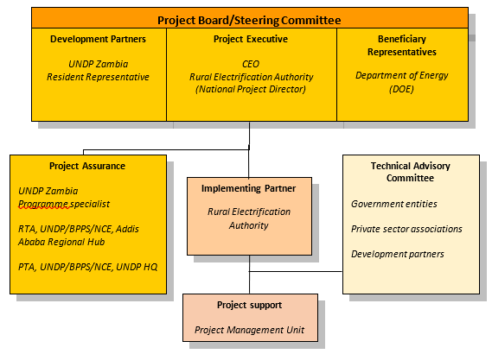

As noted in the Minimum Fiduciary Standards for GEF Partner Agencies, in cases where a GEF Partner Agency (i.e. UNDP) carries out both implementation oversight and execution of a project, the GEF Partner Agency (i.e. UNDP) must separate its project implementation oversight and execution duties, and describe in the relevant project document a: 1) Satisfactory institutional arrangement for the separation of implementation oversight and executing functions in different departments of the GEF Partner Agency; and 2) Clear lines of responsibility, reporting and accountability within the GEF Partner Agency between the project implementation oversight and execution functions.

In this case, UNDP is only performing an implementation oversight role in the project vis-à-vis our role in the project board and in the project assurance function and therefore a full separation of project implementation oversight and execution duties has been assured.

Section 4: Roles and Responsiblities of the Project Organization Structure:

- Project Board: All UNDP projects must be governed by a multi-stakeholder board or committee established to review performance based on monitoring and evaluation, and implementation issues to ensure quality delivery of results. The Project Board (also called the Project Steering Committee) is the most senior, dedicated oversight body for a project.

The two main (mandatory) roles of the project board are as follows:

- High-level oversight of the execution of the project by the Implementing Partner (as explained in the “Provide Oversight” section of the POPP). This is the primary function of the project board and includes annual (and as-needed) assessments of any major risks to the project, and decisions/agreements on any management actions or remedial measures to address them effectively. The Project Board reviews evidence of project performance based on monitoring, evaluation and reporting, including progress reports, evaluations, risk logs and the combined delivery report. The Project Board is responsible for taking corrective action as needed to ensure the project achieves the desired results.
- Approval of strategic project execution decisions of the Implementing Partner with a view to assess and manage risks, monitor and ensure the overall achievement of projected results and impacts and ensure long term sustainability of project execution decisions of the Implementing Partner (as explained in the “Manage Change” section of the POPP).

Requirements to serve on the Project Board:
- Agree to the Terms of Reference of the Board and the rules on protocols, quorum and minuting.
- Meet annually; at least once.
- Disclose any conflict of interest in performing the functions of a Project Board member and take all measures to avoid any real or perceived conflicts of interest. This disclosure must be documented and kept on record by UNDP.
- Discharge the functions of the Project Board in accordance with UNDP policies and procedures.
- Ensure highest levels of transparency and ensure Project Board meeting minutes are recorded and shared with project stakeholders.

Responsibilities of the Project Board:
- Consensus decision making:
  - The project board provides overall guidance and direction to the project, ensuring it remains within any specified constraints, and providing overall oversight of the project implementation.
  - Review project performance based on monitoring, evaluation and reporting, including progress reports, risk logs and the combined delivery report;
  - The project board is responsible for making management decisions by consensus.
  - In order to ensure UNDP’s ultimate accountability, Project Board decisions should be made in accordance with standards that shall ensure management for development results, best value money, fairness, integrity, transparency and effective international competition.
  - In case consensus cannot be reached within the Board, the UNDP representative on the board will mediate to find consensus and, if this cannot be found, will take the final decision to ensure project implementation is not unduly delayed.
- Oversee project execution:
  - Agree on project manager’s tolerances as required, within the parameters outlined in the project document, and provide direction and advice for exceptional situations when the project manager’s tolerances are exceeded.
- Appraise annual work plans prepared by the Implementing Partner for the Project; review combined delivery reports prior to certification by the implementing partner.
- Address any high-level project issues as raised by the project manager and project assurance;
- Advise on major and minor amendments to the project within the parameters set by UNDP and the donor and refer such proposed major and minor amendments to the UNDP BPPS Nature, Climate and Energy Executive Coordinator (and the GEF, as required by GEF policies);
- Provide high-level direction and recommendations to the project management unit to ensure that the agreed deliverables are produced satisfactorily and according to plans.
- Track and monitor co-financed activities and realisation of co-financing amounts of this project.
- Approve the Inception Report, GEF annual project implementation reports, mid-term review and terminal evaluation reports.
- Ensure commitment of human resources to support project implementation, arbitrating any issues within the project.
- Risk Management:
  - Provide guidance on evolving or materialized project risks and agree on possible mitigation and management actions to address specific risks.
  - Review and update the project risk register and associated management plans based on the information prepared by the Implementing Partner. This includes risks related that can be directly managed by this project, as well as contextual risks that may affect project delivery or continued UNDP compliance and reputation but are outside of the control of the project. For example, social and environmental risks associated with co-financed activities or activities taking place in the project’s area of influence that have implications for the project.
  - Address project-level grievances.
- Coordination:
  - Ensure coordination between various donor and government-funded projects and programmes.
  - Ensure coordination with various government agencies and their participation in project activities.

Composition of the Project Board: The composition of the Project Board must include individuals assigned to the following three roles:

- Project Executive: This is an individual who represents ownership of the project and chairs (or co-chairs) the Project Board. The Executive usually is the senior national counterpart for nationally implemented projects (typically from the same entity as the Implementing Partner), and it must be UNDP for projects that are direct implementation (DIM). In exceptional cases, two individuals from different entities can co-share this role and/or co-chair the Project Board. If the project executive co-chairs the project board with representatives of another category, it typically does so with a development partner representative. The Project Executive is: Chief Executive Officer, Rural Electrification Authority (REA)
- Beneficiary Representative(s): Individuals or groups representing the interests of those groups of stakeholders who will ultimately benefit from the project. Their primary function within the board is to ensure the realization of project results from the perspective of project beneficiaries. Often representatives from civil society, industry associations, or other government entities benefiting from the project can fulfil this role. There can be multiple beneficiary representatives in a Project Board.
- Development Partner(s): Individuals or groups representing the interests of the parties concerned that provide funding, strategic guidance and/or technical expertise to the project. The Development Partner(s) are: UNDP Resident Representative or Deputy Resident Representative.

- Project Assurance: Project assurance is the responsibility of each project board member; however, UNDP has a distinct assurance role for all UNDP projects in carrying out objective and independent project oversight and monitoring functions. UNDP performs quality assurance and supports the Project Board (and Project Management Unit) by carrying out objective and independent project oversight and monitoring functions, including compliance with the risk management and social and environmental standards of UNDP. The Project Board cannot delegate any of its quality assurance responsibilities to the Project Manager. Project assurance is totally independent of project execution.

A designated representative of UNDP playing the project assurance role is expected to attend all board meetings and support board processes as a non-voting representative. It should be noted that while in certain cases UNDP’s project assurance role across the project may encompass activities happening at several levels (e.g. global, regional), at least one UNDP representative playing that function must, as part of their duties, specifically attend board meeting and provide board members with the required documentation required to perform their duties. The UNDP representative playing the main project assurance function is an official of the UNDP Country Office, Zambia

- Project Management – Execution of the Project: The Project Manager (PM) is the senior most representative of the Project Management Unit (PMU) and is responsible for the overall day-to-day management of the project on behalf of the Implementing Partner, including the mobilization of all project inputs, supervision over project staff, responsible parties, consultants and sub-contractors. The project manager typically presents key deliverables and documents to the board for their review and approval, including progress reports, annual work plans, adjustments to tolerance levels and risk registers.

A designated representative of the PMU is expected to attend all board meetings and support board processes as a non-voting representative. The primary PMU representative attending board meetings is the Project Manager (PM). Efforts shall be made to mobilise the project team for the full project tenure to ensure the availability of experts and consultants until the end of the Project. Apart from the PM, the structure of PMU will include a Pilot Project and Monitoring Coordinator as well as a Financial-Administrative Officer. Detailed job descriptions are provided in Annex G. On an as-needed basis, short-term experts and contracted companies will be hired to work in assignments in the research, policy development, communications and outreach, technical assistance of activities in the various project components. A Lead Advisor (LA) will be hired at the start of the project at the same time as the Project Manager (with a specialization in rural and renewable energy) on an intermittent basis to support the PMU to recommend actions that focus work plans on achieving key milestones in a timely manner; recommend special expertise to be deployed on the Project to assist in its achievement of key milestones; and provide the interface between Project team and key specialist consultants, both domestic and international when appropriate.

d) Technical Advisory Committee: This Committee will advise the project team on technical issues, thematic aspects or more operational issues. At project inception, it may be decided that the Off-Grid Task Force acts or provides the core for as such a ‘technical advisory committee’. The Task Force has representatives from government entities (MoE, DoE, MoF, REA, MNDB, Office of the Vice-President), cooperating partners (WB, AfDB, EU, DFID, SIDA, IFC, USAID), private sector associations (Zarena, SIAZ) to which other representatives from financial, productive nd cooperatives sector could be added (DBZ, ZCF, Musika) as well as specially nominated representatives from the private sector.

Financial Planning and Management

The total cost of the project is USD 14,913,947. This is financed through a GEF grant of US 1,363,947 administered by UNDP and USD 200,000 in-kind and cash co-financing from UNDP with USD 9,350,000 of cash and in-kind co-financing from Zambian project partners as well as a technical assistance grant of USD 4,000,000 from AfDB. UNDP, as the GEF Implementing Agency, is responsible for the oversight of the GEF resources.

Confirmed Co-financing: The actual realization of project co-financing will be monitored during the mid-term review and terminal evaluation process and will be reported to the GEF. Note that all project activities included in the project results framework that will be delivered by co-financing partners (even if the funds do not pass through UNDP accounts) must comply with UNDP’s social and environmental standards. Co-financing will be used for the following project activities/outputs:
Box 29 Co-financing and sources
Co-financing source | Co-financing type | Co-financing amount (USD) | Contributing to project results (Y/N)
Rural Electrification Authority (REA) | grant / investment | 2,000,000 | No
Rural Electrification Authority (REA) | in-kind | 2,000,000 | No
Zambia Cooperative Federation | grant / investment | 3,600,000 | No
Zambia Cooperative Federation | in-kind | 200,000 | No
Development Bank of Zambia (DBZ) | grant | 1,500,000 | Partly (possibly with output 2.1)
Development Bank of Zambia (DBZ) | In-kind | 50,000 | No
African Development Bank (AfDB) | grant | 4,000,000 | No
United Nations Development Programme (UNDP) | grant | 100,000 | No
United Nations Development Programme (UNDP) | in-kind | 100,000 | No
TOTAL |  | 13,550,000
Note: The table includes co-financing confirmed by means of a signed cooperation (co-financing) letter attached as Annex R.

Budget Revision and Tolerance: As per UNDP POPP, the project board may agree with the project manager on a tolerance level for each detailed plan under the overall multi-year work plan. The agreed tolerance should be written in the project document or approved project board meeting minutes. It should normally not exceed 10 percent of the agreed annual budget at the activity level, but within the overall approved multi-year workplan at the activity level. Within the agreed tolerances, the project manager can operate without intervention from the project board. Restrictions apply as follows:
Should the following deviations occur, the Project Manager/IP through UNDP Country Office will seek the approval of the BPPS/NCE-VF team to ensure accurate reporting to the GEF. It is strongly encouraged to maintain the expenditures within the approved budget at the budgetary account and at the component level:
- Budget reallocations must prove that the suggested changes in the budget will not lead to material changes in the results to be achieved by the project. A strong justification is required and will be approved on an exceptional basis. Budget re-allocations among the components (including PMC) of the approved Total Budget and Work Plans (TBWP) that represent a value greater than 10% of the total GEF grant.
- Introduction of new outputs/activities (i.e. budget items) that were not part of the agreed project document and TBWP that represent a value greater than 5% of the total GEF grant. The new budget items must be eligible as per the GEF and UNDP policies.
- Project management cost (PMC): budget under PMC component is capped and cannot be increased.

Any over-expenditure incurred beyond the available GEF grant amount must be absorbed by non-GEF resources (e.g. UNDP TRAC or cash co-financing).
Project extensions: The UNDP Resident Representative and the UNDP-GEF Executive Coordinator must approve all project extension requests. Note that all extensions incur costs and the GEF project budget cannot be increased. A single extension may be granted on an exceptional basis and subject to the conditions and maximum durations set out in the UNDP POPP; the project management costs during the extension period must remain within the originally approved amount, and any increase in PMC costs will be covered by non-GEF resources; the additional UNDP oversight costs during the extension period must be covered by non-GEF resources, in accordance with UNDP’s guidance set out in UNDP POPP.
Audit: The project will be audited as per UNDP Financial Regulations and Rules and applicable audit policies. Audit cycle and process must be discussed during the Inception workshop. If the Implementing Partner is an UN Agency, the project will be audited according to that Agencies applicable audit policies.
Project Closure: Project closure will be conducted as per UNDP requirements outlined in the UNDP POPP. All costs incurred to close the project must be included in the project closure budget and reported as final project commitments presented to the Project Board during the final project review. The only costs a project may incur following the final project review are those included in the project closure budget.
Operational completion: The project will be operationally completed when the last UNDP-financed inputs have been provided and the related activities have been completed. This includes the final clearance of the Terminal Evaluation Report (that will be available in English) and the corresponding management response, and the end-of-project review Project Board meeting. Operational closure must happen at the end date calculated by the approved duration after the Project Document signature or at the revised operational closure date as approved in the project extension. Any expected activity after the operational date requires project extension approval. The Implementing Partner through a Project Board decision will notify the UNDP Country Office when operational closure has been completed. At this time, the project should have completed the transfer or disposal of any equipment that is still the property of UNDP.
Transfer or disposal of assets: In consultation with the Implementing Partner and other parties of the project, UNDP is responsible for deciding on the transfer or other disposal of assets. Transfer or disposal of assets is recommended to be reviewed and endorsed by the project board following UNDP rules and regulations. Assets may be transferred to the government for project activities managed by a national institution at any time during the life of a project (it is strongly encouraged to be done before the operational closure date). In all cases of transfer, a transfer document must be prepared and kept on file. The transfer should be done before Project Management Unit complete their assignments.
Financial completion (closure): The project will be financially closed when the following conditions have been met: a) the project is operationally completed or has been cancelled; b) the Implementing Partner has reported all financial transactions to UNDP; c) UNDP has closed the accounts for the project; d) UNDP and the Implementing Partner have certified a final Combined Delivery Report (which serves as final budget revision).
The project will be financially completed within 6 months of operational closure or after the date of cancellation. If Operational Closure is delayed for any justified and approved reason, the Country Office should do all efforts to Financially Close the project within 9 months after TE is completed. Between operational and financial closure, the implementing partner will identify and settle all financial obligations and prepare a final expenditure report. The UNDP Country Office will send the final signed closure documents including confirmation of final cumulative expenditure and unspent balance to the BPPS/NCE-VF Unit for confirmation before the project will be financially closed in Atlas by the UNDP Country Office.
Refund to GEF: Should a refund of unspent funds to the GEF be necessary, this will be managed directly by the BPPS/NCE-VF Directorate in New York. No action is required by the UNDP Country Office on the actual refund from UNDP project to the GEF Trustee.

Total UNDP Budget and Work Plan
Total Budget and Work Plan
Atlas Award ID: | 00144038 | Atlas Primary Output Project ID: | 00131925
Atlas Award Title: | National Child Project under the Africa Minigrids Program - Zambia
Atlas Business Unit
UNDP-GEF PIMS No. | 6613
Implementing Partner | Rural Electrification Authority (REA)

Component/Atlas Activity | Responsible Party (ATLAS Implementing Agent) | Funding ID | Donor Name | Atlas Budgetary Account Code | ATLAS Budget Description | Amount Year 1 (USD) | Amount Year 2 (USD) | Amount Year 3 (USD) | Amount Year 4 (USD) | Total (USD) | Budget Note:
Outcome 1:Stakeholder ownership in a national minigrid delivery model is advanced, appropriate policies and regulations are adopted to facilitate investment in low-carbon minigrids | REA | 62000 | GEF | 71200 | Internat. consultants | 15,000 | 5,000 | 0 | 10,000 | 30,000 | 1
 |  |  |  | 71300 | Local consultants | 5,400 | 5,000 | 5,000 | 5,400 | 20,800 | 2
 |  |  |  | 71800 | Contracts - individual - ImplP | 14,906 | 14,906 | 14,906 | 14,907 | 59,625 | 3 *
 |  |  |  | 71600 | Travel | 1,540 | 500 | 500 | 1,500 | 4,040 | 4
 |  |  |  | 72100 | Contracts -company | 7,230 | 1,000 | 0 | 2,600 | 10,830 | 5
 |  |  |  | 72800 | Info Techn. Equipm | 2,500 | 2,500 |  |  | 5,000 | 6
 |  |  |  | 74200 | AV&print.prod.costs |  | 2,500 | 2,500 | 2,500 | 7,500 | 7
 |  |  |  | 75700 | Training, workshops | 4,000 | 3,000 | 3,000 | 4,000 | 14,000 | 8
 |  |  |  |  | Total outcome 1 | 50,576 | 34,406 | 25,906 | 40,907 | 151,795
Outcome 2: Innovative business models based on cost reduction are operationalized, with strengthened private sector participation in low-carbon minigrid developmen | REA | 62000 | GEF | 71200 | Internat. consultants |  |  | 4,500 | 0 | 4,500 | 9
 |  |  |  | 71300 | Local consultants | 1,500 | 5,000 | 7,000 | 4,700 | 18,200 | 10
 |  |  |  | 71800 | Contracts - individual - ImplP | 14,906 | 14,906 | 14,906 | 14,907 | 59,625 | 11 *
 |  |  |  | 71600 | Travel |  | 1,000 | 2,000 | 1,510 | 4,510 | 12
 |  |  |  | 72100 | Contracts-company |  | 100,000 | 300,000 | 250,000 | 650,000 | 13
 |  |  |  | 72300 | Materials and goods |  | 5,000 |  |  | 5,000 | 14
 |  |  |  | 75700 | Training, workshops | 3,500 |  |  | 3,500 | 7,000 | 15
 |  |  |  |  | Total outcome | 19,906 | 125,906 | 328,406 | 274,617 | 748,835
Outcome 3: Financial sector actors are ready to invest in a pipeline of low-carbon minigrids and concessional financial mechanisms are in place to incentivize scaled-up investment | REA | 62000 | GEF | 71200 | Internat. consultants |  | 7,500 | 7,500 | 7,500 | 22,500 | 16
 |  |  |  | 71300 | Local consultants |  | 5,200 | 5,200 | 5,200 | 15,600 | 17
 |  |  |  | 71800 | Contracts - individual -ImplP | 14,906 | 14,906 | 14,906 | 14,907 | 59,625 | 18 *
 |  |  |  | 71600 | Travel |  | 597 | 597 | 596 | 1,790 | 19
 |  |  |  | 72100 | Contracts-company |  | 5,000 | 5,000 | 5,000 | 15,000 | 20
 |  |  |  | 75700 | Training, workshops |  | 11,000 | 7,500 | 3,500 | 22,000 | 21
 |  |  |  |  |  | 14,906 | 44,203 | 40,703 | 36,703 | 136,515
Outcome 4: Digitalization and data are mainstreamed, across stakeholders, into local minigrid market development. Increased knowledge, awareness and network opportunities in the minigrid market | REA | 62000 | GEF | 71200 | Internat. consultants | 15,000 |  |  | 0 | 15,000 | 22
 |  |  |  | 72300 | Local consultants | 1,500 | 1,000 | 1,500 | 1,200 | 5,200 | 23
 |  |  |  | 71800 | Contracts - individual - ImplP | 14,906 | 14,906 | 14,906 | 14,907 | 59,625 | 24 *
 |  |  |  | 71600 | Travel | 7,500 | 7,500 | 7,000 | 7,500 | 29,500 | 25
 |  |  |  | 72100 | Contracts -company | 5,500 | 1,500 | 1,500 | 1,500 | 10,000 | 26
 |  |  |  | 73300 | Rental, InfoTevhn | 3,582 | 3,000 |  |  | 6,582 | 27
 |  |  |  | 74200 | AV&print.prod.costs | 600 | 800 | 800 | 800 | 3,000 | 28
 |  |  |  | 75700 | Training, workshops | 2,500 | 2,500 | 2,500 | 2,500 | 10,000 | 29
 |  |  |  |  | Total outcome | 51,088 | 31,206 | 28,206 | 28,407 | 138,907
Outcome 5: Monitoring & evaluation | UNDP | 62000 | GEF | 71200 | Internat. consultants |  | 18,750 |  | 18,750 | 37,500 | 30
 |  |  |  | 71300 | Local consultants |  | 5,200 |  | 5,200 | 10,400 | 31
Outcome 5: Monitoring & evaluation |  |  |  | 71600 | Travel |  | 500 |  | 500 | 1,000 | 32
Outcome 5: Monitoring & evaluation | REA | 62000 | GEF | 72100 | Contracts -company |  |  | 8,000 | 0 | 8,000 | 33
 |  |  |  | 75700 | Training, workshops | 3,500 |  |  | 3,500 | 7,000 | 34
 |  |  |  |  | Total outcome | 3,500 | 24,450 | 8,000 | 27,950 | 63,900
Project management | REA | 62000 | GEF | 71800 | Contracts - individual - ImplP | 37,500 | 30,000 | 12,500 | 12,500 | 92,500 | 35 *
 |  |  |  | 71600 | Travel | 1,250 | 1,250 | 1,250 | 1,250 | 5,000 | 36
 |  |  |  | 72500 | Office supplies | 1,624 | 1,624 | 1,624 | 1,623 | 6,495 | 37
 |  |  |  | 72200 | Equiment & furnitture | 10,000 |  |  | 0 | 10,000 | 38
Project management | UNDP | 62000 | GEF | 74100 | Professional services | 2,500 | 2,500 | 2,000 | 3,000 | 10,000 | 39
Project management |  |  |  |  | Total PM | 52,874 | 35,374 | 17,374 | 18,374 | 123,995
 |  |  |  |  | PROJECT TOTAL - GEF | 192,850 | 295,545 | 448,595 | 426,957 | 1,363,947
Project management | UNDP | 04000 | UNDP | 71800 | Indiv. contr. IP |  | 7,500 | 42,500 | 50,000 | 100,000 | 40 *
 |  |  |  |  | Total outcome | 0 | 7,500 | 42,500 | 50,000 | 100,000
 |  |  |  |  | PROJECT TOTAL - UNDP | 0 | 7,500 | 42,500 | 50,000 | 100,000

GEF budget and co-financing:

Summary of project finance |  | Amount Year 1 (USD) | Amount Year 2 (USD) | Amount Year 3 (USD) | Amount Year 4 (USD) | Total (USD)
GEF |  | 192,850 | 295,545 | 448,595 | 426,957 | 1,363,947
UNDP (cash and in kind) |  | 25,000 | 32,500 | 67,500 | 75,000 | 200,000
REA |  | 1,000,000 | 1,000,000 | 1,000,000 | 1,000,000 | 4,000,000
DBZ |  | 400,000 | 400,000 | 400,000 | 400,000 | 1,600,000
AfDB |  | 800,000 | 1,200,000 | 1,200,000 | 800,000 | 4,000,000
ZCF |  | 50,000 | 150,000 | 1,800,000 | 1,800,000 | 3,800,000
Total |  | 2,467,850 | 3,078,045 | 4,916,095 | 4,501,957 | 14,963,947

Additional budget information:

Budget note | Description
1 | International consultancy (8 weeks @ 3750/week, incl. internat. travel) for DREI-analysis and workshop participation
2 | Local consultancy (16 weeks @ USD 1300/week) for stakeholder engagement, support DREI analysis and for gender/SES consultancy
3 | Tasks of project staff (See Note *): Project manager, Fin-Admin officer, Monitoring+Pilot Coord, (USD 50,625) as well as Lead Advisor, USD 9000) related to tasks of Component 1
4 | Travel for consultants (and staff; excl. internat. ticket of internat. experts that are included in BuLi 71200), Comp. 1
5 | Company contracts for local support of DREI analysis (USD 7080),
6 | Off-Grid Task Force website maintenance and support (USD 3,750)
7 | Support to Off-Grid Task Force with AV and printing production cost (newsletter, etc.) of USD 7,500 and information technology equipment and software (USD 5,000)
8 | Workshops and seminars (04 events @ USD 3500/day)
8 | Budget note 8 has been cancelled
9 | International consultancy (6 days @ USD 750/day, incl. internat. travel) for feasibility study design
10 | Local consultancy (14 weeks @ USD 1300/week) for stakeholder engagement, support of MG design and modelling and related gender/SES consultancy
11 | Tasks of project staff (See Note *): Project manager, Fin-Admin officer, Monitoring+Pilot Coord, (USD 50,625) as well as Lead Advisor, USD 9000) related to tasks of Component 2
12 | Travel for consultants (and staff; excl. internat. ticket of internat. Experts that are included in BuLi 71200), Comp. 2
13 | Contracts to developers for design and installation and first years of operation of pilot minigrids (supported with GEF INV, USD 650,000 in total)
14 | Equipment for measurements and surveys for prospective MG sites
15 | Workshops and seminars (02 events @ USD 3500/day) related to Component 2 activities
16 | International consultancy (6 weeks @ 3750/week, incl. internat. travel) for the design of innovative financing subcontract (see 16.), participation in workshops and design and lead financial training course
17 | National consultancy to support international consultant (14.) and assessment of MG-agro va;ue chain and financing issues and options (12 weeks @ USD 1300/week)
18 | Tasks of project staff (See Note *): Project manager, Fin-Admin officer, Monitoring+Pilot Coord, (USD 50,625) as well as Lead Advisor, USD 9000) related to tasks of Component 3
19 | Travel for consultants (and staff; excl. internat. ticket of internat. experts that are included in BuLi 71200), Comp. 3
20 | Company contract for innovative financing solutions for MGs, financial sector engagement and links with productive value chains. Advice on capacity building and participation in events (USD 15,000)
21 | Workshops (02 @ USD 3500/day) and training course (USD 15000/week) on finance-relevant subjects
22 | International consultancy (4 weeks @ 3750/week, incl. internat. travel) for design of the project QA, RMV and digital strategy (experts provided as needed from regional AMP pool of experts)
23 | Local consultancy on stakeholder engagement, gender and SES related to Component 4 activities and events (4 weeks @ USD 1300/week)
24 | Tasks of project staff (See Note *): Project manager, Fin-Admin officer, Monitoring+Pilot Coord, (USD 50,625) as well as Lead Advisor, USD 9000) related to tasks of Component 4
25 | Travel for consultants (and staff; excl. internat. ticket of internat. experts that are included in BuLi 71200), Comp. 4, as well as o facilitate participation in events linked with the UNEP-managed Global E-mobility programme)
26 | Company contract for digital platform/website/portal development (USD 10,000; part of total contract of USD 13,750, of which USD 3,750 linked with Component 1 (see 5.)
27 | Rental/maintenance of info-tech equipment (incl. licensing/maintenance platform software), USD 6,583
22 | Cost of AV, printing production (for workshops and a regional event): USD 3000
29 | Workshops (USD 10,000 for workshops and a regional event in Zambia; note that travel is in separate budget line)
30 | International consultancy for mid-term review and terminal evaluation (about 4-5 weeks each). Budget for consultancy and travel for M&E (final, MTR) is USD 37,900
31 | Local consultancy for mid-term review and terminal evaluation (about 4-5 weeks each). Budget for consultancy and travel for M&E (final, MTR) is USD 10,400
32 | Travel within Zambia of evaluation consultants
33 | Contract for measurement of progress indicators for M&E (USD 8000)
34 | Inception and final project workshops (USD 3500 each)
35 | Tasks of project staff (See Note *): Project manager, Fin-Admin officer, related to project management (USD 92,500)
36 | Travel of project staff (Manager and Monitoring+Pilot Coordinator) within Zambia
37 | Project management cost: office supplies
38 | PMU office equipment and furniture
39 | Professional hired services for project auditing (USD 10,000)
40 | Project manager (part which is co-financed by UNDP, i.e, not GEF-financed

General note:
* | Project management costs (PMC): contractual services by IP of Project Manager (PM; USD 42,500 and Fin-Admin Officer(s) (USD 50,000) for admin-managerial tasks (total USD 92,500 over 4 years).  Total budget PM over 4 years is USD 240,000, of which USD 100,000 co-financed by UNDP and USD 140,000 by GEF, of which correspond to management-admin tasks USD 42,000 and technical tasks of the project manager (PM) in the four components, USD 97,500  Contractual services by IP for Monitoring and Pilot Coordinator (Component 2) (together totalling USD 105,000 over 3.5 years) divided over the four technical components  A Lead Technical Advisor will be hired (at USD 9,000 a year and an estimated 20 days per annum) at a total budget of USD 36,000 for supporting activities in the three components. The duration of the contract of the international LTA should be one-year renewable and a condition of the contract should be that at least 50% of the number of days must be spent in the country in Zambia (travel cost in separate budget line 71600). The cost of the international CTA shall be funded from budget line 71800.

Legal context

This project document shall be the instrument referred to as such in Article 1 of the Standard Basic Assistance Agreement between the Government of Zambia and UNDP, signed on 14th October 1983. All references in the SBAA to “Executing Agency” shall be deemed to refer to “Implementing Partner.”

This project will be implemented by the Rural Electrification Authority (REA) in accordance with its financial regulations, rules, practices and procedures only to the extent that they do not contravene the principles of the Financial Regulations and Rules of UNDP. Where the financial governance of an Implementing Partner does not provide the required guidance to ensure best value for money, fairness, integrity, transparency, and effective international competition, the financial governance of UNDP shall apply.

The designations employed and the presentation of material on this map do not imply the expression of any opinion whatsoever on the part of the Secretariat of the United Nations or UNDP concerning the legal status of any country, territory, city or area or its authorities, or concerning the delimitation of its frontiers or boundaries.

Risk management

- Consistent with the Article III of the Supplemental Provisions to the Project Document, the responsibility for the safety and security of the Implementing Partner and its personnel and property, and of UNDP’s property in the Implementing Partner’s custody, rests with the Implementing Partner. To this end, the Implementing Partner shall:
- put in place an appropriate security plan and maintain the security plan, taking into account the security situation in the country where the project is being carried;
- assume all risks and liabilities related to the Implementing Partner’s security and the full implementation of the security plan.
- UNDP reserves the right to verify whether such a plan is in place and to suggest modifications to the plan when necessary. Failure to maintain and implement an appropriate security plan as required hereunder shall be deemed a breach of the Implementing Partner’s obligations under this Project Document.
- The Implementing Partner agrees to undertake all reasonable efforts to ensure that no UNDP funds received pursuant to the Project Document are used to provide support to individuals or entities associated with terrorism and that the recipients of any amounts provided by UNDP hereunder do not appear on the list maintained by the Security Council Committee established pursuant to resolution 1267 (1999). The list can be accessed via http://www.un.org/sc/committees/1267/aq_sanctions_list.shtml.
- The Implementing Partner acknowledges and agrees that UNDP will not tolerate sexual harassment and sexual exploitation and abuse of anyone by the Implementing Partner, and each of its responsible parties, their respective sub-recipients and other entities involved in Project implementation, either as contractors or subcontractors and their personnel, and any individuals performing services for them under the Project Document.
(a) In the implementation of the activities under this Project Document, the Implementing Partner, and each of its sub-parties referred to above, shall comply with the standards of conduct set forth in the Secretary General’s Bulletin ST/SGB/2003/13 of 9 October 2003, concerning “Special measures for protection from sexual exploitation and sexual abuse” (“SEA”).
(b) Moreover, and without limitation to the application of other regulations, rules, policies, and procedures bearing upon the performance of the activities under this Project Document, in the implementation of activities, the Implementing Partner, and each of its sub-parties referred to above, shall not engage in any form of sexual harassment (“SH”). SH is defined as any unwelcome conduct of a sexual nature that might reasonably be expected or be perceived to cause offense or humiliation, when such conduct interferes with work, is made a condition of employment, or creates an intimidating, hostile, or offensive work environment.
- a) In the performance of the activities under this Project Document, the Implementing Partner shall (with respect to its own activities), and shall require from its sub-parties referred to in paragraph 4 (with respect to their activities) that they, have minimum standards and procedures in place, or a plan to develop and/or improve such standards and procedures in order to be able to take effective preventive and investigative action. These should include: policies on sexual harassment and sexual exploitation and abuse; policies on whistleblowing/protection against retaliation; and complaints, disciplinary and investigative mechanisms. In line with this, the Implementing Partner will and will require that such sub-parties will take all appropriate measures to:
  - Prevent its employees, agents, or any other persons engaged to perform any services under this Project Document, from engaging in SH or SEA;
  - Offer employees and associated personnel training on prevention and response to SH and SEA, where the Implementing Partner and its sub-parties referred to in paragraph 4 have not put in place its own training regarding the prevention of SH and SEA, the Implementing Partner and its sub-parties may use the training material available at UNDP;
  - Report and monitor allegations of SH and SEA of which the Implementing Partner and its sub-parties referred to in paragraph 4 have been informed or have otherwise become aware, and status thereof;
  - Refer victims/survivors of SH and SEA to safe and confidential victim assistance; and
  - Promptly and confidentially record and investigate any allegations credible enough to warrant an investigation of SH or SEA. The Implementing Partner shall advise UNDP of any such allegations received and investigations being conducted by itself or any of its sub-parties referred to in paragraph 4 with respect to their activities under the Project Document, and shall keep UNDP informed during the investigation by it or any of such sub-parties, to the extent that such notification (i) does not jeopardize the conduct of the investigation, including but not limited to the safety or security of persons, and/or (ii) is not in contravention of any laws applicable to it. Following the investigation, the Implementing Partner shall advise UNDP of any actions taken by it or any of the other entities further to the investigation.
- The Implementing Partner shall establish that it has complied with the foregoing, to the satisfaction of UNDP, when requested by UNDP or any party acting on its behalf to provide such confirmation. Failure of the Implementing Partner, and each of its sub-parties referred to in paragraph 4, to comply with the foregoing, as determined by UNDP, shall be considered grounds for suspension or termination of the Project.
- Social and environmental sustainability will be enhanced through the application of the UNDP Social and Environmental Standards (http://www.undp.org/ses) and related Accountability Mechanism (http://www.undp.org/secu-srm).
- The Implementing Partner shall: (a) conduct project and program-related activities in a manner consistent with the UNDP Social and Environmental Standards, (b) implement any management or mitigation plan prepared for the project or program to comply with such standards, and (c) engage in a constructive and timely manner to address any concerns and complaints raised through the Accountability Mechanism. UNDP will seek to ensure that communities and other project stakeholders are informed of and have access to the Accountability Mechanism.
- All signatories to the Project Document shall cooperate in good faith with any exercise to evaluate any program or project-related commitments or compliance with the UNDP Social and Environmental Standards. This includes providing access to project sites, relevant personnel, information, and documentation.
- The Implementing Partner will take appropriate steps to prevent misuse of funds, fraud or corruption, by its officials, consultants, responsible parties, subcontractors, and sub-recipients in implementing the project or using UNDP funds. The Implementing Partner will ensure that its financial management, anti-corruption, and anti-fraud policies are in place and enforced for all funding received from or through UNDP.

- The requirements of the following documents, then in force at the time of signature of the Project Document, apply to the Implementing Partner: (a) UNDP Policy on Fraud and other Corrupt Practices and (b) UNDP Office of Audit and Investigations Investigation Guidelines. The Implementing Partner agrees to the requirements of the above documents, which are an integral part of this Project Document and are available online at www.undp.org.
- In the event that an investigation is required, UNDP has the obligation to conduct investigations relating to any aspect of UNDP projects and programs in accordance with UNDP’s regulations, rules, policies, and procedures. The Implementing Partner shall provide its full cooperation, including making available personnel, relevant documentation, and granting access to the Implementing Partner’s (and its consultants’, responsible parties’, subcontractors’ and sub-recipients’) premises, for such purposes at reasonable times and on reasonable conditions as may be required for the purpose of an investigation. Should there be a limitation in meeting this obligation, UNDP shall consult with the Implementing Partner to find a solution.
- The signatories to this Project Document will promptly inform one another in case of any incidence of inappropriate use of funds, or credible allegation of fraud or corruption with due confidentiality.
Where the Implementing Partner becomes aware that a UNDP project or activity, in whole or in part, is the focus of investigation for alleged fraud/corruption, the Implementing Partner will inform the UNDP Resident Representative/Head of Office, who will promptly inform UNDP’s Office of Audit and Investigations (OAI). The Implementing Partner shall provide regular updates to the head of UNDP in the country and OAI of the status of, and actions relating to, such investigation.
- UNDP shall be entitled to a refund from the Implementing Partner of any funds provided that have been used inappropriately, including through fraud or corruption, or otherwise paid other than in accordance with the terms and conditions of the Project Document. Such amount may be deducted by UNDP from any payment due to the Implementing Partner under this or any other agreement. Recovery of such amount by UNDP shall not diminish or curtail the Implementing Partner’s obligations under this Project Document.
Where such funds have not been refunded to UNDP, the Implementing Partner agrees that donors to UNDP (including the Government) whose funding is the source, in whole or in part, of the funds for the activities under this Project Document, may seek recourse to the Implementing Partner for the recovery of any funds determined by UNDP to have been used inappropriately, including through fraud or corruption, or otherwise paid other than in accordance with the terms and conditions of the Project Document.
Note: The term “Project Document” as used in this clause shall be deemed to include any relevant subsidiary agreement further to the Project Document, including those with responsible parties, subcontractors, and sub-recipients.
- Each contract issued by the Implementing Partner in connection with this Project Document shall include a provision representing that no fees, gratuities, rebates, gifts, commissions or other payments, other than those shown in the proposal, have been given, received, or promised in connection with the selection process or contract execution, and that the recipient of funds from the Implementing Partner shall cooperate with any and all investigations and post-payment audits.
- Should UNDP refer to the relevant national authorities for appropriate legal action any alleged wrongdoing relating to the project, the Government will ensure that the relevant national authorities shall actively investigate the same and take appropriate legal action against all individuals found to have participated in the wrongdoing, recover and return any recovered funds to UNDP.
- The Implementing Partner shall ensure that all of its obligations set forth under this section entitled “Risk Management” are passed on to each responsible party, subcontractor, and sub-recipient and that all the clauses under this section entitled “Risk Management Standard Clauses” are included, mutatis mutandis, in all sub-contracts or sub-agreements entered into further to this Project Document.

Mandatory Annexes

- GEF budget template
- Additional budget information
- Project map
- Multi-year work plan
- Monitoring plan
- UNDP Atlas Risk register
- Business cases minigrids
- GEF indicators and GHG emission reduction details
- Overview of project staff and technical consultancies
- Gender analysis and action plan
- Stakeholder engagement plan
- Social and environmental safeguards planning (SESP)
- Procurement plan
- GEF 7 taxonomy
- Environmental and Social Management Framework (ESMF)
- Project capacity and HACT assessment’
- UNDP project quality assurance report
- Agreements (co-financing letters, OFP Letter)

- Gef budget template

Project Objective:
Supporting access to clean energy by increasing the financial viability, and promoting scaled-up commercial investment, in low-carbon minigrids in Zambia with a focus on cost-reduction levers and innovative business models.
Project Components |  | Type | Project Outcomes | Project Outputs | Trust Fund | (in USD)
 |  |  |  |  |  | GEF Project Financing | Co-financing
- Stakeholder ownership in a national minigrid delivery model is advanced, and appropriate policies and regulations are adopted to facilitate investment in low-carbon minigrids | TA |  | Stakeholder ownership in a national minigrid delivery model is advanced, and appropriate policies and regulations are adopted to facilitate investment in low-carbon minigrids. | 1.1 An inclusive national dialogue to identify minigrid delivery models is facilitated, clarifying priority interventions for an integrated approach to off-grid electrification  1.2 Minigrid DREI techno-economic analyses carried out to propose the most cost-effective basket of policy and financial derisking instruments  1.3 Programme to develop a competitive, skilled labour market in minigrids | GEFTF | 151,795 | 1,125,000
- Business model innovation with the private sector | INV |  | Innovative business models based on cost reduction are operationalized, with strengthened private sector participation in low-carbon minigrid development. | 2.1 Pilots developed, including productive use/innovative appliances and modular hardware/system design, leading to cost-reduction in minigrids |  | 650,000 | 7,500,000
- Business model innovation with the private sector | TA |  |  | 2.2 Pre-feasibility studies for pipeline development  2.3 Productive use pathway study |  | 98,835 | 355,000
- Scaled-up financing |  | TA | Financial sector actors are ready to invest in a pipeline of low-carbon minigrids and concessional financial mechanisms are in place to incentivize scaled-up investment. | 3.1 Innovative financing solutions for minigrid development are identified and designed with supporting human and institutional capacity building |  | 136,515 | 2,600,000
- Digital, knowledge management |  |  | Digitalization and data are mainstreamed, across stakeholders, into local minigrid market development. Increased knowledge, awareness and network opportunities in the minigrid market and among stakeholders, including benefitting from linkages to international good practice | 4.1 A project digital strategy is developed and implemented, including linkages to and following guidance from the AMP Regional Project  4.2 A ‘Minigrids Digital and Data Management Platform’ implemented to run tenders and manage data from pilots, and to support minigrids scale-up and cost-reduction  4.2 Quality Assurance and Monitoring Framework for measuring, reporting and verification is adopted and operationalized  4.3 Engage with the regional project (AMP), via (i) Communities of Practice and (ii) capturing and sharing lessons learnt |  | 138,907 | 450,000
- Monitoring and evaluation |  | TA |  |  |  | 63,900 | 270,000
Subtotal |  |  |  |  |  | 1,239,952 | 12,500,000
Project management |  | TA |  |  |  | 123,995 | 1,250,000
TOTAL |  |  |  |  |  | 1,363,947 | 13,550,000

- Additional budget information

Co-financing overview

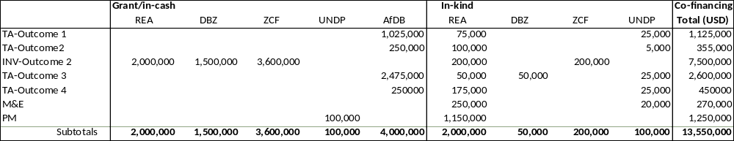

Co-financing source |  | Co-financing type | Description | Co-financing amount (USD)
Rural Electrification Authority (REA) |  | grant / investment | Estimated annual expenditure of USD 0.5 million on minigrid investment during 2023-2026 | 2,000,000
Rural Electrification Authority (REA) |  | in-kind | Project management and administration (office space, materials; printing), USD 950,000, and for support in various components (planning/technical and support staff; survey and measurement equipment; AV and materials; communications and inf) | 2,000,000
Zambia Cooperative Federation |  | grant / investment | Replication in solar mills of the refurbishment/expansion in the pilot mills proposed to be supported by the Project. The original investment of about USD 100,000 each (in PUE and solar PV) is taken as co-financing | 3,600,000
Zambia Cooperative Federation |  | in-kind | Staff time and support activities to the realization of two solar mills (and replication plan preparation | 200,000
Development Bank of Zambia (DBZ) |  | grant | It is assumed that 60% of the DBZ-WB Off-grid loan facility can potentially be made available for loans to minigrid developers. The pilot developers may apply to loans if they need and will be approved according to the usual requirements and bank due diligence | 1,500,000
Development Bank of Zambia (DBZ) |  | In-kind | Staff time and support activities related to financial capacity strengthening activities | 50,000
African Development Bank (AfDB) |  | grant | Grant support through AfDB’s Sustainable Energy Fund for Africa (SEFA) and Green Climate Fund (GCF) part in Zambia Renewable Energy Financing Framework for technical assistance to enable conditions for (private) financing of offgrid (minigrids) systems | 4,000,000
United Nations Development Programme (UNDP) |  | grant | Part of the cost of the Project Manager | 100,000
United Nations Development Programme (UNDP) |  | in-kind | Staff time and project support activities | 100,000
TOTAL |  |  |  | 13,550,000
Note: The table includes co-financing confirmed by means of a signed cooperation (co-financing) letter attached as Annex R.
GEF budget per output and budget line
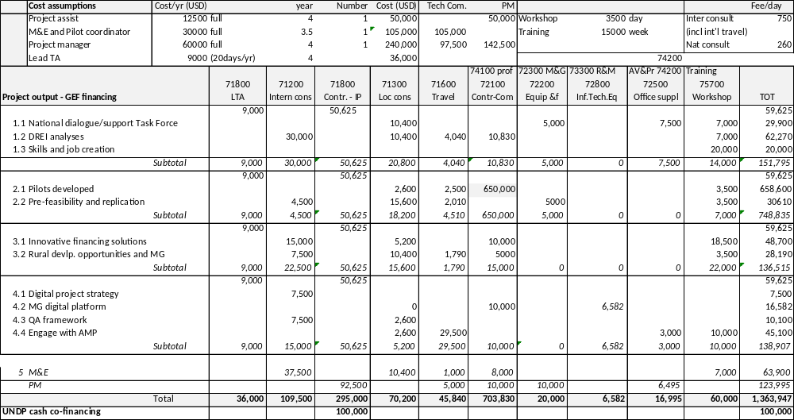

- Project map

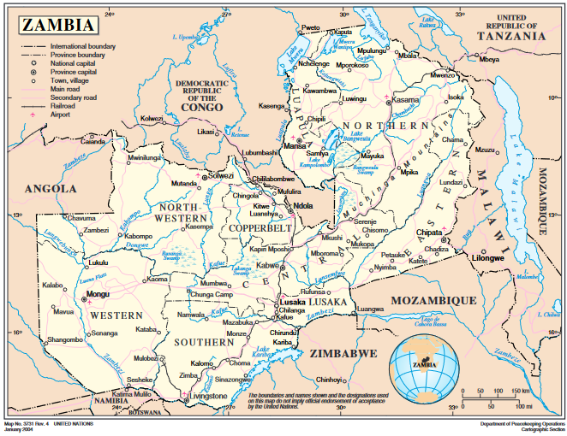

- Multi-Year Work Plan

Output  Activity (short title) | Yr1 Yr2 Y3 Yr4
Output  Activity (short title) | Q1 | Q2 | Q3 | Q4 | Q1 | Q2 | Q3 | Q4 | Q1 | Q2 | Q3 | Q4 | Q1 | Q2 | Q3 | Q4
Component 1 Stakeholder ownership in a national minigrid delivery model is advanced, and appropriate policies and regulations are adopted
Output 1.1 An inclusive national dialogue to identify minigrid delivery models is facilitated, clarifying priority interventions for an integrated approach to off-grid electrification
1.1.1 Facilitation of national dialogue decision-making on minigrids
1.1.2 Establish feedback loop between national dialogue and the project
Output 1.2 Minigrid DREI techno-economic analyses carried out to propose the most cost-effective basket of policy and financial derisking instruments
1.2.1 Initial, full quantitative national DREI analysis (Year1)
1.2.2 Dissemination of DREI analyses and adaptive management (Year 2)
1.2.3 Coordination with regional project on national DREI analysis update (Year 4)
Output 1.3 Programme to develop a competitive, skilled labour market in the minigrid sector
1.3.1 Assessment of technical skills needs and job creation
1.3.2 Apprenticeships
Component 2 Business model innovation with the private sector
Output 2.1 Pilots developed, including productive use/innovative appliances and modular hardware/system design, leading to cost-reduction in minigrids
2.1.1 Develop a Minigrid Pilot plan
2.1.2 Design and launch of Call for Proposals (year 2), using a digital platform
2.1.3 Execution of tender, contracting and payments to the selected pilot proponents
2.1.4 Monitor pilot(s), collect and aggregate data shared by pilot(s)
Output 2.2 Pre-feasibility studies for pipeline development
2.2.1 Pre-feasibility analysis of selected prospective MG sites
2.2.2 Investment and replication plan
Output 2.3 Productive use pathway study
2.4.1 Assessment and drafting of a report on the role of MGs in rural development and financing sources
Component 3 Scaled-up financing
Output 3.1 Innovative financing solutions for minigrid development are identified and designed with supporting human and institutional capacity building
2.3.1 Assessment and recommendations for MG financing institutionalisation
2.3.2 Design & implementation of a capacity building plan on stimulation of access to local finance
2.3.3 Detailed feasibility assessment and business plans for EV and charging facilities for demo
Component 4 Digital and knowledge management
Output 4.1 A project digital strategy is developed and implemented, including linkages to and following guidance from the AMP Regional Project
4.1.1. Develop and implement a project digital strategy (the ‘Project Digital Strategy’)
4.1.2 Develop recommendations for a national-level digital strategy for minigrid development.
Output 4.2 A ‘Minigrids Digital and Data Management Platform’ implemented to run tenders and manage data from pilots
4.2.1 Develop Terms of Reference (TORs) for procuring a Minigrids Digital Platform
4.2.2 Procure MG digital platform
Output 4.3 A Quality Assurance and Monitoring Framework for measuring, reporting and verification is adopted and operationalized
3.3.1 Provide inputs to the AMP Regional Project for standardized QA/M Framework
3.3.2 Operationalize the AMP-QAMF
Output 4.4 Engage with the regional project (AMP) via (i) Communities of Practice and (ii) capturing and sharing lessons learnt
4.4.1 Communities of Practice (CoPs)
4.4.2 Sharing of research and lessons learned with and by the AMP regional project.
4.4.3 Collaborate with the regional project on an ‘Insight Brief’
Component 5 Monitoring and evaluation
5.1.1 Inception workshop and report
5.1.2 Monitoring of progress indicators
5.1.4 Annual progress reporting; 5.1.3 Monitoring of key project plans
5.1.5 Mid-term review
5.1.6 Final evaluation

- Monitoring Plan

 | Objective and Outcome Indicators | Mid-term project  (end 2023) | End of Project (EoP)  target (2027) | Frequency and  source | Means of verification | Assumptions
Project Objective:  Support access to clean energy by increasing the financial viability, and promoting scaled-up commercial investment, in low-carbon mini-grids in Zambia with a focus on cost-reduction levers and innovative business models | - Greenhouse gas emissions mitigated (tCO¬2¬ lifetime reduction)  [GEF Core Indicator] | Zero, since the project pilot(s) have not yet been commissioned | Direct lifetime emission reduction (ER) of 13.78 ktCO₂ (of the ZMG-linked pilots, see Annex H). Calculations are provided Annex H).  Indirect ER = 643.33 MtCO₂. | Frequency:  Annually  Source: Market surveys and/or project data;  MTR and TE reports (M&E);  Annual Implementation reviews (PIR)  Responsible: PMU | Project progress reports:  Direct emissions from pilot monitoring; Indirect from partner reports and statistics;  Expert assessment  Project digital platform  ZMG final report | Direct ER:  Pilots are realised as planned and assumptions of Annex G remain valid.  Indirect ER: Nationally, development of off-grid plans with MGs is delayed
 | - Number of direct beneficiaries benefitting from energy access via minigrids, disaggregated by gender and by customer segment (residential, social, commercial/productive use) as co-benefit of GEF investment * [GEF core indicator] | Zero, since the project pilot(s) have not yet been commissioned | Total of 4,396 beneficiaries (2242 women) based on  (see Annex H):  - 4,190 residential  - 80 social services  - 126 people (commercial and PUE) | Frequency: Annually, PIR;  Source:  Monitoring reports of pilots (Output 2.1);  Data provided by developers  Project quarterly reports  Responsible: PMU | Pilot project reports and monitoring  Project digital platform  Mid-term survey among beneficiaries in pilot projects (see M&E) | Pilots are realised as planned (assuming the willingness of private developers to participate in pilots and build MGs) and assumptions of Annex G remain valid.  Willingness of private and public sector managers/owners to invest in EE buildings and EE technology and to participate in the Project  Project developers are able or willing to share data via digital platform
 | 3) Increase in installed solar PV capacity and battery storage [kW -solar – MWh battery]  [GEF core indicator] | Zero, since the project pilot(s) have not yet been commissioned | Minigrid pilots, installed solar capacity of 450 kW with 1.091 MWh of storage capacity
 | 4) Number of direct primary jobs created in the minigrids sector, disaggregated by gender * |  | Job creation MG (employment): 10 per MG):50 (of which 20 women), not including temporary workers or indirect supply chain effects | Frequency: Annual  Source:  Stakeholder reports; reports by participating developers’  Responsible: PMU, developers, Off-Grid Task Force/REA | Stakeholder reports; Interviews with stakeholder representatives;
Outcome 1  Stakeholder ownership in a national minigrid delivery model is advanced, and appropriate policies and regulations are adopted to facilitate investment in low-carbon minigrid | 5) Number of policy derisking instruments for minigrid investments - whose development has been supported by the project - are endorsed/adopted by the national government | Regulatory framework for minigrids approved by ERB in 219/20 but not fully compatible yet with a) 2019/20 amended energy and electricity acts, while b) procedures with different entities cause delays | Policy de-risking environment approved (a: aligned MG regulation and/or b: ‘one-stop-shop’, c. RE system waste management) endorsed by the government and mainstreamed through the work of the multi-stakeholder platform and dialogue | Frequency:  Quarterly and annually;  Source: Project technical and consultancy reports;  Draft and final roadmap
Outcome 2  Innovative business models based on cost reduction are operationalized, with strengthened private sector participation in low-carbon minigrid development. | 6) Minigrid pilots implemented that demonstrate a delivery model, cost-reduction measure(s) and/or productive use of electricity | Project pilots zero by default  (for an overview of current experiences with MGs, see Box 1) | The project’s detailed design plan (the ‘Minigrid Pilot Plan’) for advancing the minigrid pilots is developed and cleared by UNDP and the Project Board.) Any project tendering process (Call for Proposals), as applicable, for minigrid pilots has been launched. | Source:  Monitoring reports of pilots (Output 2.1);  Data provided by developers  Project quarterly reports  Responsible: PMU and project developers | Project progress reports (incl. PIR)  Private and public sector reports and statements; Stakeholder interviews;  Media and press articles  Project digital platform | Willingness/ability of private developers and project partners (REA) to invest/finance and to participate in the Project;  Access to data (including willingness to share by the private sector) and reliability of data;
 | 7) Number of MG developers active (X) and that are operating minigrids (Y) | Described in baseline analysis (see Annex G and Box 1). About 5-8 MG in operation by 5 entities | 0.5X  0.5Y | Frequency: Annual  Source:  Stakeholder reports; reports by participating developers’  Responsible: PMU, developers, REA
Outcome 3  Financial sector actors are ready to invest in a pipeline of low-carbon minigrids and concessional financial mechanisms are in place to incentivize scaled-up investment. | 8) Capacity of financial institutions and developers/proponents enhanced through training, knowledge sharing, and/or awareness-raising events aimed at increasing the financial sector’s capacity to evaluate investments in minigrids and of developers/proponents to present bankable proposals | No financial structuring or mechanisms capacity building tailored for MG sector | The capacity of targeted recipients is assessed by survey towards the end of year 2. | Frequency:  Annual, quarterly  Source: workshop and training agenda and materials  Reports from financial institutions  Project reporting  Responsible: PMU, REA | A survey would have to be developed and implemented among financial sector actors receiving support from or otherwise linked to the project, to assess the effectiveness of the project’s capacity-building efforts under Component 3  Workshop/ and training proceedings Attendance register or logs maintained during the awareness sessions; | Interest and willingness of target beneficiaries (MG project proponents and financial sector stakeholders) to participate and attend meetings (incl. women
 | 9) Number of government- or impact investor-supported financing mechanisms offering concessional finance for low-carbon minigrids | None | DBZ’s Off-grid loan facility is operational | Frequency:  Annually, quarterly  Source: Data in media; Annual and other reports from financial institutions (DBZ, Musika, banks)  Responsible: PMU, REA | Invoices for refrigerants refill; Product and technology specification; Pilot/demo progress reports | DBZ’s off-grid loan lending program will continue or even expand; commercial banks get involved  In public financing, off-grid financing will be more institutionalised
Outcome 4  Digitalization and data are mainstreamed, across stakeholders, into local minigrid market development. Increased knowledge, awareness and network opportunities in the minigrid market and among stakeholders, including benefitting from linkages to international good practice | 10) Project digital strategy is prepared and implemented by REA to contribute to project implementation and local minigrid market development | n/a | The project digital strategy is developed and implemented. | Frequency:  Annually and quarterly  Source:  Web portal; project progress reports; technical reports  Responsible: PMU, REA | Regular checks of the REA or Off-grid Task Force website and other relevant portals as well as project digital platform; Number of hits;  Consultancy and technical reports | The responsible entity is willing and capable of setting up and regularly updating the digital platform for info gathering for knowledge sharing
 | 11) Number of minigrid pilots sharing data on minigrid performance with the regional project and other stakeholders following best practices and received from the AMP Regional Project. | n/a | The project’s ‘Minigrids Digital and Data Management Platform’ is procured and operational | Frequency:  Annually and quarterly  Source:  Regional and ZMG digital platform; AMG website;  AMG and child project reports;  Project reporting | Project reporting on public awareness campaigns and workshops/seminars in progress reports;  Workshop and training materials  Post-event surveys of events participants | Interest and willingness of target beneficiaries to participate and attend knowledge management meetings. Willingness of developers to share information

Gender-specific indicators
 | Indicator |  | Target | Source, verification, and assumptions
Component 1 | National dialogue:  - M/F membership  - M/F representation on committees, boards, etc.  - M/F event attendance  - M/F presentations, speaking roles  - % of presentations, discussions, reports etc. that include a discussion of gender aspects |  | 40% F/M balance  100% of topics, discussions, and reports acknowledge gender aspects | As in component 1
Component 2 | Pilots developed:  - Y/N objection letter  - Y/N gender review of platform performed  - M/F sponsored applications to the tendering platform  - M/F successful application to tendering platform  -% Proposals received that are gender-responsive and include credible action & management plans  - % Proposals accepted that are responsive with credible plans  - No. e-cooking devices used sold (cash and finance), and still in use after one year  - Usage/performance data collected on e-cookers and effect on mini-grid (for digital platform & learning)  Pre-feasibility and replication:  % Feasibility studies mainstreaming gender |  | - No objection  - Gender review performed  - At least 40% F applicants  - At least 40% F awardees  - 80% of proposals received are gender-responsive with credible action & management plans  - 100% of accepted proposals are responsive with plans  - 50 trial-use e-cookers; 50 sold cookers  = 80% of sold cookers still in use after 1 year  - 100% feasibility studies | As in component 2
Component 3 | Innovative financing solutions and capacity building  - Y/N Gender-differentiated analysis  - Y/N Gender-inclusive window design  # of institutions supported with female majority client bases  # of institutions supported to work with female borrowers  National report  Y/N gender mainstreamed in report |  | - yes  - yes  - TBD  - yes | As in component 3
Component 4 | - Y/N risks evaluated and accounted for  - Y/N platform evaluated; necessary adjustments made  - Y/N gender-themed community of practice  - M/F attendance at events  - Y/N gender mainstreamed into Insight Brief |  | - yes  - yes  - yes  - at least 40% of female attendance  - yes | As in component 4

- UndP ATLAS RISK REGISTER

Description | Risk Category | Rating (Impact &  Likelihood) | Risk Treatment / Management Measures | Risk Owner
1: Discrimination or marginalization of vulnerable communities through the investment selection in the replication plan | Social and environmental | I = 4  L = 2 | An Environmental and Social Management Framework (ESMF) has been prepared and annexed (see Annex O). In addition, a Stakeholder Engagement Plan (SEP) has been prepared to ensure that stakeholders have an opportunity to provide feedback on decisions that may affect them. The project will also put in place a project-level and/or site-level. GRM to provide (Annex K). meaningful means for local communities and affected populations | REA  Project
2: Risk on lack of ability for people to claim their rights within the areas served by the pilot minigrids | Social and environmental | I = 3  L = 4 | Through the Stakeholder Engagement Plan, the Project shall give priority to community engagement to ensure that No-on is Left Behind (Annex K) | REA  Project
3: Marginalization of vulnerable groups when selecting the pilot minigrids | Social and environmental | I = 3  L = 3 | Through the Stakeholder Engagement Plan, the Project shall give priority to community engagement to ensure that No-on is Left Behind (Annex K) | REA  Project
4: Reproducing existing discriminations against women through excluding them from decision-making on project activities, benefiting from project outputs and capacity building initiatives | Social and environmental | I = 4  L = 4 | Measures have been established through the Gender Analysis and Action Plan established at the PPG phase, to manage and reduce the risks identified on women. In addition, this risk will be further assessed in the SESAs and Environmental and Social Impact Assessments (ESIAs) that will be undertaken during project implementation as described in the ESMF. | REA  Project
5: Damage to biodiversity, natural resources and cultural heritage sites due to installation and operation of pilot minigrids or planned minigrids in the investment plan | Social and environmental | I = 4  L = 3 | Pilot minigrids (Output 2.1) will incorporate SES criteria during the site selection process and adopt the list of exclusion criteria that is found in the ESMF. After selection and before commencement of the pilot activity each pilot minigrid will undergo a scoped ESIA that will analyze this risk. Pilots in any case have to comply with national environmental regulations (Box 7). Regarding the minigrids planned under the investment plan (Output 2.2), this will be subjected to a SESA that will address this risk and incorporate the site-selection criteria included in the ESMF. | REA  Project
6: Exposure to electrocution risks for humans and any fauna (ex. animals or birds) using the minigrid area | Social and environmental | I = 3  L = 2 | Pilot minigrids (Output 2.1) will incorporate SES criteria during the site selection process and adopt the list of exclusion criteria that is found in the ESMF. After selection and before commencement of the pilot activity each pilot minigrid will undergo a scoped ESIA that will analyze this risk. Details of this process can be found in the ESMF | REA  Project
7: Climate events and disasters (including floods) on new and existing infrastructure | Social and environmental | I = 4  L = 3 | Pilot minigrids (Output 2.1) will each undergo a scoped ESIA that will analyze this risk. Mitigation measures will then be adopted as described in the pursuant site-specific ESMP. Details of this process can be found in the ESMF. Regarding the minigrids planned under the investment plan (Output 2.2), this will be subjected to a SESA that will address this risk and incorporate the site-selection criteria included in the ESMF. | REA  UNDP
8: Risk on the community due to domestic connections and electricity usage and presence of hazardous materials (mainly batteries, e-waste). | Social and environmental | I = 4  L = 3 | Pilot minigrids (Output 2.1) will each undergo a scoped ESIA that will analyze this risk. Mitigation measures will then be adopted as described in the pursuant site-specific ESMP. Details of this process can be found in the ESMF. In particular, operators, contractors and owners of sites shall be required to abide by the ESMP’s requirements on safety measures and minimum qualifications for the handling of hazardous materials. and disposal of used batteries and e-waste. Similarly, those responsible for connecting households should ensure the provision of qualified electrician services to do so and they take into account the type of construction of roofs (thatched or not) and walls. Consumer awareness campaigns should also be performed, including through local workshops, clear signage (pictograms and local language indications) and awareness-raising activities in schools and public spaces to inform communities of risks associated with installations. Battery recycling is handled by the minigrid developer and put in as a condition for licensing. Through Output 1.1, the Off-Grid Task Force and ZEMA (the environmental authority in Zambia) will be supported in developing further the regulations for handling e-waste and batteries in off-grid and mini-grid systems | REA  Project
9: Community health and safety risks due to construction of the pilot minigrids and relevant infrastructure and new economic activities subsequent from productive use of the energy | Social and environmental | I = 3  L = 2 | Pilot minigrids (Output 2.1) will incorporate SES criteria during the site selection process and adopt the list of exclusion criteria that is found in the ESMF. After selection and before commencement of the pilot activity each pilot minigrid will undergo a scoped ESIA that will analyze this risk. Mitigation measures will then be adopted as described in the pursuant site-specific Environmental and Social Management Plan (ESMP). Electricity access will improve the functioning of existing health centre or clinics | REA  Project  UNDP
10: Risk on community health, safety and/or security due to the influx of people, mainly project workers and other newcomers subsequent to the new economic activities resulting from the productive use of the energy | Social and environmental | I = 3  L = 3 | Pilot minigrids (Output 2.1) will each undergo a scoped ESIA that will analyze this risk. Mitigation measures will then be adopted as described in the pursuant site-specific ESMP. Details of this process can be found in the ESMF. Contractors including any security personnel shall abide to UNDP’s Standards of Conduct and apply best practices at all times. The project GRM will provide a means for affected community to report on any incidents that may occur as a result of this risk | REA  Project  UNDP
11: Physical or economic displacement and loss of livelihood due to eviction from land on which pilot minigrids may be installed | Social and environmental | I = 4  L = 2 | Land needs of solar PV (the bulk of the minigrids) usually and allocated in close communication with the local Chjef and communit. After selection and before commencement of the pilot activity, each pilot minigrid will undergo a scoped ESIA that will analyze these risks. Mitigation measures will then be adopted as described in the pursuant site-specific Environmental and Social Management Plan (ESMP), which may include a Livelihoods Restoration Plan. Details of this process can be found in the ESMF. | REA  project
12: Loss of income for fuel sellers once pilot minigrids are operational. | Social and environmental | I = 2  L = 2 | The effect is small as traditional fuels are seldom bought, while kerosene or diesel use is minimal to have a big impact on sales in the region. Pilot minigrids (Output 2.1) will each undergo a scoped ESIA that will analyze this risk. Mitigation measures will then be adopted as described in the pursuant site-specific ESMP | REA  UNDP
13: Working conditions not in line with national and international standards (by contractor or other entities involved in the project) | Social and environmental | I = 4  L = 4 | As part of the ESIA/ESMP for each pilot minigrid (Output 2.1), Labour Management Procedures and an Occupational Health and Safety Plan will be prepared and applied for the project to ensure labour standards and rights are upheld for project workers. In addition, the ESIA will assess the likelihood of this risk and prevalence of child labour | REA  UNDP
14: Generation of hazardous waste (specifically e-waste) from the pilot minigrids that have been installed | Social and environmental | I = 3  L = 3 | This risk will be assessed in the ESIA that will be undertaken for each pilot minigrid (Output 2.1), such that the ESMP will include a Waste Management Plan detailing the procedures for disposal of all types of waste associated with construction and operation of the pilot minigrids. | REA  Project
15. After the COVID pandemic (2020-present) and recently the invasion of Russia in Ukraine, the macro-economic situation Zambia has been marked by little or even negative economic growth, fluctuating prices of export commodities high price of import (material, fuel), leading to a persistent budget deficit. The threat of debt default remains around the corner which could limit multilateral lending programs in the country. This leaves Zambia highly dependent on international grants to see this energy access objective through, at least for the upcoming period targeted by this intervention. | Political-economic; health | I =3  L= 4 | The risk falls outside the control of the project. A deal to restructure the foreign debt is likely, helped by the recovery in international demand and copper prices are positive developments, while the expected reduction in COVID–19 cases worldwide will boost activity both in manufacturing and tourism. The current government assumed power recently and likely to stay in place until 2026 which will give some political-economic stability | REA  MoE
16: Resurgence of COVID or new pandemic may cause supply chain delays or disruptions | Political-economic; health | L = 3  L = 3 | New Covid-19 variants may come up leading to new waves of COVID-19 infections. In such cases, a contingency plan will be made by bringing some activities forward as possible, and with online meetings. The COVID-19 pandemic can impact project implementation. The COVID-19 pandemic limits social interaction and restricts community activities. This situation may hinder proposed project activities, such as beneficiary needs and impact surveys, the design and installation of the project-supported minigrid pilots as well as the organization of stakeholder and capacity-building promotional events. The economic impact of COVID-19 may shift investment priorities of the individual, government, and companies towards preventing uncertainties. In Zambia, a strong reform program was introduced to restore macroeconomic stability and promote a private sector-led economic recovery from the COVID-19 crisis. The AMP project may be able to benefit from the support programme in access to finance by private sector developers for minigrid development. | REA  MoE
17: Decision-making on new electrification planning (NES, currently in preparation) with corresponding public budget allocations will be delayed causing uncertainty on government’s role regarding role of MGs (and electrification in general). | Political-economic; health | I = 3  L = 3 | The risk is related to the previous risk regarding Zambia’s fiscal and macro-economic situation. It is likely that Zambia will pursue the goal as, for example, committed to in the UN Energy Compact. The national dialogue (Output 1.1) between government, private sector and other stakeholders will positively influence the government to stay on course. There is a very active ecosystem of donors in Zambia that is well-coordinated through the Off-grid Task Force. | REA  MoE
18: If co-financing is not realized as anticipated, it will significantly limit the realization of (post-project) replication. | Financial | I = 3  P = 3 | Commitment letters have been provided by co-financing partners. These commitments will be tracked and reported on during implementation. The realisation is not directly linked with committed co-financing but equity-financing organised by the developer. The project will benefit from additional support and interest from stakeholders that may arise during project implementation, given the fact the Zambia has an active donor community working on off-grid energy. | REA  MoE  UNDP
19: Failure to achieve a financially viable business model for small-scale minigrids (finding a balance between financing availability, investment cost, O&M cost and ATP/WTP-reflective tariffs). Thus, encouraging private sector participation (investors, debt financing) and accelerating minigrid uptake will not be achieved. | Financial | I = 5  P = 4 | Before establishing a pilot, a detailed energy demand and supply survey should shed light on the ATP/WTP  The pilots may be implemented in PPP modality of full private-sector developed and the pros and cons will be tested. Another aim of the pilots is to experiment with demand stimulation (HE cooking; PUE) to lower the levelized cost of energy. To fill the gap between investment grants (about 50%) and actually investment needed, debt financing may be needed. Local financial institutions have not been active partners of the private sector thus far, although there are promising signs that this could change and this will be further helped by Component 3 of the Project seeking to expand private sector investment with innovative financing mechanisms. | REA  Project
20: Capacity constraints and delays in permits/licenses will present a challenge for project delivery. A delayed start to the ZMG in general and pilots in particular will impact the opportunity for synergies with parallel projects and financing | Capacity and legal | I = 4  P =3 | Current issues regarding the regulations and approvals will be discussed in the Off-Grid Task Force (Output 1.1). | REA  MoE

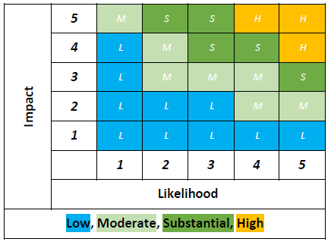 Determination ‘significance’ of risk; P: likelihood; I: impact

- Baseline information and Mini-grid model business cases

  - Background information on energy and electrification in Zambia

Country context

Zambia has an estimated population of approximately 19.3 million people (in 2022), the majority of whom (54.7%) live in rural areas. The average household size is 5.0 people per household. Zambia has a relatively low population density when compared with other East African countries, 26 people per square kilometre. The population has been growing at a steady rate of around 3% annually and the population is expected to grow to more than 24.3 million people in 2030.

Zambia’s economy is strongly dependent on its most important sector – copper mining – which alone accounts for around 70% of export revenue and contributes approximately 10% of GDP, with the bulk of the remainder coming from non-mining industries and the services sector. Zambia’s GDP in 2020 was USD 18.1 billion (current USD; down from USD 26.3 billion in 2018) . Zambia has experienced rapid economic growth with GDP growth increasing from 3.8% in 2000 to 10.2% in 2011 but has shown a downward trend to about 3.5-4% in 2016-2018 and reaching negative figures in 2020. These trends reflect the economy’s limited diversification and vulnerability to national outside pressures, such as falling copper and rising fuel prices, as well as changes in agricultural and hydroelectricity output (affected by recurrent drought phenomena). As growth has slowed down in recent years, and public debt has risen, this has resulted in borrowings increasing to such an extent that the country has been classified to be at a high risk of debt distress .
Box 30 GDP per capita, Zambia (current USD)

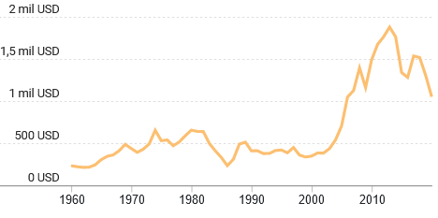
https://datacommons.org
Population health is also vulnerable: malaria is prevalent in certain areas, and increased flooding and drought cycles (because of erratic rain) can cause health and sanitation problems, in addition to malnutrition issues from lower agricultural yields. The global coronavirus pandemic (COVID-19) has been far more than a health crisis, affecting societies and economies at their core. The policy measures to limit the spread of the disease have resulted in substantial economic impacts, with a significant contraction in the global economy in 2020. These impacts are likely to have increased the level of energy poverty in Zambia. With the international poverty line of USD 1.90 per person per day, the poverty rate is around 59%; income inequality is expressed by the Gini coefficient of 49.5% (2016).

Power sector

The Ministry of Energy is the overarching regulating authority responsible for the energy sector in Zambia. Zambia Electricity Supply Corporation (ZESCO) is the state-owned vertically integrated utility company, established in 1970, that operates the national grid, and is responsible for the generation of much of the electricity supply in Zambia. The country officially regulated and liberalised the power sector so that it is open for generation by IPPs. There are a few Independent Power Producers (IPPs) that feed electricity into the grid (with ZESCO as the sole off-taker). However, ZESCO is responsible for the generation of much of the electricity supplied in Zambia (owning about 83% of installed capacity).

Zambia’s installed capacity stood at about 3,011 megawatts (MW) in 2020. About 11% comes from coal, 7% from diesel/fuel oil, 3% from solar and 80% is based on large hydropower (which is increasingly vulnerable to climate change). Zambia has struggled since mid-2015 to meet increasing electricity demand, attributed to heavy reliance on hydropower with droughts during 2015 and 2016. During the power shortage in 2015-16, power was imported through the Southern African Power Pool (SAPP) and by investing in coal-fired plants. Zambia has several future hydropower generation projects planned as well as several initiatives to improve transmission and distribution which will require significant investment. Zambia’s economic activity is concentrated in the corridor running from Lusaka to the Copperbelt and this reflects the power transmission and distribution infrastructure. Electricity consumption was 12.53 TWh in 2019 and 11.48 in 2020, with the mining sector consuming about half, almost twice that of the residential sector.

Zambia has introduced policies to incentivize a willing-buyer/willing-seller model for power purchase agreements (PPA) through Zambia’s Renewable-Energy Feed-in-Tariff (REFiT) strategy, helped by programmes such as Global Energy Transfer Feed-in-Tariff (GET-FiT) programme and IFC’s Scaling Solar that aim to bring 200 MW of smaller-scale and 600 MW of large-scale solar PV plants, respectively. The first utility-scale projects have been constructed. However, the financially distressed electricity parastatal ZESCO is currently the main off-taker of large PPAs, which is limiting large-scale development in the short term.

Prior to 2008, Zambia enjoyed the lowest electricity tariff in Southern Africa, with an average tariff of USD 0.027 per kWh (IRENA, 2013). The heavily subsidised tariffs led to challenging commercial environments for both private developers and ZESCO, resulting in very little investment in power infrastructure and new generation capacity. Also, the low tariffs have discouraged minigrid development, as the low ZESCO retail tariffs provided customers with the expectation of electricity services at a price that is often untenable on a per kWh basis with cost-reflectivity. The country has started to migrate towards cost-reflective tariffs that are in line with the objective of the Southern African Development Community (SADC). Tariffs were increased in 2017 and again in 2020 with the aim being to have more cost-reflective electricity tariffs. The average tariff in June 2020 was about USD 0.074/kWh.

Climate

According to the latest official reporting, Zambia’s GHGs emission level was 127,786 MtCO₂ (million metric ton CO2 equivalent) emissions from ‘agriculture, forestry and land-use change (AFOLU) and, without AFOLU, 8,871 MtCO₂. Energy production and use was responsible for 6,444 MtCO₂ (and industry and waste, 2,427 MtCO₂). AFOLU removals were -136,267 MtCO₂ implying that Zambia was a net sink in 2016, i.e., had negative net emissions (of 9,508 MtCO₂. It is worthwhile noting that the sink reduced by 83% in comparison with the 1994 figure of -56,866 MtCO₂, basically due to a steady increase over time in emission from AFOLU (86,063 MtCO₂ in 1994), energy-related emissions (2,178 MtCO₂ in 1994, industry and waste, 613 MtCO₂), while AFOLU removals have more or less remained at the same level (-142,929 MtCO₂) in 1994.

Significant amounts of emissions from AFOLU sector (responsible for 93% of emissions in 2016), in particular wood removals (contributing 56% to Zambia’s GHG emission, of which for commercial timber, 28%, and firewood/charcoal (28%) and from forestland conversions into cropland and settlements (25%) and biomass burning 8%. Compared to 1994, the contribution of fuelwood has been increasing relative to commercial wood removal. This reflects the large role of biomass in the overall energy balance of Zambia. Of all the energy consumed in Zambia (337,356 TJ in 2019), 72% (244,830 TJ) came from biomass, mainly used for cooking by charcoal and firewood in the residential sector (206,178 TJ). The high use of fuelwood as household fuel (in particular, the relatively energy-inefficient charcoal production) is considered a major driver of the country’s deforestation. For the period 2000 to 2010, the deforestation rate was recorded as being 0.5%; losing approximately 250,003 ha on an annual basis. For the period 2010 to 2014, the deforestation rate increased to 0.7%; losing approximately 341,067 ha of forest per annum. It has been noted that in recent years that an increase in electricity tariffs and unreliable electricity supply (load shedding) has decreased interest in electric cooking, turning to charcoal in response.

The Zambian energy market, heavily reliant on hydropower, is vulnerable to climate shocks. In 2015 and 2016, a heavy drought forced the country to import energy from neighbouring countries under the emergency power procurement plan. Drought in 2015 has left the country facing a 985 MW power deficit at the peak of its crisis (almost half of its total generating capacity). Erratic climate conditions observed during this period caused the drop in water levels at the Kariba Lake reservoir three meters below levels recorded a year before. This means that the lake was at 12% of its full capacity compared to 50+% under normal circumstances. Erratic rainfalls in 2015 and 2016 had a marked impact on the country’s economy with both agricultural yields down, and the mining industry impacted by electricity shortfalls as the country is largely dependent on hydropower.

Electrification

Access to electricity has increased from 14% (1993) to 42.2% in 2019 for the overall population, of which 37.7% are connected to the main grid and 4.7% off-grid access (mostly solar lanterns, 2.5%, rechargeable batteries 1.4%, solar home and lighting 0.7%). The rural electrification rate has only recently increased from just 5% in 2015 to close to 12% in 2019 (of which 4.1% were grid-connected and 7.8% off-grid). Grid extension is the most economical option for households in large, dense settlements that are close to the existing grid. Grid rollout is driven by the public sector through the Rural Electrification Authority (REA) and the state utility ZESCO. ZESCO has a commercially-driven mandate and concentrates on the delivery of connections to economically-viable areas. ZESCO is responsible for both urban and rural areas but tends to focus on urban connections. Due to the challenges of electrifying rural areas, the Government established the Rural Electrification Authority (REA) as an autonomous agency in 2003.

REA is tasked with developing and implementing a plan to electrify rural areas. The 2009 Rural Electrification Master Plan (REMP) was developed by the REA in 2009 (with JICA support) to advance rural electrification. It served as an important plan by focusing on rural areas with a high concentration of residential settlements and economic (so-called, Rural Growth Centres), with 1,217 RGCs identified and prioritized for electrification by the national grid. All RGCs are expected to have public institutions, markets and business enterprises. About 40% have more than 400 households.
Box 31 Energy access and poverty

The Multi-Tier Framework (MTF) defines access to electricity according to a spectrum that ranges from Tier 0 (no access) to Tier 5 (full access). Nationwide, 40.3% (1.4 million households) of the households are in Tier 1 or above for electricity access, and over half of those are in Tier 5 (Figure 6). Among the 59.7% of Zambian households (2.1 million households) that fall in Tier 0, the large majority has no access to any source of electricity. About 1.9% of households using off-grid solutions and 0.2% of households connected to the grid still fall in Tier 0, because their electricity supply does not satisfy Tier 1 requirements. This is due to the limited capacity or availability of off-grid solutions or to the limited availability of the grid supply. The remaining off-grid households fall in Tier 1 (2.1%) or Tier 2 (0.7%). Grid users are concentrated in Tier 3 or above, with over half of them reaching Tier 5.
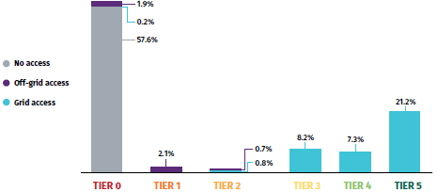

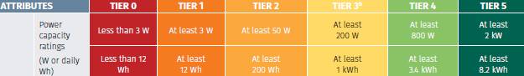

Source: Zambia, Energy Access Diagnostic Report, Multi-Tier Framework (World Bank-ESMAP, 2019)

Several shortcomings were identified in the Rural Electrification Master Plan (REMP), including the strong focus on on-grid connections (90% of all connections), despite it not being the most cost-effective solution (the plan considers 9% through solar and only 1% through minigrids) as well as the lack of a plan for non-RGC areas (60% of the rural population were therefore not considered). A new National Electrification Strategy (NES) in Zambia is currently under development, which addresses the shortcomings of the REMP, supported by geospatial modelling (see Box 32). To achieve universal electricity access in 2030, some 4.9 million new customers (meaning 17.9 million inhabitants) need to be supplied with electricity through grid densification, grid extension, minigrids (solar or hydro) and solar home systems (SHS).

According to the geospatial analysis and modelling, grid densification and extension can connect about 28% of the new customers (implying that 58% of people would be grid-connected in 2030), minigrids can serve about 27% of the new clients, while 45% would be served by stand-alone solutions. However, the national total investments required to reach universal electrification sum up to a whopping USD 2,929 Million, spread across the 2022-2030 investment periods, of which USD 2,344 million for mini-grid electrification (or USD 290 million annually).

Mini-grids

In the latest electrification modelling (see Box 32 and Box 33), the majority of the population served by grid extensions are located in the North and East of the country. Mini-grids are the least-cost technology in the North West and Western part of the country. Grid densification is centred around the major cities that are already connected. Solar home systems will be used by 32 % of the population for 0.7 % of the demand (which is low as the service level is Tier 1-2 only, see Box 31).

Mini-grids will serve 19% of the population with 35.0 % of the demand at Tier 2-to 4 service levels. In the modelling, the predominant technology for mini-grids is solar PV-battery systems due to their higher availability, with hydropower mini-grids appearing on a limited number of sites close to rivers. In principle, mini-grids can be powered by several energy sources:
- Zambia has a moderate to low wind energy potential and the focus of feasibility studies and research has only recently moved to wind power. The majority of wind speeds at 100m above the ground are between 4 to 7m/s. Most of the south-western area of the country, as well as along selected areas on the escarpment in the western part of the country, has wind speeds of between 5 to 7 m/s, which may have electricity generating potential.
- The existing estimates of hydro potential in Zambia stand at about 6,000 MW. The potential for small, mini and micro- hydro potential is an estimated 45-60 MW. However off-grid (mini-grid hydro) plants are hampered by the fact that the water resources (with sufficient height and water flow levels) are often located away from the demand centres in this sparsely populated country. This would necessitate the construction of transmission lines over large distances to the demand centres, rendering the mini-grid uneconomic. Approximately 60 potential small hydro sites ranging from 30 kW to 3 MW have been assessed by REA in North-western, Northern and Luapula provinces, of which 7–8 sites were considered to be potentially viable and sufficiently close to population centres.
- Zambia enjoys an average of 2,000 to 3,000 hours of sunshine per year. The average global horizontal irradiation (GHI) is 5.5 kWh/m2/day. Zambia, therefore, has a solar energy potential that (unlike hydro) does not differ from site to site or region to region. This makes solar an ideal power source for mini-grids and electrification by stand-alone systems, although average daily solar irradiation is not consistent throughout the year, with a noticeable decrease during the rainy season in June and July. This seasonal variation should be taken into account when designing PV systems. The results of the WB-ESMAP-supported solar energy mapping (based on measurements at six sites spread over the country) show significant potential for solar power applications all-over the county and solar MG have recently been the focus of donor-supported programmes (such as EU’s IAREP and World Bank’s ESAP).
- Conversion of biomass to electrical power potential stands at 500 MW (of which 447 MW could be from agro-wastes, 46 MW from forest wastes and 4 MW from municipal waste). Analysis by SNV and Hivos in 2012 shows that sixteen of the country’s 72 districts have biogas potential (livestock manure) for electricity generation.

In Zambia, about nine mini-grids were developed by missionaries, using hydropower. ZESCO operates eight diesel-based minigrids, and has done so for many years. ZESCO has little experience in the development and operation of renewable energy mini-grids, so far running one hydro (a 1 MW facility in Shiwang’andu, in Muchinga Province).

REA developed some mini-grids, including the 640 kW Kasanjiku mini-hydro and the 60 kW solar MG in Mpanta, to which, more recently, a small number of solar MGs have been or will be added (Chunga, Lunga, etc). The first private sector MG was set up in Zengamina in Mwinilunga District, NW Prov, powered by a 705 kW mini-hydro. The number of private sector solar MGs being planned or under development has been growing rapidly (see Box 1 in the main text).

Box 32 Electrification and geospatial modelling

The United States Agency for International Development’s (USAID) Southern Africa Energy Program (SAEP) has developed a geospatial model that determines the least-cost electrification solution for each household in Zambia. Another least-cost geospatial modelling exercise was carried out as input for the new National Electrification Strategy (NEP), supported by World Bank’s ESAP (project (see Box 33 for the electrification map). The WB-ESAP analysis is based on the assumption there will be 25.3 million people in Zambia in 2030, estimating that USD 2.93 billion would be needed spread over 2022-2030 to reach universal electricity access through grid densification and extension, minigrids and stand-alone PV options
The models map the country’s population centres; current grid lines and substations; and localities most suitable for solar, hydro and other renewable power generation, taking into account availability of resources, suitability of technologies in view of the level of rural energy demand in villages and rural income levels, expected cost development of technologies and possible productive uses. The end results are maps showing Zambia’s lowest-cost electrification options (grid extension, mini-grids or solar home systems) for each currently unelectrified household across the country, of which the most recent map (WB ESAP’s) is shown in Box 33. The modelling shows that minigrids (supplying energy at Tier 2-4 level, see Box 31) and off-grid solutions (supplying 1-2 Tier level) can play a significant role in electrification alongside grid connections (with Tier 4-5 level) for a substantial portion of the (rural) population for Zambia to achieve universal access by 2030.
However, the models have widely different outcomes regarding the role of each of the non-grid solutions with the USAID model having the largest role for stand-alone solutions, while the recent WB-Engie geospatial sees a lead role for minigrids. The differences are due to different cost assumptions of minigrid and stand-alone PV technologies and the role of productive uses. Agricultural activity, like irrigation and maize milling, can operate during household demand off-peak times, thereby potentially reducing household connection costs without increasing the capital outlay of the mini-grid that much. The USAID modelling estimates the role in 2030 of minigrids as varying between 1% and 10% of new connections, depending on assumptions on cost and role of productive uses. Even in the most MG-favourable USAID scenario, the minigrid share in 2030 is about 8% of all connections as compared to the 19% estimates in the ESAP-Engie modelling.
Another least-cost geospatial modelling exercise was carried out as input for the new National Electrification Strategy (NEP), supported by World Bank’s ESAP project (see Box 33 for the electrification map). The analysis is based on the assumption there will be 25.3 million people in Zambia in 2030, estimating that USD 2.93 billion would be needed spread over 2022-2030 to reach universal electricity access through:

 | WB-ESAP / Engie model |  |  |  |  |  |  | USAID model
 | Population  in 2030  (million) | Population  (2030)  % | Demand supplied**  (GWh/yr) | Category  demand | Number of localities | Cost  (million USD) | Cost per customer  (USD) | Connection  Share (%) | Cost  (million USD)
Already electrified* | 7,497 | 30 | 2,109 | Tier 4-5 |  |  |  | 34***
Grid densification | 4,699 | 19 | 1,157 | Tier 4-5 | 596 | 329 | 357 | 13 | 500
Grid extension | 232 | 1 | 123 | Tier 4-5 | 39 | 52 | 854 | 13
Minigrid | 4,829 | 19 | 1,851 | Tier 2-4 | 2,390 | 2344 | 2,422 | 8**** | 200
SHS | 7,999 | 32 | 35 | Tier 1 | 1,696 | 205 | 121*** | 48 | 3,300
TOTAL | 25,256 | 100 | 5,275 |  | 4,721 | 2,930 |  | 100 | 4,000
* Already electrified in 2019 at access rate of 42% (population, 17.86 million)
** The demand is less than potential demand (7,256 GWh/yr) by households (6,592 GWh/yr) and agricultural PUE (933 GWh/yr) due to supply limitations in distributed supply options, such as SHS.
*** Average cost of a solar home system. For a cost explanation of the minigrid, see references below
**** 18% on top of the 16% electrification in 2017
***** Incorporating such productive use in the least-cost mix and assuming favourable minigrid cost development brings the mini-grid share connections to about 8%,

Source:
- Geospatial model for Zambia (April 2018, PowerAfrica/USAID). See also: USAID (2018), Zambia’s Power Sector Assessment; Solar Home System Expansion Program: Session 1, Presentation and discussion document (Feb 2018);
- Preparation of a Least-Cost Geospatial Electrification Plan for Grid and Off-Grid Rollout in Zambia, World Bank by Engie-Impact (2022)
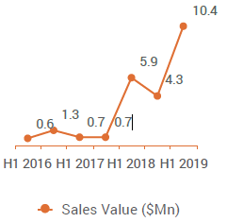
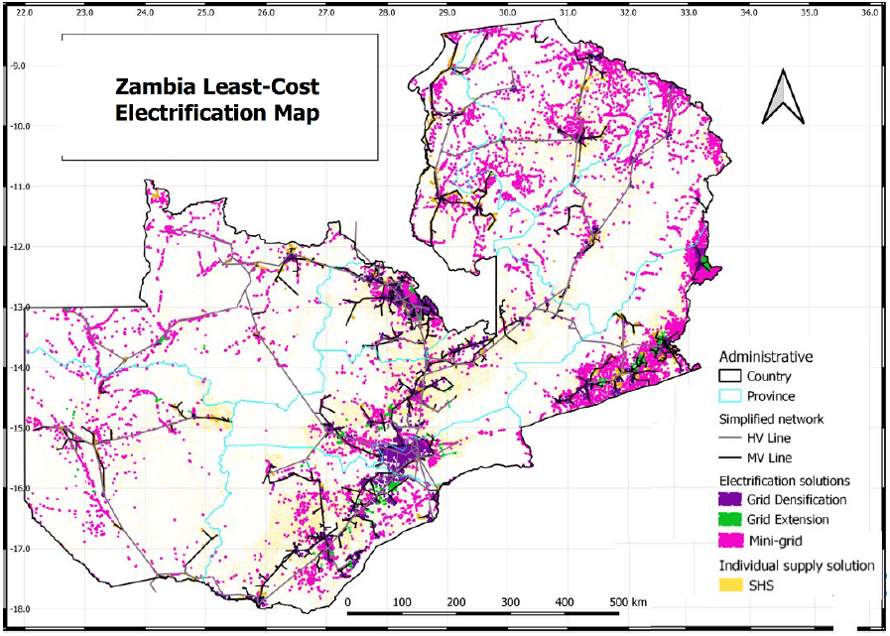
Box 33 Electrification solutions map
Source: Least-Cost Geospatial Electrification Plan for Grid and Off-Grid Rollout in Zambia, World Bank by Engie-Impact (2022)

  - Minigrids baseline situation and barrier analysis

A) Policy-regulatory environment for minigrids

Baseline situation

The recent surge in mini-grid (MG) development has been helped by advances in MG-specific regulatory framework, focusing on licensing, economic and technical requirements. The framework was developed by the Electricity Regulation Board (ERB) and the EU-financed IAREP project, in consultation with various private and public sector stakeholders, in 2018. After the road-testing of the mini-grid regulations in 2019, the ERB finalized and approved the mini-grid regulatory framework in February 2020, which covers the four areas of legal, tariffs, grid encroachment and technical (see Box 35).

The new framework allows differentiating regarding permits, technical requirements and tariff-setting between MGs based on size and complexity: a) MGs with size < 100 kW have ‘very light-handed’ regulation, b) and MGs sized between 100 kW-1 MW will have ‘light-handed’ regulations. Mini-grids of all sizes and technologies require a license to be approved by the ERB. All mini-grid licenses are issued as combined generation, distribution and sales licenses, with the option to also only apply for a separate license. MGs that were already existing before ERB’s MG regulations were introduced can continue without change in their licensing conditions or approved tariff system. Together with ZABS (Zambia Bureau of Standards), work has been carried out on technical standards for mini-grids.

Environmental impact studies are mandatory most of the time but can be simplified for small-scale projects with, for example, an Environmental Project Brief (EPB) which essentially is a simplified EIA. Both EIAs and EPBs require the approval of the Zambia Environmental Management Agency (ZEMA). For solar PV plants, storage batteries are regarded as hazardous wastes so solar power producers using battery storage are required to apply for a Hazardous Waste Licence in line with S.19(1) of the Regulations. This is a post-operational license that needs to be applied for after the plant becomes operational. The license is valid for three years. Application for renewal of a licence is to be made six months before expiry. Water use authorisations for hydropower plants are managed by Zambia’s Water Resources Management Authority (WARMA). Fees and charges for hydropower projects are based on the amount of electricity generated and/or amount of water used. Hydropower projects under 500 kW exporting are exempt from the water permit requirement and all the prescribed fees.
Box 34 Licensing process for minigrids

Business registration | Companies in Zambia are required to be registered with the Patents and Companies Registration Agency. There are no local ownership requirements f
Securing land | Securing land is an important step of the project development process. There are two categories of land in Zambia: a) Customary land, comprising about 94% of land in Zambia, is held under customary tenure and falls under the jurisdiction of Zambia’s traditional authorities, the Chiefs; and b) Statutory (or state) land, comprising around 6% of land, is governed and administered by a number of statutory
Clearance from The Department of National Parks & Wildlife | If a proposed development site is located within a Game Management Area (GMA) or a National Park, the developer must submit an application to the Director of DNPW requesting clearance.
Concession from National Heritage Conservation Commission | If the project site is within a protected cultural heritage area, the developer must apply for a concession from the NHCC. All waterfalls in Zambia are designated as heritage areas.
Environmental permitting | A developer (i.e., the entity that is proposing and will be developing the project) cannot implement a project until the Zambia Environmental Management Agency (ZEMA) has granted a no objection letter with conditions for the project.
Water use permit | For hydropower projects, including mini-hydro projects, the developer must acquire a water use permit issued by the Water Resources Management Authority (WARMA).
Investment endorsement | While obtaining an investment endorsement is optional, its procurement is likely to guarantee a developer the appropriate licence to commence project operations and secure a tariff, as advised by the ERB. Public-private partnerships also need approval from MoE’s Office of
Issuing of the Licence by ERB | Before commencing operations of a mini-grid, the developer must apply for a Combined Licence for Generation, Transmission, Distribution and Supply of Electricity from ERB. The developer can only request the licence after completing the off-grid construction

Land use authorisations for MGs can be obtained through receiving a long-term lease from the Lands Commission. If the land in issue is under customary tenure, the Chief in the area would have to be approached for a right of use by the MG developer. Agreements with the local communities (local Chief) in accordance may be required to install the distribution network. The developer will be required to enter into an agreement (memorandum of understanding) with the community prior to submitting a full application with respect to agreed tariffs/end-user price between the developer and the community. This Village Level Agreement will form the basis for a tariff application with ERB as ERB allows for a different tariff regime for mini-grids based on cost recovery and backed by ability and acceptance of the community to pay.

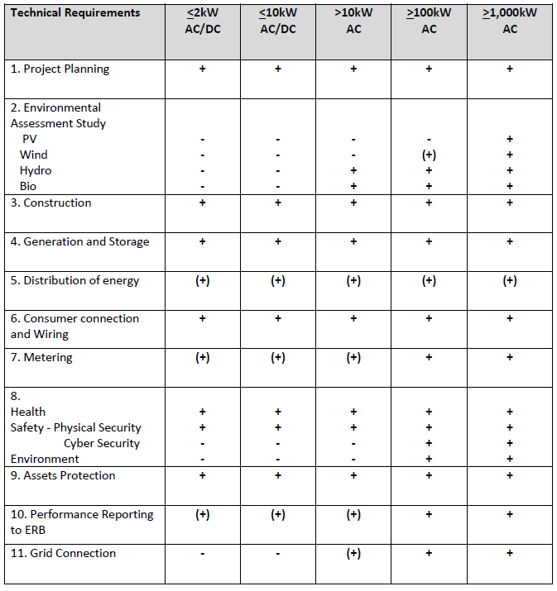
Box 35 Overview of mini-grid regulatory framework, Zambia

Topic | ≤ 100 kW  Very light handed | 100-1000 kW  Light handed regulated | ≥ 1000 kW  Fully regulated
Legal-licensing | - Fixed term, predetermined geographical area  - Developer chooses tariff/usage charge design, ERB may intervene if tariffs too high | - Fixed term, predetermined geographical area  - Pre-approved tariffs –developer provide 5-year tariff levels and escalation rates  - ERB uses an in-house modelling tool to check the alignment of the tariff request | - Fixed term, predetermined geographical area  - Normal tariff approval and review process -tariffs regulated in 5-year regulatory periods; tariffs adjusted every year
Tariff | - Mini-Grid free to apply tariffs after submission of data and data is deemed by ERB to be compliant with the requirements under the tariff rules.  - ERB may intervene if tariffs are excessive.  - Developer must show to ERB tariffs adjusted to reflect subsidy  - Developer chooses tariff/usage charge design | - Up-front tariff approval  - Developers are asked to provide 5-year tariff levels and escalation rates  - ERB uses an in-house modelling tool to check the reasonableness of tariff request  - Tariffs stay fixed in real terms for 5 years, subject to a change which breached “materiality threshold”  - ERB may trigger a detailed tariff review for unreasonable Category II Mini-Grids tariffs. Developer chooses tariff/usage charge design | - Tariffs regulated in 5-year regulatory periods during Periodic Reviews.  - Tariffs adjusted every year for cost true-up and indexation  - Allowed costs calculated according to the building-block approach  - Interim ERB approves “regulatory parameters” at beginning of each period  - Review can be triggered depending on a “materiality threshold”  - Developer chooses tariff/usage charge design

Technical requirements depend on installed generation capacity

In case of future main grid encroachment, the MG Regulations allow following:

a. Main Grid (ZESCO, other) acquires only the client base and builds a complete new Distribution Network. Minigrid operator (MGO) abandons all assets of the Mini-grid and removes from the area.
b. Main Grid acquires the client base and the distribution network of the mini-grid. MGO disconnects and abandons all generation and storage assets of the mini-grid and removes from the area.
c. Main Grid acquires the client base and the complete distribution network, generation and storage assets of the mini-grid.
d. MGO becomes a Small Power Distributor for the Main Grid. MGO discontinues operation of his generation and storage assets and resells only energy from the Main Grid as a retailer. The customer base remains with the MGO.
e. MGO becomes a small power producer or integrated/embedded power producer. MGO sells all is generated energy to the Main Grid. Main Grid acquires the client base and the distribution network of the Mini-grid from MGO.
f. MGO and Main grid conclude contract for Net-metering. In case of excess energy from the Mini-grid, MGO has the right to sell the excess energy to the Main Grid. In case of energy deficit, the Main Grid delivers the requested energy to MG
Source: Electricity Regulation Board; GETInvest (2019)

Some tax, import duty and other non-fiscal incentives have been created to attract investments in renewable energy technologies. For example, a tax waiver was introduced for all imported goods for the purpose of supply, installation and maintenance of solar systems, regardless of investment size.

However, the discussion has been ongoing about what parts of renewable energy should be exempt and what not. Investors that invest more than USD 500,000 in a priority sector (which includes the energy sector) can also receive tax and import duty incentives. There are a number of incentives which are available for smaller projects.

Remaining barriers

- The existence of clear strategies and budgeted policies on the role of minigrids vis-à-vis grid extension and stand-alone options for rural electrification in Zambia is limited
As previously mentioned, the REMP requires revision. World Bank-supported geospatial modelling provides an indication where off-grid solutions (through mini-grid and stand-alone solar PV systems) will be the least-cost option for most rural areas, given the low population density and high grid extension cost. While geospatial planning forms a basis, at this point, the National Electrification Strategy is still a work in progress. Zambia does not have an approved electrification plan budget allocation between ZESCO and REA and how to involve the private sector in the huge amounts of investments needed for electrification (see Box 32). This means that it is necessary to conduct field research on the ground and consult closely with MoE, ZESCO, REA and ERB to identify and collate site-specific opportunities.

While ERB licensing for MGs has been streamlined, permits also depend on regulatory approval from other agencies (that may not have special procedures for small generating projects. An agency such as ERB or MoE’s Promoting Private Power Investment (OPPPI) may be assigned as ‘one-stop-shop’ entity to coordinate better the various procedures and avoid lengthy licensing processes.

The approval of the mini-grid regulatory framework coincided with the adoption by the Government of the Electricity Act and Energy Regulation Act (drafted in 2019) in 2020. The new legislation impacts the mini-grid licensing processes, and introduces other changes, especially concerning feasibility studies, tariffs, construction, monitoring and enforcement. Thus, the MG framework will need to be aligned with the new laws, for example, regarding net-metering. Unfortunately, aspects of the new ‘light-handed’ regulations for minigrids seem to contradict stipulations in the updated Acts on equal treatment of licence applicants, whether large or small in size.

B) Business models and private sector involvement

Baseline situation

The mini-grid landscape in Zambia is nascent but rapidly evolving. A range of delivery models for minigrid electricity exists (see Box 2). Several models have been deployed thus far in Zambia, including utility, private sector, community, and hybrid (public-private) models, which are summarised in Box 1. Until recently mini-grids were implemented by public sector agencies.

ZESCO operated seven isolated diesel-based mini-grids (of which only two remain in operation) and one MG based on mini-hydropower. REA put the first solar MG in operation in Mpanta in 2013 near Bangweulu Lake (with UNIDO/GEF funding). Recently, a minigrid using hydropower was commissioned by REA in Kasanjiku in North-Western Province. As REA can formally not own generation installation, the assets have been transferred to a community-based cooperative. In addition, some missions have operated mini-hydro facilities to power their buildings and surrounding community.

The team behind the Zengamina project, Zambia’s first private minigrid, has set up Hydro Electric Power (HEP) Limited to develop the independent hydro-powered minigrid business and is virtually the only private hydropower mini-grid developer up to date. Over the past years, several solar mini-grids are in operation, in construction or planned, either developed by the private sector or in some form of public-private partnership, supported by the European Union, Beyond the Grid for Africa, or others. Several private players have entered the MG market.

Muhanya Solar has implemented one 30 kW solar MG in Sinda (Eastern Prov.). Supported by the Beyond the Grid Fund for Zambia, EU’s IAREP programme and other sources of funding, Standard Microgrid is planning to install up to 150 microgrids and has set up a 28 kW solar MG in Chitandika. Eastern Prov), while Engie PowerCorner is planning to set up 60 minigrids with Eu-IAREP support. Other entrants in the market include Entiba Energy (planning two 50 kW minigrids in Chitungulu with 250 kWh battery storage, Eastern Prov., providing power to some 150 new users), the Egyptian-based Solera, and ID Solar Solutions.

The first MG, installed by public entities or missions, did not have a commercial focus. However, with the participation of private companies, recent developments have seen service levels on a commercial basis. While some developers focus on low-demand customers (such as Standard MG), others have developed business models that focus on productive uses and small enterprises (such as Solera) or try to build a microgrid starting from anchor loads, such as schools and clinics or a productive use (e.g., Engie PowerCorner). The private developers often use standardised equipment (e.g., Standard MG, 15 kW units; Solera’s 25 kW SunSquare) that is pre-assembled and fits in a container for easy transport and can thus be deployed quickly. Most of them also include smart metering and cloud-based supply, as well as demand-side management and a payment platform, which helps them to reduce their operational cost.
Box 36 Stand-alone solar market
The share of households (HHs) using solar home system are (SHS) or solar lighting system (SLS) is fairly small, about 1% of rural households. The use of solar solutions is a relatively recent phenomenon in Zambia. About 91% of the households in the country obtained their first solar device just within the past five years, according to the recent WB Multi-Tier energy access study. The cost of purchase of a low capacity off-grid solution is lower than the grid connection fee. Thus, providing off-grid access through solar devices of at least 3 watts (or 12 watt-hours) can move Tier 0 households to higher tiers (most likely Tier 1 or 2) for access to electricity. Recent years have seen a proliferation of solar portable lighting products that give energy access to 4.3% of rural households. Although strictly speaking, the solar lanterns (<3 W with a single lantern, costing about USD 9-40) do not meet the Tier 1 criterion (see Box 31.) it is an important means for Tier 0 households (no access) to get some lighting services.
Sales growth of stand-alone solar products

Alongside, a pico-SHS sector (< 10-30 W with LED light, radio, phone charging, costing about USD 70-200) is emerging as alternative between solar lanterns and more expensive larger solar home system (30-200 W or larger, costing about USD 300-500). Most common distribution models involve distribution through conventional dealer networks (distributor, retailer). The dealership model is often used for extending end-user financing (by providing credit to dealers and/or franchises to allow them to sell to clients on an instalment basis). This model is applied by companies (such as Azuri, Vitalite, Fenix/Engie). Another model is ‘one-stop-shop’ in which companies provide products move through a proprietary distribution channel, in which finance can be offered by the company manufacturer (e.g. Greenlight, SunTech, in Zambia). Other models include institutional partnership (in which a company teams up with a NGO or rural bank to market its products to its customer base/members)

Systems are usually bought by cash (82% in 2018) but PAYGO schemes are on the increase, in particular for larger systems, such as SHS. PAYGO is a financing platform for off-grid energy systems with high up-front capital costs. An IT system underlies the platform, allowing automated payments and system monitoring/activation. According to the WB multi-tier energy access survey, only about 9% of respondents were willing to pay upfront for SHS. However, willingness to pay (WTP) could be boosted through PAYGO models with installment periods of 6 to 12 months to 15-21% level. The WB ESAP project is USD 2 million credit line loan facility for off-grid solutions aiming at companies importing/ selling solar equipment and developers of minigrids, and also, to set up PAYGO or similar financial mechanisms to boost affordability among end-users of solar equipment.

These companies could affordable and flexible products in the Tier 2 to 3 range and become competitors with minigrid developers in in the market MGs are aiming at. However, solar companies and MG developers may want to team up. In some cases (e.g., Engie, PowerGen, Azuri, GreenLIght) they can provide both services. One model is that the minigrid administration office also serves as ‘solar kiosk’ that sell or rent out solar products or charging services or ‘business hub’ offering support (technical, marketing, finance) on productive use to small businesses. In this way, the facility can reach out to households to offer lower Tier energy services according to their ability/willingness to pay or to serve remote households in the service area that are too far to be physically connected to the MG’s distribution network

Source: Mapping the Solar Market, Zambia (Intellicap, Signify Foundation; 2019); GETInvest (2019)

Barriers to more commercial MG development

- Most rural areas in Zambia have low population densities with low energy demand and servicing these customers may not be financially viable
Most rural areas in Zambia have low population densities and servicing these customers may not be financially viable. Building up a customer base to increase the load factor and revenue stream is challenging in areas of low population density where economies of scale are lacking. Areas with low population densities also have high distribution costs, which further increases the costs to develop off-grid systems. At the usual ‘social’ tariff levels applied in Zambian MGs, both publicly and privately owned mini-grid operators (see the examples of Zengamina and Mpanta, mentioned in Box 1) report problems with payments by their customers and fee collection, combined with the lower-than-expected connection rate in the first years of operation. This puts severe limits on the revenue stream, leading to cash-flow problems and endangering their financial viability. The demand for energy services is related to the level of income and its influence on financial sustainability is often underestimated. Most of the mini-grid schemes have low load factors (20% to 50%), even after several years of operation, and only a percentage of the total households in the distribution area are connected. To achieve a sufficient load factor and to increase revenue streams, anchor loads such as telecom towers, agro-processing or other types of productive uses need to be included in the customer base.

- Off-grid tariffs in Zambia are subjected to much social pressure, and willingness and ability to pay (WTP/ATP) are far lower than cost-reflective rates
The current MG regulatory framework allows tariffs to be set on a case-by-case basis, reflecting the costs of investment and operation of the facility. In reality, setting tariffs at a financially sustainable price is quite difficult. Willingness or the ability (WTP/ATP) of customers to pay is a large factor that determines what the upper limit of an off-grid system tariff can be. Poverty and low disposable income of households in rural areas create a challenging environment to justify cost-reflective and financially viable tariffs.

According to the 2015 Living Conditions Monitoring Survey, the average monthly income for households is about USD 75 in rural areas and USD 290 in urban. The average expenditure in rural areas was USD 70 a month (of which USD 40 on food items). Using a benchmark of 10% of income for estimated ability to pay (ATP) for electricity, rural households might be expected to afford USD 8-10/month.

Another way of determining ATP is to look at what non-electrified households spend on energy. The IAREP feasibility study mentions figures of USD 4-7 per month, while another report mentions USD 8.5 per month. It should be noted that rural incomes can be highly seasonal; some agricultural households may face a lean period at the end of the “warm and wet” season (Nov-Apr), with tightened cash flows, which could affect the ability to pay (ATP) for electricity bills or upfront connection fees.

A World Bank study found a willingness to pay (WTP) by households of USD 4.6 a month for solar home systems and USD 8.4 for mini-grid service, while commercial users are willing to pay USD 30 a month. Surveys undertaken as part of the before-mentioned IAREP feasibility study give WTP levels in the order of USD 1.3-3.3 up to USD 10 per month. It should be noted that WTP statements by respondents in such surveys may be influenced by their knowledge of actual monthly expenditures in neighbouring electrified areas and reflect the subsidized ZESCO tariffs, about USD 4.8 a month (residential) and USD 18.6 (businesses) rather than their ability to pay (ATP).

The real cost of operation of minigrids is much higher. For example, the cost-reflective tariffs (based on levelized cost of energy, LCOE) for the Sinda, Lunga, Chunga and Chishi solar MGs is in the range of USD 0.98-1.65 per kWh). Such tariffs would imply monthly expenditures of USD 13-19 for low-income households, USD 40-46 for medium-income and USD 80-150 for higher-income households, clearly above ATP/WTP levels. In the case of Sinda solar MG, the tariff settled on a monthly fee of about USD 18.6-22 per month, translating into about (based on average consumption data) USD 0.23/kWh. The IAREP feasibility studies show that (with 75% capital subsidy and 15% return on investment), tariffs would be about USD 0.33-0.50 per kWh, which works out in monthly expenditures of USD 4.4-6.6 for low-income households, USD 13.7-15.8 for middle-income and USD 27.2-USD 51.4 for higher-income households. These findings are in line with World Bank estimates that a CAPEX subsidy of 75% on a typical mini-grid would allow for affordable tariffs while delivering a 15% return on investment. Revenues from electricity sales, even if increased by PUE, will in many cases hardly be enough for private minigrid companies to survive.

C) Financing and financing modalities
Box 37 REF budget inflows

(in USD) | REF – total inflow | Government | Donors, partners
2017 | 11,440,990 | 11,440,990 | -
2018 | 13,416,793 | 9,963,448 | 3,453,345
2019 | 8,509,043 | 7,307,232 | 1,201,810
Converted from ZMW to USD using the exchange rates of 10.01 (2017), 11.94 (2018) and 14.09 (2019). Data compiled from REA Annual Reports (2017, 2018, 2019).

Baseline situation

Funding for the REF has been poor. Since the establishment of REA, inadequate financing of the REF has limited the growth of REA’s operational capabilities, which in turn hampers rural access efforts. In general, the 3% levy for rural electrification collected on all retail electricity bills is not remitted in full to the REF. Even, if the electricity levy collections would be fully remitted, the amount would still fall short of the annual requirements of grid extension and densification in line with the universal energy access 2030 target. Due to the magnitude of resources required, all sources of funding should therefore be mobilized and aligned along the GRZ priorities, including from the private sector.

The financial sector in Zambia continues to experience high-interest rates and a severe shortage of liquidity. According to the World Economic Forum’s Global Competitiveness Report 2015–2016, companies in Zambia consider access to financing the main constraint to growth. Loans to small and medium and off-grid energy companies are constrained by an insistence of the commercial banks on physical collateral (sometimes representing over 100% of the value of the loan), high interest rates (usually over 30% or higher), underdeveloped procedures related to credit risk quantification and asset-liability management, nascent credit information systems, and the dominance of short-term capital. In addition to commercial financing, privately developed mini-grids require public co-funding to cover the viability gap (the difference between the cost of providing a connection and what consumers are willing/able to pay for it). Crowding in both the domestic and international private sectors to expand access will require the GRZ to improve the enabling environment, including increasing access to commercial and concessional finance, developing financial mechanisms to provide public co-funding, resolving various regulatory hurdles, and building up the existing capacity of sector institutions

Barriers

- Mini-grid initiatives are financed on a project-by-project basis, rather than as part of a long-term vision part of an off-grid electrification plan and without public or private funds to match
- Commercial financing for MGs is non-existent. Market technology and business models of minigrid companies are rather unknown to local commercial banks. Individual MG investments are often too small and considered high risk

The current tariffs applied in MGs are based on the willingness or ability to pay (WTP/ATP) but prevent reaching financial self-sustainability. Thus, to avoid that mini-grid electricity tariffs would have to be at rates that are intrinsically much higher than WTP/ATP-based tariffs, grant funding (from the government, cooperation partners or charities) remains to be a key enabler to finance the first mini-grids (as long as developers are bound by socially acceptable tariffs). The downside of this is that minigrids tend to be financed on a project-by-project basis, rather than as part of a long-term vision part of an off-grid electrification plan and with funds to match. Once the grants and other financial support ends of the multilateral or bilateral funding agency ends, the programme stops and new MG projects cease to be developed as these are not viable without some grant contribution.

Solar companies and mini-grid developers have expressed a strong need for debt financing in both U.S. dollar and Zambian
kwacha, including working capital lines and long-term finance for mini-grids. The opportunity for domestic financing of private mini-grids is limited. The market, technology, and business models of minigrid companies are rather unknown to local commercial banks. This contributes to perceptions of high risk and banks prefer more conventional investment opportunities that have a higher return and lower risk profiles than MG. In addition, interest rates for loans in local currency are high, averaging 25.4% over the period 2006-2021, and significant collateral may be required. Bank loans also typically have short tenures but financing for mini-grid projects might require a 10-year credit line. Furthermore, if a mini-grid is to be built on land ruled by customary land (often the case in rural villages), a local bank cannot consider land as collateral in the financial eligibility assessment.

The Development Bank of Zambia (DBZ) offers slightly better options. DBZ has a private-sector project finance facility that allows for loans up to 10 years in ZMW or foreign currency. A two-year grace period may be available. The minimum loan size is USD 200,000 or its equivalent in ZMW. As part of the World Bank ESAP, a USD 2.5 million fund for the off-grid sector developers and companies will be made available via DBZ to commercial banks as part of the ESAP project.

- Public support to cover the viability gap in off-grid projects has been limited and does not reach the amounts needed to reach the 2030 universal access targets

The Government of the Republic of Zambia (GRZ) established the Rural Electrification Fund (REF) in 1994 when it committed a 3% excise levy on electricity bills to the fund through an administrative arrangement. One goal in the Rural Electrification Act No. 20 of 2003, was for the new REA to oversee and manage the Fund. In practice, Other REF resources are appropriations by the Parliament and donors’ contributions. In practice, the estimated USD 50 million per year funding requirement calculated by REA has not been achieved to date, and the levy from ZESCO is not (always) remitted, limiting REA’s operations.

The REF is one of three sources of funds for REA to implement the rural electrification programme in Zambia, the others being budget allocations from the Ministry of Finance, and loans and donations. To date, most of the funding has been for medium voltage transmission expansion and distribution systems connected to the ZESCO. Capital funding by REA for off-grid projects has been limited to about USD 3 million annually, based on data provided in its annual reports. This is only a fraction of what would be needed annually during 2022-2030 for mini-grid investments and for electrification investments in general (USD 325 million annually; see Box 32).

The REF is in theory also able to support private sector rural electrification projects including mini-grids through ‘smart capital subsidies’. REA can provide up to 100% grant financing for renewable energy projects. However, in the case of private sector participation, the private sector needs to contribute a minimum level of equal to 20% of the project costs and then, theoretically, REA can contribute to the project’s funding (with remaining funds to be secured by the developer, at a minimum internal rate of return of 10% before subsidies) up to a maximum of 50%. However, REF has been barely functional in practice for off-grid development. Information on how to access the Fund is not easily available and little is known by developers in Zambia. So far, only one private mini-grid project, the Zengamina 750 kW hydro mini-grid, has successfully obtained support from REF.

D) Digitalisation and knowledge management

Baseline – mobile network

Zambia has mobile network coverage across populated areas and all service providers run mobile payment services. There are four mobile service providers: Airtel, MTN, Vodafone (data only) and Zamtel. Coverage and access to mobile services are present in all 10 provinces including most of the districts. National geographical network coverage is 78% of the country and network coverage by population is 86% (ZICTA, 2021). All service providers are currently running mobile payment services on all their networks. Coverage aligns to densely populated areas such as urban areas, main road networks and selected rural areas. About 57% of adults own a mobile (21% in rural areas, while 65% have access to mobile services (48% in rural areas. The number of mobile internet users in the country is estimated at 10.4 million in 2021, representing approximately 56% of the population. Most people who are digital literate are urban dwellers aged 40 and below, who have regular access to the internet. This means that people in rural settings or who do not have internet access most likely have inadequate digital literacy skills. About 70% of adults (9.5 million in 2020) have access to formal financial services, which is higher in urban areas (84%), where 53% of adults live, than in rural areas (56%), not surprisingly highest among middle- and higher income groups (80-84%). In 2020, the existing base of users of digital finance services was approximately 16.6 million registered accounts, of which 6.5 million were considered active. This means a substantial increase in comparison with 2016 (7 million registered accounts of which 1.3 million are active). The number of active agents increased from 12,400 in 2016 to 90,166 in 2019, indicating rapid growth in the agent distribution work.
Box 38 Mobile geographical coverage

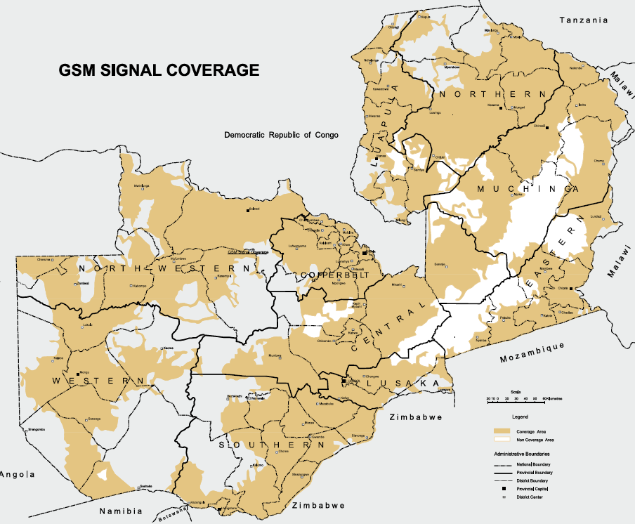
Source: Zambia Information and Communications Technology Authority (2015)

Mobile money usage in Zambia remains limited. There are several money transfer services and mobile money providers, including Airtel, MTN, Zoona, Kazang, Shoprite and Zanaco. According to the Helix Institute of Digital Finance, Zambia could become a mobile money market, whereby agents support customers to make transactions due to an apparent consumer preference for working with agents

Baseline – Minigrids and digital services

Most private developers apply digital technology in their minigrids. Engie PowerCorner applies smart metering and the cloud-based payment platform greatly limits operation and management costs, such as logistics and fault resolution. All customers have access to electricity by topping up their pay-as-you-go (PAYGO) meter. Solera supports mobile money payments to pay for Services, through integration with telecom operators. Customers have on-demand prepaid plans. Customers can use an app to manage their profile, inquire about service usage and pay for service through the app. The company’s software manages customer profiles and site profiles with real-time and historic reports to monitor and control the customer’s usage. The hardware is controlled and monitored remotely which facilitates maintenance. Similarly, Standard MG’s cloud-based grid management software enables the technical support team to monitor the performance of many grids from one location and remotely troubleshoot issues that exceed the capacity of local management.

Remaining barriers

- Government stakeholders often lack specific knowledge or face budgetary and technical capacity constraints to fully utilise the potential of digital solutions (e.g., real-time data gathering, common data reporting protocols streamline licensing, monitor quality of service) to broadly improve sector oversight and planning. Different MG developers use different software and data reporting protocols making standardization difficult. In general, the government needs to broadly improve sector oversight to carry out systematic monitoring and evaluation of electrification activities, feeding back into their planning and decision-making.

Government stakeholders could leverage digital solutions for energy sector planning, to streamline licensing, monitor quality of service and broadly improve sector oversight. However, data of sufficient quality is not always available for these purposes, and government stakeholders often lack the necessary technical capacity. And while data could be a tremendously valuable asset in the minigrid sector, this potential remains largely underutilized due to the lack of standardization and common data reporting protocols and the fact that this sector is still very nascent and remains relatively fragmented.

  - Minigrid model business cases

The Model Business Cases Annex analyses the feasibility of renewable energy minigrid facilities plant supplying a hypothetical community in rural Zambia where national grid extension is not foreseen. The analysis considers the potential sale of electricity to five customer types: households (low, medium, high-income), small businesses (shops, barber shops, bars & restaurants), social services (school, clinic, community centre, worship), and utilities (street lighting and the mini-grid's powerhouse). It is assumed that a private developer will invest in the project and be responsible for the implementation of both the plant and the distribution grid, and for the commercial operation of the system. The latter includes maintenance of the PV generator and the distribution grid and connections and the sale of electricity to customers.
Box 39 Key data of recently proposed solar PV minigrids
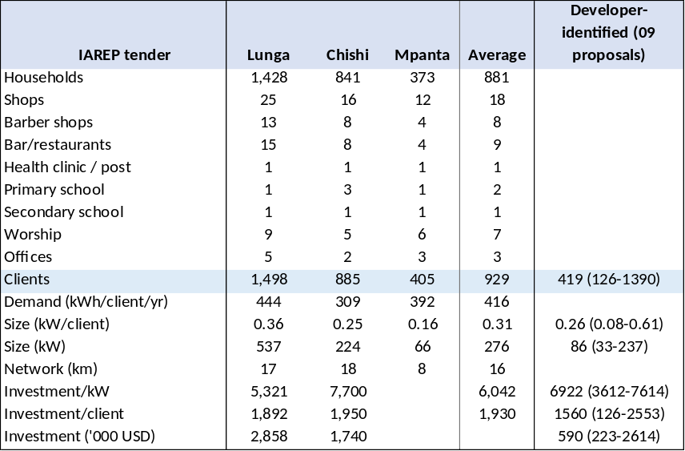

The model has been prepared considering experiences with pre-feasibility demand and minigrid supply analysis for the IAREP-supported Call for Proposals for REA-identified sites (for Lunga, Chishi and Mpanta) and a summary of nine developer-identified sites. A summary of characteristics is given in Box 39.

Assumptions

A model is prepared based on energy demand and load assumptions gathered from IAREP surveys (mid 2018) and other sources of information. The Appendix to this Annex provides more details.

A) Greenfield project: small minigrid (< 100 kW)

Case 1 Solar PV minigrid

In this case, we assume a demand of 200 households (by year 7 of the MG implementation) plus some small businesses and social services (school, health) but no larger productive uses of energy (PUE). Not all villagers will connect in the first year. Demand will start at 50% of the demand in year 5 of 243 kWh per day and then increase. Between year 5 and year 10 demand is assumed to grow at 2% annually to 269 kWh/day with a daily peak load of 36 kW and thereafter demand remains flat. A minigrid based on solar PV-battery generation option will deliver electricity from 100% renewable energy. The system design parameters and estimated CAPEX) covers typical solar PV equipment, and associated costs including modules, inverters, mounting, battery system, cabling and various balance of plant costs. The site has a distribution network of 8.6 km, a distance which represents the relatively low population density in man.
The bulk of annual operating expenses (OPEX) are staff and administration costs such as for project managers, technicians, security guards, back-office and insurance. Parts and components for maintenance are assumed to be a percentage of the CAPEX for both the generation plant and the distribution grid. In the 10th year of operations, the battery is replaced. Inverters need to be replaced after 16th year (which is within the horizon of analysis of 20 years).
Box 40 Energy demand and load curve, minigrid (without large PUE)
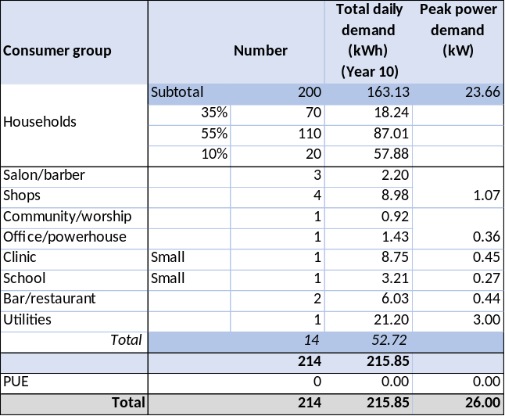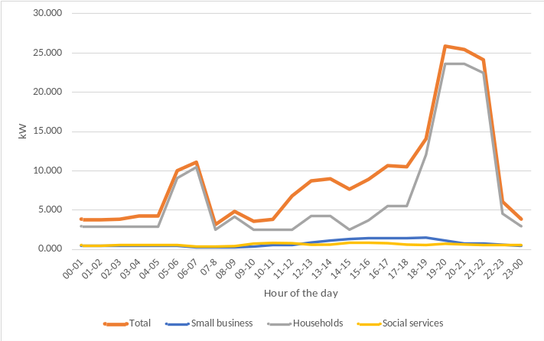
The demand in the first year is assumed to be 45% in this business case analysis and will reach 90% of maximum demand of the 214 clients by Year 5, after which demand will slowly increase to the maximum design value of 215.85 kWh per day. Relative low demand in the first year is a common problem and taken into account in the cost-benefit analysis table presented in Box 43

All electricity produced by the mini-grid is assumed to be sold to customers. An average tariff is assumed across all customer types. In reality, the tariff would likely be differentiated per end-user category. Zambia does not have an adapted tariff system for small minigrids and private mini-grids may charge different tariffs subject to regulatory approval.
Box 41 Minigrid solar PV capacity and battery configuration, Case 1 (village, no large PUE)
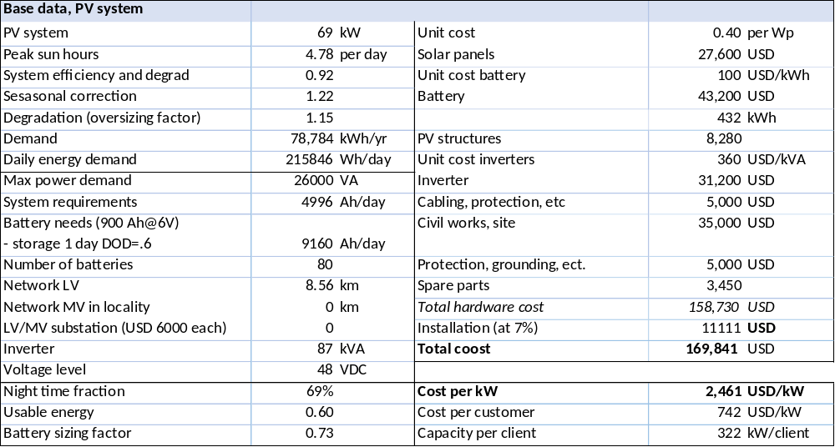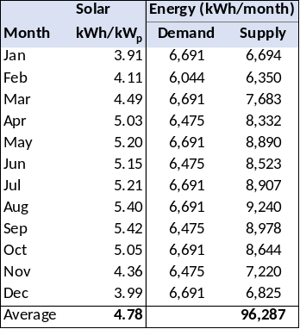
$$Solar PV Capacity for a Solar PV Battery system \left(kW\right)= Daily electricity consumption in \left(kWh\right)× Seasonal Multiplier \left(1.22\right)÷\left(1-Losses Factor \left(8\%\right)\right)÷Daily peak sun hours \left( hours\right)×(1+Solar PV Oversizing Factor$$
$$Battery Capacity for a Solar PV-Battery system\left(kWh\right)= Average daily electricity consumption in Year 3 \left(kWh\right)× Night time fraction \left(\%\right)× Night time demand to be met by battery (\%)÷(Usable Energy \left(60\%\right))×(1+Battery Oversizing Factor)$$

In principle, cost-reflective tariffs may be proposed by developers. In practice, the tariff definition will depend on a trade-off interplay between subsidy level (lowering investment cost), the end-user's ability or willingness to pay (ATP/WTP) and the developer’s desired return on investment. The model uses a combination of generic and country-specific inputs to calculate the Levelized Cost of Electricity (LCOE) in US$/kWh for the minigrid. The LCOE is the price that would have to be charged for the electricity to allow for cost-recovery of all costs (CAPEX, OPEX) over a 20-year timeframe. Financing costs are not included as it is not known to what extent developers need to or are able to access debt financing.
Box 42 Ability and willingness to pay

According to the 2015 Living Conditions Monitoring Survey, the average monthly income for households is about USD 75 in rural areas and USD 290 in urban. Average expenditure in rural areas was USD 70 a month (of which USD 40 on food items). Using a benchmark of 10% of income for estimated ability to pay (ATP) for electricity, rural households might be expected to afford USD 8-10/month. Another way of determining ATP is to look at what non-electrified households spend on on-heating energy. The IAREP feasibility study mentions figures of USD 4-7 per month, while another report mentions USD 8.5 per month. It should be noted that rural incomes can be highly seasonal; some agricultural households may face a lean period at the end of the “warm and wet” season (Nov-Apr), with tightened cash flows, which could affect ability to pay for electricity bills or upfront connection fees.

A World Bank study found a willingness to pay (WTP) by households of USD 4.6 a month for solar home systems and USD 8.4 for mini-grid service, while commercial users are willing to pay USD 30 a month.. Surveys undertaken as part of the before-mentioned IAREP feasibility study gives WTP data in the order of USD 1.3-3.3 up to USD 10 per month. It should be noted that WTP statements by respondents in such surveys may be influenced by their knowledge of actual monthly expenditures in neighbouring electrified areas and reflect the subsidized ZESCO tariffs, about USD 4.8 a month (residential) and USD 18.6 (businesses) rather than their ability to pay (ATP).

Estimation of subsidy level
The subsidy level is determined by looking at investment costs on their impact on the tariff vis-à-vis the ability or willingness to pay. Another consideration is REA’s internal set of rules which stipulates that support for private electrification initiatives cannot exceed 50% of the initial investment. The table on the left in Box 43 presents four cases:

(a/b) No grant is available
The LCOE is USD 0.811/kWh. If no investment subsidy is provided, even lower-income households would have to pay about USD 7.19-9.80 a month (tariff at USD 0.91-1.24/kWh, giving a project IRR of 12-18%). The social discount rate is assumed to be 12%. This is above the ATP/WTP range (discussed in Box 44). Lower-income households are the largest group of clients and are most likely to reject grid connections if their energy payments are above their WTP/ATP. Low participation (due to complaints about the fairness of tariffs and lack of awareness in general), especially in the initial years, has been one issue in minigrids in Zambia in the past.

(c/d 50% grant funding.
The LCOE is USD 0.494 per kWh. If a 50% investment grant is provided, their monthly payment drops to USD 4.38-5.69 per month (tariff at USD 0.55-0.72/kWh, giving a project IRR of 12-18%). This is more within the range of ATP/WTP.

A likely business case is that of a 50% investment subsidy, which would allow a small profit margin for the developer, at end-user tariffs that would be in the range of ATP/WTP of lower-income households.

Another issue is financing. In case there is no grant financing, the developer needs to provide 100% or get debt financing. Box 44 presents the scenario in which the developer provides 15% equity (with 85% debt financing). This is debt is not readily available to finance minigrid investments in Zambia, while few developers will be able to provide 100% equity. Grant support will also from this viewpoint help get the financing mix (grant with equity and/or debt). Box 44 presents the case of 50% grant, 15% equity and 35% debt financing, assuming the end-user is charged USD 0.718 USD/kWh.
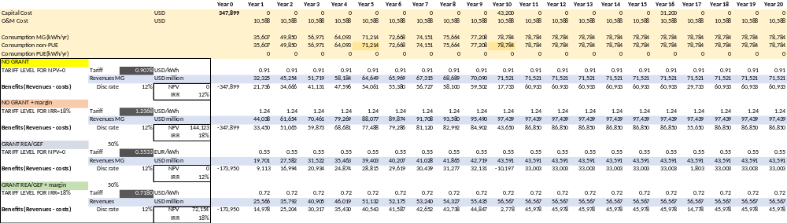
Box 43 Solar PV minigrid CAPEX, OPEX and LCOE with tariff and subsidy optimization
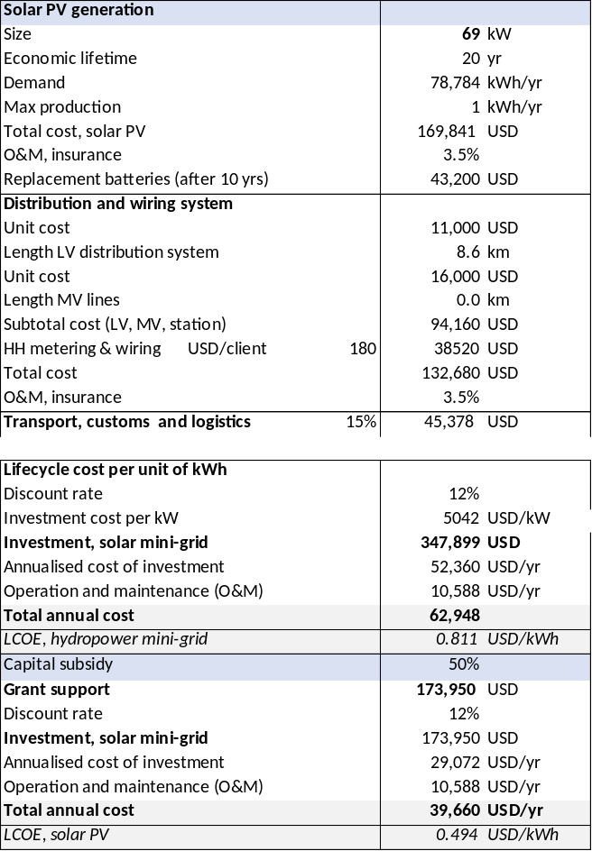
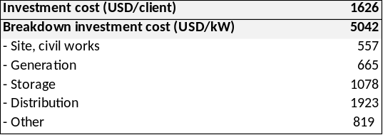
The table below gives the implications of different tariffs for the monthly payments of different household groups.
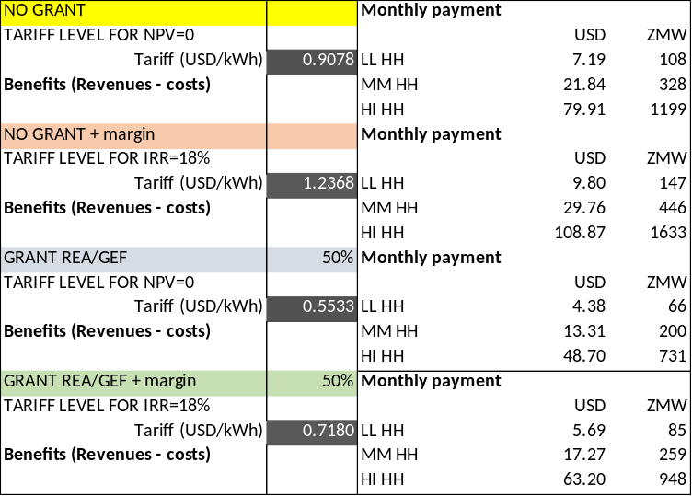
Box 44 Solar PV minigrid financial indicators (with 50% grant, 35% debt financing and 15% equity)

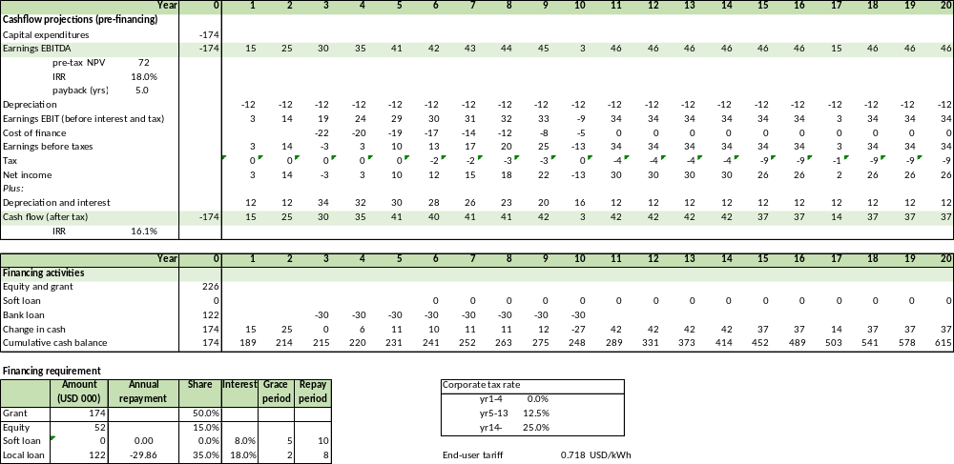

For this modelled case (with 50% grant and 35% loan), an end-user tariff of USD 0.72/kWh, with a 50% grant, can provide a 16% required return on investment in some scenarios. Box 45 provides the financial aspects of the case with no grant, 85% debt financing, showing it will also give an IRR of 16%, provided the end-user is charged the full tariff of USD 1.24 per kWh. However, such a tariff may approach the limitations of the lower-income households’ ability to pay, while lower tariffs will not allow the developer to have a margin or even restrict the lender’s ability to repay the loan.

In the no-grant case, the average tariff is USD 1.237/kWh, implying monthly expenditure of the lower-income households of USD 9.80 per month with middle-income households spending USD 30 a month. A 50% grant would enable reducing the end-user tariff to USD 0.718/kWh, implying monthly expenditures of lower-income households of USD 5.70 and USD 17 a month, respectively.

A developer of the hypothetical mini-grid site may need to find ways to address the gap between revenue needed for viability and customer affordability, such as:
- Reducing investment and operational costs. Another way to reduce cost is to develop a portfolio of sites in the same area by achieving some economies of scale.
- Having tariffs that vary per customer group. If, for example, the tariff for business users is higher, these can cross-subsidize the lower-income group.
- It is attractive to increase the productive or commercial uses of energy. In particular, if these are already operational from year 1, these can help to boost revenues in the first years when the demand has not yet reached its full level (see the comment on low demand in the first years of operation in Box 40).

A solar PV mini-grid or portfolio of sites is highly dependent on the characteristics of the site(s) and community (or communities) in question and should be taken only after a detailed assessment combining technical and socio-economic analysis, taking into consideration the location, the initial and anticipated future load, the number of larger consumers and, customer ability to pay and expectations for the level.
Box 45 Solar PV minigrid financial indicators (with no grant, 85% debt financing and 15% equity)

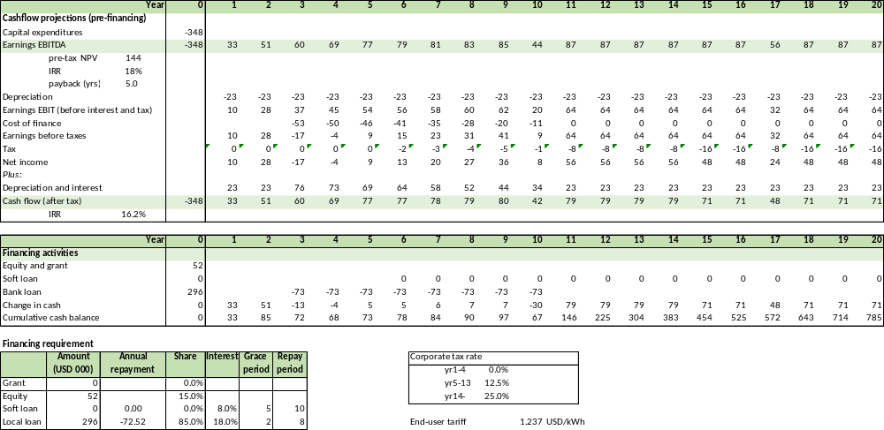

Case 2 – Minigrid with micro-hydropower

This Model Business Case analyses the financial feasibility of an off-grid micro-hydropower plant supplying the same hypothetical community in rural Zambia, discussed in Case 1. By a generic example, key features of a hydropower site such as hydrology and civil works layout, cannot be defined. It is assumed that there are no site-specific limitations to obtaining the required power output and energy production to supply the mini-grid. This means that the power output will be as required from the demand forecasting and the scheme is able to provide the required power output all year round, which is a real case would mean that the design flow is lower than the minimum flow available in the river or stream every hydrological year.

As in case 1, the hypothetical village is assumed to have 250 households by year 5 of the MG implementation (with 90% of energy demand and 100% reached by year 10) plus some small businesses and social services (school, health) but no larger productive uses of energy (PUE). Not all villagers will connect in the first year. Demand will start at 35% of the maximum design demand of 216 kWh per day and then increase. Between year 5 and year 10 demand is assumed to grow at 2% annually to the full 216 kWh/day with a maximum daily peak load of 26 kW and thereafter demand remains flat (see also Box 40 for the demand load profile). Given the anticipated load profile, the hydropower plant is estimated to have a power capacity of 26 kW.

Investment and operating costs for the hydropower plant and for the distribution network are provided in Box 46. These are based on data published by IRENA and GET.Invest and other sources. Considering the size and likely remote location of the plant, a relatively high CAPEX is assumed (for civil works, the penstock, turbine, generator, powerhouse and substation, and installation). The installation is expected to need a substantial overhaul in year 16 of its operations (which is included as an element in the estimation of the LCOE)

Box 46 CAPEX and OPEX, 32 kW micro hydropower facility
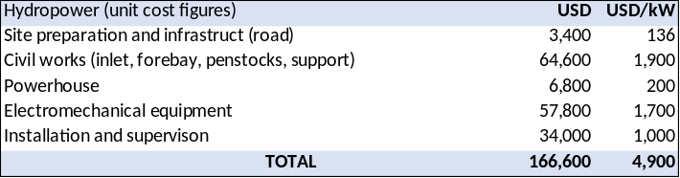

The annual OPEX for the hydropower plant is assumed at 4% of CAPEX plus 4% insurance cost. Cost assumptions for the distribution network are the same as for the solar minigrid case (8.6 km; see Box 41). The main mini-grid system parameters, CAPEX, OPEX, LCOE and are summarised in Box 46.

The subsidy level is determined by looking at investment costs on their impact on the tariff vis-à-vis the ability or willingness to pay. The table on the left in Box 47 presents four cases:

(a/b) No grant is available
The LCOE is USD 0.64/kWh. If no investment subsidy is provided, even lower-income households would have to pay about USD 7-10 a month (tariff at USD 0.61-0.84/kWh, giving a project IRR of 12-18%). The social discount rate is assumed to be 12%. This is above the ATP/WTP range (given in Box 44). Lower-income households are the largest group of clients and are most likely to reject grid connection, if their energy payments are above their WTP/ATP. Low participation, especially in the initial years, has been one issue in minigrids in Zambia in the past.

(c/d 50% grant funding.
The LCOE is USD 0.45 per kWh. If a 50% investment grant is provided, their monthly payment drops to USD 4.2-7.3 per month (tariff at USD 0.37-0.48/kWh, giving a project IRR of 12-18%). This is more within the range of ATP/WTP.

A likely business case is that of a 50% investment subsidy, which would allow a small profit margin for the developer, at end-user tariffs that would be in the range of ATP/WTP of lower-income households.

A micro-hydro mini-grid or portfolio of sites is highly dependent on the characteristics of the site(s) and community (or communities) in question and should be taken only after a detailed assessment combining technical and socio-economic analysis, taking into consideration the location (including site characteristics and hydrology), the initial and anticipated future load, the number of larger consumers and, customer ability to pay and expectations for the level.

B) Greenfield project: case of small minigrid (< 100 kW) with demand stimulation

Case 1 Adding productive use of energy (PUE)

From the perspective of the minigrid operator, productive users of power are the most valuable. Their usage tends to be significant and predictable, thus forming a reliable source of revenue. Indirectly, generating additional income increases the user’s ability to pay for services directly and contributing to the economic vibrancy in a village indirectly improves the willingness to pay from other community members.

Examples of larger ‘productive uses’ in the Zambian rural context are maize milling, irrigation (of cash crops), cold storage (e.g., for artisanal fishing communities) and local workshops. The business case studied examines the inclusion of a maize mill (sized 5 kW) and one or two repair- or workshops with a 1.5 kW power demand.

Box gives a summary with the following assumptions:
- Annual added demand is 14,782 kWh/year (after year 1 and staying constant thereafter) bringing total energy demand (after year 10) to 309,314 kWh/yr. The PUE is only operated during the day. Thus, the system peak load remains the same, 26 kW. In the case of hydropower, the system kW size remains the same.

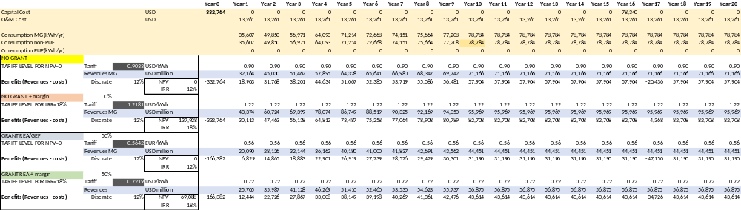
Box 47 Hydropower minigrid CAPEX, OPEX and LCOE with tariff and subsidy optimisation
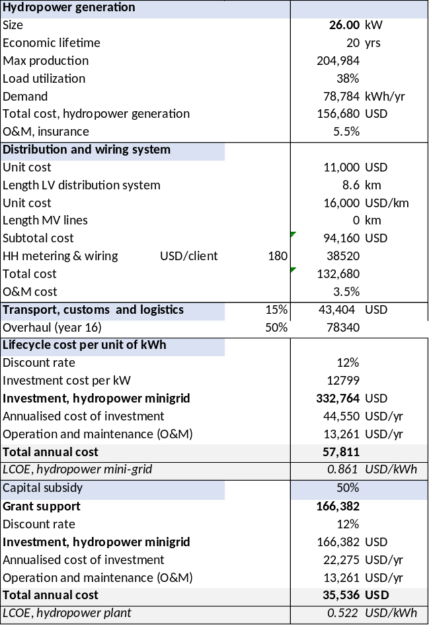

The table below gives the implications of different tariffs for the monthly payments of different household groups.

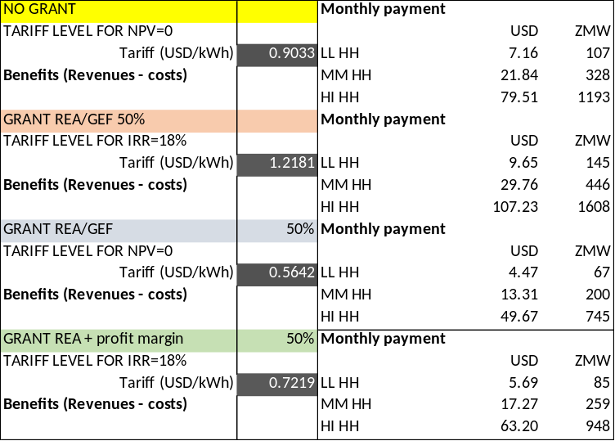
- In case of solar PV, the battery capacity is slightly expanded to allow for one day of storage. To accommodate the increased energy demand, the panel must increase from 69 to 82 kW.
Box 48 Impact of large PUE on energy demand, load curve and LCOE of a small-sized minigrid
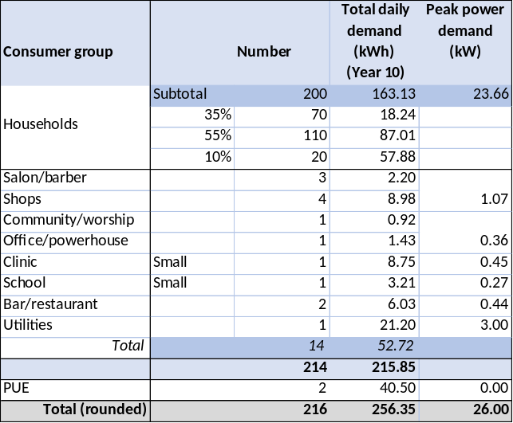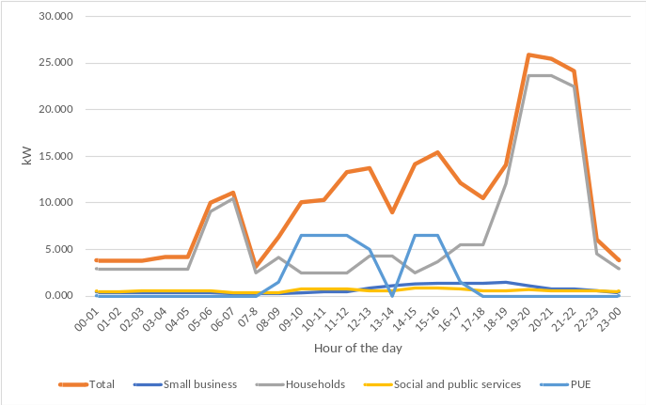

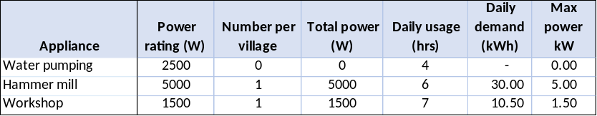

The hydropower system does not need to be resized to accommodate the new demand and load (as long the system cam meet the peak demand, which is in the evening). The PV system needs to be expanded but at a lower total cost per kW (as the battery storage is not expanded due to the daytime of the PUE). In both cases, adding a PUE outside peak hours has a positive impact on the LCOE (see the comparison between cases in the summary Box 54)

Case 2 Demand stimulation with electric cooking

Many microgrid customers still rely on costly, time-intensive and unsafe biomass fuels to cook daily meals. Electric cooking is often perceived to be prohibitively expensive given the high tariff rates charged by most minigrids or will drain the minigrid beyond its peak power capacity. Electric pressure cookers (EPC) have the potential to change this paradigm and offer a unique opportunity for customers to use microgrid electricity, thereby boosting the sales of power. The grids can hereby offer lower power tariffs, hereby partly offsetting the increase in the monthly power bill.

The Business case discussed here assumes a 850 W HE cooker is used by 1/4 of the middle-income households and a 1 kW HE cooker by half of the high-income households (for 2 hours a day). The figures are average, so can also be interpreted as meaning that half of the middle-income households use the cooker for 1 hour a day. There are many parameters to vary in the model, such as the number of households participating, hour of the day (coinciding or not with peak load), impact of the total system peak load and day/night use. Energy demand will increase (in comparison with the case without PUE and without HE cooking, see Section A.2), thus larger solar PV or hydropower capacity is needed under the assumption that the peak demand increase remains relatively small (due to demand-side management measures). Indicators of the case are presented in Box 49.

Box 49 Impact of electric cooking on energy demand and load curve of a small-sized minigrid
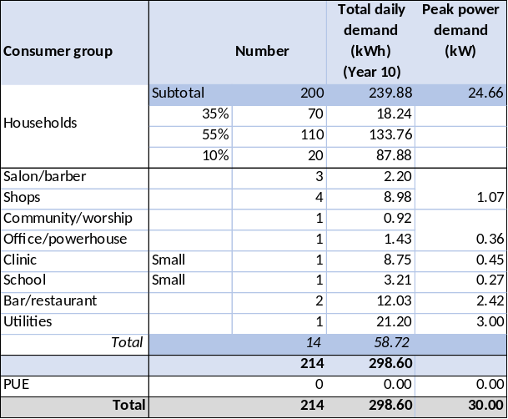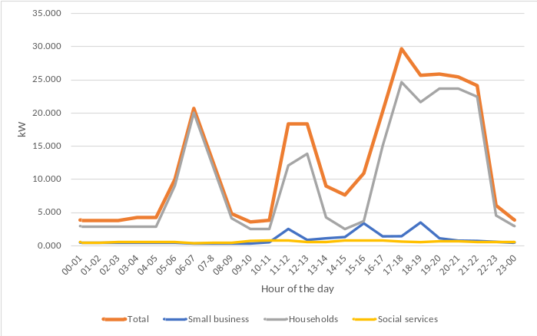
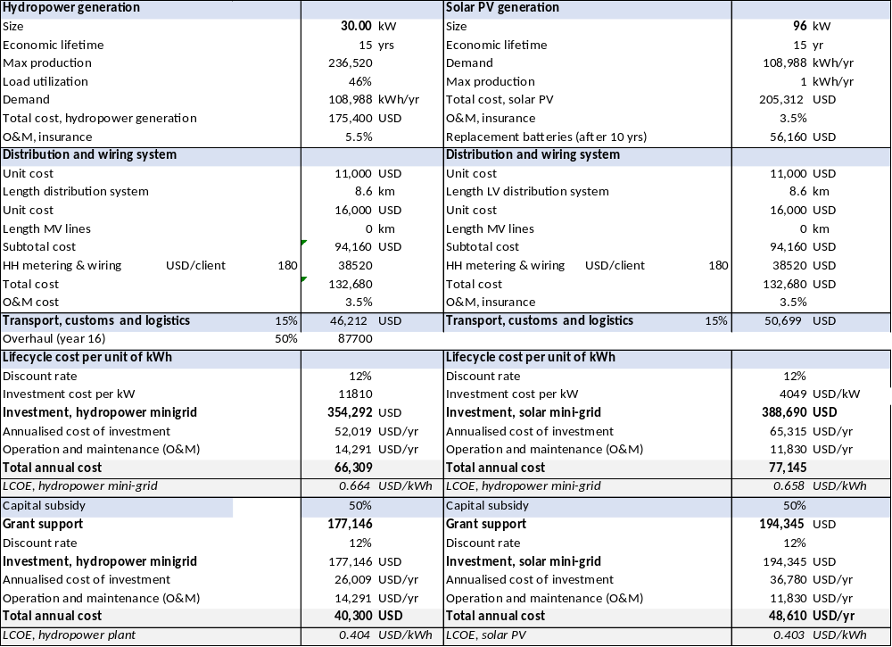
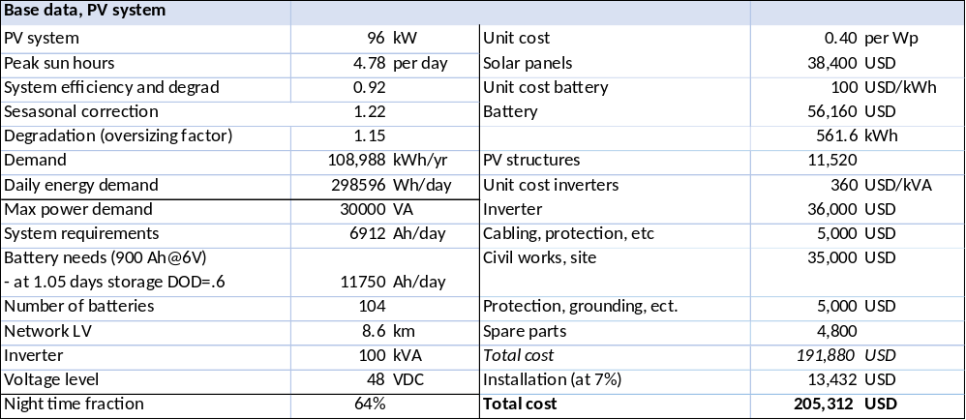
Box 50 Impact of demand stimulation through HE cooking on tariffs and household demand (solar minigrid)

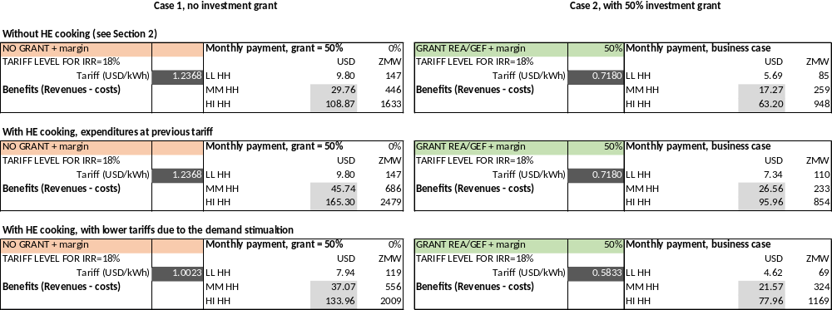

It is interesting to analyse the impact of the penetration of HE cooking (based on the before-mentioned assumptions). The average energy demand in middle-income and high-income will increase from 0.791 kWh and 2.894 kWh/day to 1.216 kWh and 4.394 per day. However, as tariffs can be lowered (assuming the same project IRR goal) the actual expenditures will be relatively less. For example, a middle-income household that (assuming there is no grant financing) spends USD 29.76 a month (in the case of no HE cooking scenario, paying a tariff of USD 1.24/kWh) would see its expenditure increase 1.5-fold to almost USD 46 a month. However, the demand stimulation has a positive effect on the system tariff (now at USD 1.00 per kW) so that the actual average payments are less (USD 37 a month). In other words, more households cooking (as long as it's not overloading the system) means higher revenues.

While electricity expenditures increase, electric cooking has benefits in terms of time savings and avoided fuel costs. Cooking some foods (such as beans) can take considerable time and consume quite a lot of wood (or charcoal). The cooker may be an extensive item, about USD 90, hence, it was assumed that low-income households cannot or do not want to acquire the cooker.

Comparison of cases of the village with 200 households with and without demand stimulation

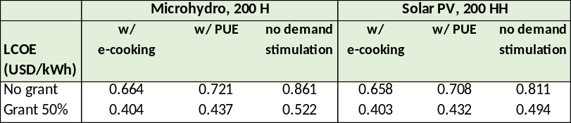

The general conclusion is that, if demand-side measures are taken to avoid increasing peak load, demand stimulation can have a positive impact on the system’s levelized cost of energy (LCOE).

C) Brownfield project: minigrid overlay on existing PUE

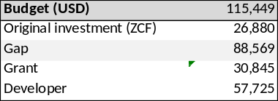
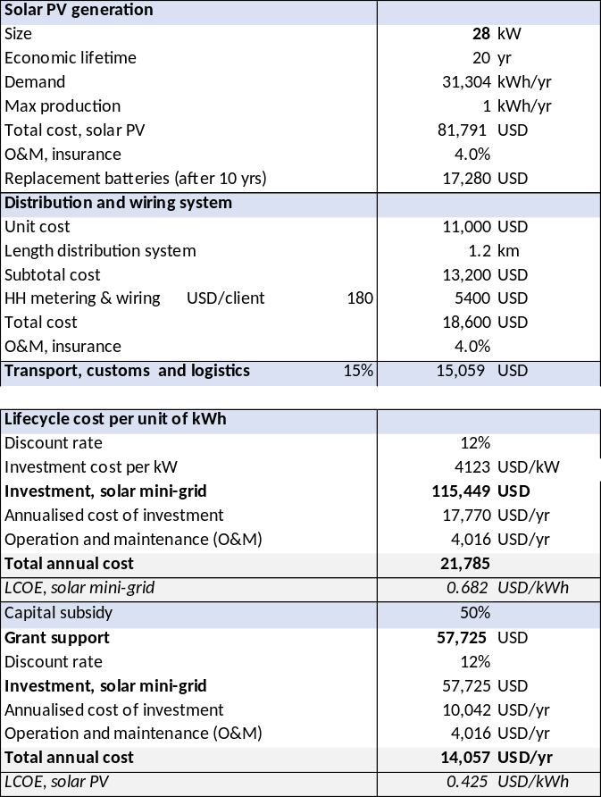
The Zambia Cooperative Federation ZCF (Zambia Cooperatives Federation) has been implementing a programme solar-powered hammer mills at a cost of about USD 200 million. The programme has aimed to install 2000 mills in various parts of Zambia. Most of the machines are used for milling maize, a staple food in Zambia, and each is powered by 60 solar panels with a capacity of 15 kilowatts.
Box 51 Business case of rehabilitation and expansion of ZCF-supported solar mill

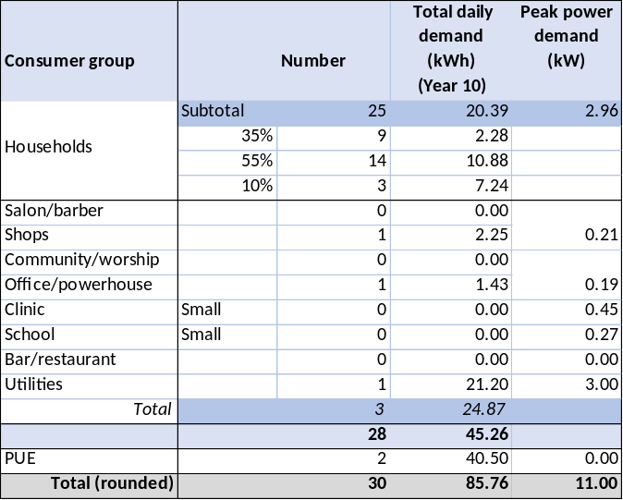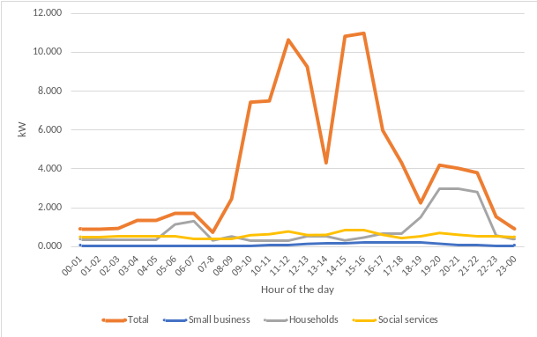

The original investment of about USD 27,000 is an estimated of the value of the 15 kW solar PV and auxiliary equipment installed and does not include the value of the productive use (the mill) itself. It is assumed that the cooperative will own the productive use in agreement as off-taker with the energy developer.

The plants were designed not only to power the mills but also for other services in the vicinity, such as powering up to 25 houses or small commercial uses. However, this has not happened in practice, as this would require battery storage and other adaptations in the power generation system not taken into account in the original design. Second, the lack of battery storage and inability to work properly on cloudy days was cited by about 60% of respondents in a recent survey as reasons of the low performance of the mills. This has had a vicious effect of farmers not supplying maize if they are not sure if it can be milled.
The ZCF has approached REA with the idea to pilot a number of solar mills to act as an energy service hub for small economic activities and supply electricity to nearby dwellings. The business case presented here assumes the realization of the original idea of installing sufficient power capacity to provide the milling service, while also providing power to 25 houses, a small shop and a small workshop. It is assumed that the whole investment cost of the solar generation is about USD 115,500, including a capacity of 28 kW solar, battery storage and a small power distribution network, of which cost the amount of USD 57,725 (50%) is invested by the developer with the other half including the USD 26,900 estimated as the value of the originally installed 15 kW solar panels) and the remaining investment gap covered by a grant (e.g. GEF).

D) Larger minigrid (> 100 kW) with PUE

The last business case presented here is a community with 1500 households with various small commercial activities, productive uses (maize mill, workshops) and several social-public services (secondary school, health centre and offices). While in a larger minigrid certain economics of scale are achieved, the cost of distribution is relatively higher as, due to distances covered, a MV line with MV/LV substations needs to be added, unlike the cases discussed in sections G.1 to G. There is demand stimulation in the form of larger PUE (maize milling, technical workshop, water pumping). Overall, the resulting LCOE is therefore similar to the previous cases. This business case corresponds to the larger PPP solar PV minigrids that have been proposed or supported by REA (such as Lunga or Chishi, see Box 39) or the proposed 200 kW hydropower minigrid at Chipota Falls.

E) Summary of business cases

Box 52 Summary table, business cases

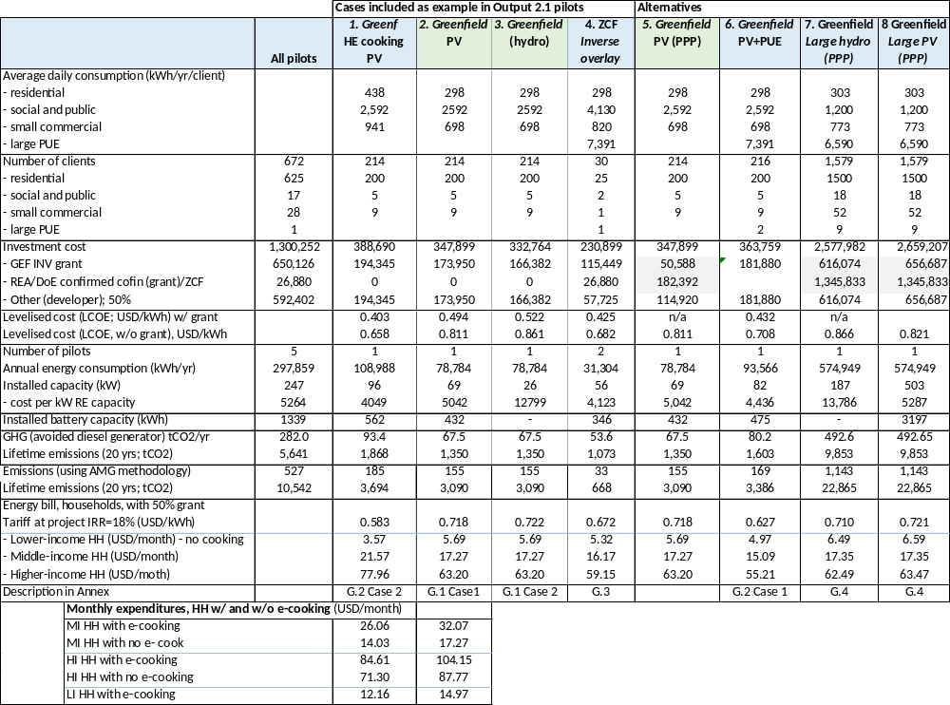
Box 53 Business case of larger minigrid (hydropower or solar PV)
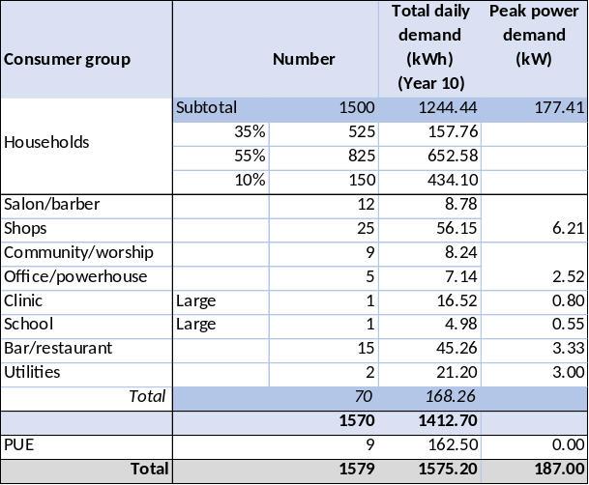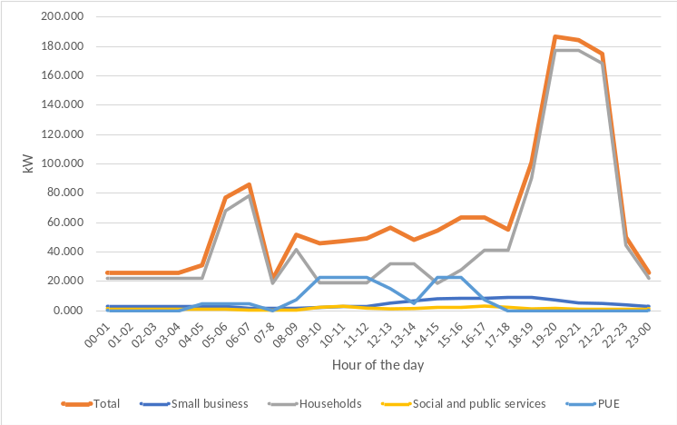
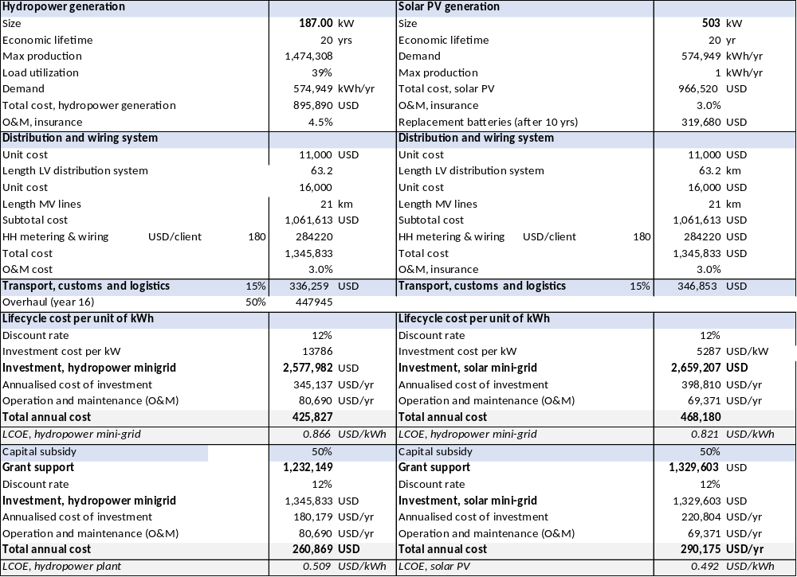
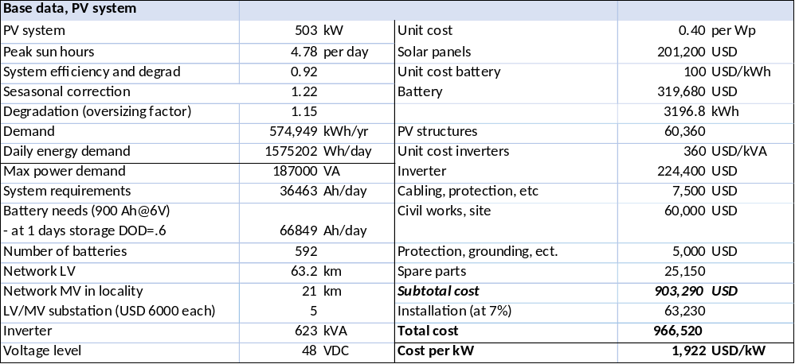

F) Energy demand base data

End-users are classified into different types, each of which has different demand categories:
- Households, subdivided into low, medium and high-income households,
- Small businesses (shops, barber shops, restaurants &bars)
- Institutions (schools, rural health centres, worship, offices)
- Other (street lighting; powerhouse)

End-users have a typical daily energy consumption in kilowatt-hour per day (kWh/day) and load profile (hourly power demand in watts (W), throughout the day). The daily energy consumption is modelled by making assumptions on the type of appliances used, the power rating of the appliance (wattage), number of appliances and their usage over a 24-hour period. The load for each appliance was aggregated for each hour of the day. The tables below show the model energy demand for each household category, their appliances and the average time of use per day. At the village or site level, the energy consumption and total hourly load can be calculated by multiplying by the number of end-users per category and aggregating the demand for all the category types. Seasonal demand variation can be important, in particular in the case of some productive uses. However, in the modelling, it is assumed that such seasonal fluctuation in energy demand can be levelled out.
Without e-cooking With e-cooking

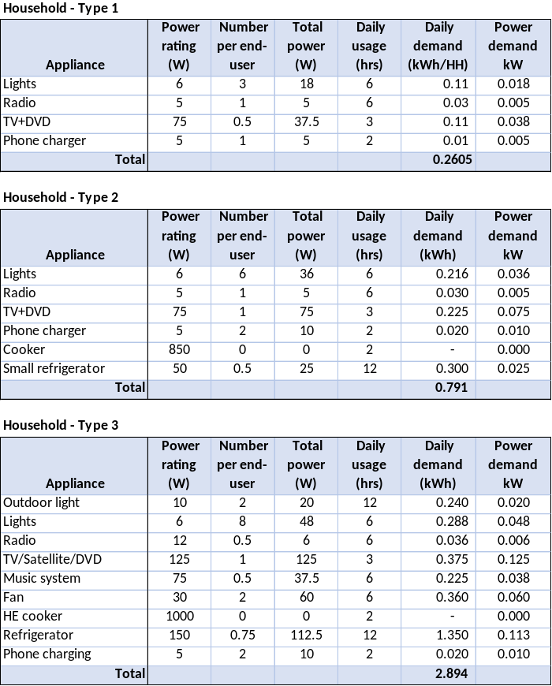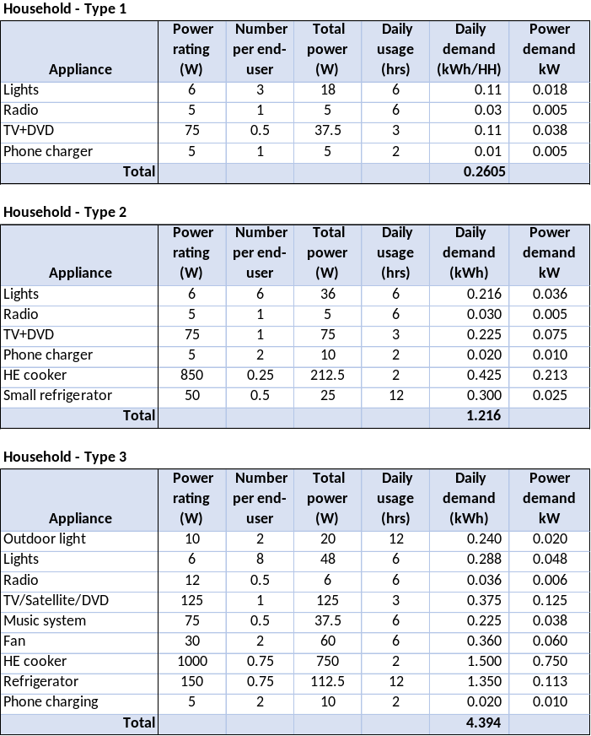
- Lower- income households living in one or two-roomed mainly grass-thatched houses use lighting, phone chargers and radio/TV with daily consumption of 373 Wh. These would be connected using a ready-board with insulated cables running from sockets on the ready-board to the respective rooms.
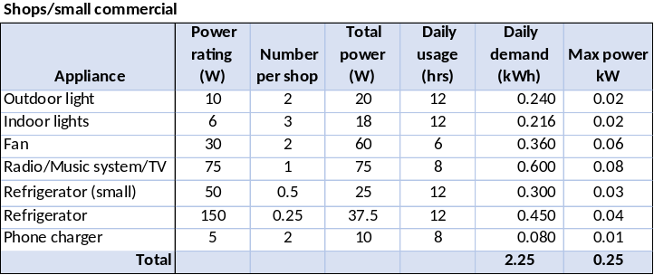

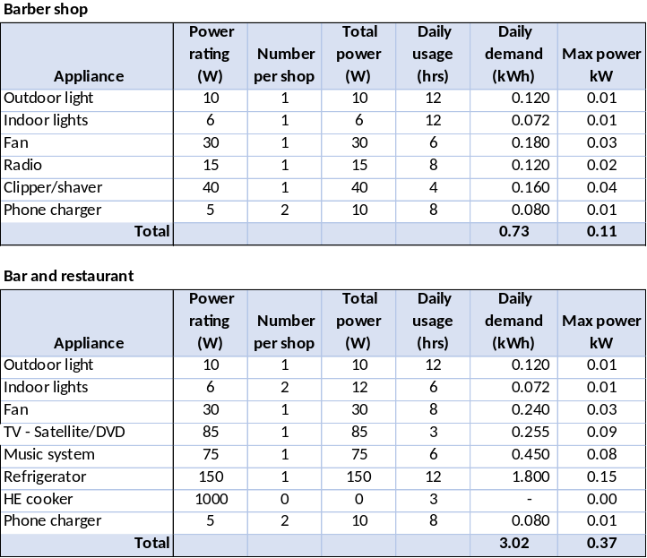
- Medium income households living in mainly grass-thatched or sometimes iron-sheet roofs with three to five rooms and are assumed to use lighting, radio/TV, phone chargers with some households using a small refrigerator. Connections would also be by ready-board, with insulated cables running from sockets on the ready-board to the respective rooms. Expected daily consumption is 791 Wh.
- High-income rural end-users living mainly in iron sheet roofed houses would include among others, the rural health workers’, school teachers’ and government department/ institutional staff houses. They are assumed to use the same appliances as medium-income households, although some of these with a higher wattage. Expected daily consumption would be 2,894 Wh. It should be noted that the definition of low, middle and high income is not according to Zambian statistical income standards but according to expected energy consumption level.
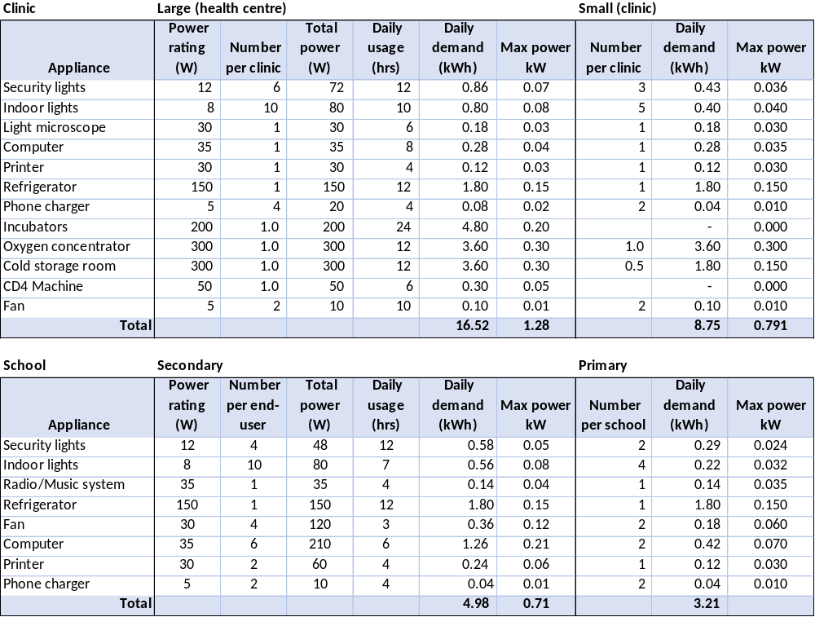
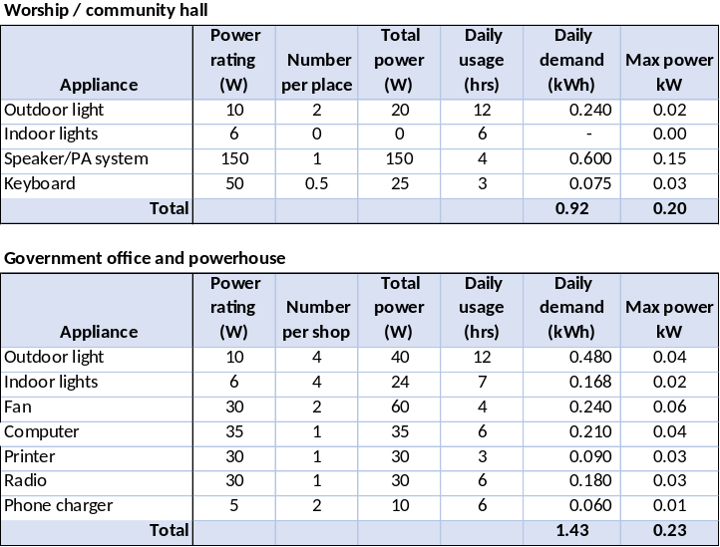

Village businesses are small grocery shops that use lighting, radio, refrigeration, barber shops (lighting, clipping or shaving), restaurants and bars (lighting, music system, phone charging, and refrigeration).

The rural health centres and posts (here referred to as ‘clinic’) in the villages need a basic set of health services, including obstetric care, immunizations, basic emergency treatment and simple medical devices. For more advanced medical diagnosis, treatment, and surgery the patients would have to go to the district hospital, which is often far away. Given the long distance to district health facilities, it is important that some basic disease diagnosis and treatment can be done by medical staff at the clinic. Without electricity, even basic medical devices, such as a powered microscope, oxygen concentrator, and incubator (for first treatment of premature childbirths). A basic load profile for a rural facility includes security lighting, indoor lighting, a microscope, a computer and a printer, an oxygen concentrator, a fan, phone chargers, a fridge for 12 hours a day (i.e. switching itself on and off every four hours), and a CD4 Machine. Larger facilities may have more equipment such as an incubator. Apart from the vaccine refrigerators, the RHC should have a cold room for the storage of medicines and blood packages.

The load profile for a typical primary school includes lighting, a computer and printer, a radio, a fan, phone charging, and a small refrigerator. A secondary school is assumed to have the same appliances (but size and number differ). Furthermore, a provision has been made for computers for ICT classes (not a luxury item, but part of the official curriculum). The load profile for a place of worship includes outdoor lighting, a PA system, and a keyboard. It is assumed that church activities take place three days a week and that the choirs continue practising when the church services are over. A typical government office would have security lighting, indoor lighting, a computer and printer, a radio, a fan, and a phone charger.

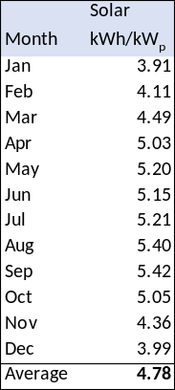
G) Energy supply base date

The Energy Sector Management Programme (ESMAP) of the WB, has carried out modelling of the solar resources in Zambia at five sites. ESMAP provides photovoltaic power production data for Zambia using numerical models developed by GeoModel Solar, taking into account meteorological parameters, such as air temperature, wind, and humidity. Since the minigrid site can be anywhere in Zambia, the model presented uses average data. The minigrid system must be capable to produce enough energy to cover the energy demand at any time of year, considering the available solar radiation and the predicted energy demand for each month.

Specialised software can be used to determine energy demand data, daily load profile and irradiation data. The model presented is based on a simple spreadsheet model with the following design considerations:
• System autonomy: 1 day of storage
• The system must be able to generate enough energy to meet the energy demand at any time of the year.
Box 54 Cost comparison between various studies

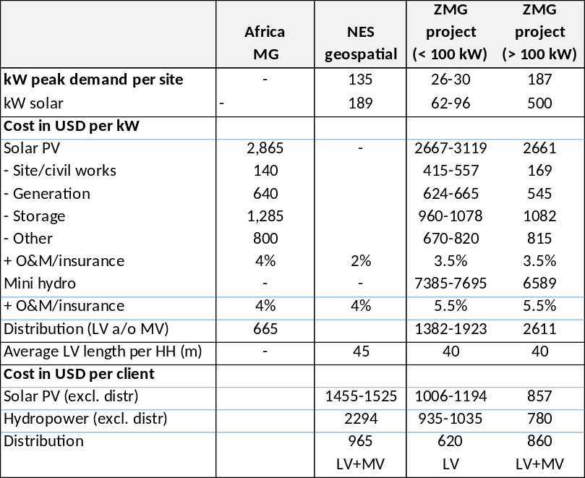
The table above gives an comparison between various cost assumptions or indicators given in:
- UNDP/GEF Africa Minigrid programme (project documentation)
- EngiePower/World Bank study for Preparation of a Least-Cost Geospatial Electrification Plan for Grid and Off-Grid Rollout in Zambia (2022)
- Analysis on solar and hydropower minigrids presented in this Annex (PPG phase analysis for project document formulation

- GEF core indicators and GHG emission reduction

  - Introduction; applicable GEF core indicators

This annex presents the results and the methodology used for estimating project contributions to the following applicable GEF-7 Core Indicators: (i) Direct and indirect Greenhouse Gas (GHG) Emissions Mitigated; (ii) Increase in installed renewable energy (RE) capacity per technology; and (iii) Number of direct beneficiaries disaggregated by gender as co-benefit of GEF investment. The resulting targets have been included as part of the project documentation (GEF CEO endorsement/approval request (CEO ER) and/or UNDP Project Document).

Indirect GHG emissions reductions (ER) are the result of the broad adoption of the project’s outcomes. As such, indirect GHG ER has been estimated at the CEO endorsement phase following a similar approach as that used at the concept approval (PIF) phase. In contrast, direct GHG ER, increase in RE capacity, and Number of direct beneficiaries will result from the project’s minigrid pilot(s) specifically. The Zambia MG project will provide partial capital expenditure (CAPEX) subsidies as direct financial support for one or more eligible minigrid pilot(s) to develop minigrid investment projects and/or purchase productive use appliances/equipment to be leased to and used by minigrid customers for income generating activities. The remaining investment costs not covered by the project’s CAPEX subsidy will have to be funded by other sources.

The ‘AMP financial model’ - developed initially for 1st round AMP projects – has been used to estimate pilot targets for this and all other 2nd round AMP projects. This model takes a standardized approach for analyzing minigrid pilots receiving support from AMP national projects. The resulting targets are presented in Annex H.4 and have been included as part of the project documentation (GEF CEO endorsement/approval request (CEO ER) and/or UNDP Project Document). The methodology used to estimate project targets is described in Annex H.5 and the differences with respect to PIF-phase methodology and targets are explained in Annex H.4.

It is important to note that the project’s pilot(s) have not been fully defined during the project preparation (PPG) phase. Various key aspects may change or remain to be defined during project implementation (e.g., pilot type, number of minigrids per pilot, % of CAPEX subsidy required, number of customers that will be served by each minigrid). Therefore, an indicative minigrid system has been identified for each pilot and targets estimated for each of these indicative systems based on a series of assumptions and calculations. Assumptions and calculations as described in this annex have been made for the sole purpose of estimating project targets and in no way constitute recommendations or guidance for pilot definition during project implementation.

This and all other AMP national projects contribute and will report on the following GEF-7 Core indicators:

Core indicator 6: Greenhouse Gas (GHG) Emissions Mitigated (tCO2e). This indicator captures the amount of GHG emissions expected to be avoided through the GEF project’s investment in RE minigrids. It should be measured above a baseline value. Mitigation benefits include both direct and indirect GHG emissions reductions:
- Direct emissions reductions are attributable to the investments made during the project's supervised implementation period, totalled over the respective lifetime of the investments (20 years). For AMP national projects, direct emission mitigation arises from minigrid pilot investments under program Component 2.
- Indirect emissions reductions result from broader adoption of the outcomes of the project plus longer-term emission reductions from a behavioural change in the post-project period. Broader adoption of the project proceeds through several processes including sustaining, mainstreaming, replication, scaling-up and market change. For AMP national projects, indirect emission mitigation results from creating a general enabling investment environment for minigrid market development, and subsequent investment flows in minigrids to electrify rural areas.

Context Sub-indicator 6.4: Increase in installed renewable energy capacity per technology (MW, MWh). This indicator captures the increase in renewable energy generation and/or storage capacity and should be disaggregate by type of renewable energy technology (biomass, geothermal, ocean, small hydro, solar photovoltaic, solar thermal, wind power, and storage). All AMP national projects will be contributing to the increase of solar photovoltaic and/or storage capacity. Therefore, this indicator will measure both the increase in solar PV generation capacity (MW) and the increase in battery storage capacity (MWh).
Box 55 Beneficiaries of pilot minigrid systems

Direct beneficiaries per project type
Type of pilot | Targeted support provided by the project | Direct beneficiaries
Greenfield | Providing access to clean/reliable/affordable electricity to new minigrid users through development of new minigrid sites | All new minigrid customers
Hybridization | Providing improved electricity services to all existing as well as new users of an existing minigrid, based on a larger share of renewable energy and a clear path for diesel phase-out | All existing as well as new customers of the hybridized minigrid
PUE Overlay | Providing improved electricity services to all existing as well as new users of an existing minigrid through the addition of productive use equipment for use by Commercial/PUE users, which improves sustainability of the minigrid for all its customers | All existing as well as new customers of the minigrid to which a PUE Overlay is added

Customer segment definition
Customer Segment | AMP - Program-level definition | # people per minigrid connection
Residential (households) | All households connected to a minigrid regardless of whether they use electricity in the household for value-adding activities. | 5 people (household residents)
Social  (community and public institutions) | Churches, community centers, health facilities, educational facilities, street lighting, government buildings, and public buildings. | 4 people (employees)
Commercial/ PUE  (productive users of electricity) | Customers who are engaged in value-adding activities powered/enabled by electricity, who in turn provide goods and services to indirect project beneficiaries. Commercial loads such as lighting, cooking, information and communication, refrigeration, space heating/cooling, and motive power are used for value-adding activities such as restaurants, shops, sewing services, beauty salons, internet-cafes, as well as transformation processes, like rice milling, usually embedded in agricultural supply chains. | 3 people (owners, employees)

Core indicator 11: Number of direct beneficiaries disaggregated by gender as co-benefit of GEF investment. This indicator captures the total number of direct beneficiaries including the proportion of women beneficiaries. Direct beneficiaries are all individuals receiving targeted support from a given project. In the context of AMP, this refers specifically to the investments in minigrids pilots under program Component 2. Only minigrid customers gaining access to electricity and/or improved electricity services are considered direct beneficiaries of the project. The exact definition of direct beneficiaries for each type of minigrid pilot considered for support under AMP is presented below. The three types of AMP minigrid pilots are further described in Annex H.2.

  - Project’s minigrid targets

At the PIF stage, it was assumed that all minigrid pilots would be greenfield minigrid projects and only residential customers of these minigrids were considered direct beneficiaries of the project. The PPG Phase has provided more nuance as to the types of minigrid pilots that will receive Program support and their respective direct beneficiaries. AMP national projects can undertake pilots of one or more of the following three types: (1) Greenfield minigrids (complete minigrids, including generation and distribution assets as well as PUE equipment), (2) Hybridization of existing or planned diesel MGs (retrofitting of existing diesel-based MGs increasing the RE fraction of power generation)( of, and (3) Productive use overlay to an existing or planned minigrid (investments in PUE equipment to a minigrid generating income, improving user’s ability to pay for services, and improving the utilization of PUE and minigrids assets).

As noted in the introduction, the project’s pilot(s) have not been fully defined during the PPG phase. Various key aspects may change or remain to be defined during project implementation (e.g., pilot type, number of minigrids per pilot, % of CAPEX subsidy required, number of customers that will be served by each minigrid). Therefore, an indicative minigrid system has been identified for each pilot for the sole purpose of estimating project targets which do not constitute any kind of technical recommendation or guidance for pilot definition during project implementation.

This project’s targets have been estimated assuming the project will provide support for the following indicative minigrid pilot(s):
- Pilot 1 –Zambia Greenfield Minigrids. A greenfield minigrid pilot consisting of a total of 3.5 indicative minigrid systems as described in Box 58
- Pilot 2 – Zambia PUE Overlay. A PUE Overlay to an existing minigrid pilot consisting of a total of 2.3 indicative minigrid system(s) as described in Box 59
Box 56 Summary of project pilots

Pilot # |  | Pilot 1 | Pilot 2
Pilot Name |  | Zambia Greenfield MG Pilot | Zambia PUE overlay Pilot
Type of Pilot |  | Greenfield MG | PUE overlay
Indicative number of minigrids |  | 3.9 | 2.3
Minigrid Technology: |  | Solar PV + Battery | Solar PV + Battery
System sizing assumptions |  | Custom-sized | PUE Overlay to a Custom-sized MG
Project Budget Allocated to pilot (as CAPEX subsidy) | GEF INV (USD) | 534,551 | 115,449
Project Budget Allocated to pilot (as CAPEX subsidy) | UNDP (USD) | - | -
Project Budget Allocated to pilot (as CAPEX subsidy) | Total (USD) | 534,551 | 115,449
Project Budget Allocated to pilot (as CAPEX subsidy) | Total (USD) | 650,000
Estimated Pilot CAPEX needs (USD) |  | 1,062,733 | 173,116
Estimated co-financing required (USD) |  | 528,182 | 57,667
Use of GEF INV funds |  | Provide CAPEX subsidies for 45% of the cost of the greenfield minigrid systems with the developer providing the remainder of the cost (private-sector developed) or by REA and developer (in PPP arrangement | Provide CAPEX subsidies for 50% of the cost of incremental minigrid investments. The PUE Overlay equipment/appliances have been provided by ZCF

  - Project’s target contributions to GEF-7 Core Indicators

Summary of the project targets

Box 57 shows the project’s target contributions to GEF-7 Core Indicators as updated at CEO ER, and compares them to those expected at the PIF phase. Variations with respect to PIF-phase targets are explained in Annex H.5. The text that follows provides additional details on how pilot-derived targets and indirect GHG ER were calculated.

The minigrid pilots supported under this project, are expected to result in 13,775 tCO_{2e} direct GHG ER over a 20-year period; increase solar PV and battery storage capacity by 0.45 MWp and 1.091 MWh respectively; and benefit a total of 4,396 direct beneficiaries (905 minigrid connections).
Box 57 Project results – expected at PIF and at CEO endorsement

Expected at PIF and CEO endorsement
Project GEF-7 Core Indicators |  | Expected at PIF | Expected at CEO Endorsement
6 | Greenhouse Gas Emissions Mitigated (metric tons of CO2e) | 11,645 (direct)  717,176 (indirect) | 13,775 (direct)  643,432 (indirect)
6.4 | Increase in installed renewable energy capacity per technology (MW, MWh) | 0.235 (solar PV) | 0.450 (solar PV - MW)  1.091 (storage - MWh)
11 | Number of direct beneficiaries disaggregated by gender (and customer segment) as co-benefit of GEF investment  Units of measure: number of people; number of connections disaggregated by customer segment | 11,745 (of which 50 % women) | 4,396 people (of which 51% women)  -------  4,190 people (residential)  80 people (social)  126 people (commercial/PUE)  -------  838 connections (residential)  20 connections (social)  47 connections (commercial/PUE)  905 connections (total)

Project results by pilot
Project GEF-7 Core Indicators |  | Pilot 1 (Greenfield) | Pilot 2 (PUE Overlay)
6 | Greenhouse Gas Emissions Mitigated (metric tons of CO2e) | 12,991 (direct) | 784 (direct)
6.4 | Increase in installed renewable energy capacity per technology (kW – solar) (kWh - storage) | 0.406 (solar PV)  0.983 (storage) | 0.044 (solar PV)  0.108 (storage)
11 | Number of direct beneficiaries disaggregated by gender (and customer segment) as co-benefit of GEF investment (number of people) | 4,085 people  -----------  3,900 people (residential)  80 people (social)  105 people (commercial/PUE)  ---------  780 connections (residential)  20 connections (social)  35 existing connections (commercial/PUE)  0 new connections (commercial/PUE)  835 connections (total) | 316 people  -----------  290 people (residential)  0 people (social)  21 people (commercial/PUE)  ---------  58 existing connections (residential)  0 existing connections (social)  7 existing connections (commercial/PUE)  5 NEW connections (commercial/PUE)  70 connections (total)
¹⁾ 10% of the indirect GHG ER of this an all GEF-funded AMP national projects have been removed from each project and allocated to the AMP regional project, in line with the apportioning of the overall program budget. This reflects the benefits of national projects accessing the regional project’s support which is expected to contribute and enhance the enabling conditions required for minigrids development.
Pilot 1 – Greenfield

Pilot 1, a Greenfield Minigrid pilot, is expected to result in direct GHG ER of 12,991 tCO2e over the technology’s 20-year lifetime. It will add 0.406 MW of solar PV and 0.983 MWh of battery storage capacity; and benefit a total of 4,085 direct beneficiaries who will gain access to electricity via minigrids. The pilot’s estimated targets are based on an indicative, custom-sized greenfield minigrid system described in Box 58

With the INV budget (USD 534,551) allocated to Pilot 1, and assuming that this entire amount will be used as CAPEX subsidy, it is estimated that a total of 3.5 of these indicative RE minigrid systems can be supported under this pilot. Each indicative RE minigrid is expected to have solar PV and battery storage capacity of 104 kW and 252 kWh respectively, add 214 new connections, benefit a total of 1,047 direct beneficiaries, and result in 166.5 tCO2e annual direct GHG ER (or 3,331 tCO2e over a 20-year period).

Details on calculations for each indicative minigrid system are provided below and the methodology used is described in Annex H.5.
Step 1 – Defining the characteristics (size, cost) of an indicative solar PV battery minigrid and its baseline - a referential diesel-based minigrid.
Box 58 Indicative MG system – Pilot 1

Input |  | Values per indicative minigrid system
Type of Pilot |  | Greenfield MG
Technology: |  | Solar PV Battery
Market size (standard/custom) |  | Standard / Medium
Indicative RE minigrid target market  (# connections) | Residential | 200
Indicative RE minigrid target market  (# connections) | Social | 5
Indicative RE minigrid target market  (# connections) | Commercial/PUE small | 9
Indicative RE minigrid target market  (# connections) | Commercial/PUE large | 0
Indicative RE minigrid target market  (# connections) | Total | 214
Indicative RE minigrid beneficiaries  (# people) | Residential | 1,000
Indicative RE minigrid beneficiaries  (# people) | Social | 20
Indicative RE minigrid beneficiaries  (# people) | Commercial/PUE small | 27
Indicative RE minigrid beneficiaries  (# people) | Commercial/PUE large | 0
Indicative RE minigrid beneficiaries  (# people) | Total | 1,047
Indicative RE minigrid system size | Solar PV (kW) | 104
Indicative RE minigrid system size | Battery (kWh) | 252
Notional diesel-only minigrid system size | Genset (kVA) | 80
Notional diesel-only minigrid system size | Genset (kW) | 64
LCOE Comparison | Indicative RE Minigrid (USD/kWh) | 1.27
LCOE Comparison | Diesel Baseline Minigrid (USD/kWh) | 0.78
LCOE Comparison | Subsidy for LCOE parity (%) | 45%
CAPEX | Average CAPEX cost (USD/kW) | 2,920
CAPEX | Total CAPEX (USD) | 303,638
CAPEX | Of which Project CAPEX subsidy (USD) | 136,637
Direct GHG ER | Lifetime (tCO2e) | 3,331
Direct GHG ER | Annual (tCO2e) | 166.5

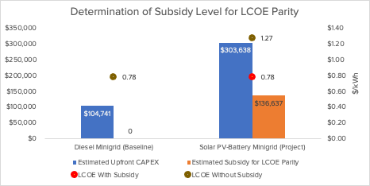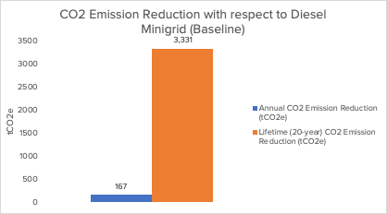

Note: The estimates of number and type of clients and electricity consumption per type of client have been taken from the Appendix to Annex G

- Based on estimated electricity demand from each of the minigrid customers over a 20-year period, the model estimates the pilot’s indicative RE minigrid would be a system with a solar PV capacity of 104 kW and battery storage capacity of 252 kWh. For comparison, a baseline, notional, diesel-only minigrid serving the same set of customers would have a capacity of 80 kW/64 kVA.
- This minigrid would serve an indicative market comprised of 200 residential, 5 social, and 9 commercial/PUE customers. Therefore, the indicative minigrid system would benefit a total of 1,047 people (5 people per residential connection, 4 people for each social sector connection, and 3 people for each commercial/PUE connection).
- A total estimated CAPEX of USD 303,638 is required to set up the pilot’s indicative RE minigrid based on an average CAPEX cost of USD 2,920 per kW of installed solar PV capacity.

Step 2 –Estimating required subsidy levels based on LCOE parity between the pilot’s indicative RE minigrid and its baseline – a referential diesel-based minigrid.

- The LCOE of the pilot’s indicative RE minigrid has been estimated at USD 1.27/kWh whereas the LCOE of the diesel baseline is estimated at USD 0.78/kWh. Thus, a subsidy of 45% of upfront CAPEX costs (USD 136,637) is necessary for the pilot’s indicative RE minigrid to achieve LCOE parity with a comparable diesel-based minigrid (the baseline) as shown in Box 58.

Pilot 2 – PUE overlay

Pilot 2, a PUE Overlay pilot, is expected to result in direct GHG ER of 784 tCO_{2e} over the technology’s 20-year lifetime. It will enable two PUE end-users (connections) to upgrade solar-powered PUE equipment/appliances for income-generating activities (milling) and provide access for new minigrid end-users (28 connections). It is expected to add 0.044 MW of solar PV and 0.108 MWh of battery storage capacity to accommodate new PUE connections. This will benefit a total of 326 direct beneficiaries that are already or will get connected to the minigrid to which the PUE Overlay will be added.

The pilot’s estimated targets are based on an indicative ‘inverse PUE Overlay’, i.e. a (custom-sized) minigrid system described in Box 59 added to an existing PUE (mill), whose solar PV system will be upgraded and expanded. With the INV budget (USD 115,449) allocated to Pilot 2, and assuming that this entire amount will be used as CAPEX subsidy for PUE equipment/connection costs and incremental minigrid CAPEX, it is estimated that a total of 2.3 indicative RE minigrids (PUE Overlays) can be supported under this pilot. Each of the pilot’s indicative PUE Overlays is expected to benefit a total of 140 direct beneficiaries by improving access for the existing 28 connections and stimulating demand for 2 new PUE connections. Due to additional RE generation, this will result in 17.0 tCO_{2e} annual direct GHG ER (or 341 over a 20-year period). The details on calculations for each indicative minigrid system (PUE Overlay) are provided below and the methodology used is described in Annex H.5

Step 1 – Defining the characteristics (size, cost) of an indicative Solar PV battery minigrid and its baseline - a referential diesel-based minigrid.

- A PUE Overlay consisting of 2 new commercial/PUE users is added to an indicative existing RE minigrid - assumed to be serving a market of 25 residential, 0 social, and 3 commercial/PUE customers - bringing total connections from 28 to 30.
- As a result, the pilot’s indicative RE minigrid (with PUE Overlay) would benefit a total of 140 people (5 people per residential connection, 4 people for each social sector connection, and 3 people for each commercial/PUE connection).
- Based on estimated electricity demand from each of the 30 minigrid customers over a 20-year period, the model estimates the pilot’s indicative RE minigrid (with PUE Overlay) would be a system with a solar PV capacity of 41 kW and battery storage capacity of 100 kWh. For comparison, a baseline, notional, diesel-only minigrid serving the same set of customers would have a capacity of 32 kVA/25 kW.
- The model calculates the incremental capacity required to add the 2 new PUE Overlay end-users to an existing minigrid. The incremental RE capacity to accommodate additional commercial/PUE connections is estimated at 19 kW and 47 kWh of Solar PV battery storage respectively.
- A total estimated minigrid CAPEX of $51,268 is required to set up the pilot’s additional minigrid capacity to accommodate new PUE end users. This is based on an average CAPEX cost of $2,698 per kW of incremental installed solar PV capacity.
Box 59 Indicative MG system – Pilot 2

Input |  | Indicative Minigrid (Values)
Type of Pilot |  | PUE Overlay
Technology: |  | Solar PV Battery
Market size (standard/custom) |  | Custom-sized
Existing RE minigrid target market  (# connections) | Residential | 25
Existing RE minigrid target market  (# connections) | Social | 0
Existing RE minigrid target market  (# connections) | Commercial/PUE | 3
Existing RE minigrid target market  (# connections) | Total | 28
PUE Overlay (# connections) - Incremental | Rice/Grain Mill | +2
PUE Overlay (# connections) - Incremental | Commercial fridges | +0
PUE Overlay (# connections) - Incremental | Egg incubation | +0
PUE Overlay (# connections) - Incremental | Incremental | +2
Indicative RE minigrid (Existing + PUE Overlay) beneficiaries  (# people) | Residential | 125
 | Social | 0
 | Commercial/PUE | 9 + 6 = 15
 | Total | 140
Existing minigrid (before PUE Overlay) | Solar PV (kW) | 22
Existing minigrid (before PUE Overlay) | Battery (kWh) | 53
Pilot’s Indicative RE minigrid system size (serving existing customer base and PUE Overlay) | Solar PV (kW) | 41 total  +19 incremental
 | Battery (kWh) | 100 total  +47 incremental
Notional diesel-only minigrid system size (Baseline) | Genset (kVA) | 17
Notional diesel-only minigrid system size (Baseline) | Genset (kW) | 13
LCOE Comparison | Indicative RE Minigrid (USD/kWh) | 1.24
LCOE Comparison | Diesel Baseline Minigrid (USDkWh) | 0.74
Subsidy levels | For Minigrid CAPEX (LCOE parity) (%) | 50%
Subsidy levels | For PUE CAPEX | 100%
CAPEX | Average Minigrid CAPEX cost (USD/kW) | 2,698
CAPEX | Minigrid CAPEX (USD) | 51,268
CAPEX | PUE CAPEX (USD) | 24,000
CAPEX | Total CAPEX (USD) | 75,268
CAPEX | Of which Project CAPEX subsidy (USD) | 49,634
Direct GHG ER - Incremental | Lifetime (tCO2e) | 341.00
Direct GHG ER - Incremental | Annual (tCO2e) | 17.0

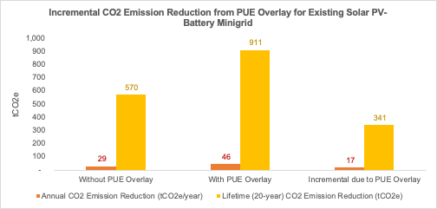

Note: The estimates of number and type of clients and electricity consumption per type of client have been taken from the Appendix to Annex G

- The model also considers CAPEX related to the PUE equipment for each of the new commercial/PUE connections. As such, a total estimated PUE CAPEX of USD 24,000 is required to purchase PUE equipment/appliances which will be made available to end-users; this is based on an average CAPEX cost of $12,000 per equipment/appliance.

Step 2 – Estimating required subsidy levels.

- The LCOE of the RE minigrid is estimated with and without the PUE Overlay. The PUE overlay results in an LCOE reduction from $1.24/kWh to $1.20/kWh due to improved minigrid capacity utilization. For reference, the LCOE of the diesel baseline (comparable to the pilot’s indicative RE minigrid including PUE Overlay) is estimated at $0.71/kWh. Thus, a subsidy of 50% of upfront CAPEX costs would be necessary for the pilot’s indicative RE minigrid to achieve LCOE parity with a comparable diesel-based minigrid (the baseline). Therefore a 50% subsidy is applied for incremental RE capacity. The cost of the already installed PUE equipment and part of solar PV has already been covered by ZCF.

Step 3 –Estimating direct GHG ER for the pilot’s indicative RE minigrid.

- Direct GHG ER from the pilot’s indicative RE minigrid are estimated by comparing the GHG emitted between the project scenario (with PUE overlay) and baseline scenario (without PUE overlay). The model estimates annual GHG ER of 247 tCO2e without the PUE overlay and 265 tCO2e with PUE overlay. Therefore, the pilot’s GHG ER are estimated at 17 tCO2e annually, or 341 tCO2 over the technology’s 20-year lifetime as shown in Box 59.

Indirect greenhouse ER

- Indirect GHG ER are the result of investments in RE minigrids that are expected to occur in the 10 years after the project has ended due to enabled investment environments for minigrid development to which the project has contributed.
- It is estimated that 51 MW of installed solar PV capacity could be installed after the project implementation period ends; this is assuming minigrids will help electrify 2,549,648 people which is 29% of the rural unelectrified population (25% of the total unelectrified population).
- Assuming a 20-year technology lifetime period, these RE minigrids will reduce 119,154 tCO_{2e} annually resulting in 2,383,080 tCO_{2e} of emissions reduced over the technology’s 20-year lifetime.
- A causality factor of 30% is used to estimate what percentage of these emissions reductions can be attributed to enabling conditions to which the project has contributed. As a result, a total of 714,924 tCO2e of emissions reductions can be attributed to the project.
- Since 90% of the project’s estimated indirect GHG ER are allocated to the project and 10% to the AMP regional Project, the project’s indirect GHG ER are thus estimated at 643,432 tCO_{2e.}

  - Differences with respect to PIF targets

This section explains the differences in targets between the PIF and the CEO ER phase.

Pilot-derived targets

At CEO ER stage, direct GHG ER are higher than at PIF stage due to a higher allocation of GEF INV to Component 2. Main differences are:
- At PIF stage, it was estimated that GEF INV USD 405,217 would be used to provide CAPEX subsidies to cover 50% of the CAPEX needed to develop 7.8 greenfield minigrid sites.
- At CEO ER stage, its estimated that GEF INV $650,000 would be used to provide CAPEX subsidies under Component 2, as follows:
  - GEF INV USD 534,551 would be used to provide CAPEX subsidies to cover 45% of the CAPEX needed to develop 3.9 greenfield minigrid sites
  - GEF INV USD 115,449 will be used to cover 100% of PUE CAPEX needed to overlay PUE equipment upon 2.3 existing minigrid systems and 50% of the incremental minigrid CAPEX.

Other changes or differences worth highlighting are explained below.

Diesel emission factor. GHG emission reduction estimation at PIF stage was based on the amount of electricity units generated from the minigrid multiplied with diesel emission factors to arrive at GHG ER estimates. The methodology used here is comparable to the one used during PIF stage, but it is more detailed due to the use of different emission factors for different types of customers (as required by the UNFCCC methodology). This results on average, in a higher diesel emission factor than the one used at PIF phase.

CAPEX Subsidy levels. The AMP Financial Model takes a different approach at estimating CAPEX subsidy levels than the one used at PIF stage. This approach results in a level of subsidy which, for greenfield minigrid pilots, is a function of the difference in the levelized cost of electricity (LCOE) between the pilot’s indicative RE minigrid and a notional diesel-only minigrid (the baseline). As such, the model estimates for each of the greenfield minigrid pilots, the LCOE of the renewable energy minigrid and of a diesel-only minigrid serving an equivalent market, and the resulting level of subsidy (as a % of CAPEX) required to make the renewable energy minigrid LCOE equal to that of the diesel-only minigrid. For PUE overlay pilots, the assumption is that 100% of the PUE equipment and connection costs are covered via subsidy.

People served per kW of installed capacity. Assumptions on the number of people served by each minigrid have been revised downward with respect to PIF stage. At PIF phase each of the project’s minigrid systems was assumed to have 10 kW of installed solar capacity and serve a population of 100 households or 500 people per minigrid. This resulted in an implicit assumption at PIF phase of 50 people served per kW of installed capacity. At CEO ER stage, the assumption is that each greenfield minigrid will serve 10 people per kW of installed capacity while the PUE Overlay minigrids will serve 3.4.

Indirect GHG ER

Indirect GHG ER were calculated using a similar methodology as used for the PIF but updating the following assumptions:
- Unelectrified population and electrification figures as per the SDG7 Tracking Progress 2022 Report.
  - At PIF phase, the number of people to be electrified by minigrids (2,679,000 people) was calculated by applying a minigrid electrification factor of 25% to the total unelectrified population as per SDG7 Tracking progress Report 2020 (17,680,000 people).
  - At CEO ER phase, unelectrified population figures have been updated based on the SDG7 Tracking progress Report 2022 leading to an estimated 2,549,648 people to be electrified by minigrids.
- The fossil fuel emissions factor was revised from 0.786 tCO_{2e}/MWh to 0.741 tCO_{2e}/MWh. This is based on IEA recommendation on diesel based stationary electricity generation (which in turn uses IPCC recommended value).

  - Methodology for calculating GEF targets

This section describes the methodology, inputs and assumptions used to estimate project targets including pilot-derived targets and indirect GHG ER.

Note regarding pilot co-financing

Pilot-derived targets have been estimated for the minigrid pilot as a whole, including both project funding and co-financing. The project will provide a partial CAPEX subsidy for minigrid pilots to cover a fraction of the upfront investment costs. Consequently, the remaining investment costs not covered by the project’s CAPEX subsidy will have to be funded by other sources which will be considered co-financing for the project.
Box 60 System sizing calculation

System sizing formula – solar PV

System sizing formula - battery

The battery capacity configuration was estimated using the formula below:

$$Battery Capacity for a Solar PV-Battery system\left(kWh\right)= Average daily electricity consumption in Year 3 \left(kWh\right)× Night time fraction \left(\%\right)× Night time demand to be met by battery (\%)÷(Usable Energy \left(60\%\right))×(1+Battery Oversizing Factor)$$

Battery capacity configuration is based on the expectation that a percentage of the minigrid night-time electricity consumption in Year 3 (100% if Solar PV-battery; 70% if Solar PV-Battery Diesel) will be met by battery and the assumption that only 60% of installed battery capacity can be utilized to supply customer demand due to limitations of typical battery discharge depth. Night-time electricity consumption is estimated as 40% of the average daily electricity demand. An overall oversizing factor (75% if Solar PV-battery; 10% if Solar PV-Battery Diesel) is applied to account for increased night-time electricity demand and battery capacity degradation over the years assuming a 13 year battery lifetime.
The Solar PV capacity configuration was estimated using the formula below:

$$Solar PV Capacity for a Solar PV Battery system \left(kW\right)= Daily electricity consumption in Year 3 \left(kWh\right)× Seasonal Multiplier \left(1.28\right)÷\left(1-Losses Factor \left(8\%\right)\right)÷Daily peak sun hours \left( hours\right)×(1+Solar PV Oversizing Factor)$$

Solar PV capacity is a function of:
Electricity demand parameters – namely, the expected daily average electricity consumption in Year 3 (kWh/year)
Weather parameters – namely the average Solar Irradiation (daily average number of hours of peak sun at a solar radiation of 1 kW/m2) received by the proposed minigrid pilot location (or a provincial/national average if an exact minigrid pilot location has not been defined), a Seasonal multiplier to account for solar irradiation variations throughout the year, and a generation and distributions losses factor.
Technical parameters – an overall system oversizing factor (75% if Solar PV-battery; 50% if Solar PV-Battery Diesel) to account for Solar PV output degradation as PV modules become older, and the capacity needed to charge the batteries.

Methodology for estimating pilot-derived targets (Direct GHG ER increase in RE capacity, and number of direct beneficiaries)

The AMP Financial Model uses pilot- and country-specific inputs (where available), and various other generic inputs from different sources, and adopts a 3-step process to estimate pilot-derived project targets, namely direct GHG ER, increase in RE capacity, and number of direct beneficiaries.

Calculations (Steps 1 – 3) are done at the individual minigrid level for an indicative minigrid system. Depending on the available budget, required CAPEX subsidy levels, and minigrid CAPEX requirements, a pilot may be able to support one or more such indicative minigrids. Similarly, a project may have one or more different pilots. Therefore, project targets are the result of aggregating (i) targets from all minigrid systems under each pilot, and (ii) targets from all pilots considered under the project.

Step 1 – At the minigrid level - Defining the characteristics (size, cost) of an indicative Solar PV battery minigrid and its baseline - a referential diesel-based minigrid.
- Based on assumptions regarding the target market that the minigrid pilot will serve (i.e. number of customers by segment, average electricity demand, demand growth), the model estimates the system size that would be required to meet electricity demand from the minigrid customers. This is done both for the pilot’s indicative RE minigrid and a notional diesel-only minigrid (the baseline);
- For the solar PV battery minigrid system sizing, the model uses customized demand metrics and typical average load profiles of different customer types (i.e., residential, commercial/PUE, social) to estimate optimized Solar PV battery system size configuration using the formulas described in Box 60
- Based on system sizing and cost inputs, the model estimates the capital expenditures (CAPEX) required to set up these minigrid systems and the operational expenditures (OPEX) required to operate and maintain them.

Box 60 provides inputs used to determine system sizing (load profile of the customers, day-night usage split, capacity utilization factor and system oversizing requirement to compensate for yield degradation and internal electricity losses) of the indicative pilot minigrid, and to estimate the capital expenditures (CAPEX) and the operational and maintenance costs (OPEX) for the indicative pilot minigrids.

Step 2 – At the minigrid level - Estimating required subsidy levels based on LCOE parity between the pilot’s indicative RE minigrid and its baseline – a referential diesel-based minigrid.
- The model uses a combination of generic and country-specific inputs to calculate the Levelized Cost of Electricity (LCOE) in US$/kWh for the pilot’s indicative RE minigrid and the diesel baseline. The LCOE is the price that would have to be charged for the electricity to allow for cost-recovery of all costs (CAPEX, OPEX and financing costs) over a 20-year period timeframe;
- Financing costs are estimated based on a capital structure that reflects a pre-derisking scenario in which debt is not readily available to finance minigrid investments and instead, minigrid investors have to finance projects with 100% Equity;
- The resulting LCOEs are compared to estimate the CAPEX subsidy that would be required for the pilot’s indicative RE minigrid to reach LCOE parity with the diesel baseline; the level of CAPEX subsidy required is expressed as an absolute dollar amount as well as a % of CAPEX and is a key factor to determine how many minigrids can be supported with the project’s available budget.

Box 60 gives the inputs used to estimate the Weighted Average Cost of Capital (WACC) for the minigrid investments analyzed.

Step 3 – At the minigrid level – Estimating direct GHG ER for the pilot’s indicative RE minigrid.

- Estimation of GHG ER is based on fossil fuel emission factors for various consumer types as per AMS-III.BB: Electrification of Communities through grid extension or construction of new minigrids. This methodology is applicable to project activities involving the electrification of a community of consumers (each consumer with a single electrical connection to a grid) through either: (a) Extension of an existing grid (national, regional or minigrid); or (b) Construction of a new minigrid. No leakage or project activity emissions were considered.
- To that end, the model calculates GHG ER as a function of renewable electricity generated from the solar PV- battery minigrid over a 20-year period and a baseline emission factor which for residential consumers is chosen based on their average annual electricity consumption (a combination of 6.8, 1.3 and 1.0 tCO_{2e/}MWh) and for non-residential users is 1.0 tCO_{2e}/MWh.
- The model calculates total annual renewable electricity generation, as required to meet customer demand for the pilot’s indicative minigrid, using the formula describedbelow

Power Generation from pilot’s indicative RE minigrid
Annual renewable electricity generation is derived from the following formula:

$$Annual RE power generation \left(kWh\right)= Annual electricity consumption of minigrid consumers in year y \left(MWh\right)÷\left(1-Loss Factor\right)×Renewable energy fraction of total power generation \left(\%\right)$$

- Special considerations for PUE Overlay pilots. The model calculates GHG ER as a function of incremental renewable electricity generated from the PUE Overlay over a 20-year period. It compares and calculates the difference between the GHG emitted in the project scenario (existing Solar PV Battery minigrid system with PUE overlay) and the baseline scenario (existing Solar PV Battery minigrid system).

The following are the different emission factors by customer segment as per AMS-III.BB: Electrification of Communities through grid extension or construction of new minigrids. It is assumed that all consumers (Type I (household) and Type 2 (non-household) will have metered connections for simplicity reasons.

Input | Units | Values (all pilots)
Emission Factor (for GHG ER calculations)
Residential (<55 kWh annual consumption) | - | 6.82
Residential (55-250 kWh annual consumption) | - | 1.30
Residential (>250 kWh annual consumption) | - | 1.00
Commercial | - | 1.00
Industrial | - | 1.00
Social | - | 1.00

Methodology for estimating Indirect GHG ER

Indirect GHG ER were estimated using a top-down approach, on the basis that the project contributes to an enabled environment which subsequently attracts investment in RE minigrids adding Solar PV installed capacity over a 10-year post-project period. Indirect emissions mitigation from these minigrids is calculated over their technology lifetime of 20 years.
- The methodology assumes that minigrids will electrify either 33%, 25% or 15% (in this case 25%) of the rural unelectrified population according to the latest ‘SDG7 Tracking Progress Report’ published in 2022. This is referred to as the minigrid electrification factor. The selection of this minigrid electrification factor was based on several criteria, including (1) current levels of grid coverage; (2) recent and ongoing initiatives for grid extension; (3) geographical size of countries; and (4) spread of off-grid communities in terms of population density.
- The total number of people to be electrified via minigrids is estimated based on the minigrid electrification factor and the rural unelectrified population.
- The number of minigrids and solar PV capacity required to electrify this population, as well as the total RE annual generation from these minigrids are calculated, assuming an indicative RE minigrid with an Average Minigrid System Size of 10 kW/minigrid, serving 100 households/minigrid, and a load factor of 0.36.
- GHG ER due to RE generation are estimated using a fossil fuel emissions factor of 0.786 tCO2e/MWh over the minigrids’ technology lifetime of 20 years.
- Thereafter the methodology applies a causality factor that indicates what percentage of the estimated indirect GHG ER can be attributed to the project; this factor varies between 20% and 80% for AMP national projects depending on the state of the minigrid market and ongoing baseline initiatives in each country; for this project it was estimated at 50%.

Box 61 Inputs used to determine system sizing, CAPEX and OPEX, and WACC

Input |  | Units | Pilot 1 |  |  | Pilot 2
Average daily consumption by customer segment/type
Residential | kWh / day |  |  |  | 0.82 |  |  | 0.82
Social | kWh / day |  |  |  | 1.2 - 2.4 |  |  | Not applicable
Commercial | kWh / day |  |  |  | 0.5 - 10.32 |  |  | 8.29
Productive users | kWh / day |  |  |  | Not applicable |  |  | 20.25
Day/Night consumption Split
Day Time Electricity Consumption | % |  |  |  | 60% |  |  | 60%
Night Time Electricity Consumption | % |  |  |  | 40% |  |  | 40%
Connection of customers to the minigrid
% of total demand - Year 1 | % |  |  |  | 75% |  |  | 75%
% of total demand - Year 2 | % |  |  |  | 85% |  |  | 85%
% of total demand - Year 3 | % |  |  |  | 100% |  |  | 100%
Technical inputs
Solar Irradiation (kWh/m2) | kWh/m2 |  |  |  | 1850 |  |  | 1850
Solar Capacity Utilization Factor % | % |  |  |  | 21% |  |  | 21%
Seasonal Multiplier | - |  |  |  | 1.28 |  |  | 1.28
Usable Battery Energy % | % |  |  |  | 60% |  |  | 60%
Battery Oversizing % | % |  |  |  | 75% |  |  | 75%
Diesel Generators Power Factor | - |  |  |  | 0.8 |  |  | 0.8

Input |  | Units |  | Pilot 1 |  | Pilot 2
RE Minigrid Operations & Maintenance (OPEX)
Annual Insurance Costs as % of Minigrid Capex |  | % upfront CAPEX |  | 2% |  | 2%
Annual O&M Costs as % of Minigrid Capex |  | % upfront CAPEX |  | 2% |  | 2%
Number of kWh per Liter of Fuel (only if Solar PV-hybrid MG) |  | kWh / Liter of diesel |  | 3.5 |  | 3.5
Fuel Cost Per Liter (only if Solar PV-hybrid MG) |  | US$ / Liter of diesel |  | 1.00 |  | 1.00
RE Minigrid Capital Expenditures (CAPEX)
Site Development |  | US$ / kWp |  | 140 |  | 140
Electricity Generation |  | US$ / kWp |  | 440 |  | 440
Electricity Storage |  | US$ / kWp |  | 1,282 |  | 1,305
Electricity Distribution |  | US$ / kWp |  | 257 |  | 13
Other Costs - Transport, Installation, Soft Costs, Duties etc. |  | US$ / kWp |  | 800 |  | 800
Total CAPEX per kWp |  | US$ / kWp |  | 2,920 |  | 2,698
Input | Units |  | Values (all pilots)
RE Minigrid Financial structure and costs
Equity % | % |  | 100%
Debt % | % |  | 0%
Cost of Equity % | % |  | 25%
Loan Tenor (Years) | Years |  | 8
Interest Rate % | % annual |  | 20%
Weighted Average Cost of Capital (WACC) | % annual |  | 25%

- Project staff, consultancies and subcontracts

A) Key project staff

Project Coordinator/Manager (PM) - Full time (48 months)

The Project Manager (PM), together with the Lead Advisor will be responsible for the overall management of the project, including the mobilization of all project inputs, supervision over project staff, consultants and sub-contractors.
Duties and Responsibilities

- Manage the overall conduct of the project.
- Plan the activities of the project and monitor progress against the approved work plan.
- Execute activities by managing personnel, goods and services, training and low-value grants, including drafting terms of reference and work specifications, and overseeing all contractors’ work.
- Monitor events as determined in the project monitoring plan, and update the plan as required.
- Provide support for completion of assessments required by UNDP, spot checks and audits.
- Manage requests for the provision of UNDP financial resources through funding advances, direct payments or reimbursement using the FACE form.
- Monitor financial resources and accounting to ensure the accuracy and reliability of financial reports.
- Monitor progress, watch for plan deviations and make course corrections when needed within project board-agreed tolerances to achieve results.
- Ensure that changes are controlled and problems addressed.
- Perform regular progress reporting to the project board as agreed with the board, including measures to address challenges and opportunities.
- Prepare and submit financial reports to UNDP on a quarterly basis.
- Manage and monitor the project risks – including social and environmental risks - initially identified and submit new risks to the Project Board for consideration and decision on possible actions if required; update the status of these risks by maintaining the project risks log;
- Capture lessons learned during project implementation.
- Prepare revisions to the multi-year work plan, as needed, as well as annual and quarterly plans if required.
- Prepare the inception report no later than one month after the inception workshop.
- Ensure that the indicators included in the project results framework are monitored annually in advance of the GEF PIR submission deadline so that progress can be reported in the GEF PIR.
- Prepare the GEF PIR;
- Assess major and minor amendments to the project within the parameters set by UNDP-GEF;
- Monitor implementation plans including the gender action plan, stakeholder engagement plan, and any environmental and social management plans;
- Monitor and track progress against the GEF Core indicators.
- Support the Mid-term review and Terminal Evaluation process.
- Consult with the project board through the National Project Director for any issues that require their attention, including issues related to deviation from the approved work plans and its tolerance (e.g., deviation from the approved target, and/or budget); and
- Perform project management duties on UNDP’s ERM (ATLAS) in line with the NIM manual and as outlined in the delegation of authority for the Project Manager.
- Ensures effective monitoring of project performance, and the preparation of high-quality and results-oriented progress reports.

The following are AMP-specific tasks that will take a minimum of 10% of the person’s time allocated to AMP Regional Project activities:
- Liaise with the AMP Regional Project PMU Staff to request and receive operational and technical support as needed, to participate in activities led by the AMP Regional Project, and share data and information with the AMP Regional Project as required.
- Identify best practices and lessons learnt from the project and from other initiatives that can be helpful to the project in achieving its goals and objectives; Lead in generating knowledge products such as best practices and lessons learned for knowledge sharing; and Contribute to knowledge networks and communities of practice.

Project financial-administrative assistant

Duties and Responsibilities

It should be noted that a minimum of 10% of the person’s time will be allocated to AMP Regional Project activities. Under the guidance and supervision of the Project Manager, the Project Assistant will carry out the following:

Administrative
- Assist the Project Manager in day-to-day management and oversight of project activities;
- Assist the M&E officer in matters related to M&E and knowledge resources management;
- Assist in the preparation of progress reports;
- Ensure all project documentation (progress reports, consulting and other technical reports, minutes of meetings, etc.) are properly maintained in hard and electronic copies in an efficient and readily accessible filing system, for when required by PB, TAC, UNDP, project consultants and other PMU staff;
- Provide PMU-related administrative and logistical assistance.

Financial
- Keep records of project funds and expenditures, and ensure all project-related financial documentation are well maintained and readily available when required by the Project Manager;
- Review project expenditures and ensure that project funds are used in compliance with the Project Document and GoI financial rules and procedures;
- Validate and certify FACE forms before submission to UNDP;
- Provide necessary financial information as and when required for project management decisions;
- Provide necessary financial information during project audit(s);
- Review annual budgets and project expenditure reports, and notify the Project Manager if there are any discrepancies or issues;
- Consolidate financial progress reports submitted by the responsible parties for implementation of project activities;
- Liaise and follow up with the responsible parties for implementation of project activities in matters related to project funds and financial progress reports.
- Liaise with the AMP Regional Project PMU Staff to request and receive operational and technical support as needed, to participate in activities led by the AMP Regional Project, and share data and information with the AMP Regional Project as required.

Pilot project and monitoring coordinator - - Full time (48 months)

Description of responsibilities:

The incumbent will be responsible for the implementation of Outcome 2, including assistance to mobilize all component resources, and supervision of consultants and sub‐contractors. Under the direction of the PM, the Demo Project Coordinator will liaise with the national and local governments, UNDP, and all stakeholders involved in Outcome 2 of the project. She/he will be specifically responsible for:
    - Overall management of component 2, in particular by providing technical guidance on the planning of the pilot and demonstration projects (Output 2.1) and investment replication plan (Output 2.2)
    - Oversee and guide the design of surveys/ assessments commissioned for monitoring and evaluating project results;
(c) Provide technical support on the formulation of Call for Proposals text and annexes (such as site information)
(d) Coordination of technical and organisational institutional aspects of component 2 (demo/pilots) under the PM
(e) Supervise monitoring and evaluation of pilot/demo activities of Component 2
Monitor project progress and participate in the production of progress reports ensuring that they meet the necessary reporting requirements and standards; Ensure project’s M&E meets the requirements of the Government, the UNDP Country Office, and UNDP-GEF; develop project-specific M&E tools as necessary; Oversee and ensure the implementation of the project’s M&E plan,
(f) Ensuring management of component funds consistent with UNDP requirements, and budget planning and control.
(g) Assisting the PM in the submission of progress reports and key‐issues reports to the PB (PSC)
(h) Undertaking other activities as assigned by the PM.

Lead (technical) Advisor - (part-time, 20 working days a year)

Description of responsibilities:

Under the overall supervision of the Project Manager, the non-resident Lead (technical) Adviser will:
- Provide guidance and assistance to the PM and project staff to ensure that the project activities conform to the approved project document;
- Assist the PM during the initiation of the project, in the preparation of an “inception report” which will elaborate on the project Logical Framework Matrix and planned project activities, the Annual Work Plan and Budget, ToRs for key project staff, and an M&E plan;
- Assist the PMU in the development of relevant ToRs and recruitment/mobilization of qualified national and international experts and organizations as needed to provide specific consultancy and engineering services;
- Support formulation of plans for operating minigrid pilots at different scales (including techno-economic modelling, financial feasibility assessment and tariff setting in support of business model design, impact of demand stimulation and PUE and integration of PUE/demand stimulation financing with minigrid financing,
- Support the PM in reporting to the PB on the progress of project implementation and achievement of project results in accordance with the project's logical framework matrix, including guidance to the PMU on the tracking and measurement of project success indicators, e.g., energy savings and substitution, GHG emission reduction
- Support the PMU in project-related meetings, as required;
- Review reports of national and international consultants, project budget revisions, and administrative arrangements as required by UNDP/GEF procedures;
- Assist the M&E expert in the development of a concrete Monitoring and Evaluation Plan at the outset of the project (as part of the inception report);
- Support the PM in preparing project progress reports, and in the preparation and implementation of Mid-Term Review and Terminal Independent Evaluation Missions (TOR’s, identification and recruitment of appropriate candidates, organization of missions, joint field missions and discussion with evaluators, etc.)
- Assist in preparation of the project scale-up and roll-out plan, including preparation of project results/impacts communication articles

B) Consultants and contracts

The table below gives an overview of short-term staff and subcontracts hired with GEF funding.

Consultants | Inter-national | National | Main tasks
Consultants | (person.weeks) |  | Main tasks
DREI consultants and innovative financing | 8 | 6 | - The expert will work with UNDP DREI team and local contracted part in applying the DREI methodology and carry out analysis on mini-grids:  - Risk environment. Data collection and market research to assess the risk environment and develop DREI financing cost waterfalls to describe the contribution of risk to financing costs.  - Public instrument selection. Overview of the public instruments in place and an assessment of the risk mitigation potential of instruments  - Levelised cost of electricity (LCOE) modelling.  - Evaluation and sensitivity analysis  - Cross-cutting activities e.g. developing and maintaining an Assumptions Book and feedback on the methodology for continual improvement  - Preparation of a DREI Report for minigrids in Zambia that consists of an Executive Summary (~20 pages) report, a final report ([indicate format: Word/PowerPoint/other]) together with completed financial tools, and an Annex capturing the assumptions behind the analysis; Assist in organising round table workshops for the dissemination of DREI analysis  - S/he will advise on the design and structuring of financial instruments (loans, guarantee schemes) with financial service providers and work closely with the entity contracted on financing and financing models
Stakeholder engagement |  | 12 | - Support the team and consultants with designing a capacity-building programme for various groups of stakeholders, i.e. training and workshops on RE planning, design, implementation, operation and maintenance as well as financing of RE projects.  - Provide expert stakeholder engagement guidance and support to the PMU in needs assessments, community engagement (consultation and information sharing) for pilots and for MG replication
MG design, business and replication | 6 | 12 | - Provide, as-needed, modelling expertise for pilot project development and replication (pre-feasibility studies) including data capture, monitoring and analysis; technical demand-supply modelling (e.g., with PVSys or other software),
MG GIS and agro value chains | 2 | 8 | - Based on existing GIS models (USAID, World Bank) deliver data overlays and map analysis for minigrid potential in Zambia linked with kinked with statistics (from ZamStat), GIS data and maps of other development thematic areas (agricultural value chain; social services such as clinics and schools; mobile network data) and provider data overlay to existing WB modelling on value chain, rural enterprises, social services and least-cost electrification options
Gender and social- environmental safeguards (combined or two separate positions) |  | 12 | The expert(s) will:  - Advise on the socio-economic profile of the households in the targeted villages, households' income and ability to pay in Project villages, use of electricity in the Project villages, as well do an assessment of the impact of electricity on changing lives and the gender dimension in energy demand and supply and the role of women in operating the energy systems and developing income-generating activities  - Monitor progress in implementation of the project Gender Action Plan and of SESP/ESMF and update and suggest a revision of corresponding management plans as necessary;  • Advice on implementation of all gender-related work; Advice on safeguards-related work  - Ensure social and environmental grievances are managed effectively and transparently;  - Ensure environmental and social risks are identified, avoided, mitigated and managed throughout project implementation;  - Work with the M&E officer to ensure reporting, monitoring and evaluation fully address the safeguard issues of the project  • Work with the M&E/Pilots officer and other consultants to ensure reporting, monitoring and evaluation fully address the gender and safeguards issues of the project;
QA, digital strategy | 4 |  | Expertise will be required (on an as-needed basis and obtained in consultation with the regional AMP) in:  • Designing the QAMF to correspond and integrate with the regional framework  • Ensuring data quality, integrity and compliance of project monitoring, reporting and verification when integrated with AMP  • Designing the digital strategy and MRV framework
Review and evaluation | 10 | 8 | - External (independent) consultants for mid-term review and terminal evaluation
 | 30 | 54

Contract | Value  (USD) | Description
Support for DREI analysis | 5,000 | - Full DREI analysis for (solar PV-battery) minigrids in Malawi, including:  o Risk environment. Assist with data collection and gathering of market information, facilitate the scheduling and arrangement of meetings and set up interviews aimed at quantifying the contribution of risk to financing costs in the country. Participate in meetings and interviews.  o Public instrument selection. Assist in the development of a baseline view on public instruments and collecting data on costs and benchmarks to inform the costing of public instruments.  o Levelised cost of electricity (LCOE) modelling and evaluation. Assist in gathering data and assumptions for the baseline technology and solar PV-battery minigrids.  - Preparation of the DREI Report for solar PV-battery minigrids in Malawi with review and comments or inputs as relevant.
Call for Proposals, minigrids | 265,000 | - Depending on the size and investment needs of the pilot minigrids, a number of contracts will be awarded to successful bidders to design, build and operate a the renewable energy minigrid system, either in private sector-delivery or PPP modality.
Website portal development and maintenance |  | - Develop an online portal for REA Calls for Proposals for ensuring transparency and integration with digital platforms currently used (Edison) or regionally (Odyssee);  - Update, maintain and expand the existing offgrid.gov.zm website as well as REA website and develop into a repository of minigrids in Nigeria based on the results of the pilots and other Project activities. respectively. The repository can be in one of two forms, namely: (i) updating the repository that already exists at FMP; and
Innovative financing |  | - Support the project in carrying out a barrier and risk review on financial issues and options regarding MG (and PUE) development  - Provide inputs in relation to innovative financing models for MG assets of the pilots and replication, and possible combination with (micro)-financing for PUE and efficient appliances  - Capacity building on financing for project stakeholders for Project-supported pilots and minigrids on business models and financial structuring  - Capacity building on financing of MGs (and PUE) for financial sector stakeholders

- Gender analysis and action plan

  - Gender mainstreaming analysis

Zambia’s latest (2018) Gender Inequality Index (GII) value of 0.540 (close to the SADC regional average of .573) reflects inequalities between men and women in parliament, health, and education, as well as labour markets. Though the country has made notable strides in improving gender equality recently, notably in the domains of education and health, challenges still exist.

Norms and Legal Regime
The constitution establishes the principle of gender equality. When amended in 2016, additional articles related to gender equality were included. The legal system, a blend of English common law and customary law, is not fully protective of women’s rights, however, and some gender discrimination persists. In practice, women may experience a range of traditional socio-cultural practices alongside certain statutory protections, with the latter generally weaker in rural areas compared to urban ones.

There are over 70 ethnic groups and three rough classifications of inheritance systems (matrilineal, patrilineal, and bilateral) in Zambia, though all three systems are patriarchal (male-dominated) in nature. Traditional leaders have significant influence and governance roles in their communities, especially regarding the allocation of land and land deeds. Certain customary practices, left to the discretion of local leaders, derive women’s access to land through their male relatives, leaving women vulnerable to having that access revoked if their family situation changes. Even in some cases where women are the recognized owners of land, it is widely accepted that male relatives will control the use of the land. While land ownership rates are low among both sexes, women constitute almost three-quarters (74 percent) of those who don’t own any land.

Both civil and customary marriages are recognized, providing one example of the contradictions embedded in the dual legal system. Thus, though the statutory legal age for marriage is 21, a child can be entered into a customary marriage upon reaching puberty. The payment of a traditional lobola, or bride price, especially as the practice has evolved in recent times, can have the effect of cementing women’s subordinate position in marriages according to focus groups of women and men in Lusaka, resulting in “limiting women’s rights to children, women being viewed as husbands’ property, limiting women’s decision making power, limiting women’s control on sexual matters, compelling women to do more housework… among others.” In effect, it strengthens patriarchal norms and encourages the treatment of married women as property. In 2018, 47 percent of women, and 32 percent of men, aged 15-49 considered wife-beating justified in specific cases.

Other social beliefs that remain strongly held among significant portions of the population include that having children with disabilities is a divine punishment, that menstruating women and girls are unclean and must stay isolated, and that a girl’s place is in the kitchen.

Health
Females in Zambia face an overall lower mortality risk than males. Life expectancy at birth in Zambia is 64 years, 67 for women and 61 for men and the infant mortality rate per 1,000 live births is 42, 38 for girls and 45 for boys (2020). Thirty-five percent of children under 5 exhibit stunting (38% of boys and 31% of girls), with the greatest prevalence in the Northern and Luaula Provinces. Factors inversely correlated with stunting include the availability of improved drinking water, age and education of the mother, and household wealth. The lifetime risk of maternal death has been decreasing steadily for the last two decades from roughly 3% in 2000 to 1% in 2017.

HIV/AIDS remains the leading cause of death, with women more affected than men; accidents and injuries are the second leading cause of death for men while tuberculosis is the second most prevalent cause of death for women. The FAO (2018) reports, “The fact that HIV prevalence is consistently higher in women than in men demonstrates the existence of the underlying causes of transmission which include among others, Gender-Based Violence (GBV), low income, harmful gender norms including those that reinforce the submissive role of women, low status and unequal power relations within heterosexual relations, cross-generational sex, and concurrent partnerships which leads to increased vulnerability of women to HIV infection.”

Family Formation
In 2018, 56 percent of women and 50 percent of men reported being married, and more women than men reported being divorced/separated (10 percent v. 4 percent) and widowed (3 percent v. less than 1 percent). The majority (72 percent) of small and medium farm households are headed by men while 28 percent are headed by women. Western province has the highest percentage of households headed by women (35 percent), followed by Southern province (31 percent).

Among individuals ages 25-49, the median age of first marriage is 19 years for women and 24 years for men; 9% of women were first married and 6% had started childbearing by age 15. Eleven percent of married women aged 15-49 reported having co-wives, with the phenomenon being more prevalent in rural areas, especially in the Southern Province, and in instances when women report having no education. Early childbearing is extremely dangerous for both young mothers and their offspring. Early marriage and polygyny can be indicative of women having reduced autonomy and bargaining power within their households.

The figure in Box 62 shows that married women overall are more involved in daily spending decisions, but major purchases are more likely to be decided jointly or by their spouses. From the project’s perspective, this has implications for demand estimation, marketing, and financing of electric appliances and productive use equipment for mini-grid customers.

The fertility rate in Zambia remains significantly higher in rural areas (5.8 births per woman) compared to urban ones (3.4 births), the overall desired fertility rate (5.0 across rural areas and 2.9 in urban ones) is lower than the actual one, and men on average desire more children. The dependency ratio, the number of dependent young (<15) and old (>64) individuals per working-age individual, has been falling since 2010 and as of 2020 stands at 0.86. Female potential beneficiaries may have difficulty managing care responsibilities and project activities at the same time unless thoughtful accommodations are made; or, they may need to take periodic breaks to give birth or care for other family members and then resume project activities later on.
Box 62 Married women ages 15-49 who participate in decision-making at the household level

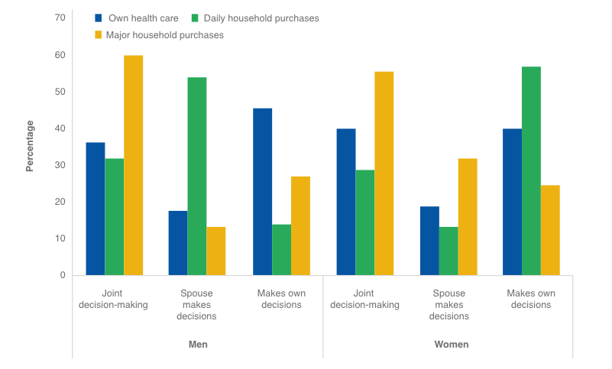
Source: Zambia Demographic and Health Survey 2018, in Ministry of Gender, “Gender Status Report 2017 – 2019.”

Forty-seven percent of ever-married women report having experienced physical, sexual, or emotional violence by their current or most recent husband or partner. For this reason, it’s important that project interventions include consultations with all household and community members and be sensitive to the possibility that project activities (e.g., additional time commitments) or outcomes (e.g., additional income) could trigger intimate partner violence.
Box 63 Labour force participation rate (percent) by rural/urban and sex (2020)

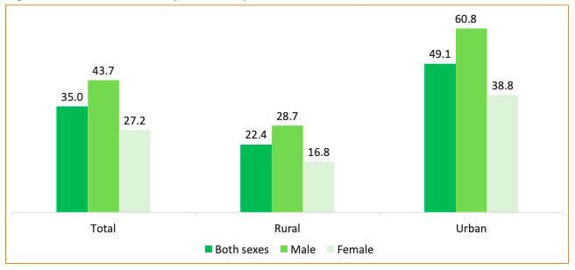
Source: 2020 Labour Force Survey, Zambia

Economic Considerations
Fifty-nine percent of the population was below the poverty line ($1.90, 2011 PPP) in 2015, but in rural areas, the poverty rate is higher. Rural poverty is closely tied to agricultural yields in any given year, which is closely tied to climatic conditions. Women have much more difficulty escaping from rural poverty than men because the most promising avenues of escape—namely non-farm income-generating activities and accumulation of land (and the ability to irrigate it)—are areas in which they struggle to reach parity with men. Thus, these are issues a minigrid program can try to address (e.g., by working with local leaders to guarantee access to land, freeing up women’s time to diversify their livelihood strategies, and providing complementary inputs needed to succeed in non-farm businesses).
Box 64 Gender balance of select occupational categories in rural Zambia, 2020

Female-dominated |  |  |  | Male-dominated (selected)
Sector | Female | Male |  | Sector | Male | Female
Wholesale and retail trade; repair of motor vehicles and motorcycles | 58% | 42% |  | Mining and quarrying | 91% | 9%
Accommodation and Food service activities | 76% | 24% |  | Construction | 100% | 0%
 |  |  |  | Transport and storage | 93% | 7%
 |  |  |  | Real estate | 88% | 12%
 |  |  |  | Activities of extraterritorial organisations and bodies | 100% | 0%
 |  |  |  | Manufacturing | 59% | 41%
Source: 2020 Labour Force Survey

In rural areas, 61 percent of the labor force is male and 39 percent female. The segment of the economy with the greatest number of workers in rural areas is “Agriculture, forestry, and Fishing” (approximately half a million employed persons, or 48% of the labor force) and this sector is 65% male, 35% female. There is significant gender segregation in a number of rural occupations (see Box 64).

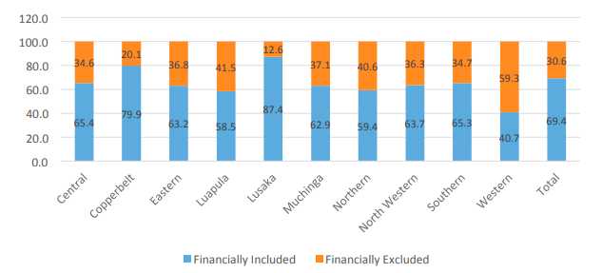
As for financial inclusion—which can influence an individual’s ability to connect to a mini-grid, purchase electrical appliances and equipment, and start or grow an electricity-enabled enterprise—Zambia exhibits both urban-rural and gender gaps, though financial inclusion is trending upwards across all demographics. In 2020, the urban-rural gap (84 percent v. 56 percent) was significantly larger than the gender one (68 percent of women and 71 percent of men), with the Western Province notably trailing the rest of the country (see Box 64).
Box 65 Gender balance of select occupational categories in rural Zambia, 2020

Source: FinScope 2020 Topline Findings

Rural female heads of households accessed agricultural loans at only slightly lower rates than male heads (15 percent v. 17 percent), but those individuals with larger parcels got larger and more formal loans; men on average control larger parcels than women. The Rural Agricultural Livelihoods Survey does not track agricultural credit access by women living in male-headed households, who anecdotally struggle to finance improved inputs for their plots.

Despite being formally counted among the financially included (i.e., having a bank account or access to micro-loans), many female entrepreneurs according to the Zambia Federation of Associations of Women in Business (ZFAWIB) report that it is more difficult for them than their male counterparts to access affordable, sufficiently sized SME loans from financial institutions. In 2018, the Bank of Zambia launched a gender unit to examine gendered patterns in access to finance.

Zambia has very high levels of female entrepreneurship. Though recent data is scarce, in 2013, Zambia’s total early-stage entrepreneurial activity ratio (the percent of individuals 18-64 with a new business venture) was 40 percent, and women outnumbered men (104:100), though women were slightly less likely than men to be driven by opportunity (93:100), as opposed to necessity.

Energy
Ensuring the mini-grid program achieves gender diversity and balance in the value chain is possible but will require deliberate outreach to actively recruit women and men with the required passion and aptitude. According to the 2020 Labour Force Survey, the “Electricity, gas, steam and air conditioning” industry only counts 686 workers in rural areas but is closer to being gender-balanced (60 percent male, 40 percent female) than even the agricultural sector (65 percent male to 35 percent female). Even with notable recent progress towards gender balance in the energy sector additional effort is needed to reach 50-50 targets, and to ensure women work in high value-add energy sub-sectors, technical roles, and leadership positions at rates similar to their male colleagues. There are numerous examples of female leaders and role models in the solar energy and mini-grid space for the project to draw on (see Box 66).
Box 66 Select examples of women leaders in renewable energy
• Likonge Makai Mulenga, an electrical engineer with extensive experience in the mining sector, prestigious Fellow of the Engineering Institution of Zambia, and PhD candidate, founded a non-profit, LiChi’s Community Solution (LSC) that designed, built and managed solar village kiosks. Created using a fee-for-service model, these projects electrified a community school and established an information and technology center, provided pumped water, offered battery-charging for phone and kits, and more. Eng. Likonge is focused on the gender-, holistic community development, and productive use aspects of energy systems as well, for example working on “the first solar reticulation and bio-digester drier fish hatchery in Chingola district with 125 rural women trained and women out grower scheme using bio-slurry as manure to improve crop yield.”
• Mukabanji Mutanuka was responsible for the technical and financial design of off-grid innovations for the Power Africa Off-Grid Energy Challenge before leading business and commercial development for PowerCorner, a mini-grid developer with operations in Zambia. She is deeply involved in developing innovations around supplying mini-grid customers with ultra-efficient, appropriate appliances, either through cash purchase or lease-to-own arrangements, and supplying electricity-enabled services, such as water, wi-fi, and more. She views customers as key partners of PowerCorner; when they are able to improve their livelihoods it makes PowerCorner’s operating model more financially sustainable. For this reason, she prioritizes investing in education and training of both household and commercial customers. Households learn about energy efficiency and electrical safety, for instance, and business clients receive training on equipment usage and maintenance, how to make electricity use profitable, and even how to improve their overall marketing and accounting capabilities.
Source: Kamwi, “Woman Engineer Lights Up Zambia’s Rural Community” and frica Secretariat LEDS GP, Webinar.

Box 67 Gender analysis of Zambia's first solar PV mini grid
A 2019 study examined the gender implications of modern energy transition in the context of the Mpanta solar mini-grid, a 60 kW installation sponsored in 2013 by REA with support from UNIDO and GEF, in a fishing village in the northeastern part of the country. Local governance and operational support were provided by Kafita Multi-Purpose Cooperative.
The study found that women’s lived energy experience changed relatively little post-intervention as their primary energy tasks, related to cooking, remained unchanged and they by and large were unable to take advantage of new opportunities created by electrification.
The authors write:
“…the transition to more modern energy services is far from gender neutral: despite providing broad benefits within the community, the benefits derived from a new technology and service were not evenly distributed between men and women due to broader socio-cultural practices and norms.” For example:
- Where there was electric appliance uptake, these were predominantly used by men, though some women would listen to the radio while cooking.
- Gendered spaces remained gendered, both at home and in public, and electrification patterns and priorities reflected the “value” accorded by a patriarchal society to those spaces.
  - At home, women and girls still spent more time in the kitchen (which would have an electric light if covered by a roof and close to the main house) and men spent more time in the lighted living room where the TV and/or radio would also be located if the house had one.
  - Men also retained their privileged access to formal businesses premises, while women’s economic activities would take place in informal, ad hoc settings. As such, it was mostly male shopkeepers who took advantage of electrification opportunities. Even though there was a local women’s farming collective and savings and loans group, it did not finance business upgrades and electrification opportunities for its members.
Men and women in the community both desired a larger capacity mini-grid, but they expressed different preferences for future energy services.
- Men wanted electricity for use with equipment like hammer mills, welders, and refrigerators, that could reduce their physical strain, increase their business productivity, or allow diversification into new products and services.
- Women overall wanted technology that could reduce the physical strain and time required for harvesting firewood and cooking.
Source: Kamwi, “Woman Engineer Lights Up Zambia’s Rural Community” and frica Secretariat LEDS GP, Webinar.

Nationally, 8 percent of the population is estimated to have access to clean and affordable fuels for cooking, but only 1.5 percent of the rural population has such access, meaning over 98 percent of the population there relies on biomass or charcoal. Women undertake the majority of fuelwood collection and cooking tasks, sometimes with assistance from men and children. An estimated 8,227 deaths were attributable to Household Air Pollution (HAP) in 2016 in Zambia, and these were roughly split between males and females.

REA has already begun conducting research, awareness-raising, and user-acceptance exploration for high-efficiency electric pressure cookers. They have identified locally available technology (in Lusaka) that they consider promising vis-à-vis performance, robustness in the field, and price-point, and are eager to continue their user acceptance testing. Among peer nations, Zambia has higher than average rates of cooking with electricity (16 percent of households nationally, 34 percent across urban areas, and 41 percent in Lusaka). The upshot of this is that there is significant awareness already of e-cooking as an aspirational fuel and the market for e-cooking appliances is relatively well-developed. On the other hand, the government is wary of e-cooking uptake because of issues related to demand management.

A recent (2021) study of three sites in Western and Northern Provinces correlates the beginning of the cooking fuel transition there (i.e., from collected fuelwood to purchased charcoal) with the phenomenon of rural out-migration, suggesting that the household labor constraint (i.e., fewer members available for chores), and to a lesser extent increased income through remittances, contribute to the switching, which is a gradual process involving fuel stacking. If clean e-cooking pilots are pursued under the program, it may be advisable to initially target either small households (i.e. that are labor-constrained), households receiving remittances or who have higher-than-average income within the community, or households where women already have established economic activities (i.e., there is a clear opportunity cost for their time) as the most promising route to sustained adoption.

Agriculture
An estimated 90 percent of rural agricultural households grow maize; 56 percent grow groundnuts; and 35 percent grow cassava. Compared to other some other countries, there does not appear to be strong gendering of crop production or differences in yields between male- and female-headed households, though this may disguise discrepancies at the plot level, particularly when women struggle to compel and/or direct male labour on their own plots.

Institutional and Policy Framework
Chiefs in Zambia can greatly influence the lives of citizens, especially those in rural areas, making them key stakeholders in advancing gender equality. In other countries in southern Africa, it is perceived that female chiefs have made significant contributions to gender equality, especially in the areas of reducing child marriage and promoting education. In Zambia, however, despite the existence of matrilineal traditions, there are very few female chiefs, especially at the upper echelons, and power structures remain mostly patriarchal (see Box 68).

Zambia established a Ministry of Gender in 2012. However, it faced “financial, institutional, and technical capacity challenges, such as inadequate funding and human resource capacity to effectively implement its programme,” and was dissolved in 2021. At present, the portfolio is handled by a cabinet office, the Gender Division, that works with line ministries on gender equality priorities.
Box 68 Gender of chiefs by year in Zambia

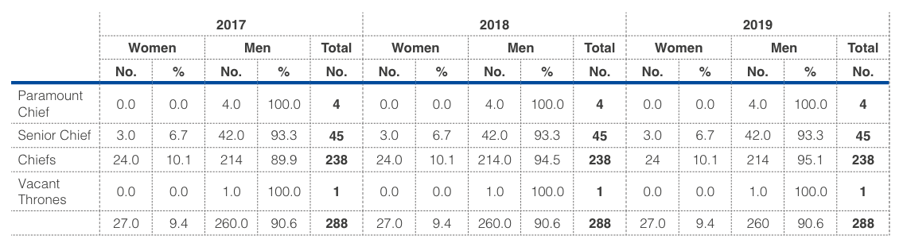

Source: Ministry of Chiefs and Traditional Affairs, 2019 (in Ministry of Gender, 2020)

The National Gender Policy (2014) states that there has been a historic focus on energy for industrial development at the expense of domestic use. Despite mentioning there are connections between gender, energy access, and energy development, it does not offer specific, detailed actions to advance gender equality in the energy sector.

The National Energy Policy includes a specific objective on gender mainstreaming and specific measures related to affirmative action, gender analysis of programs, and promotion of gender and energy research. The latest revision of the National Energy Policy in 2019 reaffirms the linkages between energy, poverty, and inequality, and the disproportionate impacts sustained by women; it also contains provisions related to local content and the promotion of citizen-owned entities active in the power sector.

The Gender Equity and Equality Act (2015) calls for mainstreaming gender in all strategies, policies, programs and budgets; it also requires public and private bodies to set targets for women’s representation and develop gender action plans to improve the inclusivity and safety of work environments.
Box 69 Main messages from IAEREP gender assessment report

Key Findings |  | Key Recommendations
- Men and women have different energy needs  - Energy for cooking is overlooked  - There is a lack of institutional capacity in gender mainstreaming  - Gender-blind legislation and policies  - Stakeholder-led energy and gender platform not active any more  - Sex-disaggregated data and gender-sensitive indicators are lacking  - There is increased gender balance on Energy Boards but few measures in place to address women’s low representation in the workforce  - Sexual harassment policies are missing  - No measures are in place to promote gender equality in procurement  - Pro-poor approaches are increasingly being used by energy service companies |  | - Prioritize energy for cooking  - Increase use of complementary services to maximize impact  - Increase women’s representation in workforce  - Offer training in gender mainstreaming  - Support M&E units for gender-sensitive data collection  - Make procurement gender-sensitive  - Use gender certification procedures for programs and projects  - Revive the Zambia Gender and Energy Network

Source: Ministry of Chiefs and Traditional Affairs, 2019 (in Ministry of Gender, 2020)

REA is one of the few institutions in Zambia that has a dedicated gender policy. It conducted, with partners, a comprehensive gender assessment for its IAEREP program. The top findings from that report are presented in Box 69.

Regarding recommendations #1 and #8, these are being partly addressed at present. The Zambia Gender and Energy Network (ZGEN) was established in 2004 within the Ministry of Energy and Water Development, and with external support from ENERGIA. In 2011, ZGEN spearheaded the development of a national Gender and Energy Mainstreaming Strategy. At some point, ZGEN fell apart due to a change of funding priorities of ENERGIA’s donors, but it was recently relaunched by USAID as part of the Alternatives to Charcoal (A2C) project focused on clean cooking.

The Non-Governmental Gender Organisations Coordinating Council (NGOCC), founded in 1985, exists as an umbrella network of over 100 nongovernmental, faith-based, and community-based organizations. It has a presence in 62 districts across all 10 provinces. NGOCC and REA have executed an MOU focused on increasing the uptake of household electricity and productive use.

  - Gender action plan (GAP)

Efforts will be made to make every part of the Zambia Mini-grid Program gender-aware, inclusive, and equitable, recognizing that doing so is not just the ethical course of action but also the one most likelihood to ensure that program outcomes are achieved. Gender mainstreaming in this program falls along two main axes: 1) making sure that men and women are included at all phases of consultation, design, and implementation, and 2) promoting equitable benefit incidence between men and women.

1. To ensure widespread participation and inclusion, the program should:
- Invite women and women’s groups’ representatives to all project-related discussions, meetings and events, whether at the national or community level; if women are unable to attend (e.g., for financial, transportation, time, childcare reasons), find out why and collaboratively address the barrier
- Encourage women to elevate and amplify each other’s voices within meetings by providing speaking opportunities and targeting at least 60-40% gender balance
- Use the program as a platform to promote female role models, connect women and key professional networks in the sector, and foster mentoring opportunities for students and young professionals
- Analyze both women’s and men’s issues (separately and how they intersect) when undertaking any kind of study (DREI, site/feasibility analysis, outcome harvesting or other program monitoring)
- Engage with male stakeholders, particularly chiefs and family members, to explain the program’s gender approach, listen to their concerns and ideas, and ultimately build consensus around women’s inclusion and empowerment

2. To promote equitable benefit incidence:
- Foreground gender differences when thinking about what individuals need (e.g., financial literacy, credit, decision-making power within their family, established business track record, professional networks) in order to be able to derive benefits from the pilot programs, tendering, and financing opportunities offered by the program; accommodate those differences during design and implementation
- Leverage program investments in electrification to address women’s (and households’) single greatest energy need – cooking energy.

An e-cooking pilot will seek to create a field-based learning laboratory to answer fundamental questions about the uptake of e-cooking technology in a mini-grid setting in Zambia. High-efficiency e-pressure cookers are already popular in the country, especially in urban areas, and have the potential to solve major environmental and public health challenges while relieving households of significant drudgery. Initial modelling performed during this project design phase suggests that the adoption of e-cooking can act as a cost-reduction lever for mini-grid development in Zambia (by increasing utilization and driving down tariffs). Thus, the pilot will explore the following research questions:
- What are the factors that promote or impede rural uptake of e-cooking practices?
- To what extent can mini-grid technical design specifications be matched to this new type of demand, the dynamics of which may be poorly understood (i.e., how many users will acquire appliances, to what extent will they continue to fuel stack, when will they cook with the appliances, etc.)

MECS (Modern Energy Cooking Solutions) has already done significant research on e-cooking in Zambia that can serve as a starting point and they should be considered as a key ally, if not potential partner, going forward.

Because the use of e-cooking with mini-grids is nascent, it is recommended that the program evaluation remain somewhat open-ended (e.g., using outcome harvesting) to explore the effects of the pilot on mini-grid technical and financial performance, end-user satisfaction and quality of life, and environmental sustainability. Digital data loggers that track usage and time of use for a sample of appliances may be a useful tool to employ.

Due to the risk of outstripping electricity supply, in the case the demand for e-cooking is stronger than expected, it is recommended to attempt the first pilot within an existing community where there are pre-existing mini-grid assets with excess/unutilized capacity.

Initial activities can focus on establishing the community’s familiarity with the technology. These might include, among others: short- and long-term user acceptance testing panels, a series of village cooking demonstrations, cooking contests with prizes, and grant-based use of appliances in homes of community leaders or in social institutions (churches, schools). The extent to which users are willing to shift cooking times based on time-of-use tariffs can also be explored, as can so-called “collaborative consumption” practices.

Willingness to pay surveys can be used to establish baseline expenditures on cooking energy, both monetary and time expenditures. A catalogue of costs and benefits anticipated from e-cooking can also be developed with respondents, for example: additional time available for farming, lower probability of girls missing school, decreased risk of children being burned, etc. Household cash flows (daily, weekly, seasonal) can also be examined so that willingness to pay is also characterized by its temporal aspect.

If there is consumer interest and willingness to pay, the next step is to explore the combinations of subsidy (if any: CapEx, usage tariff, interest rate, etc.) and end-user financing packages that could support market-based distribution of the appliances. This can be done in close consultation with local microfinance providers, savings groups, or agricultural cooperatives. Program timeline permitting, the program can begin to facilitate these transactions, for example, by engaging with finance providers to educate them about the demand for the product and the results of the willingness to pay study, or possibly even backstopping the transactions by providing portfolio guarantees or product guarantees (product breakage being a significant cause of defaults).

Finally, the program can engage with local mini-grid developers, national policymakers, financial institutions, product manufacturers, product distributors, and the regional AMP to share what has been learned from the e-cooking pilot, including user preferences, drivers of uptake, characterization of demand, level of complementary supports required, and assistance in incorporating e-cooking, if warranted, into mini-grid system modelling, demand management, and marketing.

Outcome 1 |  | Gender Mainstreaming Objective
Stakeholder ownership in a national minigrid delivery model is advanced, and appropriate policies and regulations are adopted to facilitate investment in low-carbon minigrids |  | Gender diversity and balance in national dialogue, with women’s and men’s concerns addressed in equal measure, leading to gender-aware policies and regulations (i.e., not gender-blind or gender-neutral)
Outputs | Gender Actions | Suggested Indicators | Suggested Targets | Budget
1.1 An inclusive national dialogue to identify minigrid delivery models is facilitated, clarifying priority interventions for an integrated approach to off-grid electrification | Participation by NGOCC and ZGEN and their memberships in Task Force events, working groups, steering committees, etc.  Mainstreaming of gender into each subject matter discussion | M/F membership  M/F representation on committees, boards, etc.  M/F event attendance  M/F presentations, speaking roles  % of presentations, discussions, reports etc. that include a discussion of gender aspects | 40% M/F balance  100% of topics, discussions, reports acknowledge gender aspects | USD 10,000
1.2 Minigrid DREI techno-economic analyses carried out to propose most cost- effective basket of policy and financial derisking instruments | Assess level of perceived risk associated with female minigrid developers  Assess whether minigrids serving large(r) numbers of women’s enterprises, or women’s domestic energy needs, require alternative financing and subsidy structures | None | None | USD 10,000
Component 2 |  | Gender Mainstreaming Objective
Innovative business models based on cost reduction are operationalized, with strengthened private sector participation in low-carbon minigrid development. |  | A) Business models developed with participatory input succeed in addressing the energy needs of both women and men achieve an equitable benefit distribution  B) Women and men equally implicated in electricity supply via mini-grid (and related) businesses
Outputs | Gender Actions | Suggested Indicators | Suggested Targets | Budget
Pilots developed, including on productive use/innovative appliances and modular hardware/system design, leading to cost-reduction in minigrids (INV) | Ensure mini-grid pilot plan is consistent with REA Gender Policy and objectives; letter of no objection obtained from NGOCC and ZGEN  Gender review of digital tendering platform (functioning and applicant requirements)  Deliberate outreach and support to female potential mini-grid sponsors  Requirement that submitted proposals be gender-responsive and include gender action and management plans  Inclusion of e-cooking activities as part of at least one pilot | Y/N objection letter  Y/N gender review of platform performed  M/F sponsored applications to tendering platform  M/F successful application to tendering platform  % Proposals received that are gender-responsive and include credible action & management plans  % Proposals accepted that are responsive with credible plans  No. e-cooking devices used on trial basis, sold (cash and finance), and still in use after one year  Usage/performance data collected on e-cookers and effect on mini-grid (for digital platform & learning) | No objection  Gender review performed  At least 40% F applicants  At least 40% F awardees  80% of proposals received are gender responsive with credible action & management plans  100% of accepted proposals are responsive with plans  50 trial-use e-cookers  50 sold e-cookers  80% of sold e-cookers still in use after 1 year | USD 20,000  (as part of pilot with e-cooking, see Box 16)
Pre-feasibility conducted for selected minigrid sites and replication plan for minigrid development | Mainstream gender and intra-household dynamics into demand estimation, willingness to pay, load profiles, etc. What would these estimates be in the absence of gender inequality? To what extent would initiatives to dismantle gender inequality improve the feasibility of minigrids? | % Feasibility studies mainstreaming gender | 100% of feasibility studies | No additional budget, covered under main activity
Component 3 |  | Gender Mainstreaming Objective
Financial sector actors are ready to invest in a pipeline of low-carbon minigrids and concessional financial mechanisms are in place to incentivize scaled-up investment. |  | Financing channels tailored for women and men resulting in equitable access to financing products and services
Outputs | Gender Actions | Suggested Indicators | Suggested Targets | Budget
Innovative financing solutions for minigrid development are identified and designed with supporting human and institutional strengthening | Differentiated analysis of barriers faced by male and female minigrid developers, enterprise customers, and domestic end users  Gender-inclusive design of national financing window (appropriate products, tailored processes, reasonable criteria, strategic partnerships with existing financial inclusion initiatives, heavy marketing to underserved borrowers/investees/grantees) | Y/N Gender-differentiated analysis  Y/N Gender-inclusive window design | Gender-differentiated analysis  Gender-inclusive design | USD 5,000
Domestic financial sector capacity-building on business and financing models for minigrids | Capacity building of financial institutions and initiatives with female-majority client-bases  Education of domestic financial sector on specific issues/barriers faced by female-led SMEs and how to address them | # of institutions supported with female majority client bases  # of institutions supported to work with female borrowers | TBD  TBD | USD 5,000
National report on opportunities to boost economic activities through electricity access and productive use and financial support mechanisms | Gender mainstreaming in report, for example including analysis of intra-household labor allocation, role of land tenure, shadow prices, latent demand, etc. | Y/N | Gender mainstreamed in report | No additional budget, covered under main activity
Component 4 |  | Gender Mainstreaming Objective
Digitalization and data are mainstreamed, across stakeholders, into local minigrid market development. Increased knowledge, awareness and network opportunities in the minigrid market and among stakeholders, including benefitting from linkages to international good practice |  | Ensure digital capabilities don’t unintentionally discriminate, violate user privacy, or serve as tools of coercive control
Outputs | Gender Actions | Suggested Indicators | Suggested Targets | Budget
A project digital strategy is developed and implemented, including linkages to and following guidance from the AMP Regional Project | Digital strategy evaluates the risks that smart meters, digital pre-payments, location data, payment data, could disadvantage or endanger women (e.g., who may have lower access to phones, mobile banking, whose family members could remotely disable power, who could be offered less favorable commercial terms, who could be remotely tracked, etc.) | Y/N risks evaluated and accounted for | Risks evaluated and accounted for | No additional budget, covered under main activity
A ‘Minigrids Digital and Data Management Platform’ implemented to run tenders and manage data from pilots, and to support minigrids scale-up and cost-reduction | Same as above  E-tendering module evaluated to ensure that female applicants have equal opportunity, including recourse and advising if stuck in process (website technical issue or substantive question); use of focus groups and beta testing | Y/N platform evaluated; necessary adjustments made | Platform evaluated and necessary adjustments made | USD 10,000
Quality Assurance and Monitoring Framework for measuring, reporting and verification is adopted and operationalized | None at this time | None at this time | None at this time | None at this time
Engage with regional project, via (i) Communities of Practice and (ii) capturing and sharing lessons learnt | Establish a gender community of practice  Ensure that events, especially in-person ones, are gender-balanced in their attendance  Ensure gender is mainstreamed into the Insight Brief | Y/N gender-themed community of practice  M/F attendance at events  Y/N gender mainstreamed into Insight Brief | Gender-themed community of practice  At least 40% female attendance  Gender mainstreamed into Insight Brief | USD 10,000
Component 5 |  | Gender Mainstreaming Objectives
Monitoring and Evaluation
Outputs | Gender Actions | Suggested Indicators | Suggested Targets | Budget
Ensuring compliance with all mandatory monitoring and reporting requirements of the GEF | Expand on GEF Core Indicator #11 (number of beneficiaries disaggregated by gender) to include metrics (or alternatively qualitative outcome harvesting) related to the degree of benefit received. For example…  For a residential connection:  - Do household members use and benefit from electricity in equal measure?  - Who decided which appliances to acquire?  - Who paid for the connection and appliances?  - Who keeps the appliances and connection in case of divorce or widowhood?  For commercial connection:  - What was the increase in total factor productivity pre- and post- connection?  For institutional connection:  - What is the gender split of patients/students/clients making use of electricity-enabled services?  - Do the various demographics benefit equally? | TBD, but related to extent of benefit | Gender equity | USD 15,000

Appendix Gender-relevant bibliography

Light Up Zambia. “About LCS.” Accessed June 18, 2022. https://lightupzambia.org/about-lcs/.
AECOM International Development Europe SL. “Enhancement of the Policy, Legal and Regulatory Environment and Capacity Building for Renewable Energy and Energy Efficiency: Gender Assessment of the Energy Sector in Zambia (Version 2).” European Union, May 2019. https://www.moe.gov.zm/?wpfb_dl=52.
Africa Secretariat LEDS GP. Webinar: Mini Grids for Rural Electrification and Development, 2018. https://www.youtube.com/watch?v=yLfj43EIcDA.
Bank of Zambia. “FinScope 2020 Survey Report,” 2021. https://www.boz.zm/FinScope-2020-Survey-Report.pdf.
Chisumpa, Vesper H., Clifford O. Odimegwu, and Nandita Saikia. “Adult Mortality in Sub‐Saharan Africa: Cross‐sectional Study of Causes of Death in Zambia.” Tropical Medicine & International Health 24, no. 10 (October 2019): 1208–20. https://doi.org/10.1111/tmi.13302.
Diwakar, Vidya, Mitelo Subakanya, Mary Lubungu, and Antony Chapoto. “Rural Poverty Dynamics in Zambia: 2012-2019.” Chronic Poverty Advisory Network, 2021. file:///Users/jennyegreene/Downloads/RALS%20formatted_final.pdf.
FAO. “National Gender Profile of Agriculture and Rural Livelihoods - Zambia.” Country Gender Assessment Series, 2018. https://www.fao.org/3/i8461en/I8461EN.pdf.
GCF. “Gender Assessment and Action Plan: Zambia Renewable Energy Financing Framework.” Green Climate Fund, April 2018. https://www.greenclimate.fund/sites/default/files/document/gender-assessment-fp080-afdb-zambia.pdf.
GEM Global Entrepreneurship Monitor. “Entrepreneurship in Zambia.” Accessed June 17, 2022. https://www.gemconsortium.org/economy-profiles/zambia.
Indaba Agricultural Policy Research Institute. “Rural Agricultural Livelihoods Survey: 2019 Report,” 2019. http://www.iapri.org.zm/wp-content/uploads/2020/11/RALS_2019.pdf.
Johnson, Oliver W., Vanessa Gerber, and Cassilde Muhoza. “Gender, Culture and Energy Transitions in Rural Africa.” Energy Research & Social Science 49 (March 2019): 169–79. https://doi.org/10.1016/j.erss.2018.11.004.
Kamwi, Ruth Kanyanga. “Woman Engineer Lights Up Zambia’s Rural Community.” AboveWhispers (blog), December 19, 2016. http://abovewhispers.com/2016/12/19/woman-engineer-lights-zambias-rural-community/.
Kayombo, Monica. “Gender Mainstreaming through Clean Cooking.” Zambia Daily Mail, June 1, 2022. http://www.daily-mail.co.zm/gender-mainstreaming-through-clean-cooking/.
Malunga, Julia. “Parley Approves Turning Gender Ministry into Office of the President Dept, among Other Changes.” Zambia: News Diggers! (blog), September 15, 2021. https://diggers.news/local/2021/09/15/parley-approves-turning-gender-ministry-into-office-of-the-president-dept-among-other-changes/.
Mate, Lyatitima Ernest. “The Need to Foster Local Participation in the Zambian Power Sector Part 2: Review of the National Energy Policy 2019.” LinkedIn, May 8, 2020. https://www.linkedin.com/pulse/need-foster-local-participation-zambian-power-sector-part-mate.
McNeish, Hannah. “Malawi’s Fearsome Chief, Terminator of Child Marriages.” Accessed January 28, 2021. https://www.aljazeera.com/features/2016/5/16/malawis-fearsome-chief-terminator-of-child-marriages.
Ministry of Labour and Social Security, and Zambia Statistics Agency. “2020 Labour Force Survey Report,” n.d.
Moono, Patience, Kusanthan Thankian, Gaurav B Menon, Sidney O C Mwaba, and J Anitha Menon. “Bride Price (Lobola) and Gender-Based Violence among Married Women in Lusaka,” n.d., 11.
Mzumara, Bubile, Phoebe Bwembya, Hikabasa Halwiindi, Raider Mugode, and Jeremiah Banda. “Factors Associated with Stunting among Children below Five Years of Age in Zambia: Evidence from the 2014 Zambia Demographic and Health Survey.” BMC Nutrition 4, no. 1 (December 2018): 51. https://doi.org/10.1186/s40795-018-0260-9.
OECD Development Centre. “Social Institutions and Gender Index: Zambia,” 2019. https://www.genderindex.org/wp-content/uploads/files/datasheets/2019/ZM.pdf.
Oyama, Shuichi. “Renewed Patronage and Strengthened Authority of Chiefs Under the Scarcity of Customary Land in Zambia.” In African Land Reform Under Economic Liberalisation, edited by Shinichi Takeuchi, 65–86. Singapore: Springer Singapore, 2022. https://doi.org/10.1007/978-981-16-4725-3_4.
Republic of Zambia, Ministry of Gender. “Gender Status Report 2017 - 2019.” Accessed June 16, 2022. https://www.giz.de/en/downloads/giz2021_en_Zambia_Gender_Report_2017-2019.pdf.
Scott, Nigel, and Lloyd Archer. “Basic Use of Electricity for Cooking (Zambia).” MECS, November 2021.
UNdata. “Gender Inequality Index,” 2019. http://data.un.org/DocumentData.aspx?q=gender+inequality+index&id=415.
WHO. “Household Air Pollution Attributable Deaths.” Accessed June 12, 2022. https://www.who.int/data/gho/data/indicators/indicator-details/GHO/household-air-pollution-attributable-deaths.
World Bank. “World Development Indicators | Data,” 2022. https://data.worldbank.org.
Wu, Yu, Barbara Entwisle, Cyrus Sinai, and Sudhanshu Handa. “Migration and Fuel Use in Rural Zambia.” Population and Environment 43, no. 2 (December 2021): 181–208. https://doi.org/10.1007/s11111-021-00385-7.
Zambia Statistics Agency, Ministry of Health, and ICF. “Zambia Demographic and Health Survey 2018,” 2020. https://www.dhsprogram.com/pubs/pdf/FR361/FR361.pdf.

- Stakeholder engagement plan

  - Stakeholder engagement plan

Introduction
This Stakeholder Engagement Plan (SEP) for the Africa Minigrids Program (AMP) in Zambia defines how the AMP will identify and engage key stakeholders, and integrate their inputs into project implementation and risk management. Implementation of this plan will provide stakeholders with meaningful access to dialogue and decision-making in the development and implementation of the project. By providing channels for all stakeholders, including the disadvantaged and vulnerable, effective stakeholder engagement helps to ensure understanding, acceptance, and ownership of the project, thereby strengthening its benefits and sustainability.

Stakeholder engagement is an end in itself, ensuring that no one is left behind and that disadvantaged and vulnerable project stakeholders have a voice in project development and implementation. It is also a means for improving project design, identifying and managing risks, and ensuring transparency, accountability and integrity. In this light, one important purpose of this plan is to provide a feedback and monitoring mechanism to ensure the project is achieving its intended results and identifies potential unintended consequences.

The development and implementation of the SEP is part of the UNDP Social and Environmental Safeguards (SES) requirements. Hence, the presented SEP will be reviewed and updated during the social and environmental assessment processes required for the development of the project’s Environmental and Social Management Framework (ESMF).

Purpose and objective
Unlike grid-connected power plants, the successful operation of mini-grids requires continuous collaboration between operators and end-users. In the design of the pilots under the AMP in Zambia, it is important to understand the needs and priorities of ESPs, but also the needs and priorities of the communities in which the mini-grids will be located, to obtain the necessary local support and ensure sustainability and longevity of the intervention. ‘

Furthermore, the enhancement of the commercial viability of solar PV systems depends on the level of flow of information between stakeholders from the private sector and decision-makers in the public sector. This flow will guarantee that the decisions made are well-informed and constitute the best use of resources to serve the best interest of the country and beneficiaries. The flow will also guarantee that investors, developers and ESPs are actively engaged in the development of regulations governing the energy sector before they become legally binding and are allowed to utilize their technical expertise in the formulation of national plans and laws aiming to increase energy access rates and elevate the living conditions for populations in the rural areas. Hence, this SEP is developed to ensure tripartite engagement of public entities, private sector actors, and representatives of beneficiaries and potentially affected communities in all stages of pilot development and overall project implementation.

Project preparation
As part of the project development phase, and in addition to the desk review and data collection exercise, the PPG team of National and International Consultants identified key stakeholders and engaged with them in a series of in-person and online meetings. The purpose of these meetings was to share information about the ZMG Project, to seek first-hand information on baseline conditions and needs, and to scope out potential project activities and partnerships. The discussions also aimed to identify the gaps that the ZMG can work to fill, especially in the presence of several projects targeting energy access and renewable energy development financed by development partners besides UNDP and the GEF.

Last but not least, a stakeholder validation was organised in Lusaka (with presential and online attendance)

Project inception and implementation
The project will effectively engage the stakeholders involved in the project to get their support and guide the project implementation to achieve higher results.
- Project outreach proposed includes project website, media (print/audio-visuals), workshops, training, etc.
- The PMU and the Project Board will ensure that the Gender Action Plan recommended by the project is pursued and implemented. The various groups especially women will be engaged during the consultation meetings, prioritized to avail of the programme, and be included in the different capacity-building programs. The project will also ensure through the Off-Grid Task Force that the ZMG Project will be closely coordinated with the activities of NGOs, government bodies and development partners\
- Meetings, monitoring visits, surveys, and written communications will be used to receive feedback to continue the ongoing dialogue as well as during implementation.
- The project will follow a participatory approach in decision-making by engaging all the relevant stakeholders. Government agencies, NGOs, CSOs, and private sector actors will be actively involved during the project implementation.

A detailed list of stakeholders and their involvement in particular project outcomes and outputs are given in Box 22. The key indicator for the engagement of each group of stakeholders is their practical involvement in implementation and dissemination.

Category | Stakeholder or group
Government and public sector | - Ministry of Energy (MoE)  - Rural Electrification Authority (REA)  - Energy Regulation Board (ERB) and other agencies  - ZESCO Limited  - Off-Grid Task Force  - Other relevant ministries and agency, such as ZamStat (statistics); ZABS (standards); Ministry of Agriculture; Ministry of Commerce, Trade and Industry
Multilateral and bilateral development partners; Financial institutions | - World Bank (Incl. ESAP project)  - Power Africa, USAID  - Sweden, BGFA  - European Union (incl. IAREP project)  - KfW (Germany)  - African Development Bank (AfDB; incl. GCF-funded energy programmes)  - Development Bank of Zambia; Pension Fund  - Commercial banks
NGOs, universities; | - University of Zambia and other higher educational institutes  - Vocational education and training institutes  - Non-governmental organisation (women, youth, training, rural development)
Business and sectoral associations | - ZARENA (Zambia Renewable Energy Association)  - SIAZ (Solar Industry Association of Zambia (SIAZ)  - AMDA (Africa Mini-Grid Developers Associations  - Zambia Cooperative Federation
Direct beneficiaries | - Minigrid customers (residential, small commercial/PUEl; public services, other)  - Local community groups  - Recipients of project’s training and awareness-raising

The ZMG Project has not yet selected the specific localities for its planned pilot cooperative-led minigrids and associated productive use (Outputs 2.1). These localities will be selected from a list provided by MoWE at the inception of the project. At that point, the project will identify and connect with all local stakeholders, including both partners and beneficiaries.

Engagement methods and communication mediums
The following list presents the main engagement mediums to be utilized by the project team during implementation to ensure continuous engagement and active participation of stakeholders.
1) In-person meetings:
o Consultation workshops: These workshops will have a pre-structured agenda which will be designed to present a specific result/report and discuss with stakeholders the best way forward. These workshops will also be an opportunity to gain consensus from stakeholders on a specific action plan prior to proceeding with implementation. Therefore, stakeholder consultation meetings and workshops are included in the project design as part of the main activities to be carried out by the consultants in charge of each output.
o Interviews and focus group: These will be conducted with different groups of indirect beneficiaries, with special attention to ESPs and NGOs, to overcome their generally low participation capacity and ensure that their input is integrated in the different stages of project implementation. The Project Manager will be responsible for ensuring that these interviews and focus groups have been conducted by the responsible consultants, as appropriate.
o Community-based consultations: These consultations will focus on the pilot locations to identify and discuss stakeholder concern within the community environment, but will also extend to neighbouring villages and communities. The SES Officer will be responsible for conducting these consultations on a regular basis and reporting to the Project Manager and M&E Officer per the project’s ESMF.
2) Written communication:
- Emails: Email communication is widely used in Niger to provide direct access to individuals and representatives of organizations. Emails will be used as the main tool for organizing meetings, i.e. sending invitations to participants, sending the meeting minutes after the meeting, etc.
- Letters: Being the formal method for communication and conveying messages between public parties, letters will be requested by the project team and provided by the relevant authority, as appropriate.
- Survey forms: Several activities under the project implementation strategy constitute undertaking a needs assessment or other types of analyses, with some requiring a survey to collect information. The responsibility for the surveys is that of the consultant undertaking the analysis. However, the SES Officer will be responsible for supporting the project consultants with the sampling process and surveying procedure to ensure that the results are as representative and inclusive as possible.
- Project brochures and manuals to present the results of specific studies and outcomes of certain activities.

3) Online meetings and phone calls: Virtual communication is sometimes preferred since it is quicker and easier compared with email and letters, and is a viable alternative to in-person meetings. Online applications and telecommunication tools will be used throughout project implantation to facilitate the work and ensure the project team have easy access to stakeholders, and vice versa.

Although the mode of communication may vary according to task and participants, all consultations and engagement activities will be undertaken with the goal of ensuring full participation of relevant stakeholders, whereby all participants will be provided sufficient notice to prepare well and provide input for the project. Moreover, the AMP in Zambia project will also use all possible opportunities, i.e. workshops, meetings, training and awareness events, to promote diversity and gender balance. Balanced representation of relevant stakeholders will be ensured by reaching out to both men and women and different groups through appropriate communication mean and encouraging their participation, noting the most socially and culturally acceptable language and method of communication for each group of stakeholders.

Public disclosure of information
Project-affected, marginalized, and disadvantaged stakeholders at the pilot location will be identified during site selection and assessment, including persons with disabilities and other disadvantaged groups as per the list of stakeholder groups provided above. For each group, the following assessments will be conducted as part of the stakeholder engagement activities, taking into account their involvement in each project component:
- Identify limitations for understanding project information and participating in the consultation process (e.g. language differences, lack of transportation, accessibility of venues, disability, etc.)
- Develop measures to support and accommodate engagement, e.g. provide information in accessible formats, choose convenient locations for consultations, ensure venues are accessible, provide transportation to meetings, change the time of meetings to accommodate needs, provide facilitation and explain complex issues and terminology, provide support workers for assisting participants with disabilities, provide simultaneous interpretation (including sign language).
- On the national level, methods to receive feedback and to ensure ongoing communications with stakeholders (outside of a formal consultation meeting) will be developed as part of the project’s knowledge management and dissemination plans (to be developed as part of the implementation of Component 4).

Diversity, inclusion and gender-balance
The inclusion of women and other relevant groups will be made possible through enhancing opportunities, improving access to resources, making their voices heard and ensuring respect for their rights. The process of identification of these groups and their representatives and engaging them through the various project activities is achieved using two approaches:
1) Conducting context-specific gender analysis using gender and mini-grid analysis framework and developing participatory action plans at the community level at locations where pilot projects and productive use will be supported. The analysis will be sensitive in scheduling community-level meetings selecting appropriate time and location, giving deliberate attention to the participation of diverse groups to listen to their voice and applying appropriate language that fit the audience level. It will also explore the existing status of the different groups their roles, responsibilities, opportunities, and deprivations and seek participatory solutions in their engagement as consumers and actors at various levels of the mini-grid value chain.
2) At every stage of the project implementation the project team will make a specific effort to make sure opportunities are created and accessed by women and other vulnerable groups while implementing institutional level capacity building training, policy level discussions, access to education and financial opportunities

Responsibilities
The PMU is primarily responsible for carrying out the specified stakeholder engagement activities. The stakeholders will be engaged while carrying out various assessments and studies, training, and workshop events.

Monitoring and reporting
The project stakeholders would be engaged at various levels to carry out the monitoring activities. Then the PMU will liaise with relevant Government agencies and other partners and collect data and monitor the activities regularly. The PMU will report back the results to the stakeholders at the earliest through letters or conduct meetings both individually as well as through engagement of all relevant agencies.

Resources, responsibilities and timelines
The size of the project does not allow for extensive stakeholder engagement measures or dedicated staff for this purpose. Stakeholder engagement will therefore form part of the broader interactions with project stakeholders. The frequency of communication will be guided by the specific level of stakeholder interest. Specific opportunities for engagement will coincide with anticipated outputs and the development phases for deliverables and milestones towards outputs. More deliberate consultation and engagement activities will be implemented for the two pilot projects and as part of the project monitoring and reporting activities.
At the national level, project-affected, marginalized and disadvantaged stakeholders have been identified, including persons with disabilities and other disadvantaged groups as per the list of stakeholder groups provided above in this document. This list will also be completed at the local level for the pilot sites.

There is no budget specified for SEP activities but has been included in the budgets of related outputs, notably the interfacing for training with the regional program, National Dialogue, Community of Practice, stakeholder consultation for pilot projects and extensive data collection for the monitoring of impacts.

Stakeholder engagement plan

# | Stakeholder category (alphabetically listed) | Type of Information (shared and collected) | Communication channels or methods | Frequency | Engagement
Directly involved
1 | State and local government; public agencies and sector entities | Info on project implementation. Permits and approval. Update on outputs and findings | Stakeholder project meetings; Training and info sharing; Participate in Board meeting and Advisory Committee | Very frequent | Partner  Involve  Consult
2 | Developers and financial institutions involved in the project’s pilot(s) | Info on project implementation. Pilot project design, implementation and operation. Recipients of training and future implementers of innovative financing schemes and incentive mechanisms | Stakeholder project meetings; Training and info sharing. Participate in Advisory Committee Recipients of training and future implementers of innovative financing schemes and incentive mechanisms | Very frequent | Involve
3 | Communities in pilot location | Info on project benefits and costs; conditions and ways of connection. Info on PUE and electric cooking. | Stakeholder meetings; surveys community meetings. Training and info sharing | Frequent during pilot design and | Involve
Not directly involved
 | Academic and higher education community | Policy, regulatory, technology /industry and project developments. Training needs and training offerings consult | Emails, website, webinars, workshops, community of practice events, meetings, training events | Less frequent | Consult / Inform
 | Development Partner (general)  Industry groups (agriculture, fisheries, manufacturing)  NGOs and civil society | Policy, regulatory, technology /industry and project developments. | Progress updates, emails, newsletters, website, webinars, workshops, community of practice events, meetings, training events. Participate in Advisory Committee  Interviews with stakeholder representatives, Surveys, polls, and questionnaires  Participate in Advisory Committee. Interviews with stakeholder representatives, Surveys, polls, and questionnaires | Frequent | Inform
 | Developers and financial institutions not involved in the pilot project(s) | Recipients of training and future implementers of innovative financing schemes and incentive mechanisms. Policy, regulatory, technology /industry and project developments. Project developments. Update on outputs and findings. |  | Frequent | Inform  Consult
 | Communities in non-pilot location |  | Surveys, polls, and questionnaires, Meetings, workshops, and/or focus groups with specific groups. | Less frequent | Inform

  - Grievance mechanism

Project-level Grievance Redress Mechanism
During the design and implementation of any project, a person or group of people may perceive or experience potential harm, directly or indirectly due to the project activities. The grievances that may arise can be related to social issues such as eligibility criteria and entitlements, disruption of services, temporary or permanent loss of livelihoods and other social and cultural issues. Grievances may also be related to environmental issues such as excessive dust generation, damages to infrastructure due to construction-related vibrations or transportation of raw material, noise, traffic congestion, decrease in quality or quantity of private/ public surface/ ground water resources during irrigation rehabilitation, damage to home gardens and agricultural lands, etc.

Should such a situation arise, there must be a mechanism through which affected parties can resolve such issues in a cordial manner with the project personnel in an efficient, unbiased, transparent, timely and cost-effective manner. To achieve this objective, a Grievance Redress Mechanism will be agreed upon during the Inception Phase. The design of the Grievance Redress Mechanisms (GRM) will be discussed at the project inception workshop and operationalized prior to the initiation of activities.

The Grievance Redress Mechanism will be designed to:
- be a legitimate process that allows for trust to be built between stakeholder groups and assures stakeholders that their concerns will be assessed in a fair and transparent manner;
- allow simple and streamlined access to the Grievance Redress Mechanism for all stakeholders and provide adequate assistance for those that may have faced barriers in the past to be able to raise their concerns;
- provide clear and known procedures for each stage of the Grievance Redress Mechanism process, and provides clarity on the types of outcomes available to individuals and groups;
- ensure equitable treatment to all concerned and aggrieved individuals and groups through a consistent, formal approach that is fair, informed and respectful to a concern, complaints and/or grievances;
- to provide a transparent approach, by keeping any aggrieved individual/group informed of the progress of their complaint, the information that was used when assessing their complaint and information about the mechanisms that will be used to address it; and
- enable continuous learning and improvements to the Grievance Redress Mechanism. Through continued assessment, the learnings may reduce potential complaints and grievances.

The GRM will be gender- and age-inclusive and responsive and address potential access barriers to women, the elderly, the disabled, youth and other potentially marginalized groups as appropriate to the Project. The GRM will not impede access to judicial or administrative remedies as may be relevant or applicable and will be readily accessible to all stakeholders at no cost and without retribution.

Information about the Grievance Redress Mechanism and how to make a complaint and/or grievance will be communicated during the stakeholder engagement process and placed at prominent places for the information of the key stakeholders.

All complaints and/or grievances regarding social and environmental issues can be received either orally (to the field staff), by phone, in a complaints box or in writing to the UNDP. A key part of the grievance redress mechanism is the requirement for the PMU to maintain a register of complaints and/or grievances received. The following information will be recorded:
- time, date and nature of enquiry, concern, complaints and/or grievances;
- type of communication (e.g. telephone, letter, personal contact);
- name, contact address and contact number;
- response and review undertaken as a result of the enquiry, concern, complaints and/or grievances; and
- actions taken with the name of the person taking action.

UNDP SRM and SECU
In addition to the project-level and national grievance redress mechanisms, complainants have the option to access UNDP’s Accountability Mechanism, with both compliance and grievance functions.

The Social and Environmental Compliance Unit investigates allegations that UNDP's Standards, screening procedure or other UNDP social and environmental commitments are not being implemented adequately, and that harm may result to people or the environment. The Social and Environmental Compliance Unit is housed in the Office of Audit and Investigations and managed by a Lead Compliance Officer. A compliance review is available to any community or individual with concerns about the impacts of a UNDP programme or project. The Social and Environmental Compliance Unit is mandated to independently and impartially investigate valid requests from locally impacted people, and to report its findings and recommendations publicly.

The Stakeholder Response Mechanism offers locally affected people an opportunity to work with other stakeholders to resolve concerns, complaints and/or grievances about the social and environmental impacts of a UNDP project. Stakeholder Response Mechanism is intended to supplement the proactive stakeholder engagement that is required of UNDP and its Implementing Partners throughout the project cycle. Communities and individuals may request a Stakeholder Response Mechanism process when they have used standard channels for project management and quality assurance and are not satisfied with the response (in this case the project-level grievance redress mechanism). When a valid Stakeholder Response Mechanism request is submitted, UNDP focal points at country, regional and headquarters levels will work with concerned stakeholders and Implementing Partners to address and resolve the concerns. Visit www.undp.org/secu-srm for more details.

  - Communication and knowledge management plan

The Project will also emphasize strong communications with a broader range of stakeholders. Key elements of the project’s communication strategy are outlined in the table below:

Key element | Relevant group | Means | Timeframe
1. Project governance meetings; PSC meetings and its Working Group meetings | All stakeholders that are members of the PSC or its Working Groups or are invited to attend | Meetings | Periodically, depending on PSC and Advisory Committee frequency of meetings
2. Seminars/workshops and training events, including the Inception workshop, and final project workshop | National and sub-national government officials  Private sector; NGOs and CSOs | Workshop, meeting, seminar, training  On-the-job training  Budget: | Typically, workshops will be held to start up an activity and/or at the end to present results. The timeline of each activity is given in Annex D of the UNDP ProDoc
3. Project documents, thematic reports and publications; Technical and other reports | Government departments and decision-makers at the national and subnational level;  Development partners  Research institutes and academia; individual experts; NGOs | Direct dissemination (e.g., email or hard copy/ USB-drive)  Access via website to reports and documents and database and info systems | Technical reports will typically be published at the end of an assignment (see Annex D of the ProDoc).
4. Project knowledge capturing and info dissemination and two-way KM and info exchange with regional AMP project | Government officials  Financial and private sector  Development partners;  NGOs and CSOs | Online access;  Printed materials  Media | Thematic reports and knowledge products are published at the end of one or more outputs to provide a summary of findings, results, and lessons learnt
The budget for workshops, training and information dissemination (printed materials, etc.), including engagement with the regional AMP is about USD 101,000 (not including consultancy or contracted services which are in separate budget lines).

- Social and environmental safeguards planning (SESP)

- Project Information

Project Information
1. Project Title | National child project under the GEF Africa Minigrids Program: Zambia Minigrids (ZMG) Project
2. Project Number (i.e. Atlas project ID, PIMS+) | PIMS+ 6613, Atlas award 00144038 / Atlas Output 00131925
3. Location (Global/Region/Country) | Zambia
4. Project stage (Design or Implementation) | Design stage
5. Date | 08-07-2022

- Part A. Integrating Programming Principles to Strengthen Social and Environmental Sustainability

QUESTION 1: How Does the Project Integrate the Programming Principles in order to Strengthen Social and Environmental Sustainability?
Briefly describe in the space below how the project mainstreams the human-rights based approach
Rights holders are women and men, a great number belongs to the poor and marginalized sector such as customary community groups, rural population and resource dependent groups. This project will ensure that their rights are exercised by facilitating their own capacity to think, act, organize, and advocate these rights. Primary duty-bearers comprise the State, with all its provincial agencies and institutions, and the staff dedicated to the project. This project will ensure their mandate will respect, protect, promote and fulfill the rights of the poor and marginalized sectors/groups in all spheres of life.
The project addresses the human rights to sustainable development through the provision of measures to prevent the potential pollution from batteries and e-waste used at the project, as well as the monitored reduction of greenhouse gases emissions. Likewise, the project addresses the human rights to poverty alleviation and sustaining peace by taking into account the local communities as a workforce, including the fuel/energy sellers from the informal sector. Similarly, the project will ensure fair distribution of development opportunities and benefits through the empowerment of disadvantaged groups for example by capacity building.
Altogether, the project fully incorporates the human Leave No One Behind approach, in particular through ensuring the participation, inclusion, equality and non-discrimination of disadvantaged groups (marginalized, discriminated and excluded), including the informal sector. This is achieved by design in the project, to empower them as active agents of the development process, facilitating their participation on the project design and implementation through the requirements established in this report. Similarly, the requirements here include actions to be taken related to advocacy, creating enabling environments, capacity development and support for civil society, community empowerment, and enhancing the quality and accessibility of services.
Across all project components, activities include the participation of varied stakeholders through capacity building strategies at the policy, program, monitoring and evaluation, knowledge management on environmental conservation, human rights, gender equality, and social protection perspectives so that the intended project results are achieved also beyond the project cycle.
Briefly describe in the space below how the project is likely to improve gender equality and women’s empowerment
As the implications of gender in the sector are not fully understood or appreciated, a gender analysis has been conducted during project preparation to fully gauge the gender implications, identify possible interventions that can meaningfully improve and enhance women’s participation, and develop specific indicators and targets related to gender equality. Based on that, a gender action plan has been established at the same phase for the preparation of specific investment interventions that will include along the whole project cycle special attention for vulnerable groups, especially women and girls, who face multiple and intersecting forms of discrimination in the energy sector and in general in the society. Women are often marginalized and excluded from other forms of formal participation in the sector and the economy; often, they are reduced to the lower positions in the job market and as beneficiaries.
Briefly describe in the space below how the project mainstreams sustainability and resilience
The project is primarily focused on environmental sustainability. It should be noted that no activities that could cause harm may proceed until assessments are undertaken and management plans are in place for specific sites. The monitoring, reporting and verification (MRV) system that will be set up by the project will include social, environmental and financial indicators to safeguard the improvement of individuals and local communities, with an emphasis on the most vulnerable groups and individuals identified. Additionally, a comprehensive Quality Assurance Framework (QAF) is expected to be operationalized through technical support from the regional AMP. Finally, the mechanisms established in this report will help to strengthen the enforcement of existing laws interacting with the energy sector in order to fulfil public services while promoting the vulnerable groups and their human rights involved to achieve such task.
Briefly describe in the space below how the project strengthens accountability to stakeholders
The Stakeholder Engagement Plan, the information disclosure process, the Grievance Redress Mechanism (GRM) and the Accountability Mechanism will strengthen remarkably the accountability of the most vulnerable groups and individuals affected by the Project both directly and indirectly at a fair level to the conventional groups. These processes and mechanisms have been established at the design phase and will continue along the project cycle. For example, to achieve this a multi-stakeholder platform will be set up to enhance horizontal participation and will include representatives from a varied range of groups in society.

- Part B. Identifying and Managing Social and Environmental Risks

QUESTION 2: What are the Potential Social and Environmental Risks?  Note: Complete SESP Attachment 1 before responding to Question 2. | QUESTION 3: What is the level of significance of the potential social and environmental risks?  Note: Respond to Questions 4 and 5below before proceeding to Question 5 |  |  | QUESTION 6: Describe the assessment and management measures for each risk rated Moderate, Substantial or High
Risk Description  (broken down by event, cause, impact) | Impact and Likelihood (1-5) | Significance (Low, Moderate, Substantial, High) | Comments (optional) | Description of assessment and management measures for risks rated as Moderate, Substantial or High
Risk 1: Discrimination or marginalization of vulnerable communities through the investment selection in the replication plan  Related to:  - Human Rights; P.4, P.5, P.6  - Accountability; P.14 | I = 4  L = 2 | Moderate | As part of the Project, a plan will be formulated as a basis for scaling up minigrid investments. During preparation of this plan, vulnerable communities (such as low-income households) may not be adequately consulted on their priorities and the tariffs that may be set and may thus be discriminated against once priority investments are determined. | As the project risk category has been rated as Substantial, an Environmental and Social Management Framework (ESMF) has been prepared and annexed to the ProDoc. The ESMF requires that the pre-feasibility and replication plan for minigrid development (Output 2.2) undergo a Strategic Environmental and Social Assessment (SESA) that would take this risk into consideration in the decision-making process. In addition, a Stakeholder Engagement Plan (SEP) has been prepared to ensure that stakeholders have an opportunity to provide feedback on decisions that may affect them. Through this SEP, the Project will devise strategies to reach out to low-income families, including prepaid schemes.  The project will also put in place a project-level GRM to provide meaningful means for local communities and affected populations to raise concerns and/or grievances when activities may adversely impact them.
Risk 2: Risk on lack of ability for people to claim their rights within the areas served by the pilot minigrids  Related to:  - Human Rights; P.2, P.3  - Accountability; P.14 | I = 3  L = 4 | Moderate | Lack of transparency and tedious or costly procedures of people/customers to claim their rights may exist within the pilot areas and often the legal or contractual basis for claiming these rights is not well defined or even absent. A large part of the economy is informal. In addition, conduits for voicing civil society concerns are incipient. Outside the public sector, association levels are very low. | Through the Stakeholder Engagement Plan, the Project shall give priority to community engagement to ensure that No-on is Left Behind. This will imply a proactive attitude to reach out to vulnerable people and groups and treat people equally.
Risk 3: Marginalization of vulnerable groups when selecting the pilot minigrids  Related to:  - Human Rights; P.4, P.5, P.6  - Accountability; P.13, P.14 | I = 3  L = 3 | Moderate | Selection of the pilot minigrids, if not done in collaboration with all stakeholders’ risks marginalizing certain groups. | A Stakeholder Engagement Plan has been prepared to manage this risk through engaging stakeholders to ensure that standards do not marginalize any specific group and exclude them from the decision-making process on issues that affect them.  The project GRM will also help in managing this risk by providing a means for affected stakeholders to raise concerns and/or grievances.
Risk 4: Reproducing existing discriminations against women through excluding them from decision-making on project activities, benefiting from project outputs and capacity building initiatives  Related to:  - Gender Equality and Women Empowerment; P.10 | I = 4  L = 4 | Substantial | The male oriented nature of the electricity sector and the limited social statues and opportunities identified for women. This may pose a challenge to ensure that women will have the chance to participate at the decisions-making level. | Measures have been established through the Gender Analysis and Action Plan (GAP) established at the PPG phase, to manage and reduce the risks identified on women. Gender mainstreaming in this program falls along two main axes: 1) making sure that men and women are included at all phases of consultation, design, and implementation, and 2) promoting equitable benefit incidence between men and women (as described in the GAP in Annex J.2  Examples include building an inclusive national dialog that mainstreams gender topics into all the discussions, the development of an e-cooking pilot to address women’s needs for cooking energy, ensuring the national tendering process is equal opportunity and solicits gender-informed proposals, promotion of a financial ecosystem aware of and supportive of female borrowers, and the cultivation of a gender-themed community of practice.  In addition, this risk will be further assessed in the SESAs and Environmental and Social Impact Assessments (ESIAs) that will be undertaken during project implementation as described in the ESMF.
Risk 5: Damage to biodiversity, natural resources and cultural heritage sites due to installation and operation of pilot minigrids or planned minigrids in the investment plan  Related to:  - Standard 1: Biodiversity Conservation and Natural Resource Management; 1.1, 1.2, 1.3, 1.4, 1.7  - Standard 4: Cultural Heritage; 4.1, 4.2, 4.3, 4.4 | I = 4  L = 3 | Substantial | Pilot minigrids may be located within or near critical habitats, environmentally sensitive areas or cultural heritage sites. As some pilots will entail greenfield activities, this will require changes to the use of lands and resources, affecting natural ecosystems. Most pilot minigrids involve the construction of new infrastructure and operational activities, which may lead to changes in nearby ecosystems or land uses and lead to various impacts including air emissions. Excavation activities may lead to the removal, destruction or displacement of the existing cultural heritage to allow the new structures to be built. Furthermore, mini-grids with a productive use entail unforeseen impacts should be expected according to the type of sector and activity to develop. This risk is also applicable to minigrids planned under the investment plan that may be constructed outside the scope of the project. | Pilot minigrids (Output 2.1) will incorporate SES criteria during the site selection process and adopt the list of exclusion criteria that is found in the ESMF. After selection and before commencement of the pilot activity each pilot minigrid will undergo a scoped ESIA or targeted assessment that will analyze this risk. Mitigation measures will then be adopted as described in the pursuant site-specific Environmental and Social Management Plan (ESMP). Details of this process can be found in the ESMF.  Regarding the minigrids planned under the investment plan (Output 2.2), this will be subjected to a SESA that will address this risk and incorporate the site-selection criteria included in the ESMF.
Risk 6: Exposure to electrocution risks for humans and any fauna (ex. animals or birds) using the minigrid area  Related to:  - Standard 1: Biodiversity Conservation and Natural Resource Management; 1.1, 1.2, 1.4  - Standard 3: Community Health, Safety and Security; 3.2 | I = 3  L = 2 | Moderate | All mini-grids involve electrical equipment. At the operational stage, the electrical structure alien to pre-existing conditions in the area, may cause the damage/death/fire/et due to the interaction with people living nearby, fauna and flora. | Pilot minigrids (Output 2.1) will incorporate SES criteria during the site selection process and adopt the list of exclusion criteria that is found in the ESMF. After selection and before commencement of the pilot activity each pilot minigrid will undergo a scoped ESIA or targeted assessment that will analyze this risk. Mitigation measures will then be adopted as described in the pursuant site-specific ESMP. Details of this process can be found in the ESMF.
Risk 7: Climate events and disasters (including floods) on new and existing infrastructure  Related to:  - Standard 2: Climate Change and Disaster Risks; 2.1, 2.2  - Standard 3: Community Health, Safety and Security; 3.3 | I = 4  L = 2 | Substantial | Zambia is considered highly vulnerable to natural hazards, especially floods and drought. All mini-grids are open air structures exposed to climate events and involve build structures that may be vulnerable to the impacts of climate change or disasters. This risk is also applicable to minigrids planned under the investment plan that may be constructed outside the scope of the project. The risk applies more to hydropower (damage of civil works in floods and water shortage in times of drought) than to solar PV, which will constitute the bulk of minigrids in Zambia | Pilot minigrids (Output 2.1) will each undergo a scoped ESIA or targeted assessment that will analyze this risk. Mitigation measures will then be adopted as described in the pursuant site-specific ESMP. Details of this process can be found in the ESMF.  Regarding the minigrids planned under the investment plan (Output 2.2), this will be subjected to a SESA that will address this risk and incorporate the site-selection criteria included in the ESMF.
Risk 8: Risk on the community due to domestic connections and electricity usage and presence of hazardous materials (mainly batteries, e-waste).  Related to:  - Standard 3: Community Health, Safety and Security; 3.2 | I = 4  L = 3 | Substantial | The novelty of some structures and practices brought about by the project could become a source of harm if not accompanied with concomitant awareness of risks and safe practices, in particular because many houses will have thatched roofs. More specifically, the use of potentially hazardous materials by the project, domestic electrical wiring and connection activities and subsequent domestic usage of electricity. | Pilot minigrids (Output 2.1) will each undergo a scoped ESIA or targeted assessment that will analyze this risk. Mitigation measures will then be adopted as described in the pursuant site-specific ESMP. Details of this process can be found in the ESMF. In particular, operators, contractors and owners of sites shall be required to abide by the ESMP’s requirements on safety measures and minimum qualifications for the handling of hazardous materials. Similarly, those responsible for connecting households should ensure the provision of qualified electrician services to do so and they take into account the type of construction of roofs (thatched or not) and walls. Consumer awareness campaigns should also be performed, including through local workshops, clear signage (pictograms and local language indications) and awareness-raising activities in schools and public spaces to inform communities of risks associated with installations (e.g. prevention of trespassing and/or makeshifts connections attempts, etc.) and of the safe usage of electricity domestically.
Risk 9: Community health and safety risks due to construction of the pilot minigrids and relevant infrastructure and new economic activities subsequent from productive use of the energy  Related to:  - Standard 3: Community Health, Safety and Security; 3.1, 3.2, 3.3, 3.4, 3.5, 3.6 | I = 3  L = 2 | Moderate | Some new activities and/or structures may interact with the surrounding area and/or involve the alteration of the normal functioning of the community health, safety and/or security in the project’s area of influence, mainly as noise and physical hazards, however, these are very small in case of PV.. On the other hand, electricity may improve the functioning to existing health centre or clinic (e.g., cold storage of vaccines) and does improve the health situation | Pilot minigrids (Output 2.1) will incorporate SES criteria during the site selection process and adopt the list of exclusion criteria that is found in the ESMF. After selection and before commencement of the pilot activity each pilot minigrid will undergo a scoped ESIA or targeted assessment that will analyze this risk. Mitigation measures will then be adopted as described in the pursuant site-specific Environmental and Social Management Plan (ESMP), which shall include a Pollution Prevention and Management Plan and a Traffic Management Plan. Details of this process can be found in the ESMF.
Risk 10: Risk on community health, safety and/or security due to the influx of people, mainly project workers and other newcomers subsequent to the new economic activities resulting from the productive use of the energy  Related to:  - Standard 3: Community Health, Safety and Security; 3.4, 3.7, 3.8 | I = 3  L = 3 | Moderate | New activities in the project’s area of influence may attract newcomers affecting community health, safety and/or security as this new influx of people, expected to be mainly men, may interact with the local residents and/or involve the alteration of the normal functioning of the community leading to new diseases and/or gender safety concerns. | Pilot minigrids (Output 2.1) will each undergo a scoped ESIA or targeted assessment that will analyze this risk. Mitigation measures will then be adopted as described in the pursuant site-specific ESMP. Details of this process can be found in the ESMF. Contractors including any security personnel shall abide to UNDP’s Standards of Conduct and apply best practices at all times.  The project GRM will provide a means for affected community to report on any incidents that may occur as a result of this risk.
Risk 11: Physical or economic displacement and loss of livelihood due to eviction from land on which pilot minigrids may be installed  Related to:  - Standard 5: Resettlement and Displacement; 5.1, 5.2, 5.4 | I = 4  L = 4 | Substantial | All minigrids involve the construction of new infrastructure. New built structures occupy land, and access to the area may be restricted. Expected impacts include the displacement of existing legal or illegal inhabitants to allow the new structures to be built.  This risk is also applicable to minigrids planned under the investment plan that may be constructed outside the scope of the project. | Pilot minigrids (Output 2.1) will incorporate SES criteria during the site selection process and adopt the list of exclusion criteria that is found in the ESMF. In addition, the Project will aim to ensure that the selected minigrids (1) operate only in established demographic environments (stable settlements); (2) anticipate on demographic expansion and economic growth potential where such development is desired; and (3) collaborate with Government and development partners to view (rural electrification) in support of territorial planning and a development vision for the country as a whole.  After selection and before commencement of the pilot activity, each pilot minigrid will undergo a scoped ESIA that will analyze these risks. Mitigation measures will then be adopted as described in the pursuant site-specific Environmental and Social Management Plan (ESMP), which may include a Livelihoods Restoration Plan. Details of this process can be found in the ESMF.  Regarding the minigrids planned under the investment plan (Output 2.2), this will be subjected to a SESA that will address this risk and incorporate the site-selection criteria included in the ESMF.
Risk 12: Loss of income for fuel sellers once pilot minigrids are operational.  Related to:  - Human Rights; P.5 | I = 4  L = 4 | Substantial | Traditional fuels supplied by local providers, including those from the informal/traditional sectors see their market diminished. Some mini-grid systems and project appliances to be implemented may replace an activity that was fueled with other energy sources like wood charcoal, paraffin, kerosene and diesel. The decrease in fuel demand will lead to the loss of income for fuel supplier. In rural areas, wood is usually not purchased, while amounts of paraffin or diesel are small in absolute terms. | Pilot minigrids (Output 2.1) will each undergo a scoped ESIA or targeted assessment that will analyze this risk. Mitigation measures will then be adopted as described in the pursuant site-specific ESMP. Details of this process can be found in the ESMF.
Risk 13: Working conditions not in line with national and international standards (by contractor or other entities involved in the project)  Related to:  - Standard 7: Labour and Working Conditions; 7.1, 7.2, 7.3, 7.4, and 7.5, 7.6 | I = 4  L = 4 | Substantial | All stages of the pilot minigrids will require labour, some of which may be sourced to unskilled/manual labourers who could be less familiar with the type of installations considered for this project and the concomitant occupational health and safety requirements and risks. Maintenance of the right-of-way and bush-clearing under transmission lines by manual labourers is especially relevant in this context. This may lead to the use of child, forces, discriminatory, under-minimum practices and/or occupational health and safety accidents/incidents.  In addition, manufacturers, suppliers, subcontractors and subcontractors within the solar supply chain may not be in line with SES and thus procurement of solar panels for the demonstration pilots may contribute to working conditions that undermine worker human rights, health and safety. | For each pilot minigrid (Output 2.1), Labour Management Procedures (including requirements and terms/conditions related to the selection, procurement and management of primary suppliers of solar panels) and an Occupational Health and Safety Plan will be prepared and applied for the project to ensure labour standards and rights are upheld for project workers.  In addition, the ESIA or targeted assessment will assess the likelihood of this risk and prevalence of child labour within the energy sector in the target area and propose measures to reduce it and find working persons under the age of 18 perform tasks appropriate to their age.
Risk 14: Generation of hazardous waste (specifically e-waste) from the pilot minigrids that have been installed  Related to:  - Standard 1: Biodiversity Conservation and Natural Resource Management; 1.14  - Standard 8: Pollution Prevention and Resource Efficiency; 8.1, 8.2, 8.3, 8.4 | I = 3  L = 3 | Moderate | While minigrids are small-scale technology, construction and maintenance involves the use of minor amounts of chemicals (paints, solvents, cleaning liquids, solder). Montreal Protocol chemicals can be present in appliances power by minigrids (i.e., cooling equipment). Persistent organic pollutants will not be used under this project. However, proper work procedures and equipment handling are sufficient measures to prevent releases into the environment. In addition, modest amounts of waste will be generated during construction (ground movement and concrete residues); electric wiring and insulator ends; broken or rejected parts and components.  Operation of minigrids will lead to the generation of different types of waste, in particular electronic waste (“e-waste”) in the form of solar panels and/or batteries at the end of their useful lives will be generated. Without proper handling directives, disposal and/or recycling mandate for obsolete equipment, this could result in additional waste generation, including of hazardous/phase-outs materials, chemicals or other pollutants (e.g. from batteries). Failure to recycle non-hazardous waste could also contribute to additional waste generation. This risk is also applicable to minigrids planned under the investment plan that may be constructed outside the scope of the project. | This risk will be assessed in the ESIA or targeted assessment that will be undertaken for each pilot minigrid (Output 2.1), such that the ESMP will include a Waste Management Plan detailing the procedures for disposal of all types of waste associated with construction and operation of the pilot minigrids.  Regarding the minigrids planned under the investment plan (Output 2.2), this will be subjected to a SESA that will address this risk and incorporate the site-selection criteria included in the ESMF.

 | QUESTION 4: What is the overall project risk categorization?
 | Low Risk | ☐
 | Moderate Risk | ☐
 | Substantial Risk | X | Fourteen potential risks have been identified for this project, seven of which are assessed as MODERATE and seven as SUBSTANTIAL. As a result, this project is rated overall as a SUBSTANTIAL Risk project. During the PPG, an ESMF, IPPF, Stakeholder Engagement Plan and Gender Action Plan have been prepared to meet SES requirements. During project implementation, SESAs addressing potential environmental and socioeconomic impacts of upstream activities will be performed, and a scoped ESIA or targeted assessment along with a site-specific ESMP will be prepared for each pilot minigrid. The ESMP will include an Occupational Health and Safety Plans, Pollution Prevention and Management Plan, Waste Management Plan, and Traffic Management Plan, and any other plans required for SES compliance including potentially a Livelihoods Restoration Plan. These plans will be developed and put in place prior to commencement of the pilot demonstrations and disposal activities.
 | High Risk | ☐

 | QUESTION 5: Based on the identified risks and risk categorization, what requirements of the SES are triggered? (check all that apply)
 | Question only required for Moderate, Substantial and High Risk projects
 | Is assessment required? (check if “yes”) | X |  |  | Status? (completed, planned)
 | if yes, indicate overall type and status |  | X | Targeted assessment(s) | Completed during PPG: gender analysis, stakeholder analysis
 | if yes, indicate overall type and status |  | X | ESIA (Environmental and Social Impact Assessment) | Planned (during implementation)
 | if yes, indicate overall type and status |  | X | SESA (Strategic Environmental and Social Assessment) | Planned (during implementation)
 | Are management plans required? (check if “yes) | X
 | If yes, indicate overall type |  | X | Targeted management plans (e.g. Gender Action Plan, Emergency Response Plan, Waste Management Plan, others) | Completed during PPG: Gender Action Plan, Stakeholder Engagement Plan
 | If yes, indicate overall type |  | X | ESMP (Environmental and Social Management Plan which may include range of targeted plans) | Planned (for during implementation)
 | If yes, indicate overall type |  | X | ESMF (Environmental and Social Management Framework) | Completed during PPG
 | Based on identified risks, which Principles/Project-level Standards triggered? |  | Comments (not required)
 | Overarching Principle: Leave No One Behind
 | Human Rights | X
 | Gender Equality and Women’s Empowerment | X
 | Accountability | X
 | 1. Biodiversity Conservation and Sustainable Natural Resource Management | X
 | 2. Climate Change and Disaster Risks | X
 | 3. Community Health, Safety and Security | X
 | 4. Cultural Heritage | X
 | 5. Displacement and Resettlement | X
 | 6. Indigenous Peoples
 | 7. Labour and Working Conditions | X
 | 8. Pollution Prevention and Resource Efficiency | X

Final Sign Off

Signature | Date | Description
QA Assessor |  | UNDP staff member responsible for the Project, typically a UNDP Programme Officer. Final signature confirms they have “checked” to ensure that the SESP is adequately conducted.
QA Approver |  | UNDP senior manager, typically the UNDP Deputy Country Director (DCD), Country Director (CD), Deputy Resident Representative (DRR), or Resident Representative (RR). The QA Approver cannot also be the QA Assessor. Final signature confirms they have “cleared” the SESP prior to submittal to the PAC.
PAC Chair |  | UNDP chair of the PAC. In some cases, PAC Chair may also be the QA Approver. Final signature confirms that the SESP was considered as part of the Project appraisal and considered in recommendations of the PAC.

Appendix - SESP Attachment 1. Social and Environmental Risk Screening Checklist

Checklist Potential Social and Environmental Risks
INSTRUCTIONS: The risk screening checklist will assist in answering Questions 2-6 of the Screening Template. Answers to the checklist questions help to (1) identify potential risks, (2) determine the overall risk categorization of the project, and (3) determine required level of assessment and management measures. Refer to the SES toolkit for further guidance on addressing screening questions.
Overarching Principle: Leave No One Behind  Human Rights | Answer  (Yes/No)
P.1 Have local communities or individuals raised human rights concerns regarding the project (e.g. during the stakeholder engagement process, grievance processes, public statements)? | No
P.2 Is there a risk that duty-bearers (e.g. government agencies) do not have the capacity to meet their obligations in the project? | Yes
P.3 Is there a risk that rights-holders (e.g. project-affected persons) do not have the capacity to claim their rights? | Yes
Would the project potentially involve or lead to:
P.4 adverse impacts on enjoyment of the human rights (civil, political, economic, social or cultural) of the affected population and particularly of marginalized groups? | Yes
P.5 inequitable or discriminatory impacts on affected populations, particularly people living in poverty or marginalized or excluded individuals or groups, including persons with disabilities? | Yes
P.6 restrictions in availability, quality of and/or access to resources or basic services, in particular to marginalized individuals or groups, including persons with disabilities? | Yes
P.7 exacerbation of conflicts among and/or the risk of violence to project-affected communities and individuals? | No
Gender Equality and Women’s Empowerment
P.8 Have women’s groups/leaders raised gender equality concerns regarding the project, (e.g. during the stakeholder engagement process, grievance processes, public statements)? | No
Would the project potentially involve or lead to:
P.9 adverse impacts on gender equality and/or the situation of women and girls? | No
P.10 reproducing discriminations against women based on gender, especially regarding participation in design and implementation or access to opportunities and benefits? | Yes
P.11 limitations on women’s ability to use, develop and protect natural resources, taking into account different roles and positions of women and men in accessing environmental goods and services?  For example, activities that could lead to natural resources degradation or depletion in communities who depend on these resources for their livelihoods and well being | No
P.12 exacerbation of risks of gender-based violence?  For example, through the influx of workers to a community, changes in community and household power dynamics, increased exposure to unsafe public places and/or transport, etc. | No
Sustainability and Resilience: Screening questions regarding risks associated with sustainability and resilience are encompassed by the Standard-specific questions below
Accountability
Would the project potentially involve or lead to:
P.13 exclusion of any potentially affected stakeholders, in particular marginalized groups and excluded individuals (including persons with disabilities), from fully participating in decisions that may affect them? | Yes
P.14 grievances or objections from potentially affected stakeholders? | Yes
P.15 risks of retaliation or reprisals against stakeholders who express concerns or grievances, or who seek to participate in or to obtain information on the project? | No
Project-Level Standards
Standard 1: Biodiversity Conservation and Sustainable Natural Resource Management
Would the project potentially involve or lead to:
1.1 adverse impacts to habitats (e.g. modified, natural, and critical habitats) and/or ecosystems and ecosystem services?  For example, through habitat loss, conversion or degradation, fragmentation, hydrological changes | No
1.2 activities within or adjacent to critical habitats and/or environmentally sensitive areas, including (but not limited to) legally protected areas (e.g. nature reserve, national park), areas proposed for protection, or recognized as such by authoritative sources and/or indigenous peoples or local communities? | No
1.3 changes to the use of lands and resources that may have adverse impacts on habitats, ecosystems, and/or livelihoods? (Note: if restrictions and/or limitations of access to lands would apply, refer to Standard 5) | No
1.4 risks to endangered species (e.g. reduction, encroachment on habitat)? | No
1.5 exacerbation of illegal wildlife trade? | No
1.6 introduction of invasive alien species? | No
1.7 adverse impacts on soils? | No
1.8 harvesting of natural forests, plantation development, or reforestation? | No
1.9 significant agricultural production? | No
1.10 animal husbandry or harvesting of fish populations or other aquatic species? | No
1.11 significant extraction, diversion or containment of surface or ground water?  For example, construction of dams, reservoirs, river basin developments, groundwater extraction | No
1.12 handling or utilization of genetically modified organisms/living modified organisms? | No
1.13 utilization of genetic resources? (e.g. collection and/or harvesting, commercial development) | No
1.14 adverse transboundary or global environmental concerns? | No
Standard 2: Climate Change and Disaster Risks
Would the project potentially involve or lead to:
2.1 areas subject to hazards such as earthquakes, floods, landslides, severe winds, storm surges, tsunami or volcanic eruptions? | Yes
2.2 outputs and outcomes sensitive or vulnerable to potential impacts of climate change or disasters?  For example, through increased precipitation, drought, temperature, salinity, extreme events, earthquakes | Yes
2.3 increases in vulnerability to climate change impacts or disaster risks now or in the future (also known as maladaptive or negative coping practices)?  For example, changes to land use planning may encourage further development of floodplains, potentially increasing the population’s vulnerability to climate change, specifically flooding | No
2.4 increases of greenhouse gas emissions, black carbon emissions or other drivers of climate change? | No
Standard 3: Community Health, Safety and Security
Would the project potentially involve or lead to:
3.1 construction and/or infrastructure development (e.g. roads, buildings, dams)? (Note: the GEF does not finance projects that would involve the construction or rehabilitation of large or complex dams) | Yes
3.2 air pollution, noise, vibration, traffic, injuries, physical hazards, poor surface water quality due to runoff, erosion, sanitation? | Yes
3.3 harm or losses due to failure of structural elements of the project (e.g. collapse of buildings or infrastructure)? | Yes
3.4 risks of water-borne or other vector-borne diseases (e.g. temporary breeding habitats), communicable and noncommunicable diseases, nutritional disorders, mental health? | Yes
3.5 transport, storage, and use and/or disposal of hazardous or dangerous materials (e.g. explosives, fuel and other chemicals during construction and operation)? | Yes
3.6 adverse impacts on ecosystems and ecosystem services relevant to communities’ health (e.g. food, surface water purification, natural buffers from flooding)? | Yes
3.7 influx of project workers to project areas? | Yes
3.8 engagement of security personnel to protect facilities and property or to support project activities? | Yes
Standard 4: Cultural Heritage
Would the project potentially involve or lead to:
4.1 activities adjacent to or within a Cultural Heritage site? | Yes
4.2 significant excavations, demolitions, movement of earth, flooding or other environmental changes? | Yes
4.3 adverse impacts to sites, structures, or objects with historical, cultural, artistic, traditional or religious values or intangible forms of culture (e.g. knowledge, innovations, practices)? (Note: projects intended to protect and conserve Cultural Heritage may also have inadvertent adverse impacts) | Yes
4.4 alterations to landscapes and natural features with cultural significance? | Yes
4.5 utilization of tangible and/or intangible forms (e.g. practices, traditional knowledge) of Cultural Heritage for commercial or other purposes? | No
Standard 5: Displacement and Resettlement
Would the project potentially involve or lead to:
5.1 temporary or permanent and full or partial physical displacement (including people without legally recognizable claims to land)? | Yes
5.2 economic displacement (e.g. loss of assets or access to resources due to land acquisition or access restrictions – even in the absence of physical relocation)? | Yes
5.3 risk of forced evictions? | No
5.4 impacts on or changes to land tenure arrangements and/or community based property rights/customary rights to land, territories and/or resources? | Yes
Standard 6: Indigenous Peoples
Would the project potentially involve or lead to:
6.1 areas where indigenous peoples are present (including project area of influence)? | No
6.2 activities located on lands and territories claimed by indigenous peoples? | No
6.3 impacts (positive or negative) to the human rights, lands, natural resources, territories, and traditional livelihoods of indigenous peoples (regardless of whether indigenous peoples possess the legal titles to such areas, whether the project is located within or outside of the lands and territories inhabited by the affected peoples, or whether the indigenous peoples are recognized as indigenous peoples by the country in question)?  If the answer to screening question 6.3 is “yes”, then the potential risk impacts are considered significant and the project would be categorized as either Substantial Risk or High Risk | No
6.4 the absence of culturally appropriate consultations carried out with the objective of achieving FPIC on matters that may affect the rights and interests, lands, resources, territories and traditional livelihoods of the indigenous peoples concerned? | No
6.5 the utilization and/or commercial development of natural resources on lands and territories claimed by indigenous peoples? | No
6.6 forced eviction or the whole or partial physical or economic displacement of indigenous peoples, including through access restrictions to lands, territories, and resources?  Consider, and where appropriate ensure, consistency with the answers under Standard 5 above | No
6.7 adverse impacts on the development priorities of indigenous peoples as defined by them? | No
6.8 risks to the physical and cultural survival of indigenous peoples? | No
6.9 impacts on the Cultural Heritage of indigenous peoples, including through the commercialization or use of their traditional knowledge and practices?  Consider, and where appropriate ensure, consistency with the answers under Standard 4 above. | No
Standard 7: Labour and Working Conditions
Would the project potentially involve or lead to: (note: applies to project and contractor workers)
7.1 working conditions that do not meet national labour laws and international commitments? | Yes
7.2 working conditions that may deny freedom of association and collective bargaining? | Yes
7.3 use of child labour? | Yes
7.4 use of forced labour? | Yes
7.5 discriminatory working conditions and/or lack of equal opportunity? | Yes
7.6 occupational health and safety risks due to physical, chemical, biological and psychosocial hazards (including violence and harassment) throughout the project life-cycle? | Yes
Standard 8: Pollution Prevention and Resource Efficiency
Would the project potentially involve or lead to:
8.1 the release of pollutants to the environment due to routine or non-routine circumstances with the potential for adverse local, regional, and/or transboundary impacts? | Yes
8.2 the generation of waste (both hazardous and non-hazardous)? | Yes
8.3 the manufacture, trade, release, and/or use of hazardous materials and/or chemicals? | Yes
8.4 the use of chemicals or materials subject to international bans or phase-outs?  For example, DDT, PCBs and other chemicals listed in international conventions such as the Montreal Protocol, Minamata Convention, Basel Convention, Rotterdam Convention, Stockholm Convention | Yes
8.5 the application of pesticides that may have a negative effect on the environment or human health? | No
8.6 significant consumption of raw materials, energy, and/or water? | No

- GEF Taxonomy

Level 1 | Level 2 | Level 3 | Level 4
Influencing models
 | Transform policy and regulatory environments
 | Strengthen institutional capacity and decision-making
 | Convene multi-stakeholder alliances
 | Demonstrate innovative approaches
 | Deploy innovative financial instruments
Stakeholders
 | Indigenous Peoples
 | Private Sector
 |  | Capital providers
 |  | Financial intermediaries and market facilitators
 |  | Large corporations
 |  | SMEs
 |  | Individuals/Entrepreneurs
 |  | Non-Grant Pilot
 |  | Project Reflow
 | Beneficiaries
 | Local Communities
 | Civil Society
 |  | Community Based Organization
 |  | Non-Governmental Organization
 |  | Academia
 |  | Trade Unions and Workers Unions
 | Type of Engagement
 |  | Information Dissemination
 |  | Partnership
 |  | Consultation
 |  | Participation
 | Communications
 |  | Awareness Raising
 |  | Education
 |  | Public Campaigns
 |  | Behavior Change
Capacity, Knowledge and Research
 | Enabling Activities
 | Capacity Development
 | Knowledge Generation and Exchange
 | Targeted Research
 | Learning
 |  | Theory of Change
 |  | Adaptive Management
 |  | Indicators to Measure Change
 | Innovation
 | Knowledge and Learning
 |  | Knowledge Management
 |  | Innovation
 |  | Capacity Development
 |  | Learning
 | Stakeholder Engagement Plan
Gender Equality
 | Gender Mainstreaming
 |  | Beneficiaries
 |  | Women groups
 |  | Sex-disaggregated indicators
 |  | Gender-sensitive indicators
 | Gender results areas
 |  | Access and control over natural resources
 |  | Participation and leadership
 |  | Access to benefits and services
 |  | Capacity development
 |  | Awareness raising
 |  | Knowledge generation
Focal Areas/Theme
 | Climate Change
 |  | Climate Change Mitigation
 |  |  | Agriculture, Forestry, and other Land Use
 |  |  | Energy Efficiency
 |  |  | Sustainable Urban Systems and Transport
 |  |  | Technology Transfer
 |  |  | Renewable Energy
 |  |  | Financing
 |  |  | Enabling Activities
 |  | United Nations Framework on Climate Change | Nationally Determined Contribution
 | Rio Markers
 |  | Paris Agreement
 |  | Sustainable Development Goals
 |  | Climate Change Mitigation 0
 |  | Climate Change Mitigation 1
 |  | Climate Change Mitigation 2
 |  | Climate Change Adaptation 0
 |  | Climate Change Adaptation 1
 |  | Climate Change Adaptation 2

- Procurement plan

PROCUREMENT PLAN AMG - Zambia

The procurement plan covers the final months of Yr 1 and all of Yr 4. The Rural Electrification Agency (REA) shall update the procurement plan at least annually throughout the duration of the project. All procurement is subject to applicable rules and procedures of UNDP

Table 1: Expected Goods and Non-Consulting Services
No | General Description | Contract Value USD (cumulative) | Procurement Method | Procured by | No of Contracts | Initiation of Procurement (quarter/year) | Fulfillment of Procurement  (quarter/year) | Prior or Post review
1 | Meeting space and associated catering for outcome 1 & 5. Inception meeting, National Dialogue/ support Task Force , final workshop | Variable @ 06 events @ USD 3500/day | Request for Quotation | REA | 6 | Q1/Yr1 | Q4/Yr4 | Post
2 | Support to Off-Grid Task Force with AV, printing production cost | 7,500 | Request for Quotation | REA | 1 | Q1/Yr1 | Q1/Yr1 | Post
3 | Equipment and furniture for office of Project Manager and Administrative/Financial Manager | 21,495 | Request for Quotation | REA | 1 | Q1 / Yr1 | Q4 / Yr1 | Post
4 | Meeting space and associated catering for outcome 2. | 02 events @ USD 3500/day | Request for Quotation | REA | 2 | Q1/Yr1 | Q4/Yr4 | Post
5 | Off-Grid Task Force website maintenance and support and info tech equipment | 3,750 | Request for Quotation | REA |  | Q2/Yr1 | Q3/Yr2 | Post
6 | Equipment for measurements and surveys for prospective MG sites | 5,000 | Request for Quotation | REA | 1 | Q2/Yr2 | Q2/Yr3 | Post
7 | Meeting space and associated catering services for output 3. Capacity of financial institutions and developers/proponents enhanced through training, knowledge sharing, and/or awareness-raising events | Workshops (02 @ USD 3500/day  training course (USD 15,000/week) on finance-relevant subjects | Request for Quotation | REA | 3 | Q4/Yr1 | Q4/ Yr4 | Post
8 | Meeting space and associated catering services for output 4. Number of minigrid pilots sharing data on minigrid performance with the regional project and other stakeholders following best practices and received from the AMP Regional Project | Workshops (USD 10,000 for workshops  regional event in Zambia | Request for Quotation | REA | 5 | Q4/Yr1 | Q4/Yr4 | Post
9 | AV, printing production (for workshops and a regional event) and rental/maintenance of info-tech equipment (incl. licensing/maintenance platform software) | 9, 582 | Request for Quotation | REA | 4 | Q4/Yr1 | Q4/Yr4 | Post

Table 2: Expected Contracted Consulting Services
Note: Depending on the capabilities of applicants, some consulting assignments could be bundled together.
No | General Description | Contract Value USD | Procurement Method | Procured by | No of Contracts | Initiation of Procurement (quarter/year) | Fulfillment of Procurement  (quarter/year) | Prior or Post review
1 | Project Manager (to be hired by Service Contract) | 42,500 for the 4 yrs | Advertisement | REA | 1 | Q1 / Yr1 | Q4/ 2021  Contract to be renewed annually throughout project implementation period | Post
2 | Administrative and Financial Manager | Fin-Admin Officer(s) (USD 50,000) for 4 Yrs | Request for Quotation | REA | 1 | Q1/Yr1 | Q4/ 2021  Contract to be renewed annually throughout project implementation period | Post
3 | International consultancy for DREI-analysis and workshop participation Outcome 1 | 8 weeks @ 3750/week, incl. internat. travel) | Request for Quotation | REA | 1 | Q4 / Yr1 | Q3/Yr4 | Post
4 | Local consultancy for stakeholder engagement, support DREI analysis and for gender/SES consultancy Outcome 1. | (16 weeks @ USD 1300/week) | Request for Quotation | REA | 1 | Q1 / 2022 | Q3/Yr4 | Post
5 | A Lead Technical Advisor will be hired | (at USD 9,000 a year and an estimated 20 days per annum | Request for Quotation | REA | 1 | Q1 / 2022 | Q4/Yr4 | Post
6 | Company contracts for local support of DREI analysis Off-Grid Task Force website maintenance and support Outcome 1. | (US 7,080 | Request for Quotation | REA | 1 | Q2 / Yr1 | Q3 / Yr4 | Post
7 | International consultant to support MG design and modelling Outcome 2. | consultancy (6 weeks @ 3750/week, incl. internat. travel) | Request for Quotation | REA | 1 | Q1 / Yr3 | Q4/Yr3 | Post
8 | Local consultancy for stakeholder engagement, support of MG design and modelling and related gender/SES consultancy Outcome 2. | (14 weeks @ USD 1300/week) | Request for Quotation | REA | 1 | Q2 / Yr1 | Q3 / Yr4 | Post
9 | Contracts to developers for design and installation and first years of operation of pilot minigrids outcome2. | 650,000 | Request for Quotation | REA | 1 | Q2 / Yr1 | Q3 / Yr4 | Post
10 | International consultancy for the design of innovative financing subcontract participation in workshops and design and lead financial training course Outcome 3. | (6 weeks @ 3750/week, incl. internat. travel) | Request for Quotation | REA | 1 | Q2 / Yr2 | Q3 / Yr4 | Post
11 | National consultancy to support international consultant and assessment of MG-agro value chain and financing issues and options Outcome 3. | (12 weeks @ USD 1300/week) | Request for Quotation | REA | 1 | Q2 / Yr2 | Q3 / Yr4 | Post
12 | International consultancy for design of the project QA, RMV and digital strategy Outcome 4. | (4 weeks @ 3750/week, incl. internat. travel) | experts provided as needed from regional AMP pool of esperts) | REA | 1 | Q1/Yr4 | Q4 / Yr4 | Post
 | Local consultancy on stakeholder engagement, gender and SES related to Component 4 activities and events Outcome 4. | (4 weeks @ USD 1300/week) |  | REA |  | Q2/Yr1 | Q3/Yr4
 | International and local consultancy for mid-term review and terminal evaluation Budget for consultancy and travel for M&E (final, MTR) Outcome 5. | 48,900 |  | UNDP |  | Q1-Yr2 and Q1/Yr4 | Q2/Yr2 and Q2/Yr4
 | Professional hired services for project auditing Outcome 5. | 10,000 |  | UNDP |  | Q3/Yr1 | Q3/Yr4

- Environmental and sOCIAL MANAGEMENT FRAMEWORK (ESMF)

Link The ESMF

- Project capacity and HACT assessment

Link HACT
Link PCAT

- UNDP quality assurance report

Link PQA

- Agreements (co-financing letters)

The co-financing letters with lin;

Rural Electrification Authority
Development Bank of Zambia
Zambia Cooperative Federation
African Development Bank
UNDP

Local Project Appraisal Committee, consisting of Country Office, Implementation Partner and key country and development partners, convened just before endorsement as a final step to ensure alignment.
Other evidence of government agreement may be accepted in lieu of a signature, unless the programme country government requires a signature.
Source: worldometers.info, based on 18.38 million population in 2020; https://worldpopulationreview.com/countries/zambia-population
Zambia’s total public debt to foreign and local lenders was almost USD 27 billion in 2021 (of which USD 10 billion local debt), equal to about 155% of GDP. https://www.reuters.com/article/zambia-debt-idUSKBN2HA2L5. Zambia’s debt woes triggered the continent’s first pandemic-era sovereign default in 2020 (after having to skip interest payments that year). The Government is now is in the process of restructuring of its external debts. https://www.ft.com/content/3c56f710-601d-4a41-a374-13603bd002d4
Other power producers include Copperbelt Energy Corporation (CEC); North-Western Energy Corporation (NWEC); Lunsemfwa Hydro Power Company (LHPC); and Maamba Collieries Limited
An increase in the solar share from 0.04% in 2018. Source: ERB Energy Report 2020
The coal-fired plant, Maamba Collieries, which was commissioned in late 2016 and can generate up to 300 MW of power for ZESCO. In 2020, Zambia had a demand of about 2,310 MW for the year 2020 against an average generation of about 1,500 MW with an average daily load shedding of about 471 MW. Source: ERB (2020)
About USD 9 billion for generation, about USD 2.5 billion for transmission and distribution, and USD 2 billion for rural electrification. Source: Zambia Presentation at AEMP (2018)
Zambia, Energy Access Diagnostic Report based on the Multi-Tier Framework (2019); World Bank
Own estimates, based on geospatial modelling results (see Box 32)
World Economic Forum/IEA (2018): 1.1 billion people still lack electricity. This could be the solution
T. Safdar (2017) Business models for mini-grids, Technical Report 9, Smart Villages
IRENA (2016) Innovation Outlook: Renewable minigrids,
IEA (2022), Tracking SDG7: The Energy Progress Report, 2022, IEA, Paris https://www.iea.org/reports/tracking-sdg7-the-energy-progress-report-2022
As described by SEforAll, access to energy is not the end in itself, but a means to many ends. Reliable and affordable energy is needed to improve living standards, increase rural incomes, support delivery of health and educational services, and improve gender and social inequality. It also enables access to clean cooking technologies and fuels – essential to reducing indoor air pollution and associated health risks. https://www.seforall.org/sites/default/files/Beyond-Connections-Introducing-Multi-Tier-Framework-for-Tracking-Energy-Access.pdf
At a technology or sector level, eight risks including energy market risk, social acceptance risk, hardware risk, digital risk, labour risk, developer risk, end-user credit risk and financing risk. At a macro level, two risks: currency risk and Sovereign risk, as well as two that overlaps with the technology/sector level, i.e. end-user credit risk and financing risk.
In cooperation with major developing partners in Zambia’s off-grid space in 2018, including European Union, World Bank, IFC, Swedish Embassy, DFID, AfDB and USAID
Consisting of government representatives (MoE, DoE, ERB, REA, MoF, MNDP, OVP), cooperating partners (AfDB, UK-DFID, EU, SIDA, IFC, World Bank, USAID) and private sector (ZARENA, SIAZ, companies)
In its 2022 work plan, the Off-Grid Task Force mentions the following main activities: 1. Meetings and coordination, 2. Minigrids and regulatuinb; 3. Fiscal aspects (incentives and import duties), 4. Bioenergy and cookstoves, 5. Off-grid awareness campaign, 6. Access to finance, 7. Digital aspects (mobile money, PAYG; tracking system), 8. Job creation and skills, 9. Solar fotr health, 10. Gender mainstreaming, as well as 11. Communication and publications
The Gender Action Plan suggests “Diversity and gender balance in [the] national dialogue, with concerns of women and men being addressed equally, leading to gender-sensitive (i.e. not gender-blind or neutral) policies and regulations”
The CoP focus is on key institutions, i.e., ministries, government agencies, and electric utilities, within partner countries. While it will offer a web platform that may be accessible to the wider sector, membership of the CoP dialogue space will be confined to participants from ministries, utilities and regulators of partner countries. From within the CoP, working groups will be established to focus on major challenges identified by the CoP members. The working groups will benefit from the experience of nominated participants, but will also have access to heavy facilitation and support from the AMP in developing solutions to the identified challenges.
In order to facilitate such collaboration, the project will hire a consultant or local firm to gather data and audio-visual content (video footage, photos, etc.) on the subject for the ‘insight brief’. The information and data collected at the national level will be provided to the regional project staff who will utilize this content and produce an ‘insight brief’ according to a standardized communications format for all AMP knowledge products for external audiences. The ‘insight brief’ will be produced in both the local/national language of the relevant national project as well as English for dissemination by the regional project to regional stakeholders and publishing on the AMP website.
Zambia Statistics Agency, Ministry of Health, and ICF, “Zambia Demographic and Health Survey 2018.”
AECOM International Development Europe SL.
Includes the 5 pilots activities support by ZMG project, as well as the 60 MGs planned by EngiePower and 15 by StandardMG (with EU-IAREP, BGFA and other funding)
On a scale of 1 to 5, an average score of at least 2 is achieved: in which “1” represents a low level of capacity and “5” represents a strong capacity to understand relevant issues and apply knowledge and skills to find effective solutions. (1)
Ready for data collection from the project’s mini-grid pilot(s), and for data sharing with the AMP regional project’s digital platform.
See https://www.thegef.org/gef/policies_guidelines
See http://www.undp.org/content/undp/en/home/operations/transparency/information_disclosurepolicy/
See https://www.thegef.org/gef/policies_guidelines
On a scale of 1 to 5, an average score of at least 2 is achieved: in which “1” represents a low level of capacity and “5” represents a strong capacity to understand relevant issues and apply knowledge and skills to find effective solutions. (1)
Ready for data collection from the project’s mini-grid pilot(s), and for data sharing with the AMP regional project’s digital platform.
Source: worldometers.info, based on 18.38 million population in 2020; https://worldpopulationreview.com/countries/zambia-population
https://data.worldbank.org. USD 62.5 billion (in power purchase parity) in 2018 and USD 63.56 billion in 2020
Zambia’s total public debt to foreign and local lenders was almost USD 27 billion in 2021 (of which USD 10 billion local debt), equal to about 155% of GDP. https://www.reuters.com/article/zambia-debt-idUSKBN2HA2L5. Zambia’s debt woes triggered the continent’s first pandemic-era sovereign default in 2020 (after having to skip interest payments that year). The Government is now is in the process of restructuring of its external debts. https://www.ft.com/content/3c56f710-601d-4a41-a374-13603bd002d4
https://knoema.es/atlas/Zambia/Poverty-rate-at-dollar32-a-day
Other power producers include Copperbelt Energy Corporation (CEC); North-Western Energy Corporation (NWEC); Lunsemfwa Hydro Power Company (LHPC); and Maamba Collieries Limited
An increase in the solar share from 0.04% in 2018. Source: ERB Energy Report 2020
The coal-fired plant, Maamba Collieries, which was commissioned in late 2016 and can generate up to 300 MW of power for ZESCO. In 2020, Zambia had a demand of about 2,310 MW for the year 2020 against an average generation of about 1,500 MW with an average daily load shedding of about 471 MW. Source: ERB (2020)
About USD 9 billion for generation, about USD 2.5 billion for transmission and distribution, and USD 2 billion for rural electrification. Source: Zambia Presentation at AEMP (2018)
In 2020, the MOE approved feasibility study rights to 39 pre-qualified developers for potential small hydropower sites
54.3 MW (operated by Bangweulu Power, owned by Neeon-IDCr) and 28 MW (operated by Ngonye Power, owned Enel) plants at tariffs of 6.02 US cents/KWh and 7.84 US cents/KWh and Neeon/First Solar consortium respectively. Source: MOE website; ERB Energy Sector report 2020
Residential tariff: < 100 kWh per month consumption: USD 0.027/kWh, between 100-300 kWh/month: USD 0.049/kWh, > 300 kWh: USD 0.111. Commercial tariff (consumption < 200 kWh/month: USD 0.061/kWh and > 200 kWh: USD 10.6/kWh. Converted from ERB Statistics 2020 data at USD 1 = ZMW 17.5 (2020). The rates provided are exclusive of 3% government excise duty and 16% VAT. In addition, fixed monthly charges need to be paid by customers
Data on Zambia’s GHG emissions taken from Third National Communications and First Biannual Update Report (2020)
Biomass-for-energy production was 321,702 TJ in 2009. Source: IEA energy balance Zambia, 2019. Charcoal is used in both urban and peri-urban areas and firewood in rural areas.
GCF Zambia Energy Financing Framework document; www.reuters.com/article/zambia-electricity-idUSL5N11S4D120150922
Zambia, Energy Access Diagnostic Report based on the Multi-Tier Framework (2019); World Bank
For small minigrids (< 20 kW), the term microgrid is sometimes uses
There is no exact definition, but often : pico:<5-10 kW, micro: <100kW and mini: <1000kW, while small is < 10-30 MW
Assessment of Solar Energy Source Distribution and Potential in Zambia, in: Periodicals of Engineering and Natural Sciences Vol.5, No.2, June 2017, pp. 103-116 (Mwanza, et.al.). GETInvest (2019, using REA online and p.c. information)
Mwanza et.al (2017); GETInvest (2019); Mini-Grid Market Opportunity Assessment: Zambia (AfDB-SE4All, 2018)
The ERB licensing fees are based on a percentage of the total investment cost (0.1%) and is payable as a one-off application fee as well as a monthly license fee (0.7% of monthly turnover. Applicants for solar energy projects are exempted from the monthly license fees
Where the project investment is between USD 250,000 and USD 500,000, incentives may include investment guarantees
E.g., Standard MG partnered with the NGO Empowered by Light providing lighting for schools).
IAREP Off-Grid Solar Market Trends report (2016), Bloomberg; Lighting Global
As part of the preparations for the proposed Credit for an Energy Service Access Project, the World Bank (WB) used a study on willingness to pay (WTP) for rural electricity services in Southern Province in Zambia. See: ESB International (Electricity Supply Board), Feasibility Study for the Project “Sustainable Electricity Supply Southern Division”, commissioned by the Government of Germany Division”. ESB carried out a socioeconomic survey to randomly selected 233 households and 38 small businesses, 2015.
GETInvest (2018)
Typically, higher-income households include mainly people with some form of formal employment, rural health workers’, schoolteachers’ and government department/institutional staff houses. Source: IAREP, Call for Proposals, Annex L, Additional documentation made available to the prospective applicants for Lot 1: Mini-grid and solar home system options in Lunga, Chunga and Chishi Island Demonstration Projects (2019)
2017 Project Appraisal Document for an Electricity Service Access Project for Zambia
Source: https://www.ceicdata.com/en/indicator/zambia/bank-lending-rate. Bank lending rate reached an all-time high of 33% p.a. in Jan 2006 and a record low of 16% p.a. in May 2013 and in March 2021 stood at 25.7%
In 2017: USD 3.0 million, 2018: USD 3.6 million, 2019: USD 2.6 million, of which large part USD 3 million annually for the Kasanjiku mini-hydro
If the 3% levy on electricity sales would be transferred fully, this would boost REF. For example, taking ZESCO’s sales revenues in 2017 of about USD 820 million would give USD 25 million. It is worth noting that the number of grid connections (densification and extension) in the 2022 geospatial model (see Box 32) has been made in line with ZESCO’s financial ability to scale up which is the modelling has been estimated at some 100,000 annually (implicating an average USD 357 million annually over 2022-2031)
In 2021, Zamtel had the largest area coverage with 52%, followed by MTN Zambia (36%) and Airtel Zambia (43%). Source: ZICTA
http://onlinesystems.zicta.zm:8585/statsfinal/index.html
Including commercial banks and other formal services (pensions, insurance, microfinance, mobile money) but not including informal services (local energy savings groups, or informal moneylenders/kaloba). Source: FinScope Zambia 2020 Survey Report
GETInvest, 2019
The analysis is done using spreadsheet models kindly made available by J.H.A. van den Akker, ASCENDIS (www.ascendis.nl)
The mini-grid does not have a diesel generator. The systems are assumed to be designed as such because the logistics of regularly procuring, transporting and storing diesel fuel and operating and maintaining a diesel generator can be challenging in remote areas
Based on Electric Pressure Cooking: Accelerating Microgrid e-Cooking through Business & Delivery Mode Innovations (PowerGen, CLASP; 2020)
Economic Assessment of Solar Milling Plants as an Investment Tool: A Case of Katete District-Zambia, by. H. Hunyenyembe in Texila International Journal of Management (2015)
Chilanga, Choma, Kaoma, Kasama, Lusaka, and Mutanda
This pilot type is called “inverse overlay’, because the AMP general case assumes a PUE is newly added to an existing minigrid (PUE overlay), while in the case of Zambia, a new minigrid is provided extending and upgrading an existing PUE (thus, an inverse PUE overlay),
The AMP national projects provide capital cost subsidies, preset as a share of “reasonable” capital costs or based on lowest-subsidy bids, to provide direct financial support for one or more eligible minigrid operator(s) to: (i) develop minigrid projects, and/or (ii) purchase productive use appliances/electromechanical equipment to be leased to and used by minigrid customers.
The price that would have to be paid for each unit of electricity output (e.g. kWh) to cover total costs of electricity supply (including capital investments, operating costs, and financing costs) over the lifetime of the system.
This is a conservative estimate compared to the about 4.5 million people, mentioned in Box 32
https://cdm.unfccc.int/methodologies/DB/TI8KFU0GX1JBYZLOIJ6OMCSVYXCZUJ
For the purpose of this methodology a minigrid is defined as a small-scale power system with a total capacity not exceeding 15 MW (i.e. the sum of installed capacities of all generators connected to the minigrid is equal to or less than 15 MW) which is not connected to a national or a regional grid.
UNdata, “Gender Inequality Index.”
OECD Development Centre, “Social Institutions and Gender Index: Zambia.”
Oyama, “Renewed Patronage and Strengthened Authority of Chiefs Under the Scarcity of Customary Land in Zambia.”
Republic of Zambia, Ministry of Gender, “Gender Status Report 2017 - 2019.”
Moono et al., “Bride Price (Lobola) and Gender-Based Violence among Married Women in Lusaka.”
Zambia Statistics Agency, Ministry of Health, and ICF, “Zambia Demographic and Health Survey 2018.”
Republic of Zambia, Ministry of Gender, “Gender Status Report 2017 - 2019.”
World Bank, “World Development Indicators | Data.”
Zambia Statistics Agency, Ministry of Health, and ICF, “Zambia Demographic and Health Survey 2018.”
Mzumara et al., “Factors Associated with Stunting among Children below Five Years of Age in Zambia.”
World Bank, “World Development Indicators | Data.”
Chisumpa, Odimegwu, and Saikia, “Adult Mortality in Sub‐Saharan Africa.”
FAO, “National Gender Profile of Agriculture and Rural Livelihoods - Zambia.”
Zambia Statistics Agency, Ministry of Health, and ICF, “Zambia Demographic and Health Survey 2018.”
Indaba Agricultural Policy Research Institute, “Rural Agricultural Livelihoods Survey: 2019 Report.”
Zambia Statistics Agency, Ministry of Health, and ICF, “Zambia Demographic and Health Survey 2018.”
Zambia Statistics Agency, Ministry of Health, and ICF.
Zambia Statistics Agency, Ministry of Health, and ICF.
World Bank, “World Development Indicators | Data.”
Zambia Statistics Agency, Ministry of Health, and ICF, “Zambia Demographic and Health Survey 2018.”
World Bank, “World Development Indicators | Data.”
Diwakar et al., “Rural Poverty Dynamics in Zambia: 2012-2019.”
Ministry of Labour and Social Security and Zambia Statistics Agency, “2020 Labour Force Survey Report.”
Bank of Zambia, “FinScope 2020 Survey Report.”
Indaba Agricultural Policy Research Institute, “Rural Agricultural Livelihoods Survey: 2019 Report.”
GEM Global Entrepreneurship Monitor, “Entrepreneurship in Zambia.”
Ministry of Labour and Social Security and Zambia Statistics Agency, “2020 Labour Force Survey Report.”
Republic of Zambia, Ministry of Gender, “Gender Status Report 2017 - 2019.”
Zambia Statistics Agency, Ministry of Health, and ICF, “Zambia Demographic and Health Survey 2018.”
WHO, “Household Air Pollution Attributable Deaths.”
https://m.radianonline.co.zm/midea-6l-electric-pressure-cooker-my-cs6004w.html
Scott and Archer, “Basic Use of Electricity for Cooking (Zambia).”
Wu et al., “Migration and Fuel Use in Rural Zambia.”
Indaba Agricultural Policy Research Institute, “Rural Agricultural Livelihoods Survey: 2019 Report.”
Republic of Zambia, Ministry of Gender, “Gender Status Report 2017 - 2019.”
E.g., see McNeish, “Malawi’s Fearsome Chief, Terminator of Child Marriages.”
Republic of Zambia, Ministry of Gender, “Gender Status Report 2017 - 2019.”
Malunga, “Parley Approves Turning Gender Ministry into Office of the President Dept, among Other Changes.”
AECOM International Development Europe SL, “Enhancement of the Policy, Legal and Regulatory Environment and Capacity Building for Renewable Energy and Energy Efficiency: Gender Assessment of the Energy Sector in Zambia (Version 2).”
GCF, “Gender Assessment and Action Plan: Zambia Renewable Energy Financing Framework.”
AECOM International Development Europe SL, “Enhancement of the Policy, Legal and Regulatory Environment and Capacity Building for Renewable Energy and Energy Efficiency: Gender Assessment of the Energy Sector in Zambia (Version2).”
Mate, “The Need to Foster Local Participation in the Zambian Power Sector Part 2.”
AECOM International Development Europe SL, “Enhancement of the Policy, Legal and Regulatory Environment and Capacity Building for Renewable Energy and Energy Efficiency: Gender Assessment of the Energy Sector in Zambia (Version 2).”
AECOM International Development Europe SL.
Kayombo, “Gender Mainstreaming through Clean Cooking.”
Where Very frequent is likely to be ongoing or at least once a month, Frequent is likely to be monthly to quarterly, Less frequent: once or twice a year and Occasional: on an ad hoc basis, but with all general information readily available for access.
See “SESP Summary” for detailed breakdown by event, cause, impact.
Prohibited grounds of discrimination include race, ethnicity, sex, age, language, disability, sexual orientation, gender identity, religion, political or other opinion, national or social or geographical origin, property, birth or other status including as an indigenous person or as a member of a minority. References to “women and men” or similar is understood to include women and men, boys and girls, and other groups discriminated against based on their gender identities, such as transgender and transsexual people.
See the Convention on Biological Diversity and its Cartagena Protocol on Biosafety.
See the Convention on Biological Diversity and its Nagoya Protocol on access and benefit sharing from use of genetic resources.
Forced eviction is defined here as the permanent or temporary removal against their will of individuals, families or communities from the homes and/or land which they occupy, without the provision of, and access to, appropriate forms of legal or other protection. Forced evictions constitute gross violations of a range of internationally recognized human rights.

